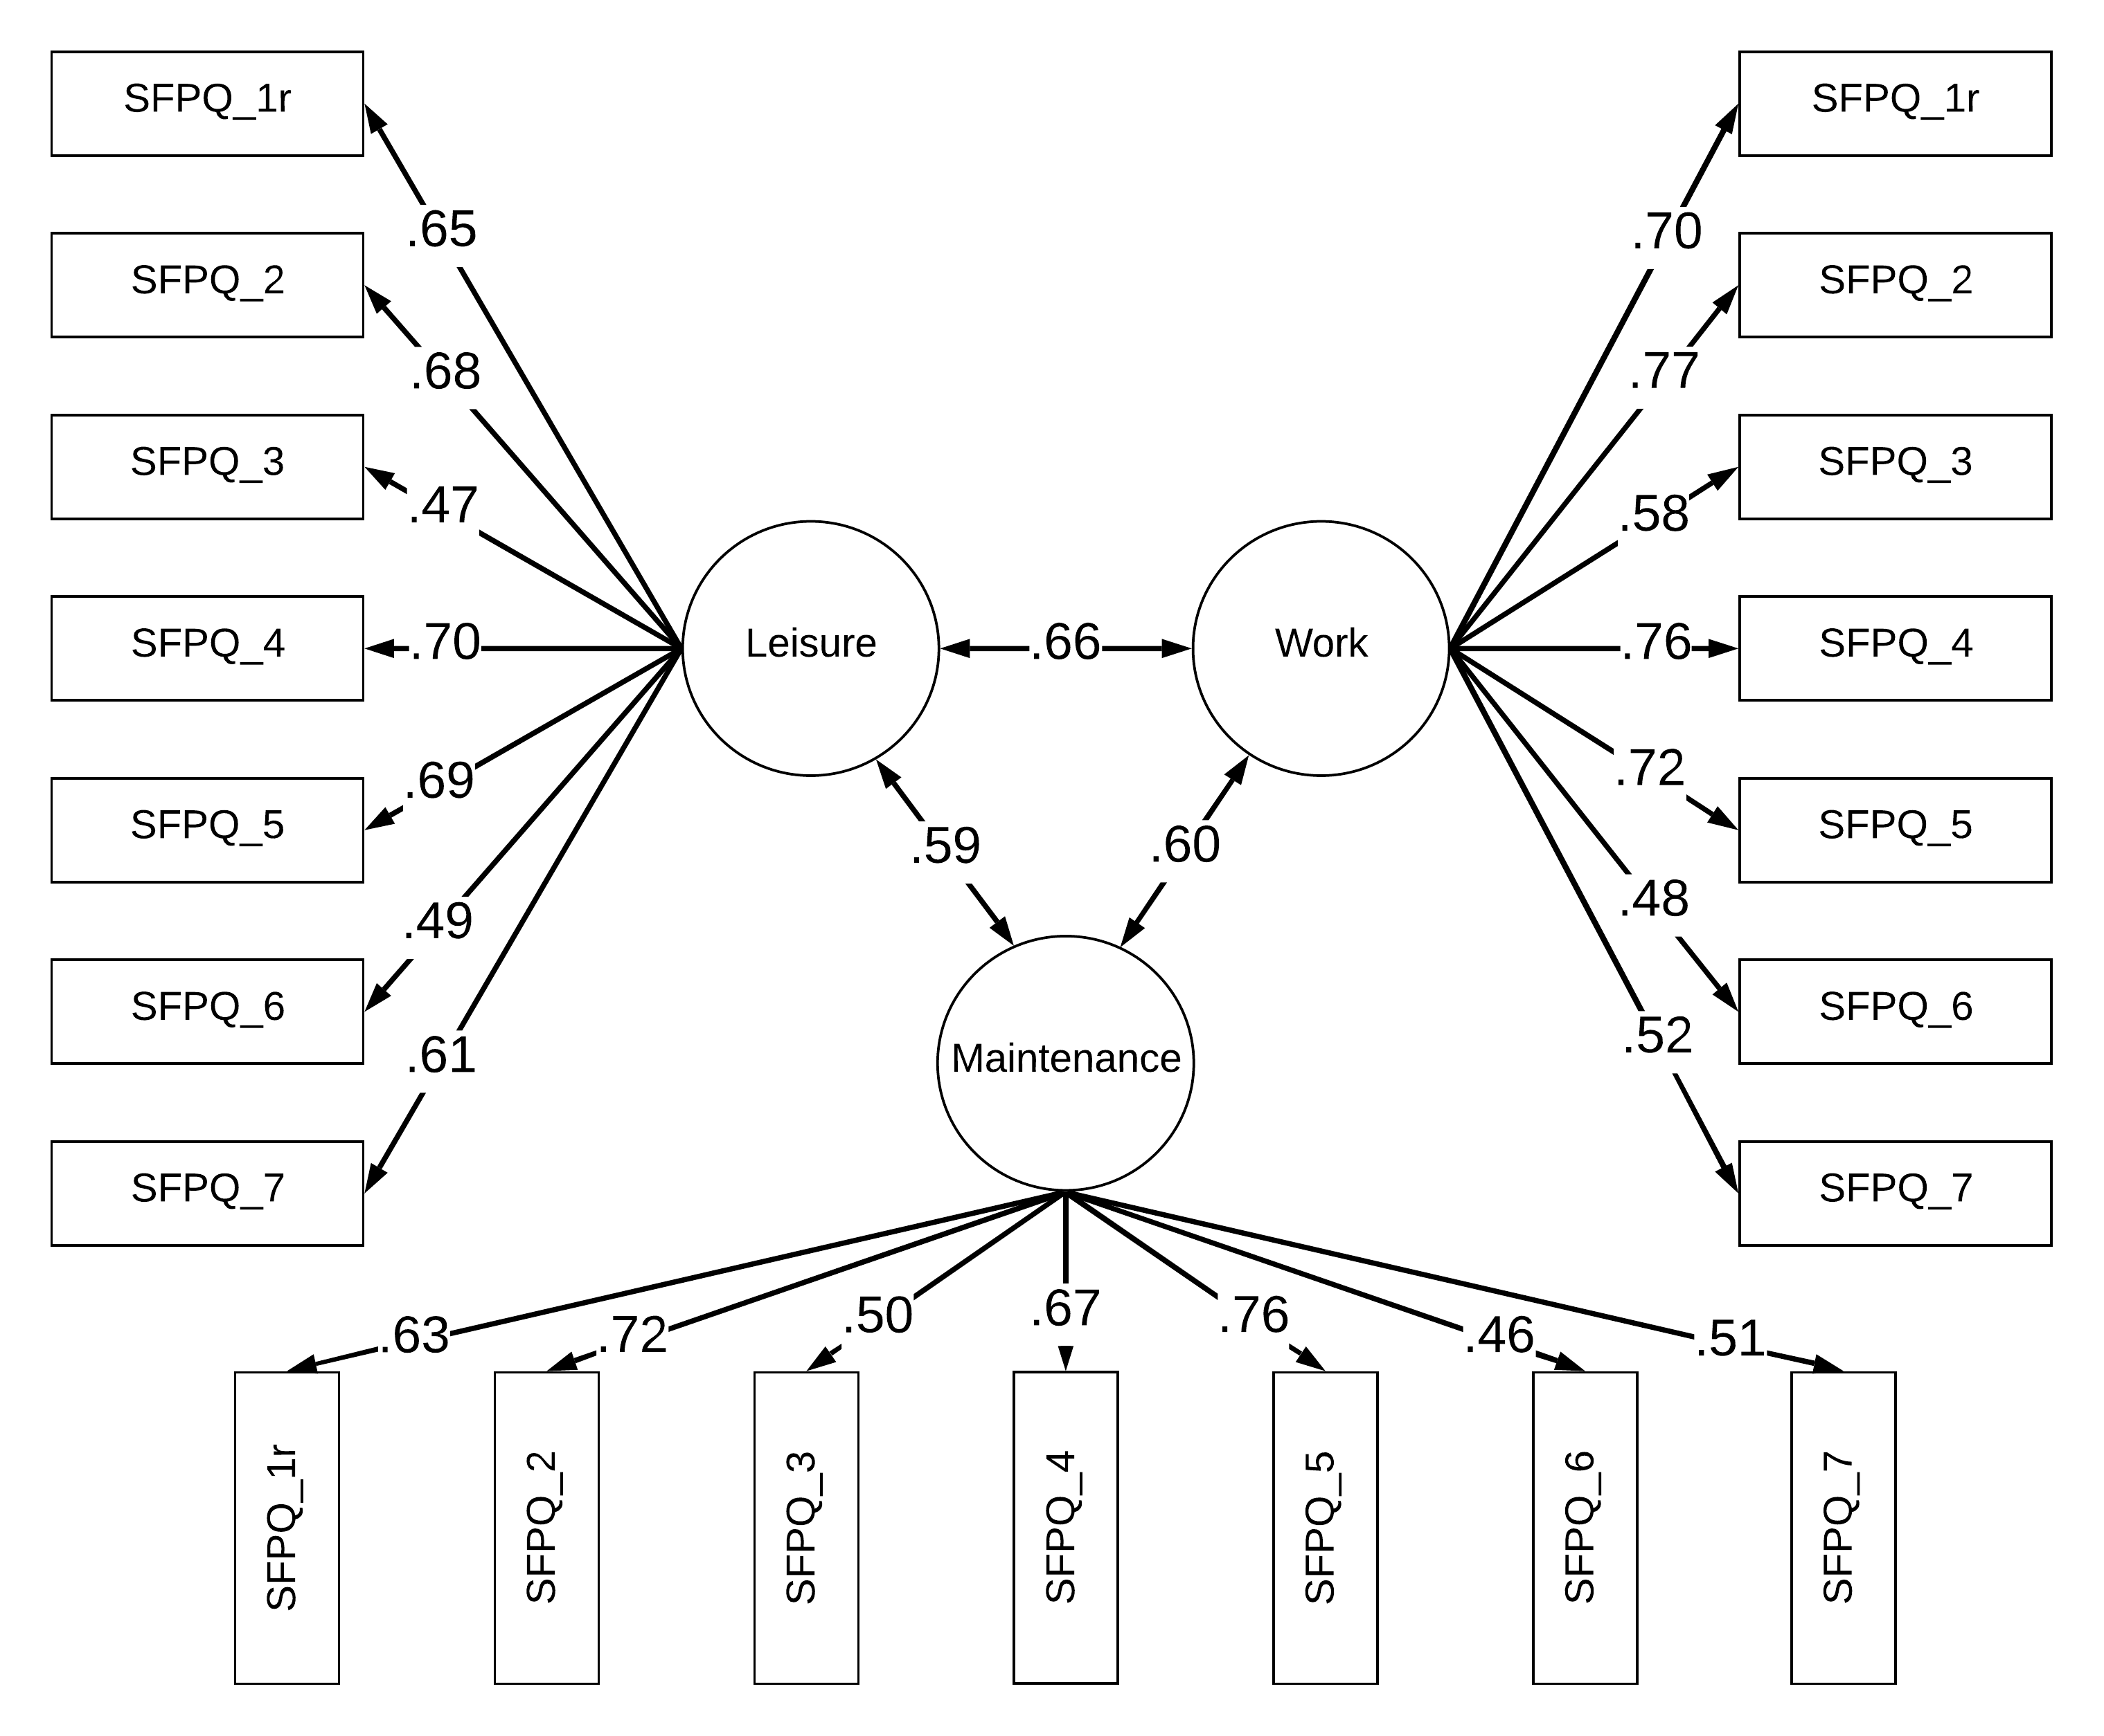
Supplementary Figure S2. Final latent factor model of SFPQ in Study 2. All factor loadings and correlations are standardized and statistically significant (ps < .05). Residuals of manifest variables are omitted.

