Supplemental Material A: Evolution of SWB in Brazil during the 2010s
Figure A1: The Evolution of Life Satisfaction in Brazil based on data from the Latinobarómetro
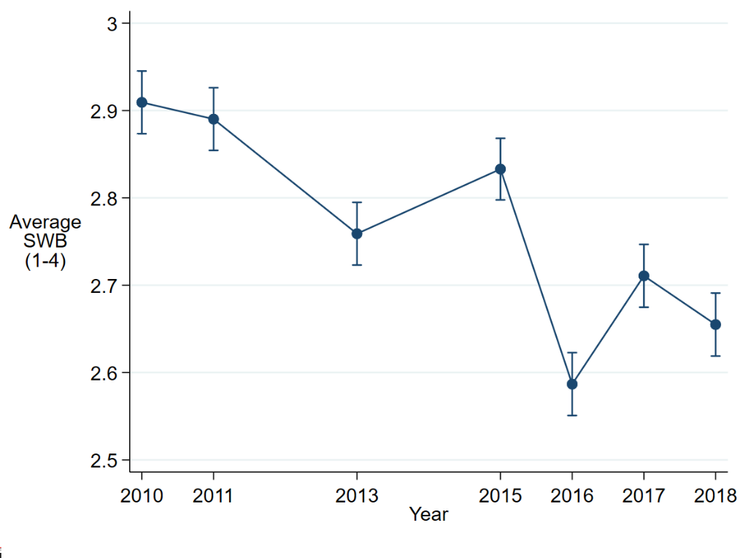
Source: Latinobarómetro (2010-2018). Notes: 95% confidence intervals shown. N=8,432. SWB is based on the question: Generally speaking, would you say you are satisfied with your life? Would you say you are...? 1=Not at all satisfied; 2=Not very satisfied; 3=quite satisfied; 4=very satisfied (reverse coded). All interviews in 2015 were held in January/February 2015. See also Veenhoven (2021).
Figure A2: The Evolution of Net Affect in Brazil Based on Data from the Gallup World Poll
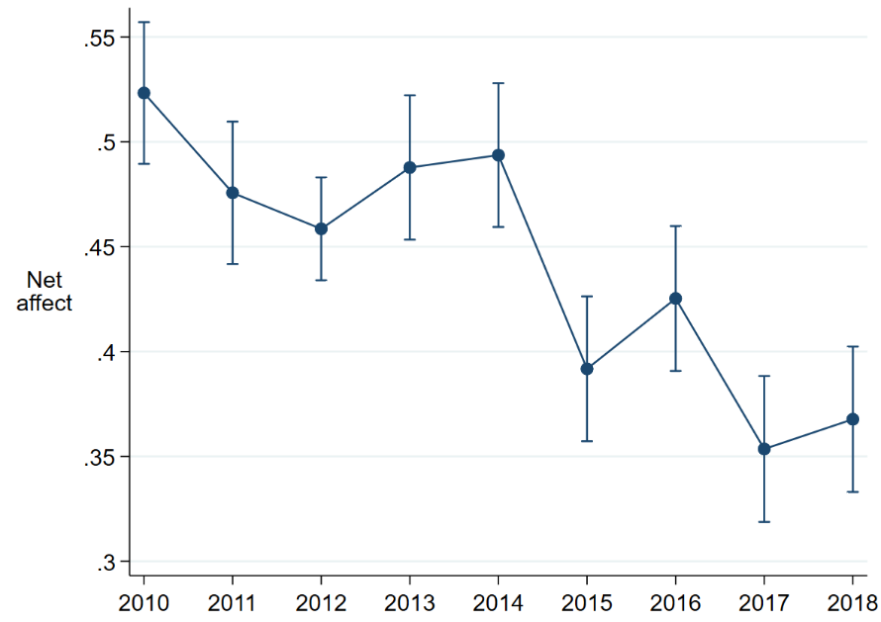
Source: Gallup World Poll. Notes: 95% confidence intervals shown. N=9,981. All interviews in 2015 were held in October/November 2015. Net Affect Score is based on the differences between the Positive Experience score and Negative Experience score. The Positive Experience score is based on the average of the following two questions on which respondents can answer yes (1) or no (0): (a) Did you smile or laugh a lot yesterday?, (b) Did you experience enjoyment during a lot of the day yesterday? Likewise, the negative experience index consists of three questions: Did you experience the following feelings during a lot of the day yesterday? How about (a) worry, (b) sadness, and (c) anger?
Supplemental Material B. Variable descriptions and definitions Gallup World Poll
Variable | Question | Scale
SWB | Please imagine a ladder, with steps numbered from 0 at the bottom to 10 at the top. The top of the ladder represents the best possible life for you and the bottom of the ladder represents the worst possible life for you. On which step of the ladder would you say you personally feel you stand at this time? | 0 (worst possible life) - 10 (best possible life)
Age & age²/100 |  | Age in years
Gender |  | Male/female
Has a partner | Dummy taking the value of 1 if the respondent is married or has a domestic partner, and 0 otherwise. | 1=yes; 0=no
Has children under 15 | Dummy taking the value of 1 if the respondent has children under 15 living in one’s household, and 0 otherwise. | 1=yes; 0=no
Immigrant | Were you born in this country, or not? | 1=no; 0=yes
Religious | Is religion an important part of your daily life? | 1=yes; 0=no
Has health problems | Do you have any health problems that prevent you from doing any of the things people your age normally can do? | 1=yes; 0=no
Had physical pain yesterday | Did you experience the following feelings during a lot of the day yesterday? How about physical pain? | 1=yes; 0=no
Lives in a rural area | The respondent’s self-reported type of settlement: (1) Rural area or farm; (2) Small town or village; (3) Large city; (4) Suburb of a large city. ‘Rural’ is defined as individuals in categories (1) and (2) and “urban” as individuals in categories (3) and (4). | 1=rural; 0=urban
Education level | What is your highest completed level of education? Elementary: Completed elementary education or less (up to 8 years of basic education); Secondary: Completed secondary education and up to 3 years tertiary education (nine to 15 years of education); Tertiary: Completed 4 years of education beyond “high school” and/or received a 4‐year college degree. | 1=elementary  2=secondary  3=tertiary
Employment status | Divided in 5 categories based on a series of questions. (1) employed full-time for an employer; (2) self-employed, (3) part-time employed, (4) unemployed, and (5) out of workforce.
Per capita income | Per capita income (reported household income divided by household size) | International dollars
Financial struggle | Index with 2 equally weighted items. Have there been times in the past 12 months when you did not have enough money to:  1. buy food that you or your family needed?  2. provide adequate shelter or housing for you and your family? | 1=yes; 0=no
Income sufficiency | Which one of these phrases comes closest to your own feelings about your household’s income these days?  1= living comfortably on present income  2= getting by on present income  3= finding it difficult on present income  4= finding it very difficult on present income | 1-4
Satisfied with standard of living | Are you satisfied or dissatisfied with your standard of living, all the things you can buy and do? | 1=satisfied; 0=dissatisfied
Personal economic progress | Right now, do you feel your standard of living is getting better or getting worse? | 1=getting worse  2=the same  3=getting better
Optimism economy | Right now, do you think that economic conditions in the city or area where you live, as a whole, are getting  better or getting worse? | 1=getting worse  2=the same  3=getting better
Social support | If you were in trouble, do you have relatives or friends you can count on to help you whenever you need them, or not? | 1=yes; 0=no
Civic engagement | Index with 3 equally weighted items. Have you done any of the following in the past month? How about:  - Donated money to a charity?  - Volunteered your time to an organization?  - Helped a stranger or someone you didn’t know who needed help? | 1=yes; 0=no
Acceptance of diversity | Index with 4 equally weighted items. Is the city or area where you live a good place or not a good place to live for:  - racial and ethnic minorities?  - gay or lesbian people?  - immigrants from other countries?  - people with intellectual disabilities? | 1=Good place;  0=Not good place
Digital access | Index with 2 equally weighted items.  - Do you have a landline telephone in your home or a mobile phone that you use to make and receive personal calls?  - Do you have access to the internet in any way, whether on a mobile phone, a computer, or some other device? | 1=yes; 0=no
Satisfied with transportation infrastructure | Index with 2 equally weighted items. In your city or area where you live, are you satisfied or dissatisfied with:  - the public transportation systems?  - the roads and highways? | 1=satisfied; 0=dissatisfied
Satisfied with quality of air | In your city or area where you live, are you satisfied or dissatisfied with the quality of air? | 1=satisfied; 0=dissatisfied
Satisfied with quality of water | In your city or area where you live, are you satisfied or dissatisfied with the quality of water? | 1=satisfied; 0=dissatisfied
Satisfied with socializing opportunities | In your city or area where you live, are you satisfied or dissatisfied with the opportunities to meet people and make friends? | 1=satisfied; 0=dissatisfied
Satisfied with health care | In your city or area where you live, are you satisfied or dissatisfied with the availability of quality health care? | 1=satisfied; 0=dissatisfied
Satisfied with educational system and schools | In your city or area where you live, are you satisfied or dissatisfied with the educational system or the schools? | 1=satisfied; 0=dissatisfied
Safety | Index with 4 equally weighted items.  - Do you feel safe walking alone at night in the city or area where you live?  - In the city or area where you live, do you have confidence in the local police force?  - Within the last 12 months, have you had money or property stolen from you or another household member? (reverse coded)  - Within the past 12 months, have you been assaulted or mugged? (reverse coded) | 1=yes; 0=no
Corruption | Index with 2 equally weighted items.  - Is corruption widespread within businesses located in Colombia, or not?  - Is corruption widespread throughout the government in Colombia, or not? | 1=yes; 0=no
Confidence in national institutions | Index with 4 equally weighted items. Do you have confidence in each of the following, or not?  - How about the military?  - How about the judicial system and courts?  - How about the national government?  - How about the honesty of elections? | 1=yes; 0=no
Approval of country’s leadership | Do you approve or disapprove of the job performance of the leadership of this country? | 1=approve; 0=disapprove
Satisfied with freedom | In Colombia are you satisfied or dissatisfied with your freedom to choose what you do with your life? | 1=satisfied; 0=dissatisfied
Social mobility is possible | Can people in this country get ahead by working hard, or not? | 1=yes; 0=no
Regional GDP per capita (Brazilian real) | Regional GDP per capita at Purchasing Power Parities (PPP) under current prices derived from data of the Brazilian Institute of Geography and Statistics. | In Brazilian real
Regional unemployment rate | Percentage of unemployed people in the population derived from the Brazilian Institute of Geography and Statistics. | In percentages

Supplemental Material C. Variable descriptions and definitions in data from Brazil Electoral Study
Variable | Question | Scale
Bolsonaro vote round 2 | Voted for Jair Bolsonaro in the second round of the presidential elections | 0=No  1=Yes
Bolsonaro-PT switch | Switched from voting for Dilma Rousseff in 2014 to Jair Bolsonaro in 2018
Age | Four age categories: <30 years, 30-44 years, 45-59 years, 60 years or older | Age in years
Gender | Gender of the respondent | Male/female
Has a partner | Dummy taking the value of 1 if the respondent is married or has a domestic partner, and 0 otherwise. | 1=yes; 0=no
Other people in household | Dummy taking the value of 1 if the respondent has other people than their partner living in the same household | 1=yes; 0=no
Evangelical | Religious denomination: evangelical | 1=yes; 0=no
White | Ethnicity: Preto, Pardo, Branco, Amarelo, Índio | 1=White (Branco)  2=Other
Immigrant | Were you born in Brazil, or not? | 1=no; 0=yes
Lives in a rural area | The respondent’s self-reported type of settlement: (1) Rural; (2) urban | 1=rural; 0=urban
Region | Region in which the respondent is living | 1= North  2= Northeast  3= Central-West  4= Southeast  5= South
Education level | Highest level of attained education | 1=Elementary  2=Secondary  3=Tertiary
Employment status | Current employment status | 1=Paid employment  2=Self-employed/Entrepreneur  3=Unemployed  4=Out of labor force
Income | Approximate monthly household income | 1= Lowest quintile-5=Highest quintile; 6=Unknown
Optimism economy | Do you think that the current economic situation in the country is much better, a little better, the same, a little worse or much worse than in the last twelve months? | 1=much/little better; 2=the same; 3=little/much worse
Personal economic progress | In recent years, it has been argued that many people have experienced a change in their social class.  - 8 years ago, you and his family belonged to the class: (1=Highest, 6=Lowest)  - Today they belong to class: (1=Highest, 6=Lowest) | 1= No change; 2= Upward  3= Downward
Perceived corruption | How widespread do you think corruption is in Brazil, such as bribes among politicians? | 1(hardly happens) -4(very widespread)
Against income redistribution | To what extent do you agree with the following statement “The government should take measures to reduce the differences between income levels” | 1(completely agree) – 5 (completely disagree)
Immigrants bad for economy | To what extent do you agree with the following statement: immigrants are good for the Brazilian economy | 1(completely agree) – 5 (completely disagree)
Satisfied with crime control | How satisfied are you with crime control? | 0 (very dissatisfied)- 10(very satisfied)
Satisfied with public services provision | Index of How satisfied are you with (1) access to healthcare, (2) access to higher education, (3) access to high schools, (4) access to vocational education, (5) access to culture, (6) access to justice for ordinary citizens, (7) access to medicines | 0 (very dissatisfied)- 10(very satisfied)
Conservatism | Based on the proposition: Minorities should adapt to the customs and traditions of Brazil | 1(completely agree) – 5 (completely disagree)
Nativism | Index based on the questions: (1) How important do you think it is to be born in Brazil to be considered truly Brazilian?, (2) How important do you think it is to have Brazilian ancestors to be considered truly Brazilian?, (3) How important do you think it is to be able to speak the Portuguese language to be considered truly Brazilian?, and (4) How important do you think it is to follow the customs and traditions of Brazil to be considered truly Brazilian? | 1(low degree nativism)-4(high degree nativism)
Confidence in the military | What is your confidence in the military? | 1(not confident)-4(very confident)
Satisfied with democracy | In general, are you very satisfied, satisfied, not very satisfied or not at all satisfied with the functioning of democracy in Brazil? | 1(not confident)-4(very confident)
Trust in political parties | What is your confidence in political parties in general? | 1(not satisfied)-4(very satisfied)
Antipetismo (Lack of leadership approval) | Can you indicate how much you like the PT party? | 0=Very much  10=Not at all
Bolsa Familia beneficiary | In the last three years, were you or a household member a beneficiary of the Bolsa Família program? | 1=Yes  0=No

Supplemental Material D – Regression Analyses for Periods 2014-2018 and 2015-2018
Variable |  | β_{B}  2010-2014 | β_{A}  2015-2018
Age |  | -0.02 (0.01)# | -0.04 (0.02)**
Age squared |  | 0.03 (0.01)* | 0.04 (0.02)**
Female |  | 0.04 (0.07) | 0.41 (0.10)**
Has a partner |  | 0.14 (0.07)# | 0.19 (0.09)*
Has children under 15 |  | 0.11 (0.07) | -0.10 (0.10)
Religious |  | -0.36 (0.18)# | 0.44 (0.19)**
Immigrant |  | 0.07 (0.43) | -0.93 (0.81)
Has health problems |  | -0.30 (0.10)** | -0.15 (0.14)
Had physical pain yesterday |  | -0.29 (0.08)** | 0.05 (0.10)
Lives in a rural area |  | 0.18 (0.08)** | -0.00 (0.09)
Elementary education |  | -0.10 (0.07) | -0.13 (0.09)
Secondary education |  | -0.04 (0.05) | -0.11 (0.07)#
Tertiary education |  | 0.13 (0.08) | 0.25 (0.10)*
Full-time employed for employer |  | -0.00 (0.07) | -0.09 (0.08)
Self-employed |  | -0.07 (0.09) | 0.09 (0.11)
Part-time employed |  | -0.02 (0.09) | 0.08 (0.09)
Unemployed |  | -0.01 (0.14) | -0.09 (0.13)
Out of workforce |  | 0.10 (0.07) | 0.01 (0.09)
Per capita income (inflation-adjusted) |  | 0.00 (0.00) | 0.00 (0.00)
In financial struggle |  | -0.21 (0.12)# | -0.52 (0.15)**
Income sufficiency (1-4) |  | 0.25 (0.05)** | 0.29 (0.07)**
Satisfied with standard of living |  | 0.62 (0.11)** | 0.87 (0.10)**
Personal economic optimism (1-3) |  | 0.58 (0.07)** | 0.38 (0.06)**
Optimism about economy (1-3) |  | -0.01 (0.07) | -0.01 (0.05)
Having social support |  | 0.18 (0.13) | 0.27 (0.15)#
Civic engagement index (0-1) |  | -0.14 (0.12) | 0.31 (0.14)*
Acceptance of diversity index (0-1) |  | 0.19 (0.10)# | -0.01 (0.15)
Digital access index (0-1) |  | 0.44 (0.14)** | 0.25 (0.18)
Safety index (0-1) |  | -0.13 (0.13) | -0.01 (0.19)
Satisfied with opportunities for socializing |  | 0.09 (0.09) | 0.13 (0.12)
Satisfied with transportation infrastructure |  | 0.01 (0.10) | 0.01 (0.12)
Satisfied with educational system |  | 0.07 (0.08) | -0.01 (0.10)
Satisfied with quality of air |  | 0.17 (0.08)* | -0.10 (0.10)
Satisfied with quality of water |  | 0.01 (0.09) | 0.19 (0.11)#
Satisfied with healthcare |  | 0.20 (0.09)* | 0.04 (0.12)
Corruption index (0-1) |  | -0.04 (0.09) | 0.08 (0.10)
Confidence in national institutions index (0-1) |  | 0.15 (0.11) | 0.17 (0.18)
Approves of country’s leadership |  | 0.00 (0.08) | 0.45 (0.16)**
Satisfied with freedom |  | 0.03 (0.09) | 0.08 (0.10)
Considers social mobility possible |  | 0.06 (0.08) | 0.06 (0.10)
Regional GDP per capita (inflation-adjusted, Brazilian real) |  | 0.00 (0.01) | 0.02 (0.01)*
Regional unemployment rate |  | 0.00 (0.02) | -0.02 (0.02)

