Supplementary Material
Table S1
Model Fit Indices for Multigroup Analysis Between Female and Male Student Groups
Model | χ² | df | χ²/df | CFI | $∆$CFI | TLI | RMSEA | RMSEA 90 % CI | SRMR
Overall Model | 2007.181 | 424 | 4.734 | .911 | - | .902 | .058 | [.056, .061] | .056
Male Model | 1309.830 | 424 | 3.089 | .899 | - | .889 | .062 | [.058, .066] | .060
Female Model | 1276.453 | 424 | 3.010 | .906 | - | .897 | .060 | [.056, .064] | .059
Configural Model | 2586.283 | 848 | 3.050 | .903 | - | .893 | .061 | [.058, .064] | .059
Metric Model | 2619.923 | 875 | 2.994 | .902 | .001 | .896 | .060 | [.058, .063] | .063
Scalar Modelª | 2676.725 | 898 | 2.981 | .901 | .001 | .897 | .060 | [.058, .063] | .064
Strict Model^{b} | 2864.097 | 929 | 3.083 | .892 | .003 | .892 | .062 | [.059, .064] | .065
Note. CFI: comparative fit index; TLI: Tucker-Lewis-Index; RMSEA: root-mean-square error of approximation; CI: confidence interval; SRMR: standardised root mean square residual.
^{ab} The scalar and strict models cannot be identified (Heywood case; Heywood, 1931). Many researchers agree that the strict model (testing the equal error variances) as an evidence of measurement invariance is overly restrictive (Byrne, 2004).

Table S2
Model Fit Indices for Multigroup Analysis Among Grade 4 to 6 Groups
Model | χ² | df | χ²/df | CFI | $∆$CFI | TLI | RMSEA | RMSEA 90 % CI | SRMR
Overall Model | 2017.429 | 424 | 4.758 | .911 | - | .902 | .058 | [.056, .061] | .056
4-Grade Model | 1105.027 | 424 | 2.606 | .898 | - | .888 | .063 | [.059, .068] | .062
5-Grade Model | 1013.690 | 424 | 2.391 | .893 | - | .882 | .062 | [.057, .067] | .063
6-Grade model | 1149.399 | 424 | 2.711 | .885 | - | .874 | .071 | [.066, .076] | .068
Configural Model | 3268.116 | 1272 | 2.569 | .892 | - | .882 | .065 | [.062, .068] | .064
Metric Model | 3335.948 | 1326 | 2.516 | .891 | .001 | .886 | .064 | [.061, .067] | .069
Scalar Modelª | 3451.304 | 1372 | 2.516 | .887 | .004 | .886 | .064 | [.061, .067] | .070
Strict Model^{b} | 3724.208 | 1434 | 2.597 | .876 | .011 | .879 | .066 | [.063, .068] | .071
Note. CFI: comparative fit index; TLI: Tucker-Lewis-Index; RMSEA: root-mean-square error of approximation; CI: confidence interval; SRMR: standardised root mean square residual.
^{ab} The scalar and strict models cannot be identified (Heywood case; Heywood, 1931). Many researchers agree that the strict model (testing the equal error variances) as an evidence of measurement invariance is overly restrictive (Byrne, 2004).

Table S3
Comparison Between First-Order Mediation Model and Second-Order Mediation Model
Model | χ2 | df | χ²/df | CFI | $∆$CFI | TLI | RMSEA | RMSEA 90 % CI | SRMR
Mediational Model: Second-order | 1486.724 | 425 | 3.498 | .918 | - | .911 | .055 | [.052, .058] | .056
Mediational Model: First-order | 1278.286 | 414 | 3.088 | .933 | .015 | .925 | .051 | [.051, .048] | .048
Note. CFI: comparative fit index; TLI: Tucker-Lewis-Index; RMSEA: root-mean-square error of approximation; CI: confidence interval; SRMR: standardised root mean square residual.
Figure S1
First-Order Construct Mediational Model
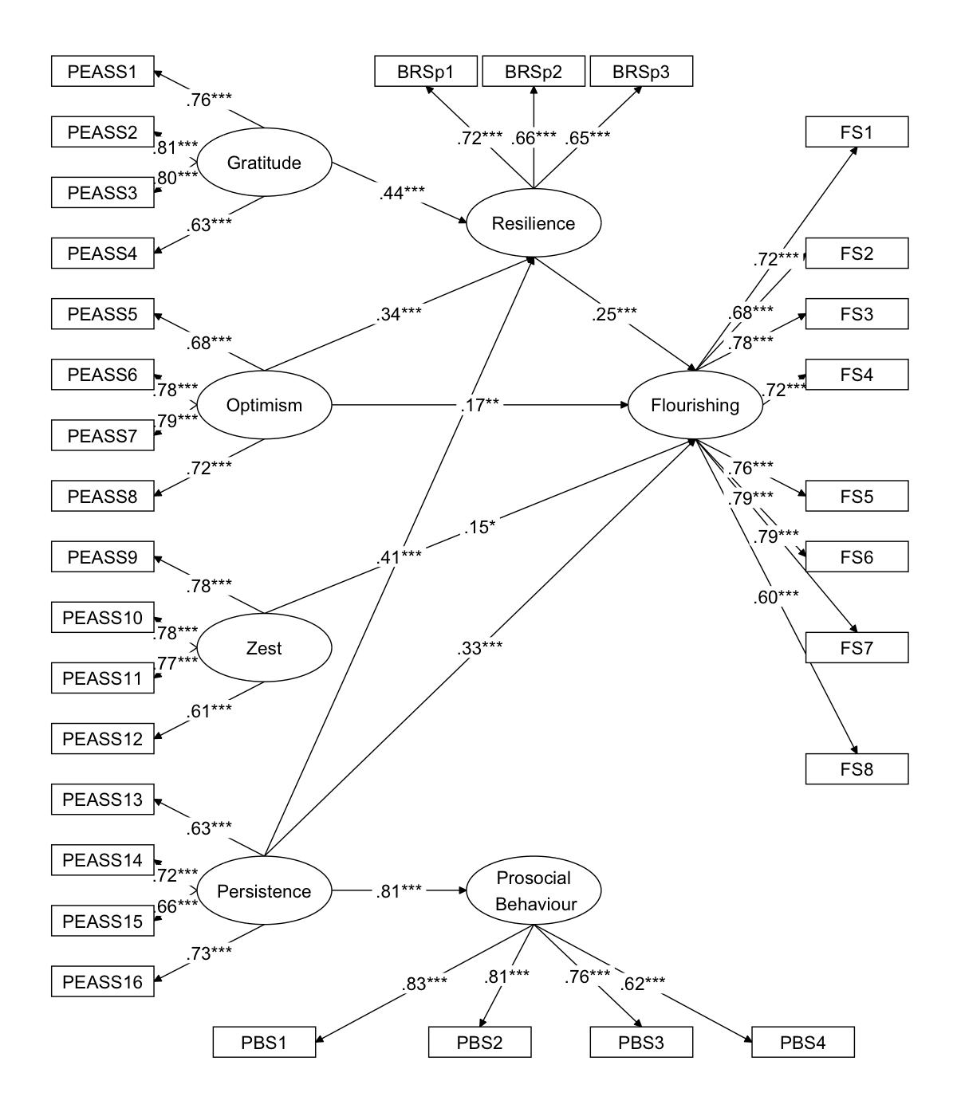
Model fit: χ² = 1278.286, df = 414, CFI = .933, TLI = .925, RMSEA = .051 (90% CI = [.048, .054]), SRMR = .048.
Note. This structural equation model predicts flourishing from student covitality, with mediating effect of resilience. Statistics are standardised regression coefficients. For easy viewing, only significant paths are shown in this study, and residual and measurement errors are omitted.
*** p < .001. ** p < .01. * p < .05

