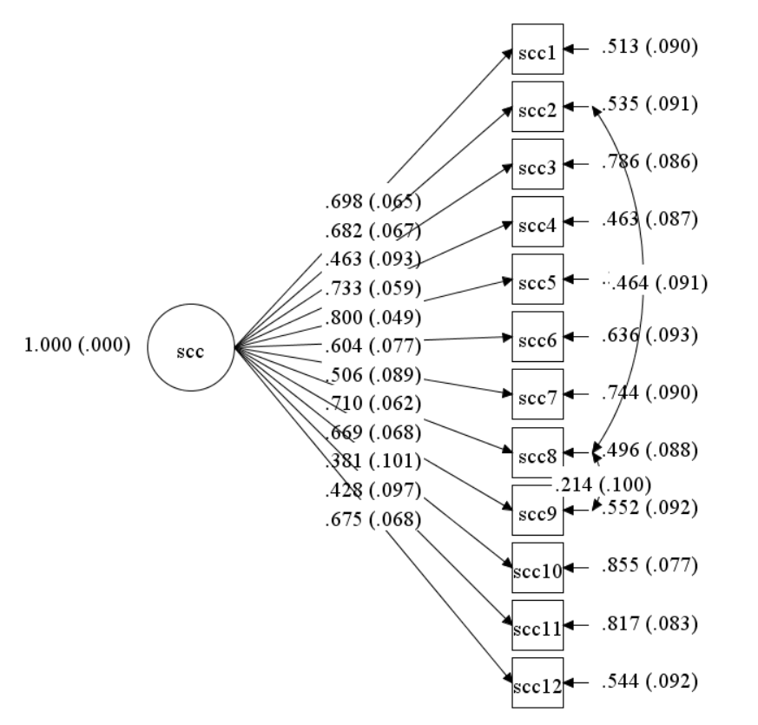
Figure S1. The path diagram of the Self-Concept Clarity scale.
Note. N = 83. Scc = self-concept clarity. The factor loadings of a one-factor confirmatory factor analysis were provided. Several residual covariances were specified in the model based on the similarity of wordings. Fit indexes: RMSEA = 0.05, CFI = 0.97, TLI = 0.96. To access the complete items of this scale, please refer to Campbell and colleagues’ (1996) paper.

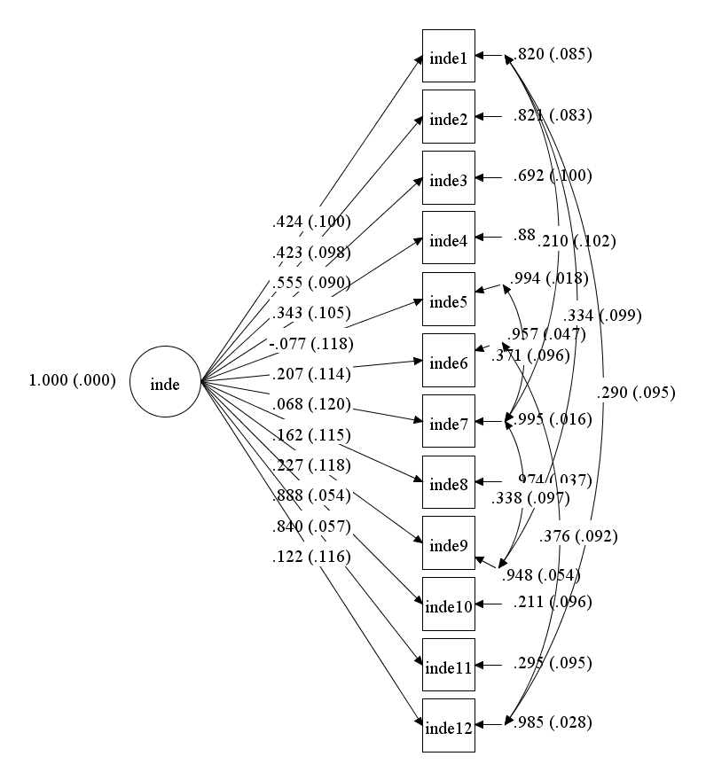
Figure S2. The path diagram of the Independent Self-Construal scale.
Note. N = 83. Inde = independent self-construal. The factor loadings of a one-factor confirmatory factor analysis for the Independent Self-Construal Scales were provided. Several residual covariances were specified in the models based on the similarity of wordings. RMSEA = 0.079, CFI = 0.88, TLI = 0.83. To access the complete items of this scale, please refer to Singelis’ (1994) paper.

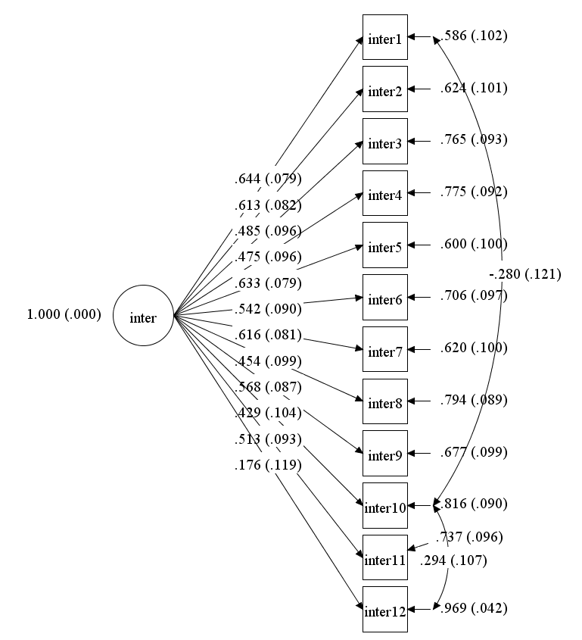
Figure S3. The path diagram of the Interdependent Self-Construal scale.
Note. N = 83. Inter = interdependent self-construal. The factor loadings of a one-factor confirmatory factor analysis for the Interdependent Self-Construal Scales were provided. Several residual covariances were specified in the models based on the similarity of wordings. RMSEA = 0.068, CFI = 0.92, TLI = 0.90. To access the complete items of this scale, please refer to Singelis’ (1994) paper.

Table S1. Multilevel factor loadings of the daily positive and negative affect.
Items | Loadings
Within-Person Level
Positive affect
Happy | .847
Enjoy | .752
Joy | .837
Satisfied | .776
Negative affect
Sad | .749
Anxiety | .485
Anger | .466
Guilty | .332
Between-Person Level
Positive affect
Happy | .963
Enjoy | .959
Joy | 1.00
Satisfied | .957
Negative affect
Sad | .932
Anxiety | .897
Anger | .756
Guilty | .968
Note. N = 83 at the between person level. N = 732 at the within-person level. The factor loadings of a two-factor confirmatory factor analysis were provided.

Table S2. Dynamic Structural Equation Models of the Relationship between Daily Self-Concept Clarity and Daily Meaning.
 | β | Posterior  S.D. | p | 95% CI LL | 95% CI UL
Autoregressive paths  Self-concept clarity_{t-1} -> Self-concept clarity _{t} | 0.21 | 0.06 | .001 | 0.10 | 0.32
Meaning_{t-1} –> Meaning _{t} | 0.08 | 0.05 | .007 | -0.03 | 0.02
Cross-lagged paths  Self-concept clarity_{t-1} –> Meaning _{t} | 0.12 | 0.05 | .014 | 0.02 | 0.22
Meaning_{t-1} -> Self-concept clarity _{t} | -0.12 | 0.05 | .007 | -0.21 | -0.03
Log residuals  Variance self-concept clarity | 0.71 | 0.06 | <.001 | 0.64 | 0.77
Variance meaning | 0.72 | 0.03 | <.001 | 0.66 | 0.78
Note.β = standardized path coefficients.

Table S3. Dynamic Structural Equation Models of the Relationship between Daily Self-Concept Clarity and Daily Coherence.
 | β | Posterior  S.D. | p | 95% CI LL | 95% CI UL
Autoregressive paths  Self-concept clarity_{t-1} -> Self-concept clarity _{t} | 0.10 | 0.06 | .042 | -0.01 | 0.22
Coherence_{t-1} –> Coherence _{t} | 0.23 | 0.06 | <.001 | 0.10 | 0.34
Cross-lagged paths  Self-concept clarity_{t-1} –> Coherence _{t} | -0.03 | 0.06 | .340 | -0.13 | 0.10
Coherence_{t-1} -> Self-concept clarity _{t} | 0.01 | 0.05 | .431 | -0.10 | 0.11
Log residuals  Variance self-concept clarity | 0.87 | 0.04 | <.001 | 0.78 | 0.93
Variance coherence | 0.82 | 0.04 | <.001 | 0.73 | 0.90
Note.β = standardized path coefficients.

Table S4. Dynamic Structural Equation Models of the Relationship between Daily Self-Concept Clarity and Daily Purpose.
 | β | Posterior  S.D. | p | 95% CI LL | 95% CI UL
Autoregressive paths  Self-concept clarity_{t-1} -> Self-concept clarity _{t} | 0.18 | 0.06 | .002 | 0.06 | 0.30
Purpose_{t-1} –> Purpose _{t} | 0.10 | 0.07 | .065 | -0.10 | 0.06
Cross-lagged paths  Self-concept clarity_{t-1} –> Purpose _{t} | 0.02 | 0.06 | .372 | -0.10 | 0.13
Purpose_{t-1} -> Self-concept clarity _{t} | -0.02 | 0.04 | .296 | -0.10 | 0.06
Log residuals  Variance self-concept clarity | 0.86 | 0.04 | <.001 | 0.76 | 0.93
Variance purpose | 0.81 | 0.04 | <.001 | 0.72 | 0.87
Note.β = standardized path coefficients.

Table S5. Dynamic Structural Equation Models of the Relationship between Daily Self-Concept Clarity and Daily Significance.
 | β | Posterior  S.D. | p | 95% CI LL | 95% CI UL
Autoregressive paths  Self-concept clarity_{t-1} -> Self-concept clarity _{t} | 0.15 | 0.06 | .009 | 0.03 | 0.28
Significance _{t-1} -> Significance _{t} | 0.19 | 0.06 | .001 | 0.07 | 0.29
Cross-lagged paths  Self-concept clarity_{t-1} -> Significance _{t} | -0.02 | 0.06 | .338 | -0.13 | 0.10
Significance _{t-1} -> Self-concept clarity _{t} | 0.01 | 0.06 | .442 | -0.11 | 0.12
Log residuals  Variance self-concept clarity | 0.68 | 0.04 | <.001 | 0.61 | 0.76
Variance significance | 0.65 | 0.04 | <.001 | 0.58 | 0.73
Note.β = standardized path coefficients.

Table S6. Dynamic Structural Equation Models of the Relationship between Daily Coherence and Daily Meaning.
 | β | Posterior  S.D. | p | 95% CI LL | 95% CI UL
Autoregressive paths  Coherence _{t-1} –> Coherence _{t} | 0.28 | 0.06 | <.001 | 0.17 | 0.39
Meaning _{t-1} -> Meaning _{t} | 0.18 | 0.06 | .002 | 0.06 | 0.30
Cross-lagged paths  Coherence _{t-1} -> Meaning _{t} | 0.00 | 0.06 | .472 | -0.11 | 0.12
Meaning _{t-1} -> Coherence _{t} | -0.07 | 0.04 | .043 | -0.14 | 0.01
Log residuals  Variance coherence | 0.83 | 0.04 | <.001 | 0.74 | 0.90
Variance meaning | 0.80 | 0.05 | <.001 | 0.70 | 0.88
Note.β = standardized path coefficients.

Table S7. Dynamic Structural Equation Models of the Relationship between Daily Purpose and Daily Meaning.
 | β | Posterior  S.D. | p | 95% CI LL | 95% CI UL
Autoregressive paths  Purpose _{t-1} –> Purpose _{t} | 0.00 | 0.05 | .488 | -0.10 | 0.11
Meaning _{t-1} -> Meaning _{t} | 0.36 | 0.06 | <.001 | 0.24 | 0.47
Cross-lagged paths  Purpose _{t-1} -> Meaning _{t} | -0.11 | 0.04 | .004 | -0.19 | -0.03
Meaning _{t-1} -> Purpose _{t} | 0.08 | 0.06 | .058 | -0.02 | 0.19
Log residuals  Variance purpose | 0.82 | 0.03 | <.001 | 0.75 | 0.88
Variance meaning | 0.78 | 0.05 | <.001 | 0.68 | 0.87
Note. β = standardized path coefficients.

Table S8. Dynamic Structural Equation Models of the Relationship between Daily Significance and Daily Meaning.
 | β | Posterior  S.D. | p | 95% CI LL | 95% CI UL
Autoregressive paths  Significance _{t-1} –> Significance _{t} | 0.15 | 0.10 | .024 | 0.00 | 0.35
Meaning _{t-1} -> Meaning _{t} | 0.27 | 0.07 | <.001 | 0.12 | 0.39
Cross-lagged paths  Significance _{t-1} -> Meaning _{t} | -0.02 | 0.07 | .386 | -0.14 | 0.12
Meaning _{t-1} -> Significance _{t} | -0.00 | 0.03 | .465 | -0.06 | 0.06
Log residuals  Variance significance | 0.90 | 0.07 | <.001 | 0.74 | 0.98
Variance meaning | 0.76 | 0.04 | <.001 | 0.68 | 0.85
Note. β = standardized path coefficients.

