Supplementary materials II
  - Data preparation
In order to calculate the effect size (Cohen’s d) for within-person studies, we required the sample size, group means, standard deviations, and correlation coefficients. If the correlation coefficient was not reported, we estimated it by using the R-code below. We created a function to estimate the correlation based on the sample size, means, standard errors, and p-values. Par = 0 states that we estimate the correlation based on the assumption that the correlation is 0.

get_cov <- function(par){
t <- qt(p = p ,df = n-1)
cov <- (se1 * par *se2)
minimize <- (t - (m1-m2/sqrt(se1^2 + se2^2 - 2*cov )))^2
minimize
}
correlate <- optim(par=0,fn=get_cov,lower=-1,upper= 1,method="L-BFGS-B")

1.2 Study samples and wellbeing scales
Table ST1. Percentage of each sample country represented in the studies.
Country | Percentage | Country | Percentage
Austria | 5% | Norway | 1%
Canada | 8% | Slovakia | 1%
China | 10% | South Korea | 1%
Denmark | 5% | Spain | 3%
Diverse | 5% | Sweden | 4%
Finland | 5% | Switzerland | 3%
India | 1% | Uganda | 1%
Italy | 4% | UK | 8%
Japan | 3% | Uruguay | 1%
Malaysia | 1% | USA | 16%
Netherlands | 10% | - | -
Note. Total is 96% due to rounding error.
Table ST2: Wellbeing scales
Wellbeing scale | Reference
Basler well-being | Hobi, 1985
Circumplex model of affect | Posner et al., 2005
EQ-5D | Devlin et al., 2020
GHQ-12 | Pevalin, 2000
Index of wellbeing | Campbell, 1976
Overall happiness/wellbeing | Marks et al., 2000
PANAS | Thompson, 2007
PGWB | Bowling, 2004
Predominant mood state | Johnson et al., 2008
Psychological wellbeing | Ryff, 1989
Q-les-Q | Endicott et al., 1993
Quality of Life | -
Quality of Life (Cantril ladder) | Cantril, 1966
Quality of Life Index | Ferrans & Powers, 1992
Satisfaction with Life Scale | Diener et al., 1985
Satisfaction with Life (1 item) | Matthews et al., 1997
SF-36 | Ware & Sherbourne, 1992
Subjective happiness | As asked in the UK Biobank: “In general, how happy are you?”
Subjective wellbeing | As asked in the Neurobehavioral Test Battery by Object-Tracker, Austria
Visual analogue scale | McCormack et al., 1988
WEMWBS | Tennant et al., 2007
WHO-5 | Topp et al., 2015
WHO-QOL | ‘The World Health Organization Quality of Life Assessment (WHOQOL)’, 1995

1.3. Risk of bias assessment.
Table ST3. Risk of bias of non-randomised trials (ROBINS-I), part I.
Study | Confounding | Participant selection | Classification of interventions | Deviation from interventions
Barba et al.,  2018 | + | + | + | +
Chirico et al., 2019 | - | ~ | + | +
De Kort et al.,  2010 | - | + | + | +
Denk et al.,  2015 | - | + | + | +
Falkenberg et al., 2019 | - | + | ~ | +
Harrison et al.,  2020 | - | + | + | +
Madsen et al.,  2021 | - | + | + | +
Mills et al.,  2007 | - | + | + | +
Najjar et al.,  2014 | - | + | + | +
Rastad et al.,  2011 | + | + | + | +
Smolders et al., 2012 | - | + | + | +
Smolders et al.,  2014 | - | + | + | +
Stemer et al.,  2015 | ~ | + | + | +
Turco et al.,  2018 | ~ | + | + | +
West et al.,  2019 | ~ | + | + | +

Note. +: low risk of bias, ~: moderate risk of bias, -: serious risk of bias, --: critical risk of bias.
Table ST3. Risk of bias of non-randomised trials (ROBINS-I), part II.
Study | Missing data | Measurement of outcomes | Selection of reported results | Overall  risk
Barba et al.,  2018 | + | ~ | - | -
Chirico et al.,  2019 | + | ~ | ~ | -
De Kort et al.,  2010 | + | ~ | ~ | -
Denk et al.,  2015 | + | ~ | + | -
Falkenberg et al., 2019 | + | ~ | ~ | -
Harrison et al.,  2020 | + | ~ | ~ | -
Madsen et al.,  2021 | ~ | ~ | ~ | -
Mills et al.,  2007 | + | ~ | + | -
Najjar et al.,  2014 | + | ~ | ~ | -
Rastad et al.,  2011 | + | ~ | + | ~
Smolders et al.,  2012 | + | ~ | ~ | -
Smolders et al.,  2014 | + | ~ | ~ | -
Stemer et al.,  2015 | + | ~ | ~ | ~
Turco et al.,  2018 | + | ~ | ~ | ~
West et al.,  2019 | ~ | - | ~ | -
Note. +: low risk of bias, ~: moderate risk of bias, -: serious risk of bias, --: critical risk of bias.

Table ST4. Risk of bias of randomized trials (RoB 2).
Study | Randomization process | Adherence to intervention | Missing outcome data | Measurement of the outcome | Selective outcome reporting | Overall risk
Aan het Rot et al., 2017 | + | + | + | + | ~ | ~
Bajaj et al.,  2021 | + | + | + | + | ~ | ~
Brunnstrom et al., 2004 | + | + | + | ~ | ~ | ~
Canazei et al.,  2019 | + | + | + | - | ~ | -
De Rui et al.,  2015 | ~ | + | ~ | - | ~ | -
Kim et al.,  2021 | ~ | + | + | + | + | ~
Lee et al.,  2013 | + | + | + | + | ~ | ~
Martiny et al.,  2005 | + | + | + | + | ~ | ~
Morton et al.,  2021 | + | + | ~ | + | ~ | ~
Okkels et al., 2020 | + | + | - | + | + | -
Partonen et al., 1998 | + | ~ | + | ~ | ~ | ~
Rutten et al.,  2019 | + | + | ~ | + | ~ | ~
Starreveld et al., 2021 | + | + | + | + | ~ | ~
Sundararajan et al.,  2021 | + | + | + | - | + | -
Taylor et al.,  2009 | + | + | + | ~ | ~ | ~
Note. +: low risk of bias, ~: some risk of bias, -: high risk of bias.

1.4 Publication bias
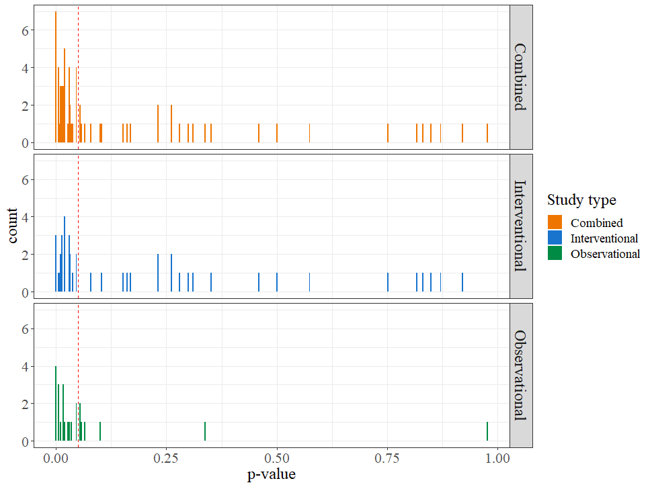
Figure SF1. Histogram of the distribution of p-values split by study type Note. Combined (k = 68), interventional studies (k = 44), and observational studies (k = 24). The red dotted-line indicates a p-value of 0.05.

1.4 Sensitivity analysis
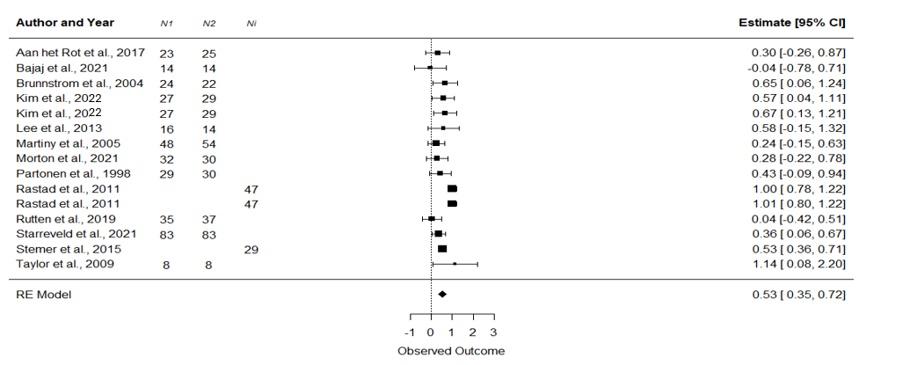
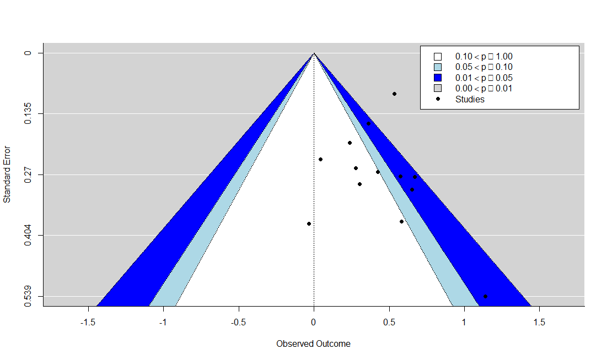
Figure SF2. Forest plot for the sensitivity analysis.

Figure SF3. Contour-enhanced funnel plot. The black dots represent each individual study. The shaded regions represent various levels of statistical significance

1.5 Exploratory analysis
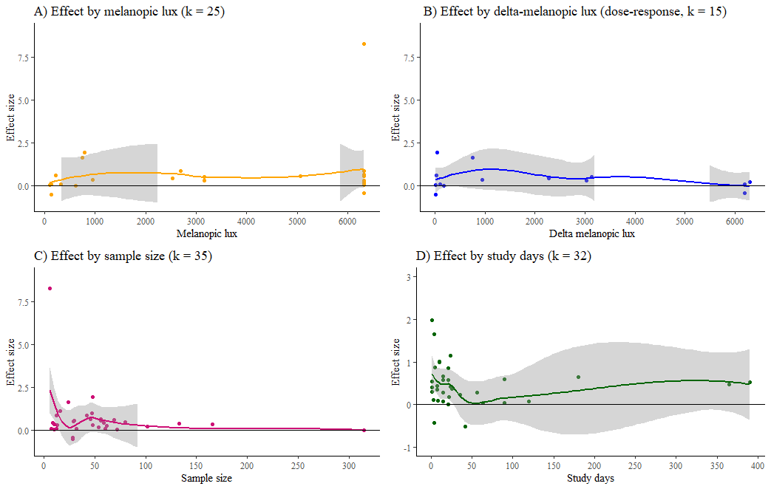

Figure SF4. Dotplots with the effect size plotted against the melanopic lux (A), delta melanopic lux (B), the sample size (C) and the number of study days (D). The plot lines represent predictions from a linear model with 95% confidence level intervals (grey area).

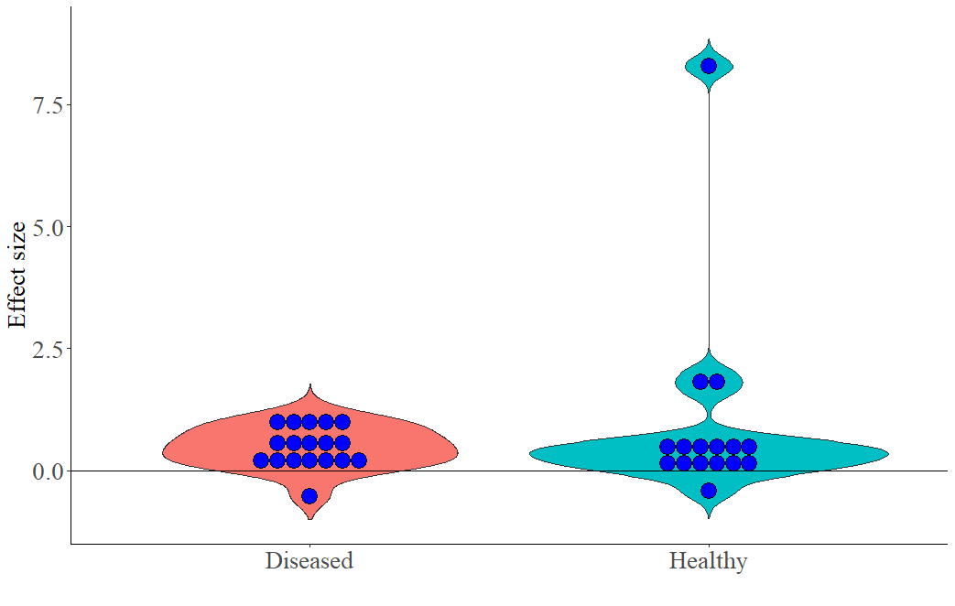
Figure SF5. Violin plots showing effect sizes in diseased (k = 18) versus healthy (k = 16) samples.

References
Bowling, A. (2004). Measuring health. A review of quality of life measurement scales. Third edition.
Campbell, A. (1976). Subjective measures of well-being. American Psychologist, 31, 117–124. https://doi.org/10.1037/0003-066X.31.2.117
Cantril, H. (1966). The pattern of human concerns. Rutgers University Press.
Devlin, N., Parkin, D., & Janssen, B. (2020). Methods for Analysing and Reporting EQ-5D Data. Springer International Publishing. https://doi.org/10.1007/978-3-030-47622-9
Diener, E., Emmons, R. A., Larsem, R. J., & Griffin, S. (1985). The Satisfaction With Life Scale. Journal of Personality Assessment. https://doi.org/10.1207/s15327752jpa4901_13
Endicott, J., Nee, J., Harrison, W., & Blumenthal, R. (1993). Quality of life enjoyment and satisfaction questionnaire: A new measure. Psychopharmacology Bulletin, 29(2), 321–326. Scopus.
Ferrans, C. E., & Powers, M. J. (1992). Psychometric assessment of the quality of life index. Research in Nursing & Health, 15(1), 29–38. https://doi.org/10.1002/nur.4770150106
Hobi V (1985) Basler Befindlichkeits-Skala. Beltz-Test, Weinheim, Switzerland
Johnson, D. R., Vincent, A. S., Johnson, A. E., Gilliland, K., & Schlegel, R. E. (2008). Reliability and construct validity of the Automated Neuropsychological Assessment Metrics (ANAM) mood scale. Archives of Clinical Neuropsychology: The Official Journal of the National Academy of Neuropsychologists, 23(1), 73–85. https://doi.org/10.1016/j.acn.2007.10.001
Marks, Gary N., Nicole Fleming, Michael Long, and Julie McMillan. ‘Patterns of Participation in Year 12 and Higher Education in Australia: Trends and Issues. Research Report. Longitudinal Surveys of Australian Youth’. ACER Customer Service, Private Bag 55, Camberwell, Victoria 3124 Australia (Code: A117LSA, $40 Australian), December 2000. https://eric.ed.gov/?id=ED470845.
Matthews, K. A., Shumaker, S. A., Bowen, D. J., Langer, R. D., Hunt, J. R., Kaplan, R. M., & Klesges, R. C. (1997). Women’s Health Initiative. Why Now? What Is It? What’s New? American Psychologist, 52(2), 101–116. Scopus. https://doi.org/10.1037/0003-066X.52.2.101
McCormack, H. M., Horne, D. J. de L., & Sheather, S. (1988). Clinical applications of visual analogue scales: A critical review. Psychological Medicine, 18(4), 1007–1019. https://doi.org/10.1017/S0033291700009934
Pevalin, D. J. (2000). Multiple applications of the GHQ-12 in a general population sample: An investigation of long-term retest effects. Social Psychiatry and Psychiatric Epidemiology, 35(11), 508–512. https://doi.org/10.1007/s001270050272
Posner, J., Russell, J. A., & Peterson, B. S. (2005). The circumplex model of affect: An integrative approach to affective neuroscience, cognitive development, and psychopathology. Development and Psychopathology, 17(03). https://doi.org/10.1017/S0954579405050340
Ryff, C. D. (1989). Happiness is everything, or is it? Explorations on the meaning of psychological well-being. Journal of Personality and Social Psychology, 57, 1069–1081. https://doi.org/10.1037/0022-3514.57.6.1069
Tennant, R., Hiller, L., Fishwick, R., Platt, S., Joseph, S., Weich, S., Parkinson, J., Secker, J., & Stewart-Brown, S. (2007). The Warwick-Edinburgh Mental Well-being Scale (WEMWBS): Development and UK validation. Health and Quality of Life Outcomes, 5(1), 63. https://doi.org/10.1186/1477-7525-5-63
The World Health Organization quality of life assessment (WHOQOL): Position paper from the World Health Organization. (1995). Social Science & Medicine, 41(10), 1403–1409. https://doi.org/10.1016/0277-9536(95)00112-K
Thompson, E. (2007). Positive and Negative Affect Schedule (PANAS) Development and Validation of an Internationally Reliable Short-Form of the. Journal of Cross-Cultural Psychology, 38. https://doi.org/10.1177/0022022106297301
Topp, C. W., Østergaard, S. D., Søndergaard, S., & Bech, P. (2015). The WHO-5 Well-Being Index: A systematic review of the literature. Psychotherapy and Psychosomatics, 84(3), 167–176. https://doi.org/10.1159/000376585
Ware, J. E., & Sherbourne, C. D. (1992). The MOS 36-item short-form health survey (SF-36). I. Conceptual framework and item selection. Medical Care, 30(6), 473–483.

