Online Resource 1
Detailed description of the art-of-living components
The category “self-care” summarizes a self-determined way of living and self-knowledge. A self-determined way of living means consciously initiating and regulating one’s own activities (Deci et al., 1989). Self-knowledge refers to knowing oneself (i.e., strengths and weaknesses; typical thoughts, feelings, and behaviors; Vazire & Carlson, 2010). The category “body-related strategies” includes savoring and bodily care. “Savoring” (Bryant & Veroff, 2006) means seeking the pleasures of the moment in terms of sensation and cognition, and “bodily care” means supporting a good physical condition (Wilkinson & Whitehead, 2009), for example, through diet and exercise. The category “motivation and emotion” subsumes the pursuit of self-set goals and serenity. Pursuing self-set goals involves choosing goals and striving to achieve them (Locke & Latham, 2002). Serenity relates to keeping calm in difficult situations (Kreitzer et al., 2009). The category “cognitive strategies” comprises a positive attitude toward life, reflection, and meaning. A positive attitude toward life (Malinowska-Cieślik et al., 2019) refers to an optimism about past, present, and future events; reflection (Malthouse & Roffey-Barentsen, 2013) involves thinking about oneself and events, interpreting them, and drawing conclusions. Meaning (Martelaa & Steger, 2016) or pursuing a purpose has to do with making one’s life valuable. The category “dealing with context” includes coping and social contact. Coping (Lazarus & Folkman, 1984) is handling events that seem to exceed one’s resources, and social contact (Moulay et al., 2017) means shaping interactions with one’s own social environment.
References
Bryant, F. B., & Veroff, J. (2006). Savoring: A new model of positive experience. Routledge.
Deci, E. L., Connell, J. P., & Ryan, R. M. (1989). Self-determination in a work organization. Journal of Applied Psychology, 74(4), 580–590. https://doi.org/10.1037/0021-9010.74.4.580
Lazarus, R. S. (1984). Stress, appraisal, and coping. Springer.
Locke, E. A., & Latham, G. P. (2002). Building a practically useful theory of goal setting and task motivation: A 35-year odyssey. American Psychologist, 57(9), 705–717. https://doi.org/10.1037/0003-066X.57.9.705
Kreitzer, M. J., Gross, C. R., Waleekhachonloet, O. A., Reilly-Spong, M., & Byrd, M. (2009). The brief serenity scale: A psychometric analysis of a measure of spirituality and well-being. Journal of Holistic Nursing, 27(1), 7–16. https.//doi.org/ 10.1177/0898010108327212.
Malinowska-Cieślik, M., Mazur, J., Nałęcz, H., & Małkowska-Szkutnik, A. (2019). Social and behavioral predictors of adolescents’ positive attitude towards life and self. International Journal of Environmental Research and Public Health, 16(22), 4404. https://doi.org/10.3390/ijerph16224404
Malthouse, R., & Roffey-Barentsen, J. (2013). Reflective practise in education and training (2nd ed.).
Martelaa, F., & Steger, M. F. (2016). The three meanings of meaning in life: Distinguishing coherence, purpose, and significance. The Journal of Positive Psychology, 11(5), 531–545. https://doi.org/10.1080/17439760.2015.1137623
Moulay, A., Ujang, N., & Said, I. (2017). Legibility of neighborhood parks as a predicator for enhanced social interaction towards social sustainability. Cities, 61, 58–64.
Vazire, S., & Carlson, E. N. (2010). Self-knowledge of personality: Do people know themselves? Social and Personality Psychology Compass, 4(8), 605–620. https://doi.org/10.1111/j.1751-
Wilkinson, A., & Whitehead, L. (2009). Evolution of the concept of self-care and implications for nurses: A literature review. International Journal of Nursing Studies, 46(8), 1143–1147. https://doi.org/10.1016/j.ijnurstu.2008.12.011

Online Resource 2
Number of subjects for subgroups, conditions, and measurement occasions
Condition | Number of Subjects by Measurement Occasion
 | Pre^{a)} |  |  |  |  | Post^{a)} |  |  |  |  | Follow-up
 | Study No. |  |  |  |  | Study No. |  |  |  |  | Study No.
 | 1a | 1b | 1c | 2 ^{b)} |  | 1a | 1b | 1c | 2 ^{b)} |  | 1a | 1b | 1c | 2 ^{b)}
Eudaimonia | 43 | 24 | 18 | 26 |  | 32 | 24 | 18 | 26 |  | 32 | 24 | 18 | 26
Hedonia | 44 | 24 | 14 |  |  | 37 | 24 | 14 |  |  | 33 | 24 | 14
Combined | 42 | 24 | 16 | 27 |  | 31 | 24 | 16 | 27 |  | 27 | 24 | 16 | 27
Control | 39 | 25 | 16 | 23 |  | 37 | 25 | 16 | 23 |  | 30 | 25 | 16 | 23
Notes. ^{a)} For the Sub-study 1a, a dropout analysis was performed, comparing the pretest scores for art-of-living and life satisfaction of the dropout sample and the sample who participated in the pre- and posttest. There were no differences.
^{b)}In Study 2, there was no hedonia group; only subjects with complete values were analyzed
Online Resource 3
Description of the procedures in Sub-studies 1b and 1c

Sub-study 1b. The study started with an interactive Zoom group session which was guided by a group leader. All group leaders had training in positive psychology and the art-of-living. They were all psychology students and had studied for at least two and a half years. Participants in the group session also performed one exercise, which varied depending on the condition (see Table 1 of Online Resource 2). All participants were arranged in pairs. Each pair was asked to communicate online with each other about the training content during the next two weeks. Participants were instructed to perform the exercise of the week daily. They were additionally offered three selective exercises from which they could choose one each week. The time required to perform these exercises was about 15 minutes. The second group session took place one week after the first. During that second group session, each group performed exercises depending on the condition. They were given instructions for a weekly exercise and three tasks to choose from (see Table 1 of Online Resource 2) .
Sub-study 1c. Participants completed an interactive Zoom training session lasting 90 minutes. They then participated in a one-week exercise period. During this time, participants were emailed three exercises. In the exercise phase, participants completed a given exercise every other day and chose one of two elective exercises. The intervention period ended with a training session lasting 30 minutes. During the initial training session, participants were introduced to the training, and then performed an exercise depending on the condition (see Table 2 of Online Resource 2). The participants were then asked to define their personal goal in terms of eudaimonia, hedonia or both (depending on which group they belonged to). The session ended with another exercise and participants were given a set exercise and an exercise of their choice for the following week.

Online Resource 3
Table 1
Exercises in Study 1a across Ten Days and for Each Condition
Day | Exercise
Day | Eudaimonia | Hedonia | Combined
1 | Gratefulness exercise | Savoring exercise | Gratefulness exercise (E)  /savoring exercise (H)
2 | Gratefulness exercise | Dream journey | Reflection about strength /potentials (E)
3 | Apply your strengths | What others appreciate about me | Best possible self (E)  /Self-congratulations (H)
4 | Tree of strengths | Self-congratulations | What others appreciate about me (H)
5 | Best possible self | Vacation in daily life | Lifeline: how did you manage life events (E)
6 | What gives you meaning | Positive memories | Positive memories (H)
7 | Lifeline: how did you manage life events | Consciously perceive the environment | What gives you meaning (E)/Consciously perceive the environment (H)
8 | My values | Three good things | Journey into the future (E) / Three good things (H)
9 | Journey into the future | Celebrating pleasure in the mind | Apply important goals (E)
10 | Apply important goals | Celebrating pleasure in the mind | Apply important goals (E)
Notes. E = eudaimonia exercises as part of the combined training; H = hedonia exercises as part of the combined training.
Participants could choose one exercise, if there were offered more than one.

Online Resource 3
Table 2
Exercises in Study 1b across Two Weeks and for Each Condition
Kind of exercise | Exercise
Kind of exercise | Eudaimonia | Hedonia | Combined
Week1
Zoom 1 exerciseª | Define values | Positive memories | Define values (E)
Exercise of the week 1^{b} | Reflect values | Collect positive moments | Reflect values (E)
Selective exercise 1^{c} | Apply your strength | Savoring silence | Savoring silence (H)
Selective exercise 2^{c} | What gives you meaning | What others appreciate about me | What others appreciate about me (H)
Selective exercise 3^{c} | Enhance important areas of your life | Indulge in culinary delights | Indulge in culinary delights (H)
Week 2
Zoom 2 exerciseª | Values in everyday life | Collect positive Moments | Positive memories (H)
Exercise of the week 2^{b} | Values in everyday life | Vacation in daily life | Collect Positive moments (H)
Selective exercise 1^{c} | Meaningful events | Sleeping ritual | Apply your strength (E)
Selective exercise 2^{c} | Tree of strengths | My favorite place | What gives you meaning (E)
Selective exercise 3^{c} | Coping with negative events | Try something new | Enhance important areas of your life (E)
Notes. E = eudaimonia exercises as part of the combined training; H = hedonia exercises as part of the combined training.
ªGroup session, depending on condition.
^{b}Exercises of the week were performed daily.
^{c}One of the selective exercises per week could be freely chosen by the participants.
.

Online Resource 3
Table 3
Exercises in Study 1c across Five Days and for Each Condition
Kind of exercise | Exercise
Kind of exercise | Eudaimonia | Hedonia | Combined
Training session 1
Givenª | Values | Dream journey | Values (E)
Given (goals)ª | Meaning goal | Savoring goal | Meaning or savoring goal (E, H)
Givenª | Meaningful activities | Joyful activities | Joyful activities (H)
Day 2
Givenª | My values | Collect positive moments | My values (E)
Choice 1^{b} | Life line | Vacation in daily life | Vacation in daily life (H)
Choice 2^{b} | Best possible self | Self-congratulation | Self-congratulation (H)
Day 4
Givenª | My values | Collect positive moments | Life line (E)
Choice 1^{b} | Values in everyday life | Interview with me | Interview with me (H)
Choice 2^{b} | Categories of values | Positive memory | Positive memory (H)
Day 6
Givenª | My values | Collect positive moments | Best possible self (E)
Choice 1^{b} | Time for values | Absorption | Absorption (H)
Choice 2^{b} | Strength and weaknesses | Counting blessings | Counting blessings (H)
Training session 2
Given (reflection)ª | Reflection pursuing meaning | Reflection pursuing savoring | Reflection pursuing meaning or savoring (E, H)
Notes. E = eudaimonia exercises as part of the combined training; H = hedonia exercises as part of the combined training.
ªGiven exercises were mandatory. ^{b}In each of the online sessions, participants could choose one out of two exercises.

Online Resource 4 Mediation analyses
Statistical procedure for mediation analyses
Mediation analyses were computed following the procedure suggested by Hayes (2022). The model is depicted in Figure 1 of Online Resource 3. The predictor is the intervention (coded as 1 for the training condition and 0 for the control group), the criterion is the change in life satisfaction (contrast of the posttest mean – pretest mean). The proposed mediator is the change in the art-of-living. The total effect (c) of the intervention on change in life satisfaction can be seen in the upper part of Figure 1 of Online Resource 3. The lower part of the same figure contains the direct (c’) and indirect effect of intervention on life satisfaction mediated by the change in the art-of-living. The indirect effect (a*b) is combined by the effect of the intervention on the change in the art-of-living (a) and the effect of the change in the art-of-living on the change in life satisfaction (b). Only the total effect (c) is tested in the first step (Model 1). Analyses were performed using the SEM program lavaan of the statistical software R (Rosseel, 2012). In the second step (Model 2), the direct effect (c’) and the effect of the mediator (b) were estimated. The testing follows the suggestions of Hayes (2022) using 1,000 bootstraps. Our bootstrap approach does not rely on any assumption of normality. A mediation effect is indicated by the following criteria: the effects a, b, and c are significant. If c’ is lower than c, partial mediation is given; if c’ is nonsignificant, complete mediation is given. The following equations describe the model:
Model 1
Wb = i₁ + c * Int + e₁
Model 2
AoL = i₂ + a * Int + e₂
Wb = i₃ + b * AoL + c’ * Int + e₃
Wb = change in life satisfaction; AoL = change in the art-of-living; Int = Intervention;
i₁ , i₂ , i₃ = intercept; e₁ , e₂ , e₃ = error

Figure 1
Mediation Model
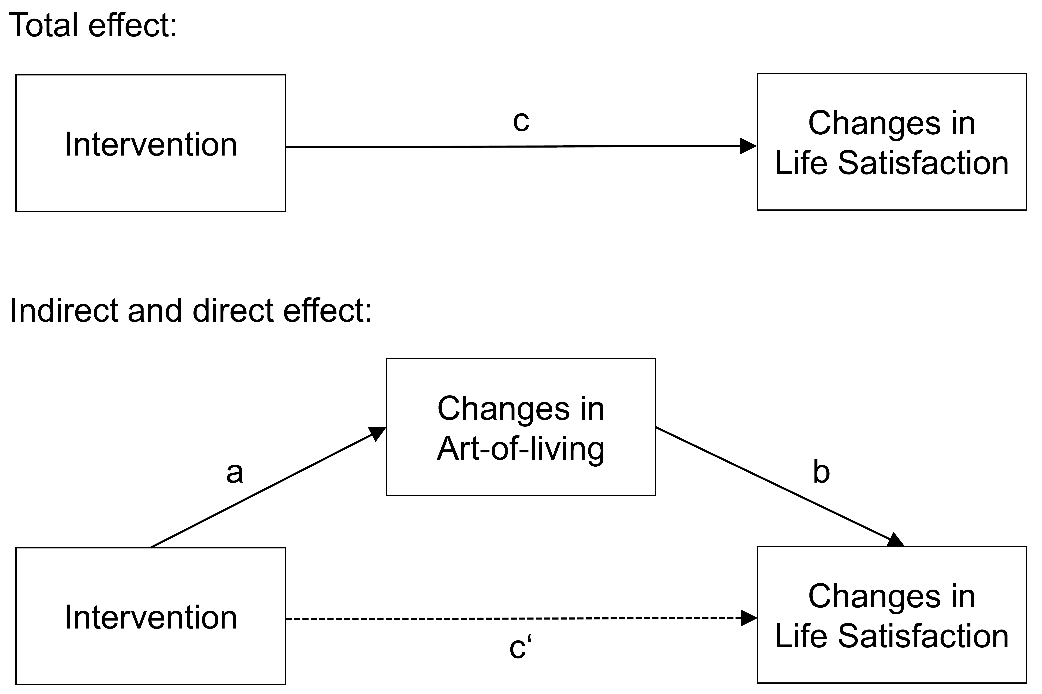

Results for Mediation analyses
H2d. Results of the mediation analysis are shown in Figure 5. We restricted our tests to the hedonia intervention group because there was no effect of the eudaimonia intervention on life satisfaction. Model 1 yielded the total effect c = 0.418 95 % CI [0.146, 0.690]. Hence, the total effect was significant. In Model 2, a = 0.206 95 % CI [0.098,0.314] and b = 0.753 95 % CI [0.410, 1.096] were significant. The significant parameter a indicates an increase in the art-of-living dependent on the intervention within the hedonia training group (compared with the control group). The significant b indicates a path from changes in the art-of-living to life satisfaction. The direct effect turned out to be c’ = 0.263 95 % CI [-0.011,0.537] which was nonsignificant, because 0 was included in the interval. Following the criteria mentioned in the statistics section (a, b, c significant and c’ nonsignificant), full mediation is indicated. To sum up, there was no effect of the eudaimonic intervention on life satisfaction, whereas the effect of the hedonic intervention on life satisfaction was mediated by the art-of-living, lending partial support for H2d.
H3d. We tested a possible mediation effect for the combined group (as displayed in Figure 5) in the same way as we did for H2d. The results were as follows: Model 1 showed a significant total effect c = 0.347 95 % CI [0.078, 0.616]. In Model 2, a = 0.153 95 % CI [0.039, 0.267] and b = 0.758 95 % CI [0.358, 1.158] were significant. The significant parameter a indicates an increase in the art-of-living dependent on the intervention within the combined training group (compared with the control group). The significant b indicates a path from changes in the art-of-living to changes in life satisfaction. The direct effect turned out to be c’ = .231 95 % CI [-0.029, 0.482] which was nonsignificant as 0 was included in the confidence interval. Following the criteria mentioned in the statistics section, (a, b, c significant and c’ nonsignificant), full mediation was found. Similar to our findings for the hedonic intervention, the effect of the combined intervention on life satisfaction was fully mediated by the art-of-living, thereby supporting H3d.

Figure 2
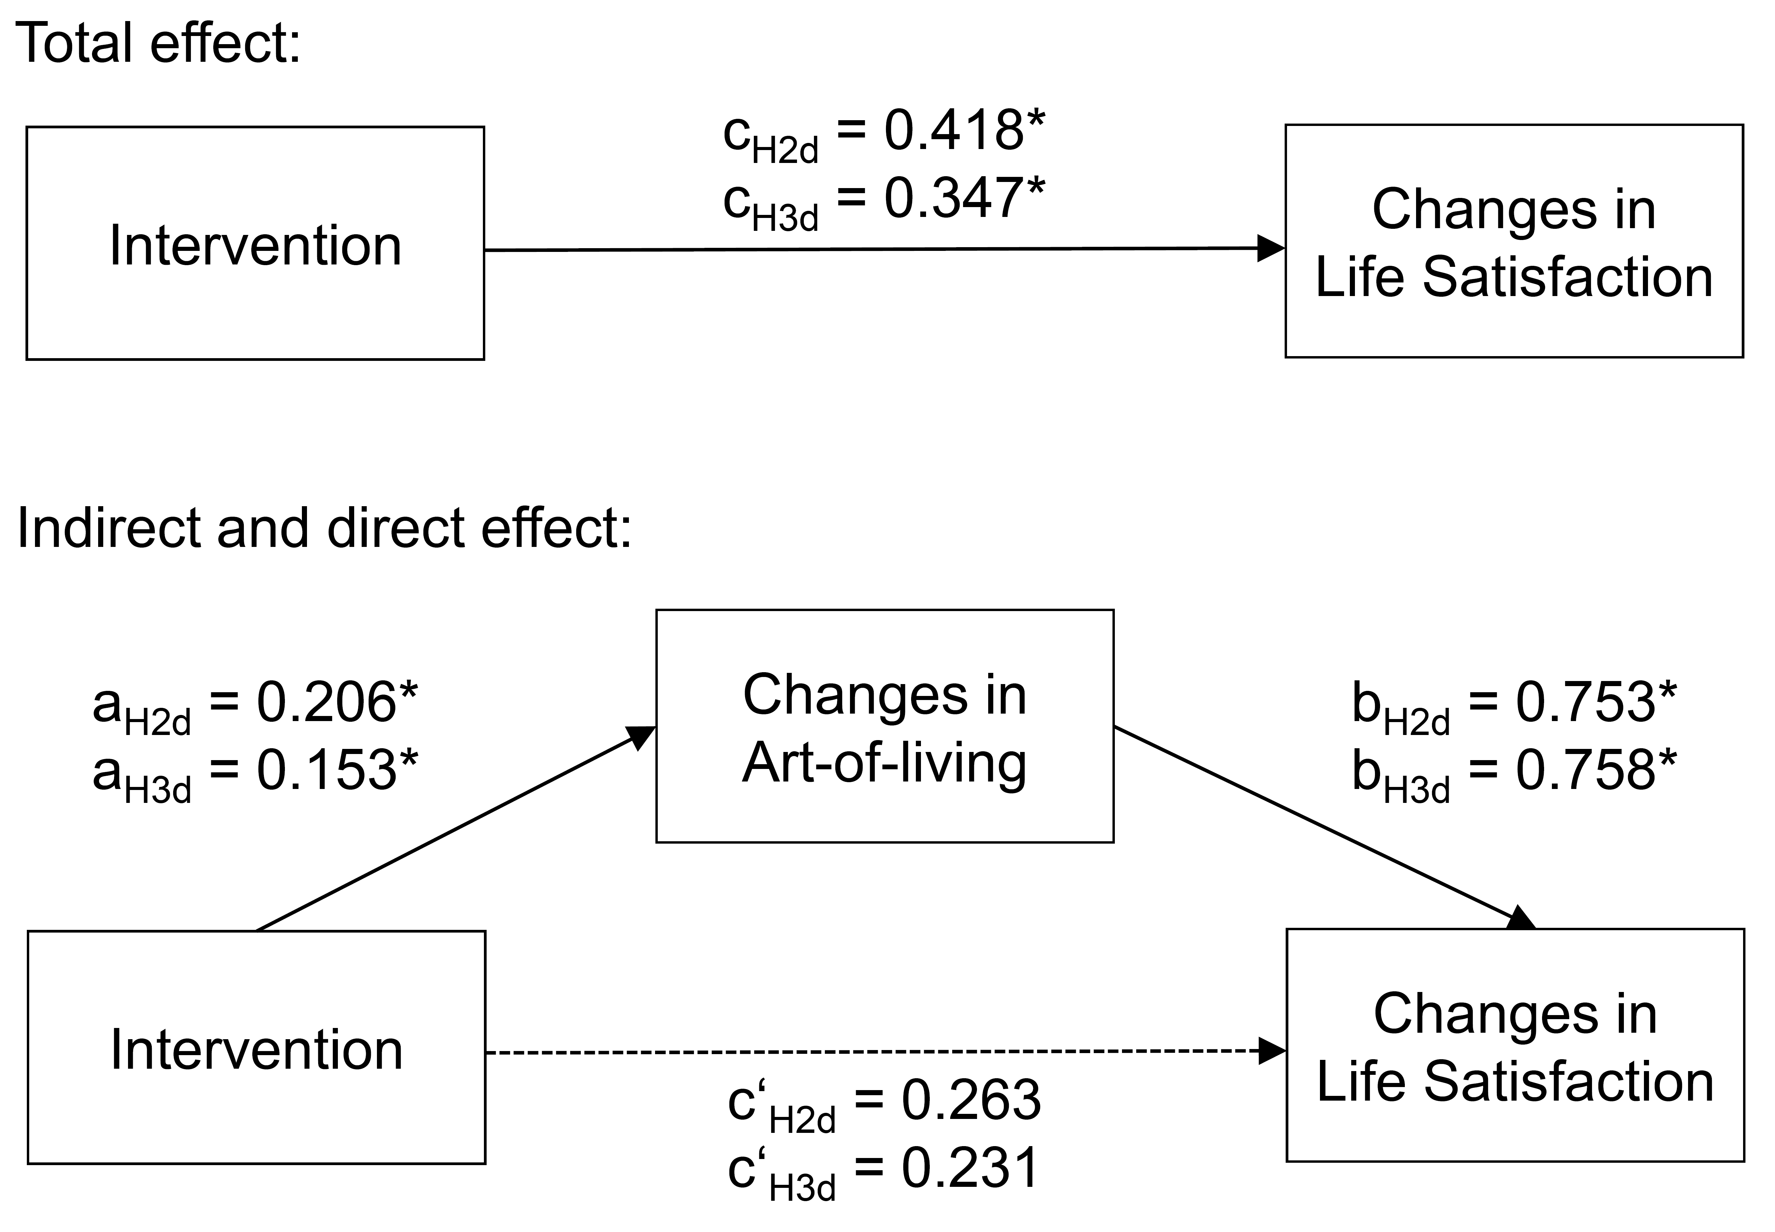
Art-of-living Mediating the Relationship between Intervention and Life Satisfaction
Notes. Intervention = dummy variable (1 = hedonia/combined training condition, 0 = control group); changes in art-of-living, life satisfaction = contrast of posttest – pretest means; a*b = indirect effect (path through art-of-living); c’ = direct effect (without mediation); c = total effect (c = a*b + c’).

References
Hayes, A. F. (2022). Introduction to mediation, moderation, and conditional process analysis: A regression-based approach. Guilford Publications.
Rosseel, Y. (2012). lavaan: An R Package for Structural Equation Modeling. Journal of Statistical Software, 48(2), 1–36. https://doi.org/10.18637/jss.v048.i02

