Supplementary material
Tables and figures

 | Variable | M | SD | Min | Max | 1 | 2 | 3 | 4 | 5 | 6 | 7 | 8 | 9 | 10 | 11 | 12 | 13
Demographics
 | 1. Sex | - | -
 | 2. Age | 27.65 | 1.15 | 24.75 | 30.08 | -.24
Predictors
 | 3. Time spent on social media | 2.82 | 1.93 | 0 | 10 | .14** | -.05
 | 4. Time spent on social media squared | 11.65 | 16.71 | .00 | 100.00 | .06 | -.03 | .66***
 | 5. Social media stress | 2.19 | .77 | 1.00 | 4.75 | .15** | -.00 | .17** | .07
 | 6. Social media self-regulation failure | 2.86 | .89 | 1.00 | 5.00 | .15** | .03 | .25*** | .04 | .43***
Moderators
 | 7. Extraversion | .04 | 1.01 | -3.50 | 3.16 | .23*** | -.05 | .13* | .07 | .13* | .13*
 | 8. Agreeableness | .06 | .97 | -2.83 | 2.43 | .23*** | .03 | -.04 | -.01 | -.16** | .00 | -.09
 | 9. Conscientiousness | .02 | 1.00 | -3.10 | 2.78 | .22*** | -.01 | .01 | .03 | .06 | -.25*** | .10 | -.19***
 | 10. Emotional stability | - .01 | .97 | -3.79 | 2.05 | -.25*** | .02 | -.16** | -.10 | -.30*** | -.29*** | -.08 | -.13* | .03
 | 11. Autonomy | - .04 | .90 | -2.50 | 2.61 | -.12* | -.03 | -.06 | .01 | -.15** | -.15** | -.05 | -.17** | .08 | .18**
Outcome variables: Subjective Well-Being
 | 12. Positive affect | 34.23 | 6.42 | 12.00 | 50.00 | -.03 | .04 | -.12* | -.09 | -.08 | -.15** | .33*** | -.07 | .20*** | .40*** | .32***
 | 13. Negative affect | 19.66 | 6.70 | 10.00 | 43.00 | -.01 | -.03 | .13* | .13* | .18* | .23*** | -.15** | -.09 | -.09 | -.59*** | -.10 | -.45***
 | 14. Life satisfaction | 25.74 | 5.53 | 6.00 | 35.00 | .09 | .01 | -.12* | -.13* | -.09 | -.16** | .25*** | -.08 | .22*** | .42*** | .28*** | .50*** | -.47***
Table S1. Correlations among demographic, social media variables, Big Five Traits, and indicators of subjective well-being. Minimum observed and maximum observed.
Note: * p<.05, ** p<.01, *** p<.001

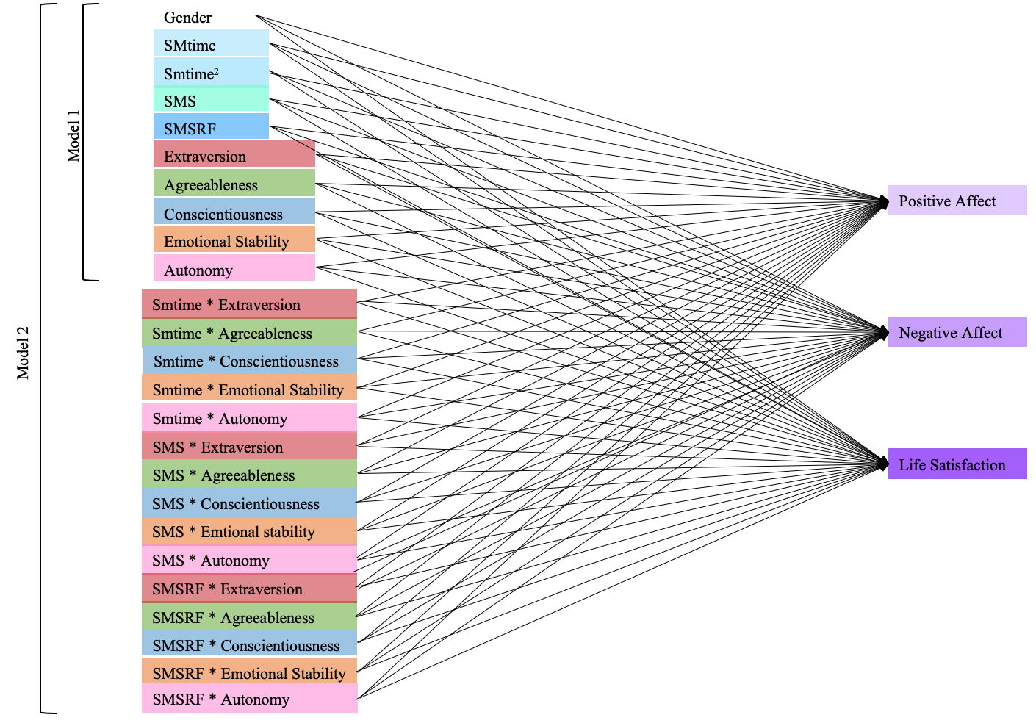

Fig. S1. Graphic representation of the proposed multivariate moderation model

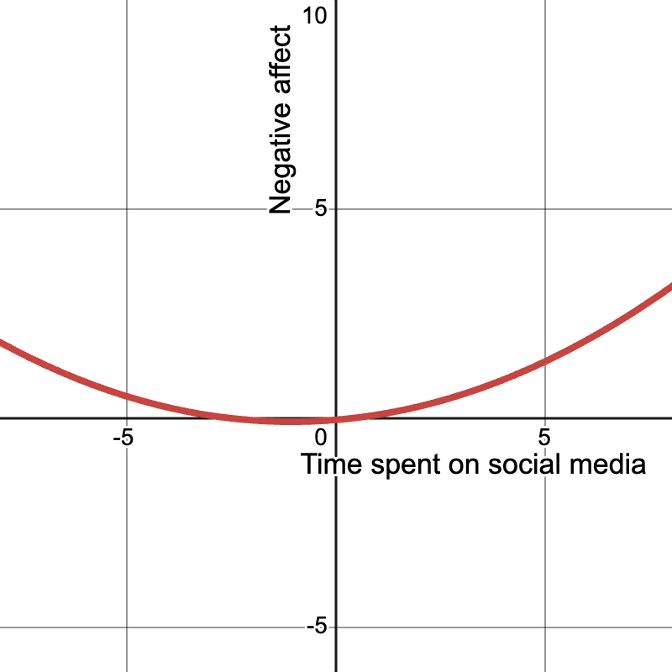
Fig. S2. Graphic representation of the curvilinear relationship between time spent on social media (standardized) and negative affect (standardized)
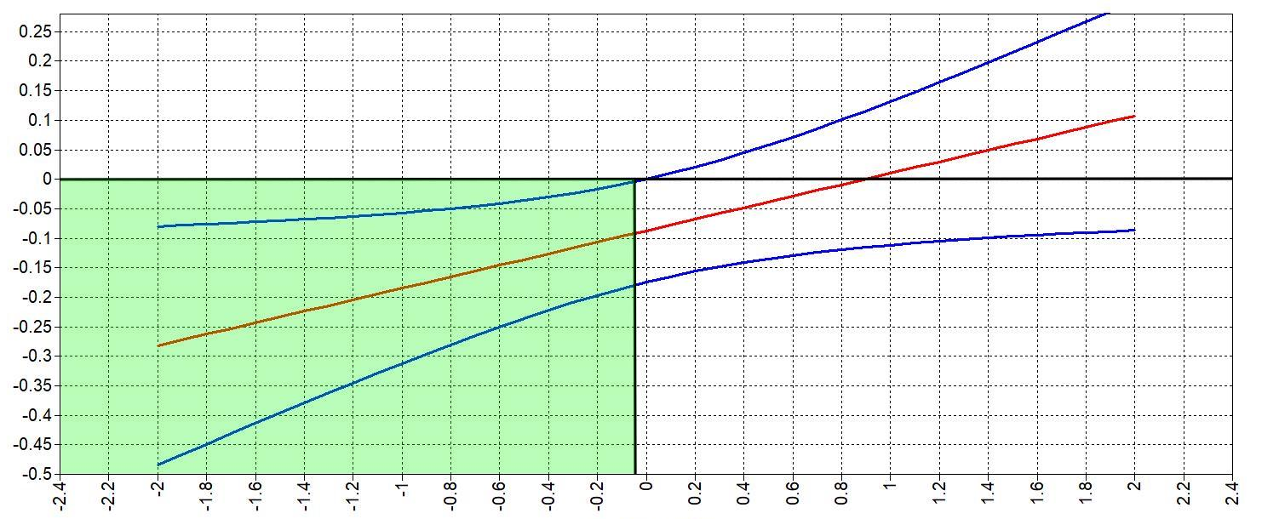
Extraversion
Slope SMtime and positive affect
Fig. S3. J-N plot of the moderation effect of extraversion on the relationship between time spent on social media (SMtime) and positive affect. Region of Significance (RoS) indicated by green section.
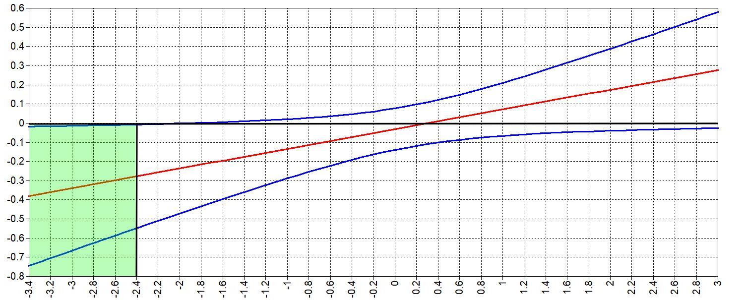
Slope SMSRF and positive affect
Agreeableness

Fig. S4. J-N plot of the moderation effect of agreeableness on the relationship between social media self-regulation failure (SMSRF) and positive affect. RoS indicated by green section.
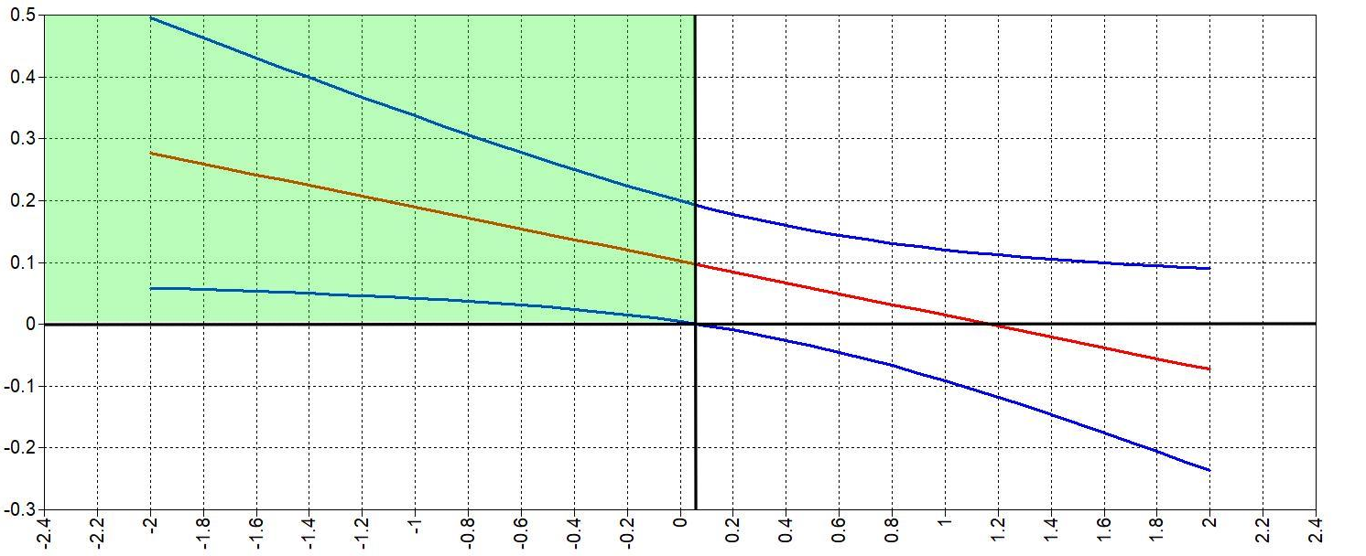
Slope SMSRF and negative affect
Agreeableness

Fig. S5. J-N plot of the moderation effect of agreeableness on the relationship between social media self-regulation failure (SMSRF) and negative affect. RoS indicated by green section.

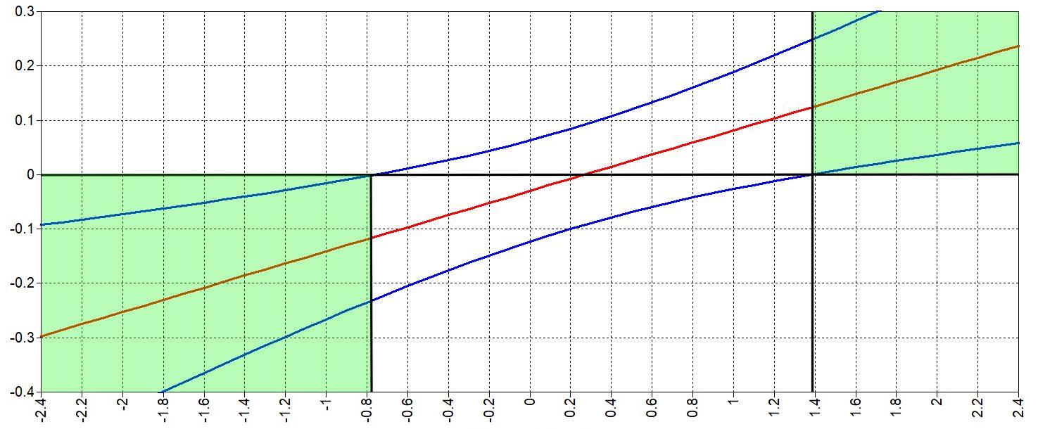
Emotional Stability
Slope SMS and negative affect

Fig. S6. J-N plot of the moderation effect of emotional stability on the relationship between social media stress (SMS) and negative affect. RoS indicated by green section.

