Supplementary Materials

Additional Studies
Study 1b
Given we observed our predicted relationships in Study 1 and furthermore found the different forms of moral engagement have opposing implications for wellbeing, we aimed to replicate these findings in Study 1b drawing on a more demographically diverse population recruited through Amazon’s Mechanical Turk platform (MTurk). We predicted that we would replicate the findings of Study 1 and find moral identity to be associated with increased wellbeing through social connectedness, while moral attentiveness would be associated with decreased wellbeing through rumination.
Methods
Participants
A sample size analysis was conducted using G*Power, revealing that a sample size of N = 193 would be adequate to detect a small-to-medium correlation (r = .20; Cohen, 1988) with a power of .80 (Faul et al., 2009). Therefore, 341 self-selected participants were recruited via MTurk (see Appendix D for recruitment advertisement). To be eligible, participants had to have an approval rating of over 95% on MTurk, have completed at least 100 tasks on the platform, and be located in the United States. Each participant was compensated with US$2.50 for their participation. In total, 113 respondents were excluded due to completing the study in less than one quarter of the median completion time (i.e., in fewer than 190 seconds), failing attention checks, being flagged as bots by reCAPTCHA detection, or not consenting to their data being used. The final sample consisted of 228 participants (139 male, 88 female, 1 preferred not to say) with ages ranging from 21 to 70 (M = 37.32, SD = 10.94). One participant did not disclose their age. Most participants were born in the United States (95.17%) with 0.88% born in China and 3.95% not disclosing their country of birth. Catholicism was the most ascribed religion among participants (49.56%; see Appendix E for religious affiliation statistics). On average, the sample held moderate views on social (M = 4.04, SD = 2.12) and economic issues (M = 4.15, SD = 2.15).

Materials
The same measures as used in Study 1, were used for Study 1b.

Procedure
All participants in the studies were required to provide informed consent before participating. After completing the study, all participants were fully debriefed.

Results
Two-tailed Pearson correlations (see Table 3) revealed the two moral engagement constructs were positively correlated, however, each construct showed different patterns of associations with wellbeing. Moral identity was positively correlated with various wellbeing measures, including psychological wellbeing, the presence of meaning, satisfaction with life, and intensity and frequency of positive emotions. Also, moral identity was negatively associated with depression and the intensity and frequency of negative emotions experienced.
In contrast, moral attentiveness had conflicting relationships with wellbeing. Moral attentiveness was negatively associated with psychological wellbeing, higher intensity and frequency of negative emotions, and increased depression. Somewhat paradoxically, moral attentiveness was also associated with increased meaning and satisfaction with life as well as higher intensity and frequency of positive emotions.
In terms of the process variables, moral identity was associated with increased social connectedness, whilst moral attentiveness was correlated with rumination. The effect sizes of the correlations spanned from small to nearing large sizes according to Cohen’s (1988) thresholds.

Table 3
Correlation Matrix for Study 1b Variables
Variable | 1 | 2 | 3 | 4 | 5 | 6 | 7 | 8 | 9 | 10 | 11
- Moral attentiveness  - Moral identity | .29***
- PWB  - Meaning | -.15*  .16* | .49***  .46*** | .64***
5. SWL | .30*** | .36*** | .26*** | .63***
6. Intensity of PE | .35*** | .39*** | .24*** | .53*** | .61***
7. Frequency of PE | .27*** | .41*** | .33*** | .60*** | .66*** | .85***
8. Intensity of NE | .27*** | -.17** | -.59*** | -.40*** | -.11 | -.03 | -.16*
9. Frequency of NE | .25*** | -.20** | -.59*** | -.41*** | -.12 | -.04 | -.17** | .92***
10. Depression | .35*** | -.26*** | -.74*** | -.44*** | -.08 | -.06 | -.15* | .82*** | .81***
11. Social connectedness | -.06 | .48*** | .80*** | .67*** | .41*** | .38*** | .43*** | -.57*** | -.59*** | -.68***
12. Rumination | .39*** | -.04 | -.51*** | -.19** | .11 | .18** | .11 | .65*** | .60*** | .75*** | -.47***
Note. N = 228. PWB = Psychological wellbeing, SWL = Satisfaction with life, PE = Positive emotions, NE = Negative emotions.
*p < .05. **p < .01. *** p < .001.

Multiple regressions were performed to ascertain whether the relationships of interest remained when controlling for demographic variables. It was found that when controlling for age, gender, and political stance on social and economic issues, the relationships between moral identity and wellbeing remained (Table 4 and 5). The relationships between moral attentiveness and the wellbeing outcomes also largely remained. However, with the inclusion of the demographic variables, moral attentiveness did not significantly predict the frequency of positive emotions experienced. Additionally, a new relationship emerged that was not evident in the correlation analyses or Study 1; increased moral attentiveness predicted decreased social connectedness (see Table 5).
Given direct and differential relationships were found between moral engagement and wellbeing, mediations analyses were conducted to test for indirect effects. Both positive and negative effects on wellbeing were examined for each mediator variable. However, only the mediation models showing significant indirect effects are reported (otherwise see supplementary materials). In line with results from Study 1, analyses revealed indirect effects of moral identity, through increased social connectedness, on various measures of wellbeing including: psychological wellbeing (direct effect: b = .14 (.05); indirect effect: b = .38, 95%CI [.26, .51]), meaning (direct effect: b = .29(.09); indirect effect: b = .45, 95%CI [.29, .63]), satisfaction with life (direct effect: b = .37 (.11); indirect effect: b = .25, 95%CI [ .07, .41]), intensity of positive emotions (direct effect: b = .59 (.15); indirect effect: b = .25, 95%CI [.05, .42]), and frequency of positive emotions (direct effect: b = .55 (.13); indirect effect: b = .29, 95%CI [.09, .47]). Moral identity also indirectly impacted lower intensity of negative emotions (direct effect: b = .38 (.18); indirect effect: b = -.89, 95%CI [-1.21, -.60]), frequency of negative emotions (direct effect: b = .32 (.17); indirect effect: b = -.88, 95%CI [-1.22, -.59]) and depression (direct effect: b = .07 (.05); indirect effect: b = -.29, 95%CI [-.39, -.20]), through increased social connectedness.
Mediation analyses were also performed to examine whether social connectedness revealed any indirect effects in the instances where moral attentiveness was positively linked to wellbeing. In line with findings from Study 1, social connectedness did not reveal any indirect effects between moral attentiveness and satisfaction with life (b = -.03, 95%CI [-.12, .06]), meaning (b = -.05, 95%CI [-.18, .09]), frequency of positive emotions (b = -.04, 95%CI [-.15, .07]) and intensity of positive emotions (b = -.04, 95%CI [-.14, .07]).

Table 4
Multiple Regressions Predicting Wellbeing with Moral Engagement Controlling for Demographic Variables in Study 1b

 |  | PWB | Meaning |  | SWL | Intensity of PE | Frequency of PE
Variable | β | 95% CI | β 95% CI | β | 95% CI | β 95% CI | β 95% CI
(Intercept)  Moral engagement variables | .00 | -.10, .10 | .00 -.11, .11 | .00 | -.12, 12 | .00 -.12, .12 | .00 -.12, .12
Moral attentiveness
-.24*** | -.35, -.12 | .05 | -.07, .18 | .14* | .02, .27 | .20** | .08, .33 | .12 | -.01, .25

Moral identity | .55*** | .44, .66 | .44*** | .31, .56 | .32*** | .20, .45 | .33*** | .21, .46 | .38*** | .25, .50
Control variables
Age | .20*** | .09, .30 | .19** | .07, .30 | .02 | -.10, .14 | -.01 | -.12, .11 | .04 | -.08, .16
Female gender | -.05 | -.16, .05 | -.07 | -.19, .05 | -.03 | -.15, .09 | .03 | -.09, .15 | .04 | -.08, .16
Conservatism (economic) | -.07 | -.27, .13 | .03 | -.19, .25 | .19 | -.04, .41 | -.03 | -.25, .19 | .06 | -.16, .29
Conservatism (social) | -.11 | -.31, .08 | -.04 | -.25, .19 | .06 | -.17, .28 | .21 | -.02, .43 | .10 | -.12, .33
R² adjusted |  | .38 |  | .23 |  | .20 |  | .23 |  | .21
Note. N = 228. β = standardized beta, CI = confidence interval, PWB = psychological wellbeing, SWL = satisfaction with life, PE = positive emotion, Conservatism (economic) = conservatism on economic issues, Conservatism (social) = conservatism on social issues.
*p < .05. **p < .01. *** p < .001.

Table 5
Multiple Regressions Predicting Negative Emotionality, Depression, and Process Variables with Moral Engagement Controlling for Demographic Variables in Study 1b

Intensity of NE Frequency of NE Depression Social connectedness Rumination

Variable | β | 95% CI | β | 95% CI | β | 95% CI | β | 95% CI | β | 95% CI
(Intercept) | .00 | -.12, .12 | .00 | -.12, .12 | .00 | -.11, .11 | .00 | -.11, .11 | .00 | -.11, .11
Moral engagement variables
Moral attentiveness | .25*** | .12, .38 | .22** | .09, .35 | .37*** | .25, .49 | -17** | -.30, -.05 | .31*** | .19, .44
Moral identity | -.23*** | -.36, -.11 | -.25*** | -.37, -.12 | -.35*** | -.47, -.24 | .52*** | .40, .63 | -.12 | -.23, .00
Control variables Age | -.18** | -.30, -.06 | -.19** | -.31, -.07 | -.21*** | -.32, -.10 | .19** | .08, .31 | -.18** | -.30, -.07
Female gender | -.02 | -.14, .10 | -.03 | -.15, .09 | -.02 | -.13, .09 | .01 | -.11, .12 | .01 | -.11, .12
Conservatism (economic) | .08 | -.15, .30 | .15 | -.07, .38 | .07 | -.14, .28 | -.04 | -.25, .18 | .01 | -.21, .22
Conservatism (social) | .20 | -.03, .42 | .14 | -.09, .36 | .15 | -.05, .36 | -.04 | -.25, .17 | .32** | .11, .54
R² adjusted |  | .21 |  | .21 |  | .33 |  | .29 |  | .28
Note. N = 228. β = standardized beta, CI = confidence interval, NE = negative emotions, Conservatism (economic) = conservatism on economic issues, Conservatism (social) = conservatism on social issues.
*p < .05. **p < .01. *** p < .001.

In line with expectations, it was found that moral attentiveness had an indirect effect on decreased wellbeing, through increased rumination. Rumination fully mediated the relationship between moral attentiveness and the intensity of negative emotions (direct effect: b = .05 (.11); indirect effect: b = .49, 95%CI [.30, .70]), the frequency of negative emotions experienced (direct effect: b = .03 (.11); indirect effect: b = .45, 95%CI [.27, .65]), depression (direct effect: b = .04 (.03); indirect effect: b = .16, 95%CI [.10, .23]), and decreased psychological wellbeing (direct effect: b = .04 (.05); indirect effect: b = -.15, 95%CI [-.22, -.09]).
Discussion
Study 1b findings largely replicate those of Study 1 in a more diverse sample. Moral identity was positively related to various wellbeing outcomes, consistent with Study 1. However, moral attentiveness showed conflicting associations with wellbeing. While it was linked to lower psychological wellbeing, increased depressive symptoms, and more frequent and intense negative emotions, it was also associated with increased meaning, life satisfaction, and positive emotions. When controlling for socio-demographic characteristics, the relationships between moral engagement and wellbeing largely remained. In line with Study 1, social connectedness partially mediated the positive relationship between moral identity and wellbeing, however, social connectedness did not explain any of the variance observed where moral attentiveness was positively related to wellbeing. In line with findings from Study 1, rumination fully mediated the negative relationship between moral attentiveness and wellbeing. Thus, these pathways appear to be unique to each moral engagement construct, with moral identity positively associated with wellbeing through social connectedness and moral attentiveness negatively associated with wellbeing through rumination.
Study 1c.
To further extend the results of Studies 1 and 2, we conducted a third study exploring the same predictions, that utilized more extensive measures of wellbeing and a second scale to assess moral identity. The Black & Reynolds moral identity scale was introduced as it differs in its conceptualization and operationalization of moral identity, with a focus on moral identity saliency and centrality to the self-concept, measuring everyday elements of decision-making. As with the previous studies, we predicted that moral identity would be positively associated with wellbeing through social connectedness, while moral attentiveness would be negatively associated with wellbeing through rumination.
Method
Participants
246 self-selected undergraduate psychology students at a large Australian university enrolled in the study, in exchange for one course credit. After pre-processing the data, five responses were excluded due to being survey previews (wherein the survey platform records the survey reviews by the primary researcher during the drafting period), one response was recorded as spam, 13 respondents did not consent to the study after enrollment and were therefore removed before initiation, 78 responses were removed for having a survey compliance rate below 80%, one response was excluded for not completing any dependent variable measures, and three straight liners were excluded. The final sample consisted of 145 participants (27 males, 111 females, 3 non-binary, 4 preferred not to say) aged 17-50 (M = 19.94, SD = 4.56). Most participants were Australian (36.6%) or Chinese nationals (24.8%). Most participants did not closely ascribe to any religion (67.6%). Most of the sample had extremely liberal political beliefs (23.4%). The final sample size was high-powered (.99) for detecting small-to-medium effects according to Cohen's thresholds (Faul et al., 2009; Sullivan & Feinn, 2012).
Materials
Study 1c included the same measure of moral attentiveness, rumination, and social connectedness utilized in Studies 1 & 2. Instead of including multiple measures of wellbeing, one comprehensive measure was utilized to assess various aspects of wellbeing. Additionally, a second scale measuring moral identity was included (see supplementary material for descriptive statistics and full question sets).
Moral Identity (BR). In addition to the moral identity (AR) scale used in the previous studies, a second scale was used to evaluate moral identity. The Moral Identity Questionnaire (Black & Reynolds, 2016), referred to from here onwards as moral identity (BR) was designed to not only capture the importance of morality to self-identity but also measure integrity. Respondents rated each item on a 5-point Likert scale (e.g., “Not hurting other people is one of the rules I live by”; 1 = strongly disagree, 5 = strongly agree; α = .90). Moreover, the moral identity (AR) scale was also standardized to a 5-point Likert scale (α = .79).
Subjective Wellbeing. Wellbeing was measured using the BBC-subjective-wellbeing (BBC-SWB) 24-item scale (Kinderman et al., 2011) that was developed to assess the full range of wellbeing through three domains: physical wellbeing, psychological wellbeing, and relationships. Respondents rated items on a 5-point Likert scale (e.g., “Are you satisfied with yourself and your achievements?”; 1 = strongly disagree, 5 = strongly agree; α = .91).

Procedure
All participants in the studies were required to provide informed consent before participating. After completing the study, all participants were fully debriefed.

Results.
Correlation analysis revealed that moral identity (BR & AR) was positively associated with moral attentiveness (p < .049; p <.002). Analyses also revealed that moral identity (BR & AR) was positively associated with wellbeing (p < .001; p <.001) and social connectedness (p < .001; p <.001). Moral identity (BR) was negatively associated with rumination (p < .031), but there was no observed relationship between moral identity (AR) and rumination. As with previous findings, moral attentiveness was positively associated with rumination (p < .001), however, the association between moral attentiveness and wellbeing was negative but not significant. Rumination was associated with decreased wellbeing (p < .001), whereas social connectedness was linked to higher wellbeing (p < .001). Overall, according to Cohen’s thresholds, the effect sizes were small to medium (Sullivan & Feinn, 2012).
Table 6.
Correlation Matrix for Study 1c Variables.
Variable | 1 | 2 | 3 | 4 | 5 | 6
1. Moral Attentiveness
2. Moral Identity (BR) | .164*
3. Moral Identity (AR) | .252** | .445**
4. Rumination | .468** | -.179* | -.006
5. Social Connectedness | -.097 | .451** | .357** | -.574**
6. BBC-SWB | -.156 | .328** | .370** | -.527** | .640**
Note. N = 145. BBC-SWB = BBC Subjective Wellbeing Scale. Moral identity was measured using two scales: BR = Black & Reynolds, AR = Aquino & Reed.
*p < .05, ** p < .01.

Multiple regression analyses were conducted to determine whether the observed relationships would remain when controlling for demographic variables of age and gender. It was found that the relationships between moral identity (both BR and AR) and higher wellbeing remained as shown in Table 7 (p < .016; p < .001). Both measures of moral identity (BR & AR) remained positive predictors of social connectedness (p < .001; p < .004) and higher moral identity (BR) continued to negatively predict rumination (p < .006; see Table 8). Additionally moral attentiveness negatively predicted wellbeing (Table 7; p < .001). In contrast to our correlational findings, multiple regression analyses revealed that moral attentiveness negatively predicted social connectedness (p < .004) but continued to be associated with increased rumination (p < .001). In sum, when controlling for demographic variables, the relationships that emerged aligned with our predictions.

Table 7.
Multiple Regressions Predicting Wellbeing with Moral Engagement, Controlling for Demographic Variables in Study 1c.
Variable |  |  | Wellbeing (BBC-SWB)
 | β |  |  | 95% CI
Intercept |  | 1.69 |  |  | .862, 2.51
Moral Engagement Variables
Moral Identity (AR) |  | .376** |  |  | .187, .564
Moral Identity (BR) |  | .218* |  |  | .041, .395
Moral Attentiveness |  | -.165** |  |  | -.254, -.076
Control Variables
Age |  | .011 |  |  | -.01, .031
Gender (Female) |  | -.045 |  |  | -.271, .181
R² adjusted |  |  |  |  |  | .217
Note. N = 145. β = Standardized Beta, CI = Confidence Interval. BBC-SWB = BBC Subjective Wellbeing Scale. Moral Identity was measured using two scales: BR = Black & Reynolds, AR = Aquino & Reed. *p < .05, ** p < .01.

Table 8.
Multiple Regressions Predicting Rumination and Social Connectedness with Moral Engagement, Controlling for Demographic Variables in Study 1c.
Variable | Rumination |  |  |  |  |  |  | Social Connectedness
 | β |  |  |  | 95% CI |  |  |  | β | 95% CI
Intercept |  | 2.70 |  |  |  | 1.90, 3.50 |  | .670 |  |  | -.644, 1.99
Moral Engagement Variables
Moral Identity (AR) |  | -.056 |  |  |  | -.239, .128 |  | .443** |  |  | .142, .743
Moral Identity (BR) |  | -.244** |  |  |  | -.417, -.071 |  | .612** |  |  | .330, .895
Moral Attentiveness |  | .319** |  |  |  | .232, .406 |  | -.208** |  |  | -.351, -.066
Control Variables
Age |  | -.019 |  |  |  | -.039, .001 |  | .027 |  |  | -.006, .059
Gender (Female) |  | .184 |  |  |  | -.037, .404 |  | -.011 |  |  | -.372, .349
R² adjusted |  |  |  |  |  | .299 .265

Note. N = 145. β = Standardized Beta, CI = Confidence Interval. Moral Identity was measured using two scales: BR = Black & Reynolds, AR = Aquino & Reed. *p < .05, ** p < .01.

Given that we found evidence for all direct relationships as predicted, mediation analyses were conducted to examine whether the process variables explained the differential associations between the moral engagement variables and wellbeing. Analyses revealed an indirect effect of moral identity on increased wellbeing through increased social connectedness, for both measures BR (direct effect: b = .07 (.08); indirect effect: b = .28, 95%CI [.14, .44]) and AR (direct effect: b = .21** (.08); indirect effect: b = .23, 95%CI [.11, .37]). Furthermore, mediation analyses revealed an indirect effect of moral attentiveness on reduced wellbeing through an increased tendency to ruminate (direct effect: b = .13** (.05); indirect effect: b = -.18, 95%CI [-.26, -.11]).

Discussion
Study 1c results, when controlling for demographic variables, showed significant pathways between moral engagement and wellbeing, with moral identity and social connectedness associated with increased wellbeing, and rumination associated with decreased wellbeing. Our findings confirm that moral identity promotes social connectedness and positively predicts wellbeing, while moral attentiveness is negatively associated with effects on wellbeing due to increased rumination. These pathways are unique to each construct, with social connectedness partially mediating higher moral identity and increased wellbeing and rumination fully mediating increased moral attentiveness and decreased wellbeing. However, studies 1-3 drew on cross-sectional data and were therefore limited in predicting the variability in relationships over time. Hence, a fourth study was conducted to provide evidence for the directional relationship between moral engagement and wellbeing over time. This study was conducted to ascertain a temporal order and causality between moral engagement and wellbeing, as well as to provide insights into how the relationship may change over time.
Detailed Correlation Matrix for Study 1

Means, standard deviations, and correlations with confidence intervals

Variable |  |  | M |  |  | SD |  |  | 1 |  |  | 2 |  |  | 3 |  |  | 4 |  |  | 5 |  |  | 6 |  |  | 7 |  |  | 8 |  |  | 9 |  |  | 10 |  |  | 11 |  |  | 12 |  |  | 13 |  |  | 14 |  |  | 15 |  |  | 16 |  |  | 17 |  |  | 18
Moral Attentiveness |  |  | 3.81 |  |  | 0.99
Moral Attentiveness (Neuroticism items) |  |  | 3.27 |  |  | 1.20 |  |  | .83**
 |  |  |  |  |  |  |  |  | [.77, .88]
Moral Attentiveness (Other items) |  |  | 3.99 |  |  | 1.01 |  |  | .98** |  |  | .69**
 |  |  |  |  |  |  |  |  | [.97, .98] |  |  | [.59, .76]
Moral Attentiveness Perceptual |  |  | 3.39 |  |  | 1.12 |  |  | .90** |  |  | .95** |  |  | .80**
 |  |  |  |  |  |  |  |  | [.87, .93] |  |  | [.93, .96] |  |  | [.74, .85]
Moral Attentiveness Reflective |  |  | 4.39 |  |  | 1.16 |  |  | .82** |  |  | .41** |  |  | .90** |  |  | .49**
 |  |  |  |  |  |  |  |  | [.75, .86] |  |  | [.27, .54] |  |  | [.87, .93] |  |  | [.36, .60]
Moral Identity |  |  | 5.04 |  |  | 0.85 |  |  | .22** |  |  | .03 |  |  | .28** |  |  | .08 |  |  | .35**
 |  |  |  |  |  |  |  |  | [.07, .37] |  |  | [-.13, .19] |  |  | [.12, .42] |  |  | [-.08, .24] |  |  | [.20, .48]
Moral Identity Internalization |  |  | 4.29 |  |  | 1.03 |  |  | .22** |  |  | .13 |  |  | .24** |  |  | .17* |  |  | .23** |  |  | .83**
 |  |  |  |  |  |  |  |  | [.06, .37] |  |  | [-.03, .28] |  |  | [.08, .39] |  |  | [.01, .32] |  |  | [.07, .37] |  |  | [.77, .87]
Moral Identity Symbolization |  |  | 5.79 |  |  | 1.02 |  |  | .15 |  |  | -.08 |  |  | .22** |  |  | -.04 |  |  | .35** |  |  | .82** |  |  | .37**
 |  |  |  |  |  |  |  |  | [-.02, .30] |  |  | [-.24, .09] |  |  | [.06, .37] |  |  | [-.20, .13] |  |  | [.20, .48] |  |  | [.76, .87] |  |  | [.22, .50]
Psychological Wellbeing |  |  | 4.56 |  |  | 0.68 |  |  | -.03 |  |  | -.12 |  |  | .01 |  |  | -.12 |  |  | .10 |  |  | .40** |  |  | .29** |  |  | .37**
 |  |  |  |  |  |  |  |  | [-.19, .13] |  |  | [-.28, .04] |  |  | [-.15, .17] |  |  | [-.27, .04] |  |  | [-.07, .25] |  |  | [.25, .53] |  |  | [.14, .43] |  |  | [.22, .50]
Presence of Meaning in Life |  |  | 4.09 |  |  | 1.11 |  |  | -.05 |  |  | -.10 |  |  | -.02 |  |  | -.08 |  |  | .01 |  |  | .31** |  |  | .34** |  |  | .16 |  |  | .61**
 |  |  |  |  |  |  |  |  | [-.21, .12] |  |  | [-.26, .06] |  |  | [-.18, .14] |  |  | [-.24, .09] |  |  | [-.16, .17] |  |  | [.15, .45] |  |  | [.19, .48] |  |  | [-.00, .32] |  |  | [.50, .71]
Satisfaction with Life |  |  | 4.27 |  |  | 1.20 |  |  | -.06 |  |  | -.08 |  |  | -.05 |  |  | -.10 |  |  | .02 |  |  | .22** |  |  | .18* |  |  | .18* |  |  | .53** |  |  | .52**
 |  |  |  |  |  |  |  |  | [-.22, .10] |  |  | [-.23, .09] |  |  | [-.21, .11] |  |  | [-.26, .06] |  |  | [-.15, .18] |  |  | [.06, .37] |  |  | [.02, .34] |  |  | [.02, .33] |  |  | [.40, .64] |  |  | [.39, .63]
Happiness |  |  | 4.22 |  |  | 1.12 |  |  | -.11 |  |  | -.11 |  |  | -.10 |  |  | -.14 |  |  | -.04 |  |  | .21* |  |  | .23** |  |  | .11 |  |  | .60** |  |  | .50** |  |  | .52**
 |  |  |  |  |  |  |  |  | [-.27, .05] |  |  | [-.26, .06] |  |  | [-.26, .06] |  |  | [-.29, .02] |  |  | [-.20, .12] |  |  | [.05, .36] |  |  | [.07, .38] |  |  | [-.05, .27] |  |  | [.48, .69] |  |  | [.37, .62] |  |  | [.39, .62]
Positive Emotion Intensity |  |  | 5.38 |  |  | 1.61 |  |  | -.08 |  |  | -.09 |  |  | -.06 |  |  | -.10 |  |  | -.02 |  |  | -.02 |  |  | -.09 |  |  | .05 |  |  | .32** |  |  | .15 |  |  | .27** |  |  | .45**
 |  |  |  |  |  |  |  |  | [-.24, .09] |  |  | [-.25, .07] |  |  | [-.22, .10] |  |  | [-.26, .06] |  |  | [-.18, .15] |  |  | [-.18, .14] |  |  | [-.24, .08] |  |  | [-.11, .21] |  |  | [.17, .46] |  |  | [-.01, .31] |  |  | [.12, .42] |  |  | [.32, .57]
Positive Emotion Frequency |  |  | 5.32 |  |  | 1.49 |  |  | -.08 |  |  | -.04 |  |  | -.09 |  |  | -.08 |  |  | -.05 |  |  | .06 |  |  | .08 |  |  | .02 |  |  | .43** |  |  | .22** |  |  | .42** |  |  | .57** |  |  | .67**
 |  |  |  |  |  |  |  |  | [-.24, .08] |  |  | [-.20, .13] |  |  | [-.25, .07] |  |  | [-.24, .08] |  |  | [-.21, .11] |  |  | [-.10, .22] |  |  | [-.08, .24] |  |  | [-.14, .19] |  |  | [.29, .56] |  |  | [.06, .37] |  |  | [.28, .55] |  |  | [.45, .67] |  |  | [.57, .75]
Negative Emotion Intensity |  |  | 5.25 |  |  | 1.73 |  |  | .21* |  |  | .26** |  |  | .17* |  |  | .26** |  |  | .08 |  |  | .00 |  |  | .07 |  |  | -.07 |  |  | -.41** |  |  | -.27** |  |  | -.37** |  |  | -.45** |  |  | -.15 |  |  | -.38**
 |  |  |  |  |  |  |  |  | [.05, .36] |  |  | [.10, .40] |  |  | [.01, .33] |  |  | [.10, .40] |  |  | [-.08, .24] |  |  | [-.16, .17] |  |  | [-.09, .23] |  |  | [-.23, .09] |  |  | [-.54, -.27] |  |  | [-.41, -.11] |  |  | [-.50, -.22] |  |  | [-.57, -.31] |  |  | [-.30, .01] |  |  | [-.51, -.23]
Negative Emotion Frequency |  |  | 5.26 |  |  | 1.63 |  |  | .13 |  |  | .16 |  |  | .11 |  |  | .15 |  |  | .06 |  |  | .03 |  |  | .04 |  |  | -.00 |  |  | -.45** |  |  | -.25** |  |  | -.34** |  |  | -.52** |  |  | -.26** |  |  | -.44** |  |  | .71**
 |  |  |  |  |  |  |  |  | [-.03, .29] |  |  | [-.01, .31] |  |  | [-.05, .27] |  |  | [-.01, .31] |  |  | [-.10, .22] |  |  | [-.14, .19] |  |  | [-.12, .20] |  |  | [-.16, .16] |  |  | [-.57, -.31] |  |  | [-.39, -.09] |  |  | [-.48, -.19] |  |  | [-.63, -.39] |  |  | [-.41, -.10] |  |  | [-.56, -.30] |  |  | [.62, .78]
Depression |  |  | 1.16 |  |  | 0.52 |  |  | .18* |  |  | .24** |  |  | .14 |  |  | .23** |  |  | .05 |  |  | -.07 |  |  | -.01 |  |  | -.10 |  |  | -.62** |  |  | -.40** |  |  | -.49** |  |  | -.66** |  |  | -.42** |  |  | -.58** |  |  | .65** |  |  | .73**
 |  |  |  |  |  |  |  |  | [.02, .33] |  |  | [.08, .39] |  |  | [-.03, .29] |  |  | [.07, .38] |  |  | [-.11, .21] |  |  | [-.23, .10] |  |  | [-.17, .15] |  |  | [-.26, .06] |  |  | [-.71, -.51] |  |  | [-.53, -.26] |  |  | [-.60, -.36] |  |  | [-.74, -.55] |  |  | [-.54, -.27] |  |  | [-.67, -.46] |  |  | [.55, .74] |  |  | [.64, .80]
Social Connectedness |  |  | 4.08 |  |  | 0.81 |  |  | -.08 |  |  | -.15 |  |  | -.04 |  |  | -.16 |  |  | .06 |  |  | .35** |  |  | .23** |  |  | .35** |  |  | .73** |  |  | .44** |  |  | .44** |  |  | .59** |  |  | .28** |  |  | .38** |  |  | -.34** |  |  | -.34** |  |  | -.56**
 |  |  |  |  |  |  |  |  | [-.24, .09] |  |  | [-.31, .01] |  |  | [-.20, .12] |  |  | [-.32, .00] |  |  | [-.10, .22] |  |  | [.20, .48] |  |  | [.07, .37] |  |  | [.20, .48] |  |  | [.65, .80] |  |  | [.30, .56] |  |  | [.30, .56] |  |  | [.47, .68] |  |  | [.13, .43] |  |  | [.23, .51] |  |  | [-.48, -.19] |  |  | [-.47, -.19] |  |  | [-.66, -.43]
Rumination |  |  | 2.32 |  |  | 0.61 |  |  | .21* |  |  | .16 |  |  | .21* |  |  | .17* |  |  | .18* |  |  | .14 |  |  | .10 |  |  | .14 |  |  | -.44** |  |  | -.24** |  |  | -.38** |  |  | -.44** |  |  | -.19* |  |  | -.32** |  |  | .50** |  |  | .56** |  |  | .69** |  |  | -.41**
 |  |  |  |  |  |  |  |  |  |  | [.04, .36] |  |  | [-.01, .31] |  |  | [.04, .36] |  |  | [.01, .33] |  |  | [.02, .34] |  |  | [-.02, .30] |  |  | [-.06, .26] |  |  | [-.03, .29] |  |  | [-.56, -.29] |  |  | [-.39, -.08] |  |  | [-.51, -.23] |  |  | [-.56, -.29] |  |  | [-.34, -.02] |  |  | [-.46, -.16] |  |  | [.36, .61] |  |  | [.43, .66] |  |  | [.59, .77] |  | [-.54, -.27]

Note. M and SD are used to represent mean and standard deviation, respectively. Values in square brackets indicate the 95% confidence interval for each correlation. The confidence interval is a plausible range of population correlations that could have caused the sample correlation (Cumming, 2014). * indicates p < .05. ** indicates p < .01.

Mediation Models for Study 1

Figure 1

Statistical Diagrams with Social Connectedness as a Mediator Between Moral Identity and Wellbeing in Study 1
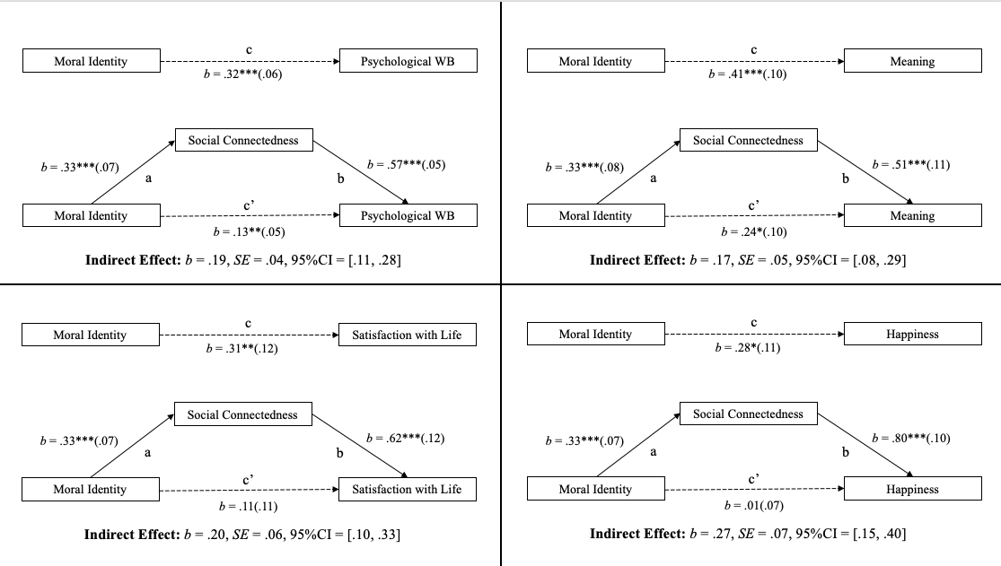

Note. b = unstandardized coefficient; SE = standard error (in parentheses); CI = 95% confidence interval. Bootstrapped with 5000 samples. *p < .05. **p < .01. ***p < .001.

Figure 2
Statistical Diagrams with Rumination as a Mediator Between Moral Attentiveness and Wellbeing in Study 1
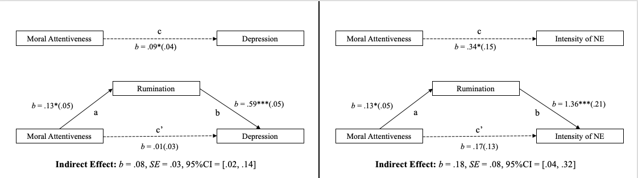

Note. b = unstandardized coefficient; SE = standard error (in parentheses); CI = 95% confidence interval. Bootstrapped with 5000 samples. *p < .05. **p < .01. ***p < .001.

Mediation Models for Study 1b

Figure 3

Statistical Diagrams with Social Connectedness as a Mediator Between Moral Identity and Wellbeing in Study 1b

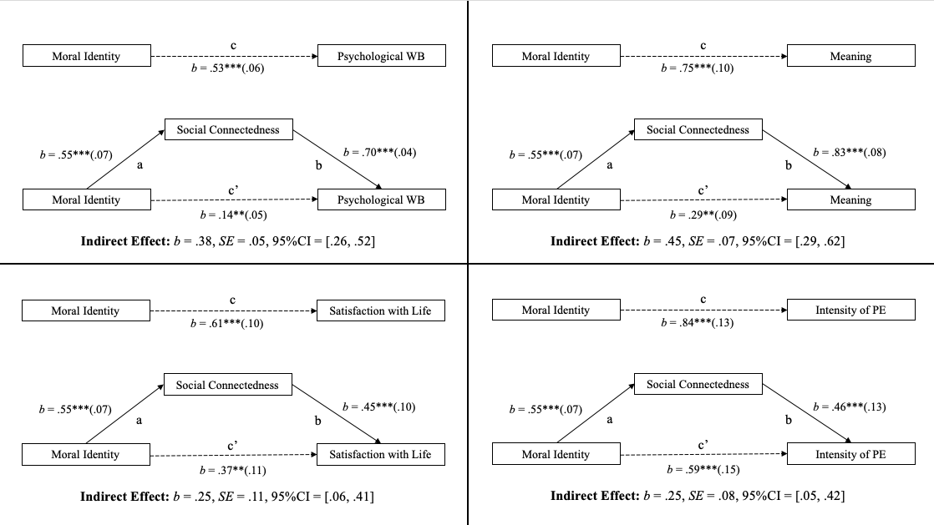

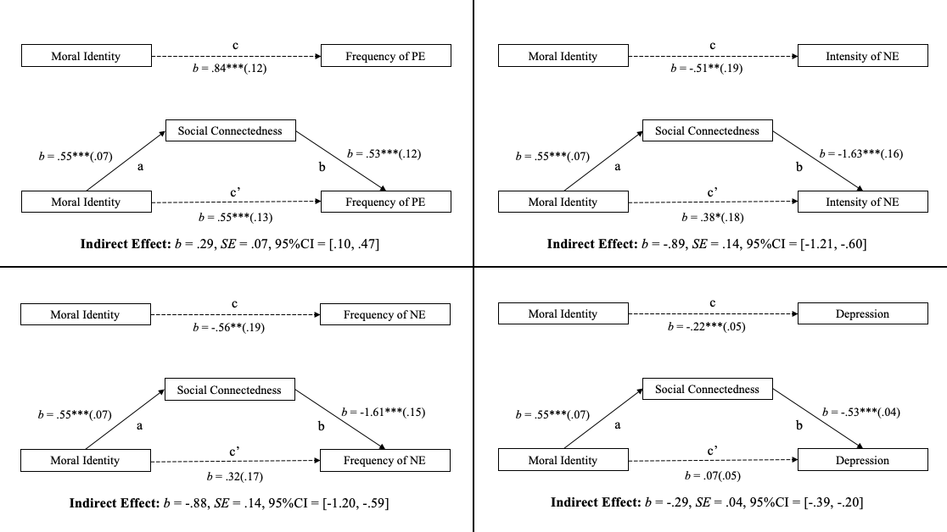

Note. b = unstandardized coefficient; SE = standard error (in parentheses); CI = 95% confidence interval. Bootstrapped with 5000 samples. *p < .05. **p < .01. ***p < .001.

Figure 4

Statistical Diagrams with Rumination as a Mediator Between Moral Attentiveness and Wellbeing in Study 1b
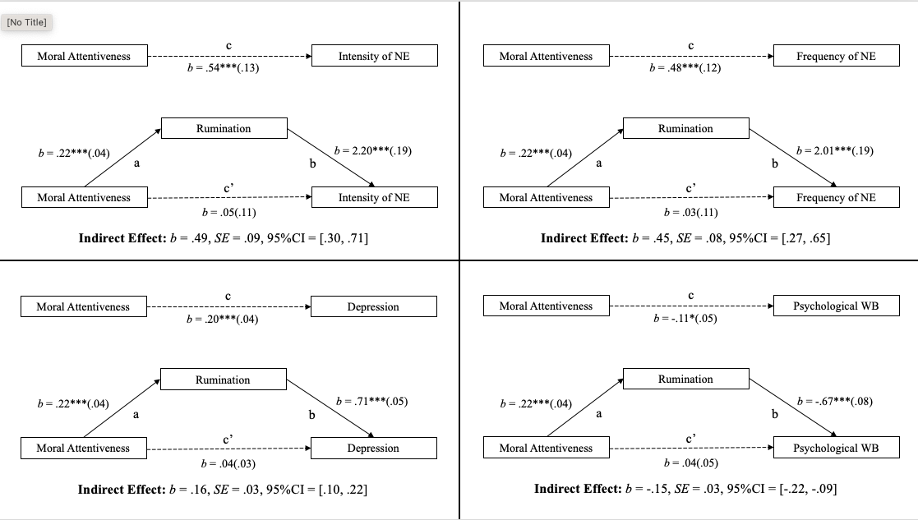
Note. b = unstandardized coefficient; SE = standard error (in parentheses); CI = 95% confidence interval. Bootstrapped with 5000 samples. *p < .05. **p < .01. ***p < .001.

Mediation Models for Study 1c

Figure 5
Statistical Diagrams with Social Connectedness as a Mediator between Moral Identity and Wellbeing in Study 1c.
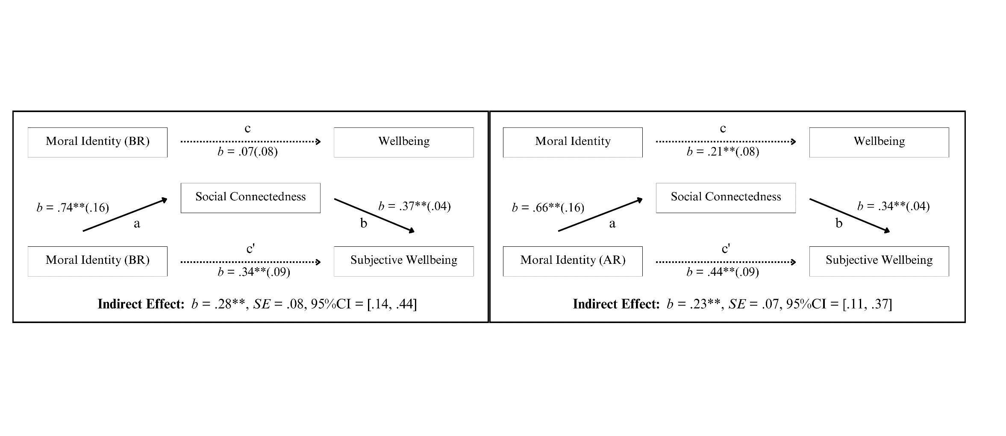
Note. b = unstandardized coefficient; SE = standard error (in parentheses); CI = 95% confidence interval. Bootstrapped with 5000 samples. *p < .05. **p < .01. ***p < .001.
Figure 6
Statistical Diagrams with Rumination as a Mediator between Moral Attentiveness and Wellbeing in Study 1c.
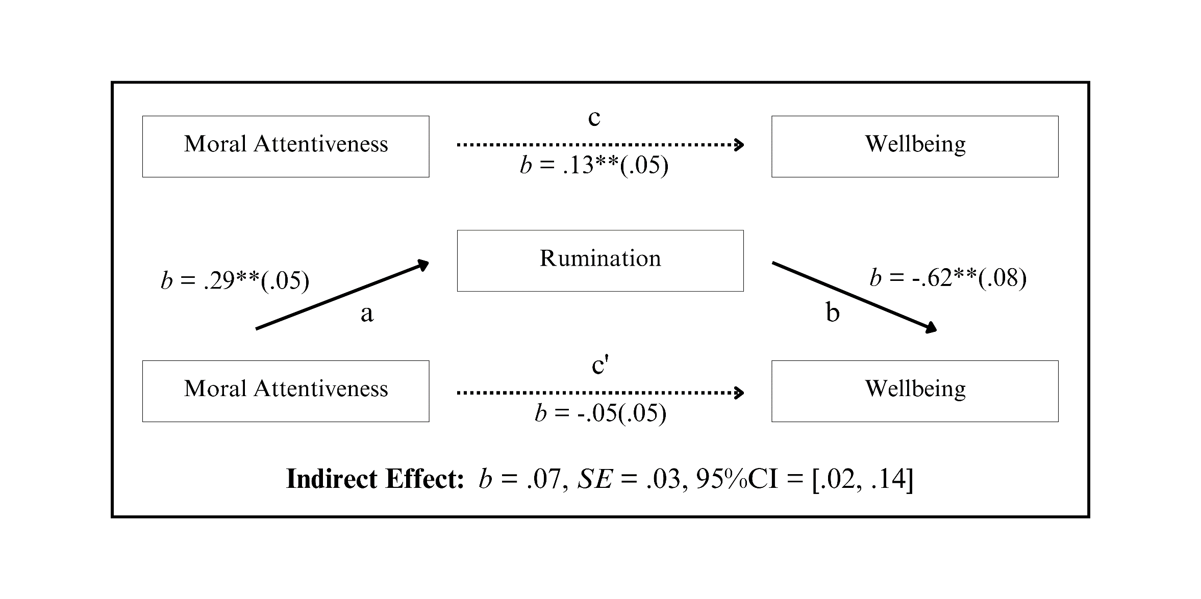
Note. b = unstandardised coefficient, SE = standard error (appears in brackets), CI = confidence interval. The 95% confidence intervals were constructed using 5000 bootstrapped samples.
*p < .05. **p < .01

Tables and Figures Referenced in Study 2 (Main Text)

Figure 7.
Statistical Diagrams with Rumination as a Mediator between Moral Identity (BR) and Wellbeing in Study 2.
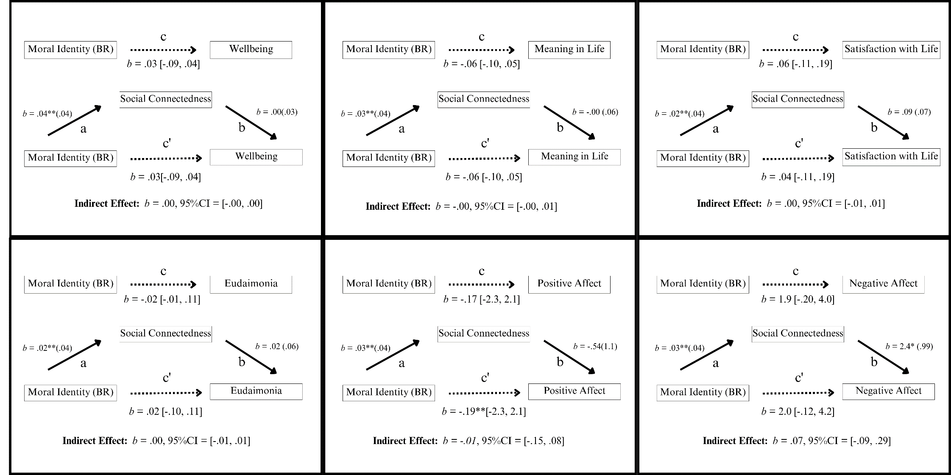
Note. b = unstandardised coefficient, SE = standard error (appears in brackets), CI = confidence interval. The 95% confidence intervals were constructed using 5000 bootstrapped samples.
*p < .05. **p < .01
Figure 8.
Statistical Diagrams with Rumination as a Mediator between Moral Attentiveness and Wellbeing in Study 2.
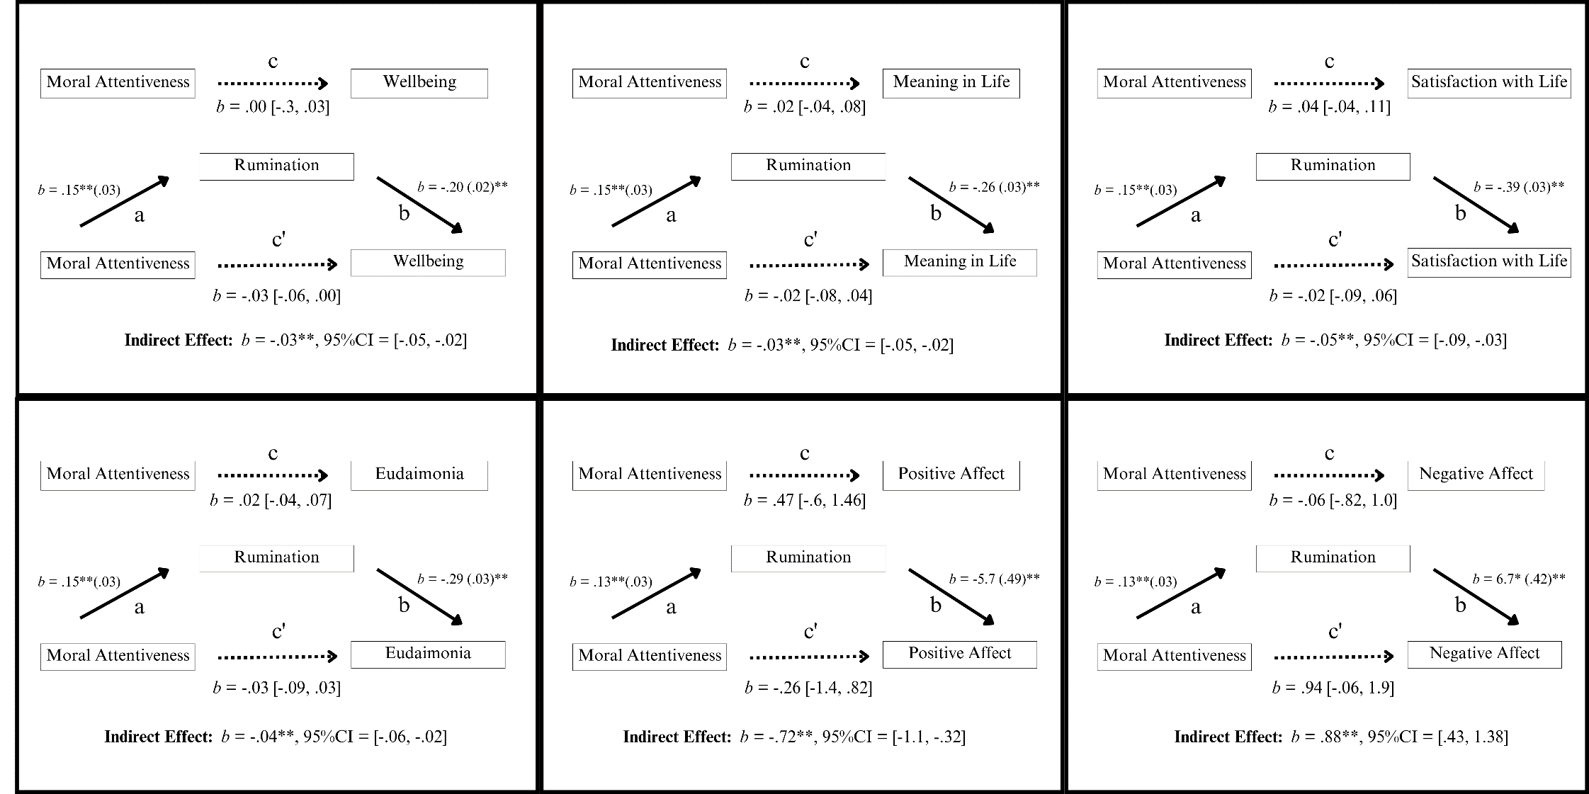

Note. b = unstandardised coefficient, SE = standard error (appears in brackets), CI = confidence interval. The 95% confidence intervals were constructed using 5000 bootstrapped samples.
*p < .05. **p < .01

Table 9.
Momentary Continuous Prediction Models (Within-Person Effects), Demonstrating the Effect of “Moral Attentiveness” and “Moral Identity” on Each Outcome Variable.
 |  | Predictor Variables
 |  |  | “Moral Attentiveness” |  |  |  | “Moral Identity (BR)” |  |  |  | “Moral Identity (AR)”
Outcome variables |  |  |  | β (SE) | 95% CI | p |  | β (SE) | 95% CI | p | β (SE) | 95% CI | p
BBC SWB |  |  |  | -0.01 (0.02) | -0.05 – 0.02 | .380 |  | 0.04 (0.02) | 0.01 – 0.08 | .013* | 0.15 (0.02) | 0.11 – 0.19 |  | < .001***
Eudaimonia |  |  |  | -0.01 (0.02) | -0.06 – 0.03 | .553 |  | 0.13 (0.03) | 0.08 – 0.18 | < .001*** | 0.36 (0.04) | 0.29 – 0.43 |  | < .001***
Life Satisfaction |  |  |  | -0.02 (0.04) | -0.09 – 0.06 | .642 |  | 0.09 (0.04) | 0.02 – 0.16 | .009** | 0.26 (0.04) | 0.18 – 0.34 |  | < .001***
Meaning in Life |  |  |  | 0.01 (0.03) | -0.05 – 0.06 | .830 |  | 0.09 (0.03) | 0.03 – 0.15 | .002** | 0.22 (0.04) | 0.14 – 0.29 |  | < .001***
Positive Affect |  |  |  | -0.53 (0.56) | -1.64 – 0.57 | .341 |  | 1.44 (0.57) | 0.32 – 2.57 | .012* | 3.18 (0.67) | 1.84 – 4.51 |  | < .001***
Negative Affect |  |  |  | 2.53 (0.53) | 1.48 – 3.58 | <.001*** |  | 0.36 (0.47) | -0.57 – 1.28 | .448 | -2.38 (0.52) | -3.42 – -1.34 |  | < .001***
Rumination |  |  |  | 0.19 (0.04) | 0.11 – 0.26 | <.001*** |  | -0.00 (0.03) | -0.07 – 0.06 | .935 | -0.15 (0.03) | -0.22 – -0.09 |  | < .001***
Social Connect |  |  |  | -0.00 (0.02) | -0.04 – 0.03 | .781 |  | 0.03 (0.01) | 0.00 – 0.06 | .023* | 0.01 (0.02) | -0.03 – 0.04 |  | .716

Note: β = standardised beta, SE = standard error, CI = confidence interval, MI was measured using two scales; MI (Black & Reynolds) & MI (Aquino & Reed). Moral Attentiveness was controlled for in Moral Identity prediction models; Both Moral Identity measures were controlled for in Moral Attentiveness prediction models.
* p < .05 ** p < .01 *** p < .001

Table 10.
Momentary Continuous Prediction Models (Within-Person Effects), Demonstrating the Effect of “Rumination” and “Social Connectedness” on Each Outcome Variable.
 |  |  | Predictor Variables
 | “Rumination” |  |  |  |  | “Social Connectedness”
Outcome variables | β (SE) | 95% CI |  | p | β (SE) |  | 95% CI |  | p
BBC SWB | -0.18 (0.05) | -0.28 to -0.08 |  | <.001*** | -0.01 (0.01) |  | -0.03 to 0.02 |  | .624
Eudaimonia | -0.24 (0.04) | -0.32 to -0.16 |  | <.001*** | 0.07 (0.04) |  | -0.01 to 0.15 |  | .076
Life Satisfaction | -0.24 (0.04) | -0.32 to -0.16 |  | <.001*** | 0.20 (0.04) |  | 0.12 to 0.28 |  | <.001***
Meaning in Life | -0.25 (0.04) | -0.33 to -0.17 |  | <.001*** | 0.21 (0.04) |  | 0.13 to 0.29 |  | <.001***
Positive Affect | -0.22 (0.05) | -0.32 to -0.12 |  | <.001*** | -0.68 (0.44) |  | -1.57 to 0.20 |  | .127
Negative Affect | -0.34 (0.05) | -0.44 to -0.24 |  | <.001*** | 0.02 (0.05) |  | -0.08 to 0.12 |  | .678

Note: β = standardised beta, SE = standard error, CI = confidence interval, BBC-SWB = BBC Subjective Wellbeing Scale. Rumination was controlled for in Social Connectedness prediction models; Social Connectedness was controlled for in Rumination prediction models.
* p < .05 ** p < .01 *** p < .001

Table 11.
Momentary Continuous Prediction Models (Within-Person Effects), Demonstrating the Effect of “Moral Attentiveness” and “Moral Identity” on Each Outcome Variable.
 |  | Predictor Variables
 |  |  | “Moral Attentiveness” |  |  |  | “Moral Identity (BR)” |  |  |  | “Moral Identity (AR)”
Outcome variables |  |  |  | β (SE) | 95% CI | p |  | β (SE) | 95% CI | p | β (SE) | 95% CI | p
BBC SWB |  |  |  | 0.00 (0.02) | -0.03 – 0.04 | 0.877 |  | 0.04 (0.02) | 0.01 – 0.07 | 0.021* | 0.14 (0.02) | 0.10 – 0.18 |  | <0.001***
Eudaimonia |  |  |  | 0.03 (0.03) | -0.02 – 0.09 | 0.227 |  | 0.13 (0.02) | 0.08 – 0.18 | <0.001*** | 0.35 (0.03) | 0.28 – 0.41 |  | <0.001***
Life Satisfaction |  |  |  | 0.02 (0.04) | -0.05 – 0.09 | 0.577 |  | 0.10 (0.03) | 0.03 – 0.16 | 0.004** | 0.25 (0.04) | 0.17 – 0.33 |  | <0.001***
Meaning in Life |  |  |  | 0.05 (0.03) | -0.00 – 0.10 | 0.053 |  | 0.09(0.03) | 0.04 – 0.14 | 0.001*** | 0.21 (0.04) | 0.14 – 0.29 |  | <0.001***
Positive Affect |  |  |  | 0.03 (0.55) | -1.06 – 1.11 | 0.957 |  | 1.33 (0.54) | 0.26 – 2.39 | 0.015* | 3.15 (0.65) | 1.86 – 4.44 |  | <0.001***
Negative Affect |  |  |  | 2.47 (0.50) | 1.49 – 3.46 | <0.001*** |  | 0.75 (0.47) | -0.18 – 1.68 | 0.112 | -2.22 (0.52) | -3.25 – -1.20 |  | <0.001***
Rumination |  |  |  | 0.17 (0.04) | 0.10 – 0.25 | <0.001*** |  | 0.03 (0.03) | -0.04 – 0.09 | 0.402 | -0.15 (0.03) | -0.22 – -0.08 |  | <0.001***
Social Connect |  |  |  | 0.01 (0.01) | -0.02 – 0.04 | 0.397 |  | 0.04 (0.01) | 0.01 – 0.07 | 0.013* | 0.01 (0.01) | -0.02 – 0.03 |  | 0.601

Note: β = standardised beta, SE = standard error, CI = confidence interval, MI was measured using two scales; MI (Black & Reynolds) & MI (Aquino & Reed).
* p < .05 ** p < .01 *** p < .001

Table 12.
Momentary Continuous Prediction Models (Within-Person Effects), Demonstrating the Effect of “Rumination” and “Social Connectedness” on Each Outcome Variable.
 |  |  | Predictor Variables
 | “Rumination” |  |  |  |  | “Social Connectedness”
Outcome variables | β (SE) | 95% CI |  | p | β (SE) |  | 95% CI |  | p
BBC SWB | -0.13 (0.02) | -0.17 – -0.09 |  | <0.001*** | -0.01 (0.01) |  | -0.04 – 0.01 |  | 0.297
Eudaimonia | -0.19 (0.03) | -0.25 – -0.13 |  | <0.001*** | 0.01 (0.02) |  | -0.04 – 0.05 |  | 0.756
Life Satisfaction | -0.25 (0.04) | -0.32 – -0.18 |  | <0.001*** | -0.01 (0.03) |  | -0.06 – 0.05 |  | 0.830
Meaning in Life | -0.18 (0.03) | -0.23 – -0.12 |  | <0.001*** | -0.01 (0.02) |  | -0.06 – 0.03 |  | 0.597
Positive Affect | -4.28 (0.57) | -5.42 – -3.15 |  | <0.001*** | -0.94 (0.45) |  | -1.83 – -0.04 |  | 0.040*
Negative Affect | 5.25 (0.51) | 4.24 – 6.25 |  | <0.001*** | 1.62 (0.45) |  | 0.73 – 2.51 |  | <0.001***

Note: β = standardised beta, SE = standard error, CI = confidence interval, BBC-SWB = BBC Subjective Wellbeing Scale.
* p < .05 ** p < .01 *** p < .001

Table 13.
Fully Cross-Lagged Models: Next-Day Predictions from Moral Engagement Variables to Process and Outcome Variables.
 |  |  |  |  |  |  |  | Predictor Variables
 | “Moral Attentiveness” |  |  |  |  |  |  |  |  | “Moral Identity (BR)” |  |  |  |  |  |  | “Moral Identity (AR)”
 | Within-people |  | Between-people |  |  |  | Within-people |  |  |  |  | Between-people Within-people |  |  |  |  |  | Between-people
Outcome variables | b | p | b |  | p |  | b |  | p |  | b |  | p |  | b p b p
BBC SWB | -0.03 | .127 | -0.01 |  | .876 |  | -0.04 |  | .396 |  | 0.44 |  | .003** |  | 0.01 .829 0.69 <.001***
Eudaimonia | -0.02 | .572 | 0.14 |  | .154 |  | -0.00 |  | .963 |  | 0.93 |  | <.001*** |  | 0.03 .537 1.24 <.001***
Life Satisfaction | -0.00 | .955 | 0.01 |  | .934 |  | 0.01 |  | .896 |  | 0.56 |  | .027* |  | 0.01 .901 1.08 <.001***
Meaning in Life | -0.02 | .514 | 0.12 |  | .289 |  | -0.12 |  | .104 |  | 0.76 |  | .005** |  | 0.05 .233 1.27 <.001***
Positive Affect | -0.23 | .688 | -0.61 |  | .690 |  | -0.83 |  | .512 |  | 5.91 |  | .115 |  | -0.58 .436 11.68 <.001***
Negative Affect | 0.64 | .273 | 4.93 |  | .001** |  | 1.55 |  | .202 |  | -3.72 |  | .306 |  | 1.83 .008** -4.71 .045*
Rumination | 0.11 | .007** | 0.43 |  | <.001*** |  | 0.07 |  | .446 |  | 0.31 |  | .299 |  | 0.11 .015* -0.49 .012*
Social Connect | -0.01 | .597 | 0.10 |  | .002** |  | 0.01 |  | .823 |  | 0.21 |  | .008** |  | 0.04 .102 0.17 <.001***
Note: Lagged models include predictors from day t predicting outcomes at day t+1, controlling for prior-day levels of both predictors and outcomes. Moral identity was assessed using both BR and AR scales. All variables are person-mean centered for within-person effects.
*p < .05. **p < .01. ***p < .001.

Table 14.
Reverse Temporal Models: Predicting Moral Engagement from Lagged Process and Outcome Variables.
 |  |  |  |  |  |  |  | Outcome Variables
 | “Moral Attentiveness” |  |  |  |  |  |  |  |  | “Moral Identity (BR)” |  |  |  |  |  |  | “Moral Identity (AR)”
 | Within-people |  | Between-people |  |  |  | Within-people |  |  |  |  | Between-people Within-people |  |  |  |  |  | Between-people
Predictor variables | b | p | b |  | p |  | b |  | p |  | b |  | p |  | b p b p
BBC SWB | 0.09 | .212 | -0.01 |  | .969 |  | 0.05 |  | .338 |  | 0.72 |  | <.001*** |  | 0.05 .361 0.72 <.001***
Eudaimonia | -0.02 | .606 | 0.18 |  | .077 |  | 0.04 |  | .102 |  | 0.51 |  | <.001*** |  | 0.04 .178 0.52 <.001***
Life Satisfaction | 0.04 | .220 | -0.00 |  | .980 |  | 0.02 |  | .379 |  | 0.40 |  | <.001*** |  | 0.01 .701 0.40 <.001***
Meaning in Life | 0.02 | .755 | 0.08 |  | .342 |  | 0.01 |  | .825 |  | 0.40 |  | <.001*** |  | -0.01 .762 0.39 <.001***
Positive Affect | 0.00 | .837 | -0.00 |  | .743 |  | 0.00 |  | .763 |  | 0.02 |  | <.001*** |  | -0.00 .939 0.02 <.001***
Negative Affect | 0.00 | .649 | 0.02 |  | .002** |  | -0.00 |  | .481 |  | -0.01 |  | .047* |  | -0.00 .507 -0.01 .049*
Rumination | 0.02 | .630 | 0.27 |  | .001** |  | -0.03 |  | .433 |  | -0.13 |  | .010* |  | -0.02 .565 -0.13 .010*
Social Connect | 0.01 | .951 | 1.02 |  | .002** |  | -0.02 |  | .761 |  | 0.75 |  | <.001*** |  | -0.02 .733 0.77 <.001***
Note: Moral identity was measured using two scales; moral identity (Black & Reynolds) & moral identity (Aquino & Reed). Person-mean-centred of predictor variables and lagged iterations of outcome variables were included as control variables. * p < .05 ** p < .01 *** p < .001

