Online Appendix
- The range of children’s educational attainments in a family
In this section, we test for the heterogeneity by the range of children’s educational attainments in a family to check if parents’ SWB might also be affected by the struggles of their least-educated child. To be more specific, we calculate the difference for years of schooling between the highest-educated and least-educated child in each family as the range for children’s educational attainment (the range is 0 for single-child families). We then interact the range with years of schooling for the highest-educated child in each family and employ the corresponding interaction term (Children’ exposure to CEL × range) as IV. The results, shown in Table A1, indicate that as the range of children’s educational attainment increases in a family, the positive effect of children’s education on parents’ SWB will become gradually muted, which suggests that parents’ SWB is somewhat negatively influenced by the struggles of their least successful (in terms of education) child. The p-value for the Anderson-Rubin Wald test is 0.06, strengthening the credibility of our results.
Table A1 Heterogeneous effects by educational range
 | Life satisfaction
Children’s education | 0.137**
 | (0.066)
Range × Children’s education | – 0.005**
 | (0.002)
Kleibergen–Paap F statistic | 9.362
Number of observations | 15,174
Notes: The regression controls for characteristics of offspring and parents, province fixed effects and children’s province-specific birth year linear trends. Standard errors are clustered at province-birth cohort level and reported in parentheses.
**p < 0.05
To check whether the dynamics are different between single-child and multiple-child families, we generate three indicators (single-child family, multiple-child family with a zero range, and multiple-child family with a positive range) and interact them with children’s education as three main explanatory variables. Utilizing the corresponding interaction terms of children’s exposure to CEL with the three indicators as IVs (for example, “Children’s exposure to CEL × single-child family” as the IV for “Children’s education × single-child family”), we report the results in Table A2 (The p-value for the Anderson-Rubin Wald test is 0.09). The positive effect of children’s education on parents’ SWB is the largest in multiple-child families with equal educational attainments and is the smallest in multiple-child families with different educational attainments, suggesting that the struggles of the least-educated child in a family could, to some extent, undermine parents’ SWB.
Table A2 Heterogeneous effects by educational range and family type
 | Life satisfaction
Single-child Family × Children’s education | 0.121**
 | (0.059)
Multiple-child Family without range × Children’s education | 0.134**
 | (0.066)
Multiple-child Family with range × Children’s education | 0.106**  (0.051)
Kleibergen–Paap F statistic | 6.041
Number of observations | 15,174
Notes: The regression controls for characteristics of offspring and parents, province fixed effects and children’s province-specific birth year linear trends. Standard errors are clustered at province-birth cohort level and reported in parentheses.
**p < 0.05

- Additional Tables and Figures

Table B1 Questions, options and scoring method of CES-D 10
Questions |  | Options and assigned scores
Positive  questions | (1) I felt hopeful about the future | (1) Rarely or none of the time: 3 points  (2) Some or a little of the time: 2 points  (3) Occasionally: 1 point  (4) Most or all of the time: 0 point
Positive  questions | (2) I was happy
Negative  questions | (1) I was bothered by things that do not usually bother me | (1) Rarely or none of the time: 0 point  (2) Some or a little of the time: 1 point  (3) Occasionally: 2 points  (4) Most or all of the time: 3 points
Negative  questions | (2) I had trouble keeping my mind on what I was doing
Negative  questions | (3) I felt depressed
Negative  questions | (4) I felt everything I did was an effort
Negative  questions | (5) I felt fearful
Negative  questions | (6) My sleep was restless
Negative  questions | (7) I felt lonely
Negative  questions | (8) I could not get “going”

Table B2 Heterogeneous effects by child’s gender and family type
 | Life satisfaction
Children’s education | 0.092**
 | (0.042)
Single-child family with daughter × Children’s education | – 0.039*
 | (0.022)
Multiple-child family with son × Children’s education | 0.007**  (0.003)
Multiple-child family with daughter × Children’s education | – 0.045*  (0.023)
Kleibergen–Paap F statistic | 8.590
Number of observations | 15,174
Notes: The regression controls for characteristics of offspring and parents, province fixed effects and children’s province-specific birth year linear trends, with “single-child family with son” serving as the reference category. Standard errors are clustered at province-birth cohort level and reported in parentheses.
**p < 0.05; *p < 0.10

Table B3 OLS estimates for the potential non-linear effect of children’s education on parents’ SWB
 | Life satisfaction
Junior high education | 0.042*
 | (0.025)
Senior high education | 0.072***
 | (0.027)
Tertiary education | 0.100***
 | (0.027)
Number of observations | 15,174
Notes: This table reports the OLS estimates for the potential non-linear effect of children’s education on parents’ SWB with children with primary (or lower) education as the reference group. The regression controls for characteristics of offspring and parents, province fixed effects and children’s province-specific birth year linear trends. Standard errors are clustered at province-birth cohort level and reported in parentheses.
***p < 0.01; *p < 0.10

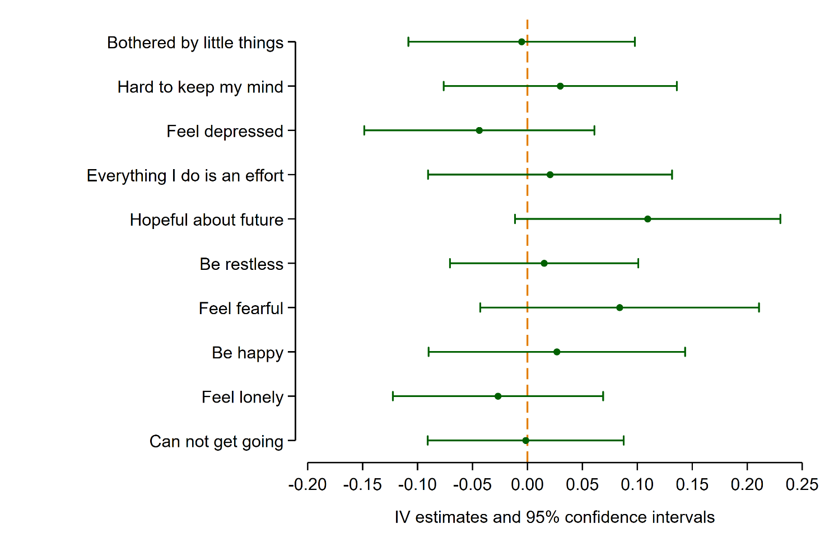
Fig. B1 IV estimates and 95% confidence intervals for CES-D 10
Notes: This figure presents the effects of children’s education on each of parents’ 10 CES-D item, separately. Every data point in the figure shows the estimated coefficient for a specific item (as marked) and the horizontal bars around each point illustrate the 95% confidence intervals. The vertical dashed line at zero serves as the baseline, indicating null effect.

