Supporting Information for

Synthesis of dialkenyl-substituted double-decker silsesquioxanes as precursors for linear copolymeric systems

Katarzyna Mituła,^{[a]} Beata Dudziec,*^{,[a]} Bogdan Marciniec*^{,[a,b]}

ªFaculty of Chemistry, Adam Mickiewicz University in Poznan, Umultowska 89B, 61-614 Poznan, Poland,
e-mail: beata.dudziec@gmail.com
^{b}Centre for Advanced Technologies, Adam Mickiewicz University in Poznan, Umultowska 89C, 61-614 Poznan, Poland

1. | Copies of ¹H, ¹³C , ²⁹Si NMR and selected IR spectra of the silsesquioxane derivatives | ••• S -2-

- Copies of ¹H, ¹³C , ²⁹Si NMR and selected IR spectra of the silsesquioxane derivatives
DDSQ-2Si-Allyl.
Ph₈(Si₁₀O₁₄)All₂Me₂ - di[9,13-allylmethyl]-1,3,5,7,11,13,15,17-octa(phenyl)pentacyclo-[11.7.1.1^{3,11}.1^{5,17}.1^{7,15}]decasiloxane. White solid. Isolated Yield 70%.
¹H NMR (300.2 MHz, CDCl₃, δ, ppm): 0.30 (s, 6H, -Si-(CH₃)₂), 1.77 (d, J_{H,H}= 8.0 Hz, 4H, H₂C=CH-CH₂-), 4.75-4.89 (m, 4H, H₂C=CH-), 5.71-5.85 (m, 2H, H₂C=CH-), 7.17-7.55 (m, 40H, -Ph).
¹³C NMR (100.6 MHz, CDCl₃, δ, ppm): -1.49 (Si-CH₃), 24.70 (-CH₂-CH=CH₂), 114.95 (H₂C=CH-), 127.79-127.90 (-Ph), 130.51 (-Ph), 131.11 (-Ph), 132.02 (-Ph), 132.85 (H₂C=CH-), 134.11-134.18 (-Ph).
²⁹Si NMR (79.5 MHz, CDCl₃, δ, ppm): -22.07 (-Si-Allyl), -78.67, -79.60.
IR (ATR, cm⁻¹): 3073.01, 3051.57 (C-H phenyl), 2972.40 (C-H), 1632.17 (C=C), 1594.09, 1430.26 (C=C phenyl), 1261.56 (Si-C), 1079.82, 1029.30 (Si-O-Si), 998.21 (C-H phenyl).

¹H NMR (300.2 MHz, CDCl₃, δ, ppm):
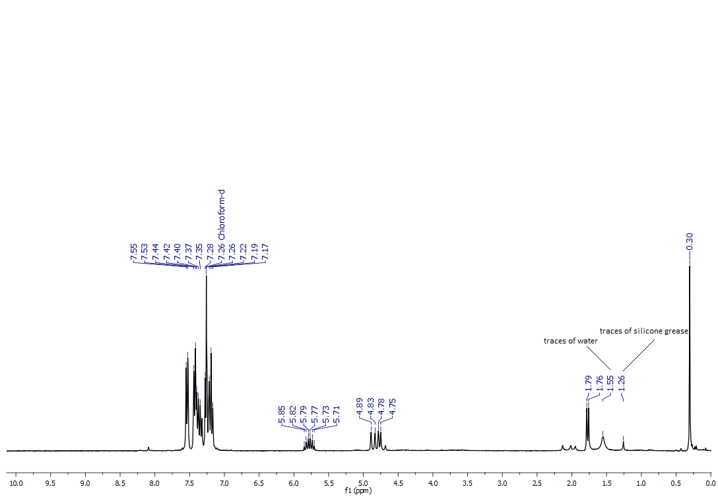

¹³C NMR (100.6 MHz, CDCl₃, δ, ppm):
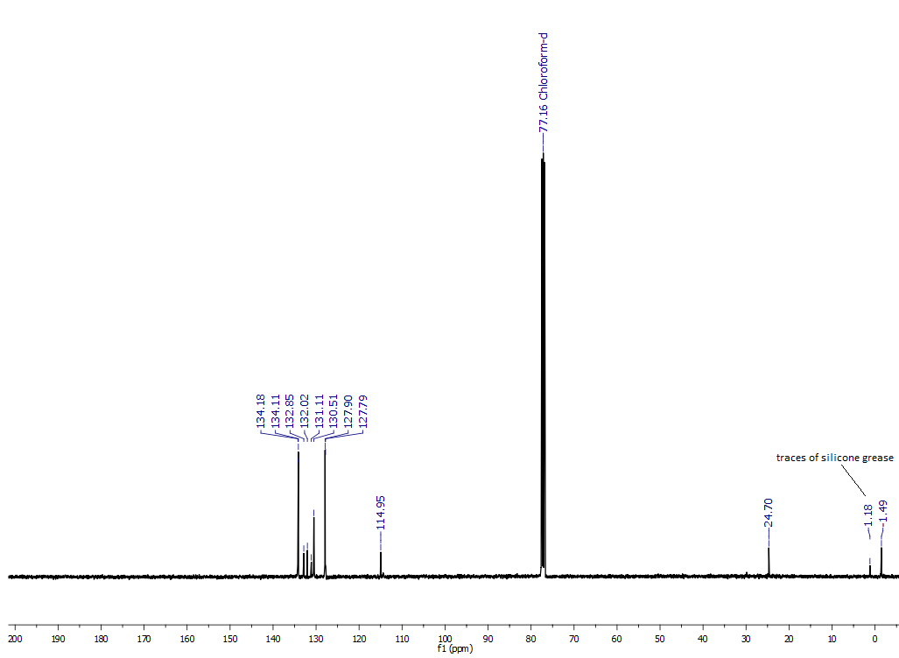
²⁹Si NMR (79.5 MHz, CDCl₃, δ, ppm):
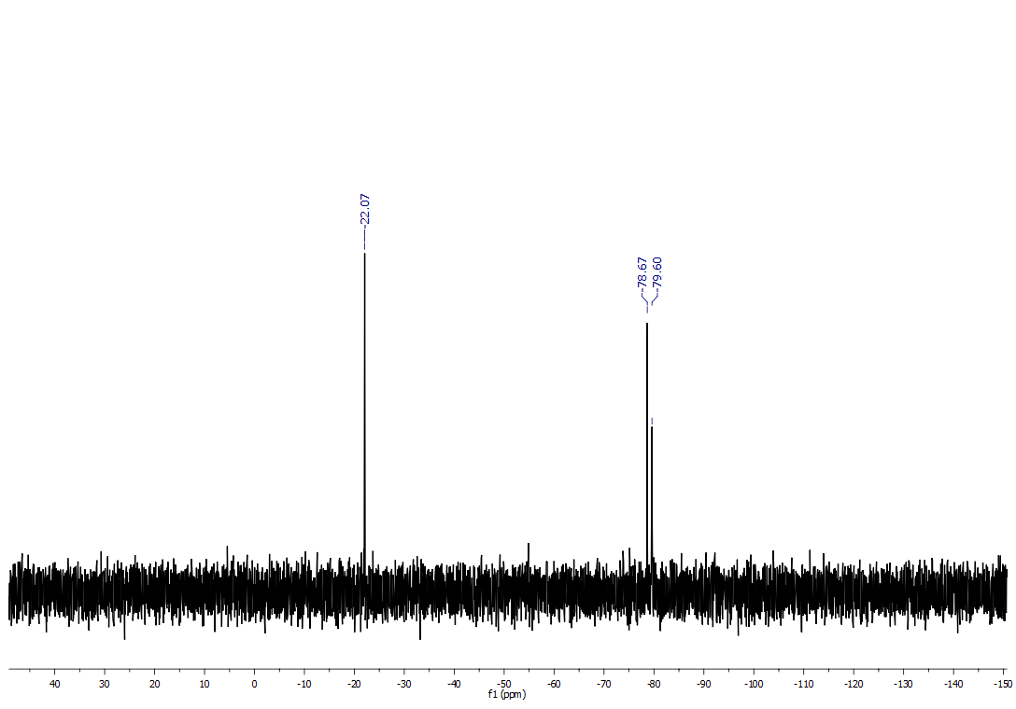

DDSQ-2Si-Hexenyl
Ph₈(Si₁₀O₁₄)Hex₂Me₂ - di[9,13-hex-5-enylmethyl]-1,3,5,7,11,13,15,17-octa(phenyl)pentacyclo-[11.7.1.1^{3,11}.1^{5,17}.1^{7,15}]decasiloxane. White solid. Isolated Yield 90%.
¹H NMR (300.2 MHz, CDCl₃, δ, ppm): 0.28 (s, 6H, -Si-(CH₃)₂), 0.71-0.76 (m, 4H, -CH₂- (hex-5-enyl)), 1.30-1.42 (m, 8H, -CH₂- (hex-5-enyl)), 1.84-1.91 (m, 4H, -CH₂- (hex-5-enyl)), 4.79-4.88 (m, 4H, H₂C=CH-), 5.58-5.71 (m, 2H, H₂C=CH-), 7.17-7.61 (m, 40H, -Ph).
¹³C NMR (100.6 MHz, CDCl₃, δ, ppm): -0.72 (Si-CH₃), 16.81 (-CH₂- (hex-5-enyl)), 22.42 (-CH₂- (hex-5-enyl)), 32.38 (-CH₂- (hex-5-enyl)), 33.53 (-CH₂- (hex-5-enyl)), 114.22 (H₂C=CH-), 127.77-127.92 (-Ph), 130.46 (-Ph), 131.26 (-Ph), 132.31 (-Ph), 134.10-134.21 (-Ph), 139.91 (H₂C=CH-).
²⁹Si NMR (79.5 MHz, CDCl₃, δ, ppm): -17.33 (-Si-hex-5-enyl), -78.72, -79.65.
IR (ATR, cm⁻¹): 3073.39, 3052.18 (C-H phenyl), 2924.71, 2856.82 (C-H), 1640.10 (C=C), 1594.19, 1430.24 (C=C phenyl), 1263.93 (Si-C), 1077.70, 1028.57 (Si-O-Si), 997.91 (C-H phenyl).

¹H NMR (300.2 MHz, CDCl₃, δ, ppm):
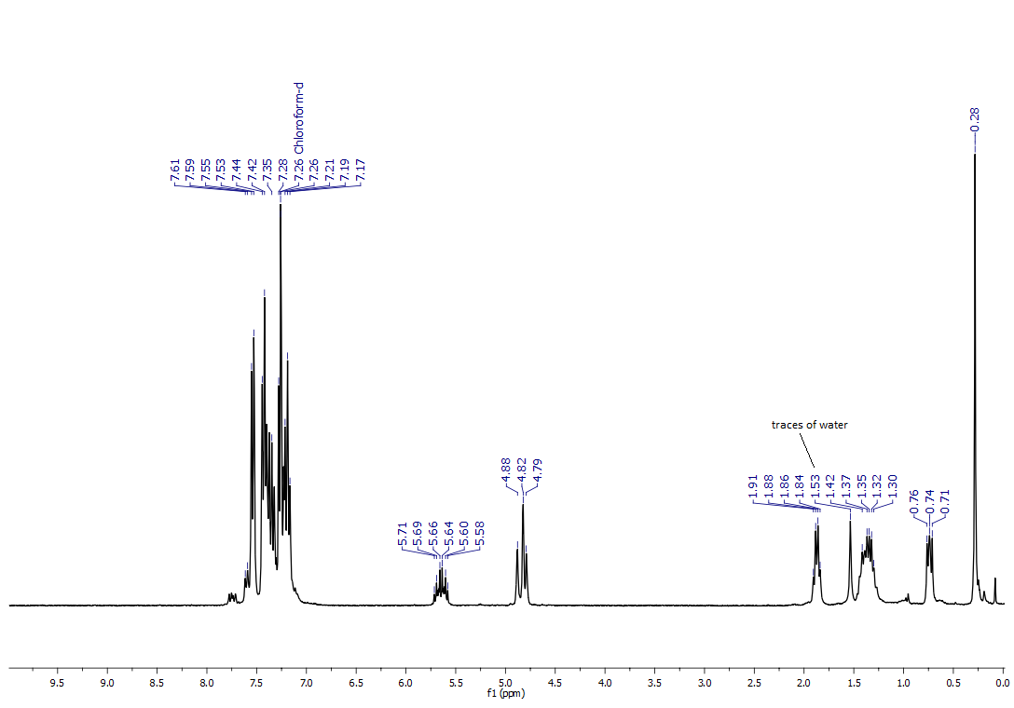

¹³C NMR (100.6 MHz, CDCl₃, δ, ppm):
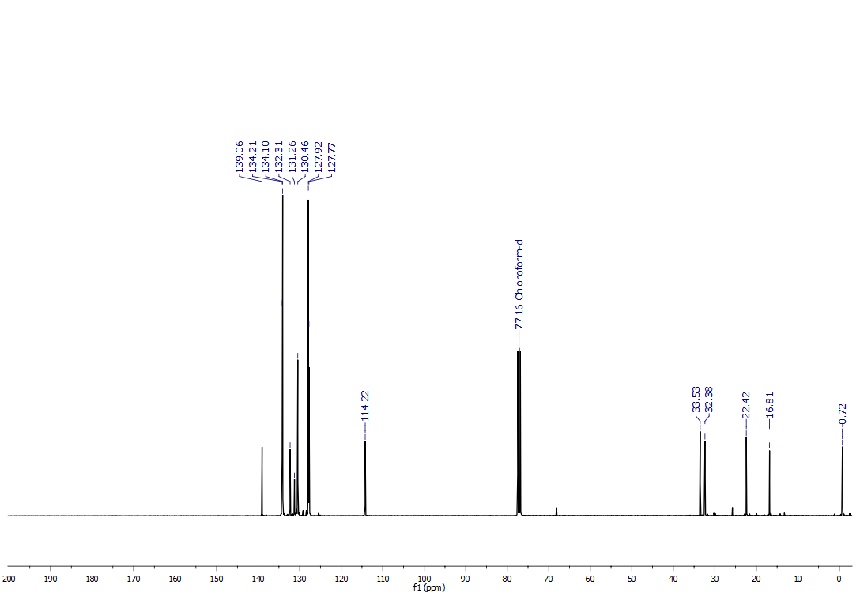
²⁹Si NMR (79.5 MHz, CDCl₃, δ, ppm):
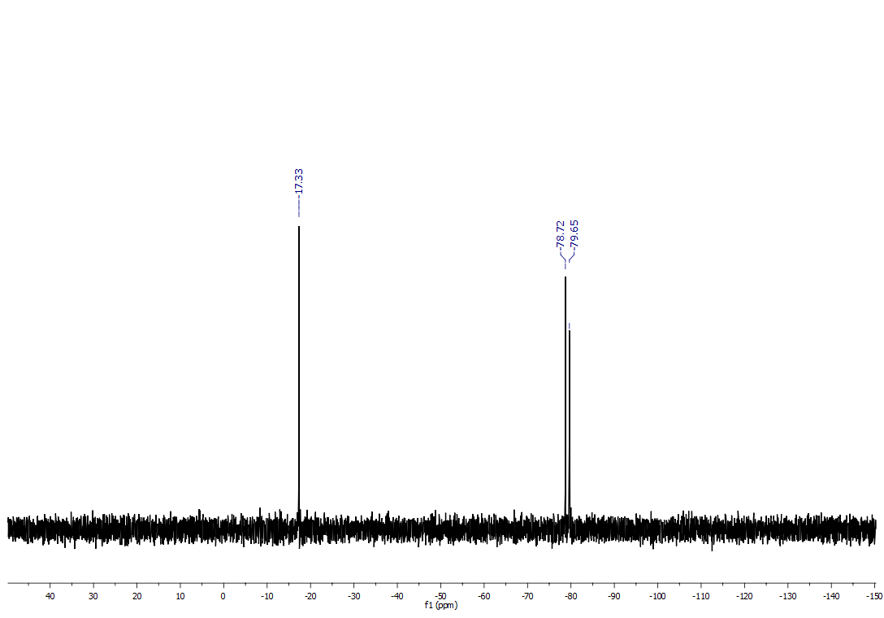

¹H NMR Comparative spactra of the DDSQ-2OSi-Hexenyl obtained via condensation and hydrosilylation reaction.
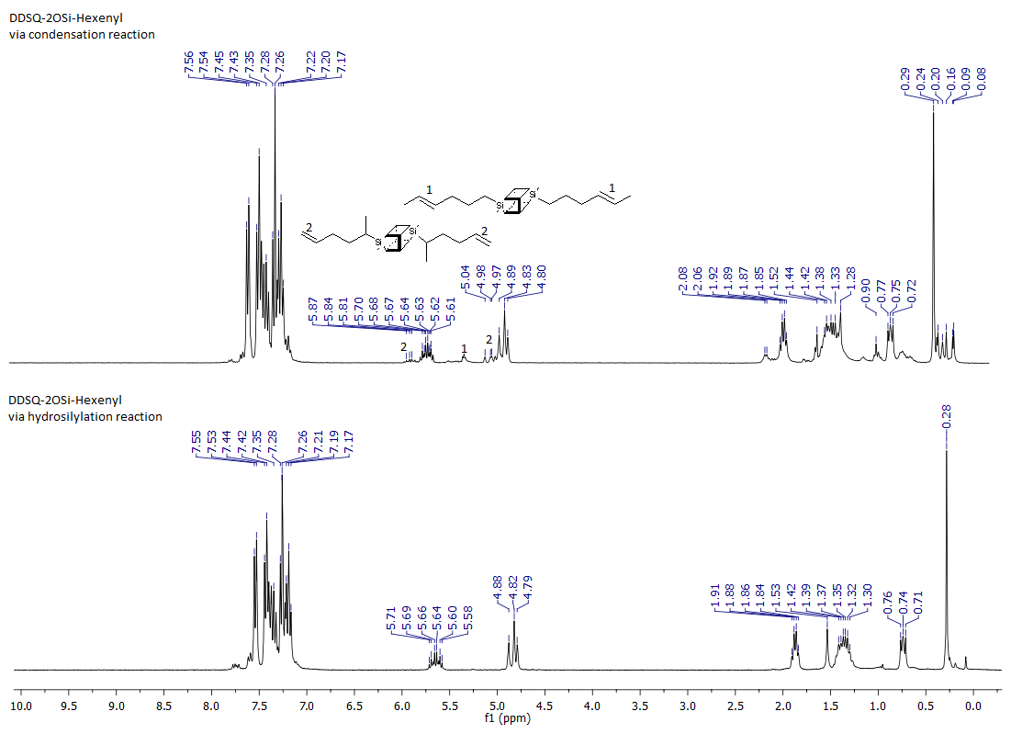

²⁹Si NMR spectrum of the DDSQ-2OSi-Hexenyl obtained via condensation reaction.
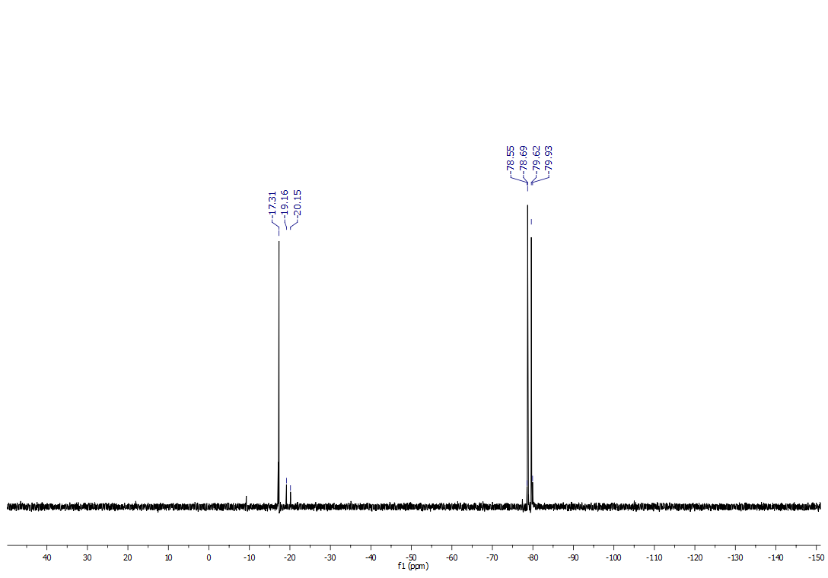
DDSQ-2Si-Decenyl
Ph₈(Si₁₀O₁₄)Dec₂Me₂ - di[9,13-dec-9-enylmethyl]-1,3,5,7,11,13,15,17-octa(phenyl)pentacyclo-[11.7.1.1^{3,11}.1^{5,17}.1^{7,15}]decasiloxane. Waxy, white solid. Isolated Yield 94%.
¹H NMR (300.2 MHz, CDCl₃, δ, ppm): 0.29 (s, 6H, -Si-(CH₃)₂), 0.72-0.77 (m, 4H, -CH₂- (dec-9-enyl)), 1.13-1.41 (m, 22H, -CH₂- (dec-9-enyl)), 1.97-2.04 (m, 4H, -CH₂- (dec-9-enyl)), 4.92-5.02 (m, 4H, H₂C=CH-), 5.74-5.87 (m, 2H, H₂C=CH-), 7.17-7.57 (m, 40H, -Ph).
¹³C NMR (100.6 MHz, CDCl₃, δ, ppm): -0.72 (Si-CH₃), 16.96 (-CH₂- (dec-9-enyl)), 22.89 (-CH₂- (dec-9-enyl)), 29.04 (-CH₂- (dec-9-enyl)), 29.30 (-CH₂- (dec-9-enyl)), 29.39 (-CH₂- (dec-9-enyl)), 29.51 (-CH₂- (dec-9-enyl)), 33.23 (-CH₂- (dec-9-enyl)), 33.97 (-CH₂- (dec-9-enyl)), 114.20 (H₂C=CH-), 127.71-127.89 (-Ph), 130.42 (-Ph), 131.29 (-Ph), 132.36 (-Ph), 134.09-134.21 (-Ph), 139.42 (H₂C=CH-).
²⁹Si NMR (79.5 MHz, CDCl₃, δ, ppm): -17.16 (-Si-dec-9-enyl), -78.76, -79.67.
IR (ATR, cm⁻¹): 3072.92, 3051.58 (C-H phenyl), 2923.98, 2853.55 (C-H), 1640.10 (C=C), 1594.25, 1430.11 (C=C phenyl), 1260.35 (Si-C), 1076.12, 1028.54 (Si-O-Si), 997.88 (C-H phenyl).

¹H NMR (300.2 MHz, CDCl₃, δ, ppm):
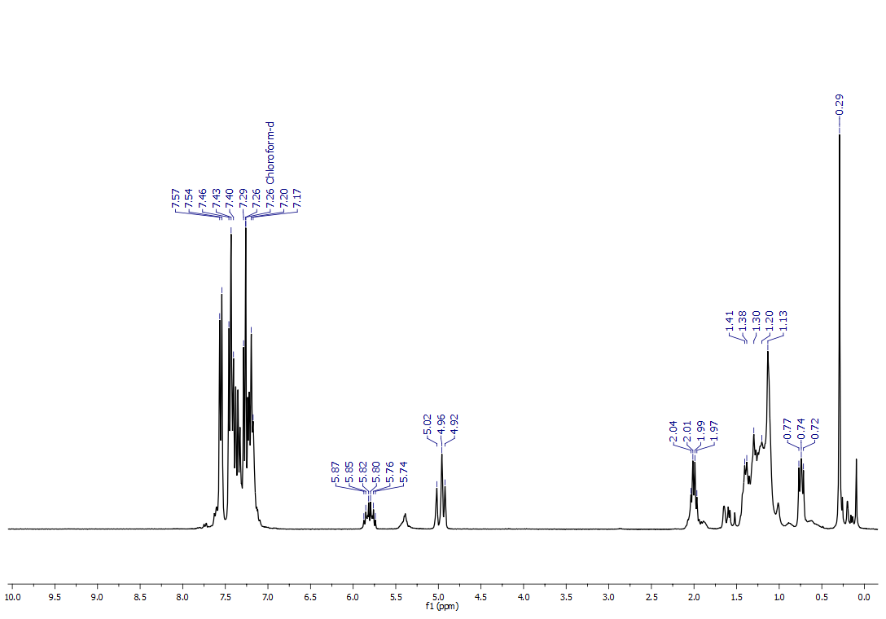

¹³C NMR (100.6 MHz, CDCl₃, δ, ppm):
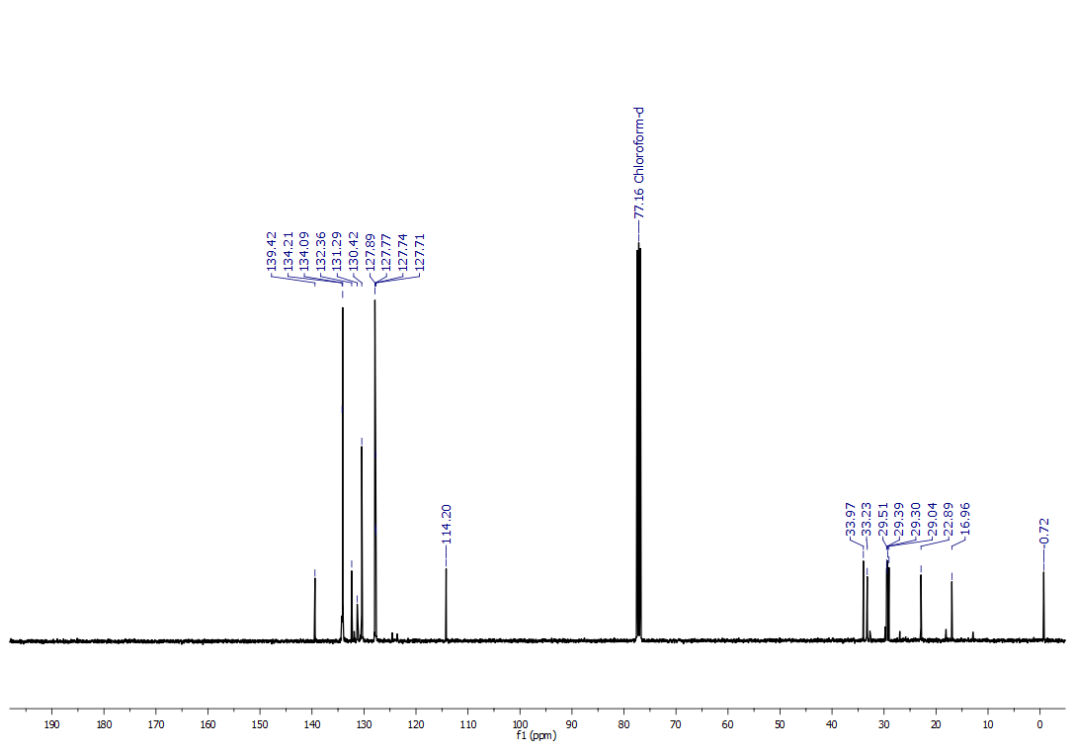
²⁹Si NMR (79.5 MHz, CDCl₃, δ, ppm):
