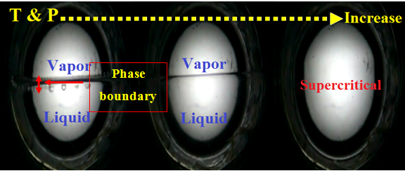
Fig. S1: Phase change of fluid with pressure and temperature.
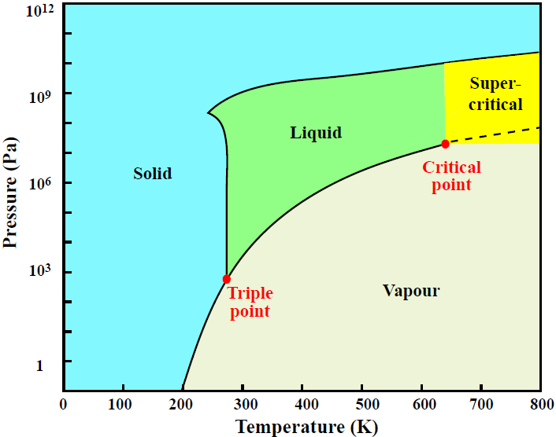
Fig. S2: Water pressure-temperature phase diagram.
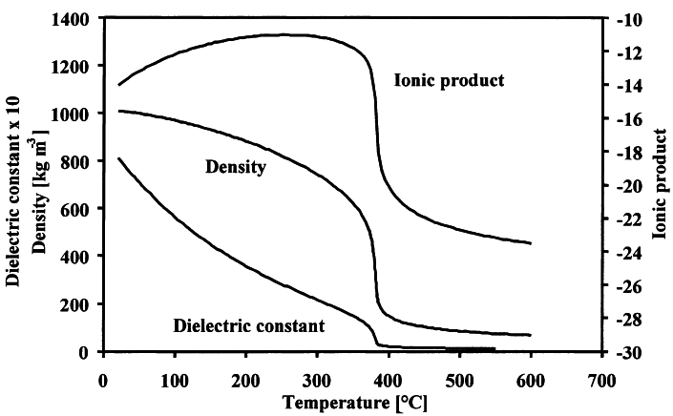
Fig. S3: Water properties versus temperature at 24 MPa, adapted from ¹.

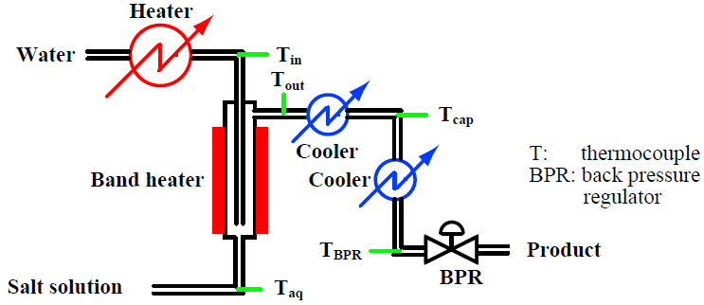
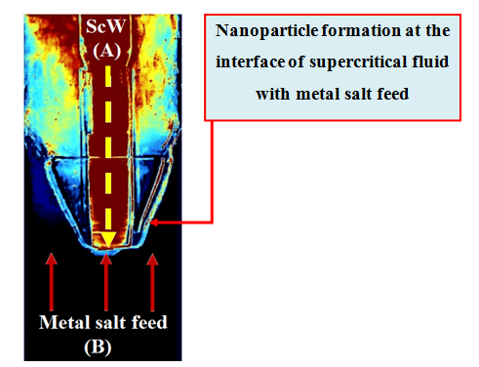
Flow (A)

Reactor (R)

Flow (B)

Fig. S4: Flow diagram of the continuous hydrothermal synthesis system used for the instant production Fe₂O₃.

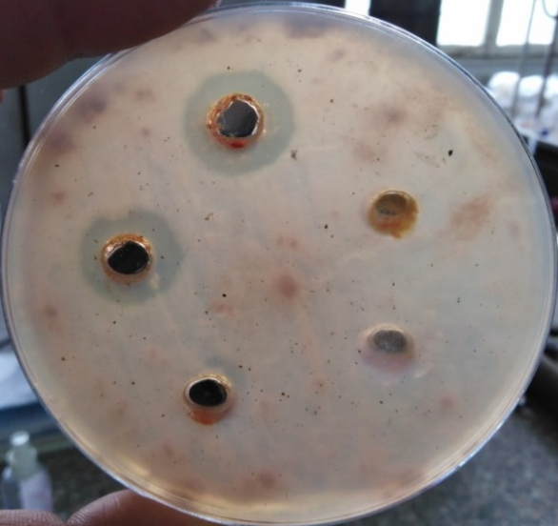
Fig. S5: Antifungal activity of different concentrations of Fe₂O₃ NPs against F. oxysporum where clear zones indicating positive results and great activity.

