Phytochemical profiling of Phragmites australis leaf extract and its nano-structural antioxidant, antimicrobial, and anticancer activities
Jeremiah O. Unuofin ¹, Adewale O. Oladipo ^{1*}, Garland K. More ², Adeyemi O. Adeeyo ³, Hassan T. Mustapha ⁴, Titus A.M. Msagati ³, Sogolo L. Lebelo ¹
¹Department of Life and Consumer Sciences, College of Agriculture and Environmental Sciences, University of South Africa, Private Bag X06 Florida 1710, South Africa
²College of Agriculture and Environmental Sciences Laboratory, University of South Africa, Private Bag X06, Florida 1710, South Africa
³Institute for Nanotechnology and Water Sustainability (iNanoWS), College of Science, Engineering and Technology, University of South Africa, Private Bag X06 Florida 1710, South Africa
⁴Department of Chemical Sciences, Crescent University, Abeokuta, Ogun state, Nigeria

Author for correspondence: oladiao@unisa.ac.za

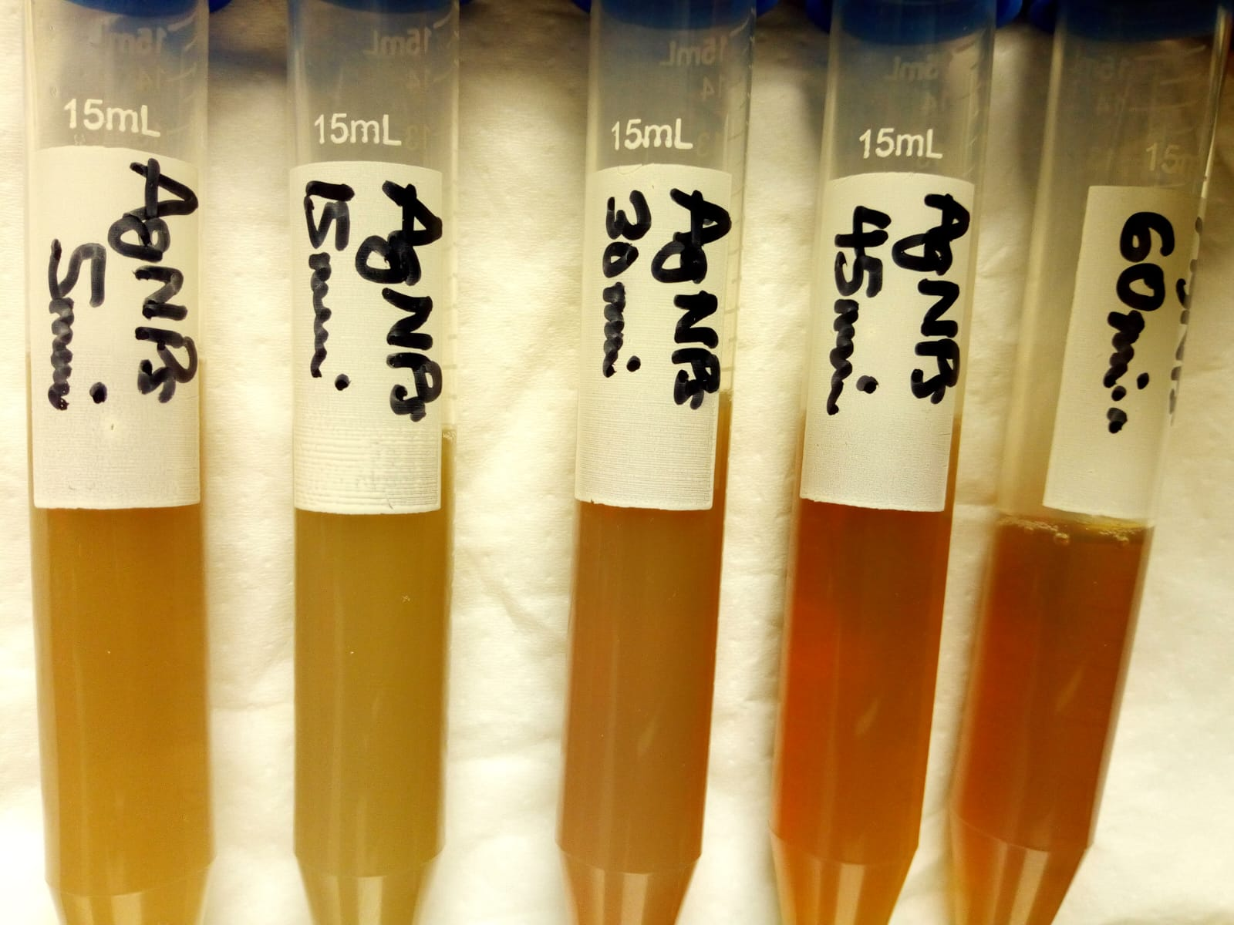
Fig. S1 Photographic image of aqueous P. australis extract synthesized AgNPs

Table S1 Zeta-potential and polydispersity index (PDI) of PA-AgNPs (Mean ± SD; n=3)
Days | Particle size (nm) | PDI |  | Zeta potential (mV)
0 | 52.4 ± 1.21 | 0.170 | -28.2 ± 2.75
1 | 52.7 ± 0.96 | 0.211 | -28.5 ± 2.16
2 | 52.6 ± 1.08 | 0.201 | -28.4 ± 2.33
3 | 53.1 ± 1.17 | 0.204 | -29.0 ± 3.25
4 | 52.9 ± 2.21 | 0.181 | -28.8 ± 3.41
5 | 53.0 ± 1.98 | 0.192 | -28.9 ± 2.74

Table S2 The calculated IC₅₀ values (µg/mL) for PAE and PA-AgNPs in MCF-7 and A549 cells incubated for 24 h
Samples | MCF-7 | A549
PAE | 74.68 | >100
PA-AgNPs | 11.47 | ~121.2

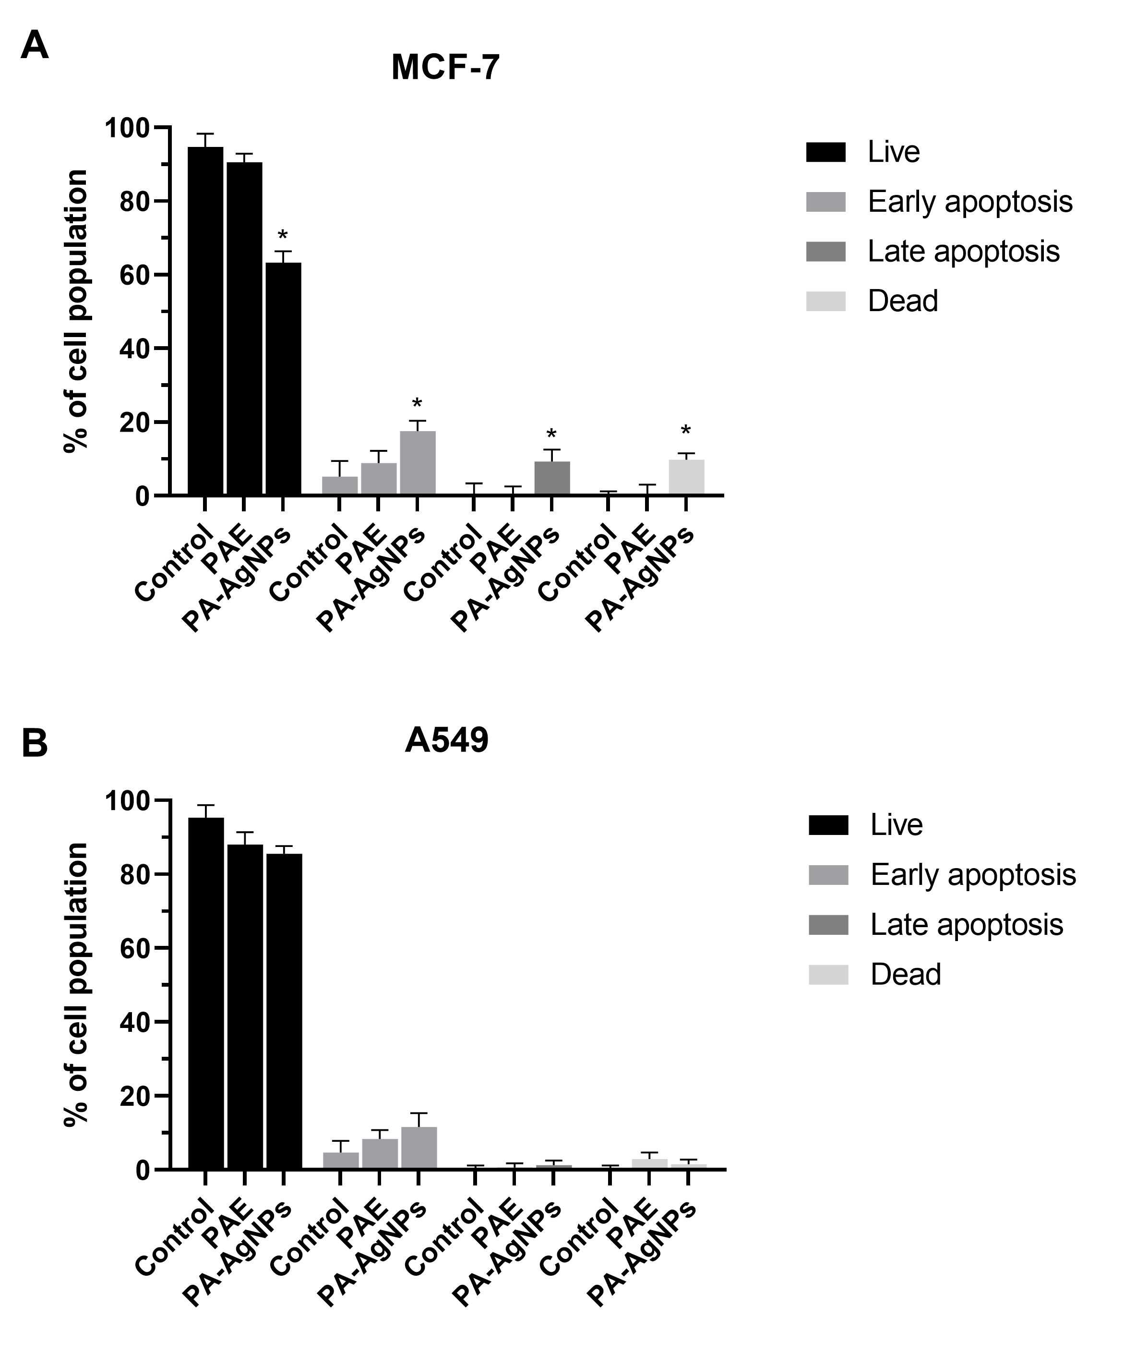
Fig. S2 The percentage of the cell population in (A) MCF-7 and (B) A549 cells after incubation for 12 h with PAE and PA-AgNPs. Data presented as mean ± SD with the differences * P < 0.05 is considered significant

