SUPPORTING INFORMATION

“Functionalized Cyclotriphosphazene-Based Cobalt Coordination Polymer: Synthesis, Characterization, and Catalytic Efficiency Evaluation”

Ayşen Orhan Erkovanª, Azam Seifi^{a,b}, Alireza Khataee^{c,d,}, Yunus Zorluª, Bünyemin Çoşut^{a*}
ª Department of Chemistry, Gebze Technical University, 41400, Gebze, Türkiye
^{b} Institute of Energy, Istanbul Technical University, 34469 Istanbul, Türkiye
^{c} Department of Chemical Engineering, Istanbul Technical University, 34469, Istanbul, Türkiye
^{d} Research Laboratory of Advanced Water and Wastewater Treatment Processes, Department of Applied Chemistry, Faculty of Chemistry, University of Tabriz, 51666−16471 Tabriz, Iran

*Author for correspondence:
E-mail: bcosut@gtu.edu.tr
Tel: 00 90 262 6053015
Fax: 00 90 262 6053105

TABLE OF CONTENTS
Fig. S1. MALDI MS Spectrum of N₃P₃(OC₆H₄CH₃COOCH₃)₆. 4
Fig. S2. ¹H-NMR spectra of compounds N₃P₃(OC₆H₄CH₃COOCH₃)₆. in DMSO-d₆. 4
Fig. S3. MALDI MS Spectrum of H₆L₁ 5
Fig. S4. ¹H-NMR spectra of compounds H₆L₁ in DMSO-d₆ 5
Fig. S5. Simulated and experimental PXRD patterns of GTU-4 6
Table S1 Selected bond lengths (Å) and bond angles (°) for GTU-4. 7
Fig. S6. TGA of the synthesized GTU-4 up to 900 ℃ 8
Fig. S7. Effect of scavenger on the DE% of RhB 9
Fig. S8. Degradation Products of RhB at (a) t=0, and (b) t=60 min 10

Similar to what we obtained in our other two publications, it has been synthesized under the same conditions [35,36]. Synthesis and characterization of the ligand are given below.
Experimental Section
Synthesis of hexakis(methyl-2-(4-phenoxyphenyl)acetatebenzene) cyclotriphosphazene (H₆L₁)
Anhydrous potassium carbonate (2.77 g, 20.09 mmol) was poured into anhydrous acetone (50 mL) solution, which contained methyl 4-hydroxyphenylacetate (3.3 g, 20.09 mmol) and phosphonitrilic chloride trimer N₃P₃Cl₆ (1.00 g, 2.87 mmol), and was heated at reflux condition for 36 h while being stirred constantly under argon atmosphere. The reaction solvent was removed with a rotary evaporator after being cooled to room temperature. For extracting the obtained solid compound 50 ml of water and DCM was used. Then anhydrous Na₂SO₄ was added to dry the organic phase. To purify the obtained unpurified product, it was passed through a silica gel chromatography column, with Hexane:THF (3:2) as the mobile phase. After drying the product (N₃P₃(OC₆H₄CH₃COOCH₃)₆), a white powder (2.8 g, 80% yield based on N₃P₃Cl₆) was obtained. MALDI-TOF (m/z) Calc. 1125.26 m/z, Found: 1126.078 [M+H] ⁺ (Fig.S1). ¹H-NMR (400 MHz, DMSO-d6, ppm), 7,10 (d, 12H, Ar-H), 6,88 (d, 12H, Ar-H, 3,69 (s, 2H, –CH₂), 3,60 (s, 3H, –CH₃ (Fig.S2).
0.77 g sodium hydroxide (19 mmol) was dissolved in 50 mL of methanol, then 1.35 g N₃P₃(OC₆H₄CH₃COOCH₃)₆ (1.19 mmol) was added to the reaction mixture. The obtained mixture was heated up to 80°C and was stirred overnight at this temperature. During this process, the volatile compounds were eliminated, and the rest were dissolved in water. Then it was filtered, and its pH was set in the range of 2-3 by dilute hydrochloric acid. After stirring, the product precipitated which was separated by filtering. Then it was washed with water and then was dried (0.90 g, 72% yield). This step resulted in pure isolation of H₆L_{1.} MALDI-TOF (m/z) Calc. 1041.78 m/z, Found: 1042.55 [M+H] ⁺ (Fig.S3). ¹H-NMR (400 MHz, DMSO-d6, ppm), 7,14 (d, 12H, Ar-H), 6,82 (d, 12H, Ar-H, 3,55 (s, 12H, –CH₂) (Fig.S4). IR υ (cm⁻¹): 2953 (-C-H), 1734 (-C=O), 1505 (-C-O-), 1154 (-P=N-), 956(-P-O-) for N₃P₃(OC₆H₄CH₃COOCH₃)₆ , and 3039 (-OH), 1702 (C=O), 1606-1407 (C=C), 1157 (-P=N-), 951(-P-O-) for H₆L₁ (Fig.S5).
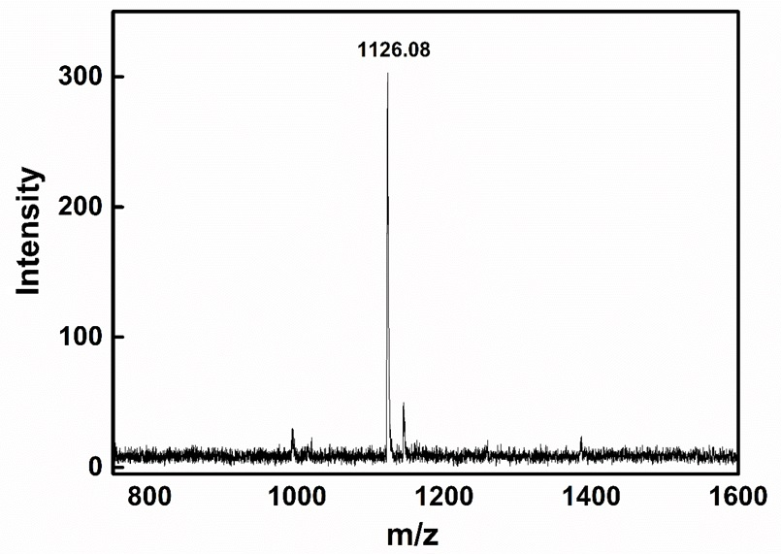
Fig. S1. MALDI MS Spectrum of N₃P₃(OC₆H₄CH₃COOCH₃)₆.

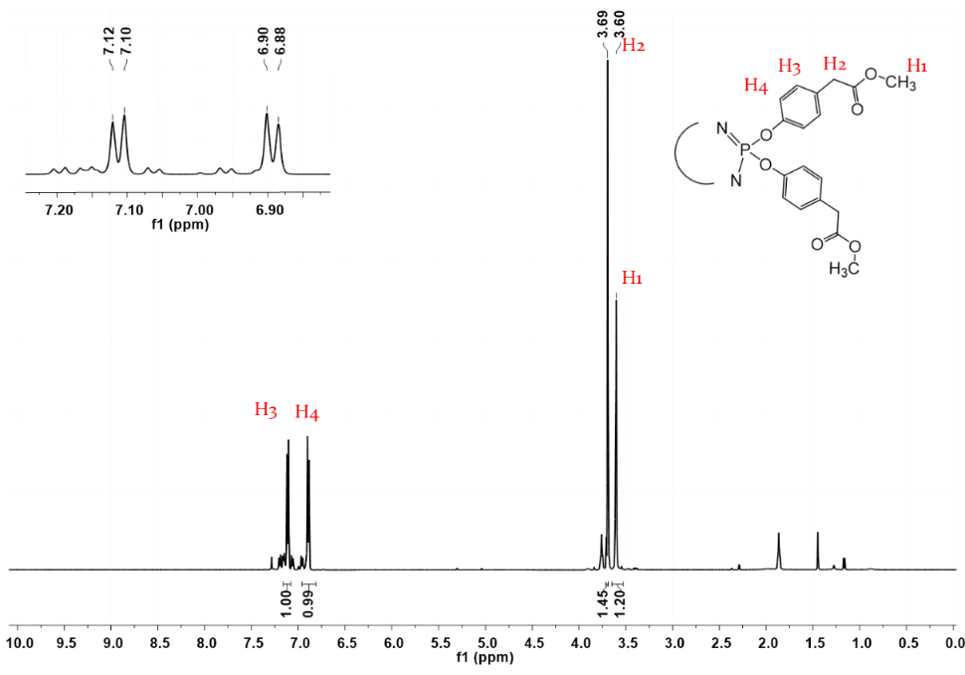
Fig. S2. ¹H-NMR spectra of compounds N₃P₃(OC₆H₄CH₃COOCH₃)₆. in DMSO-d₆.
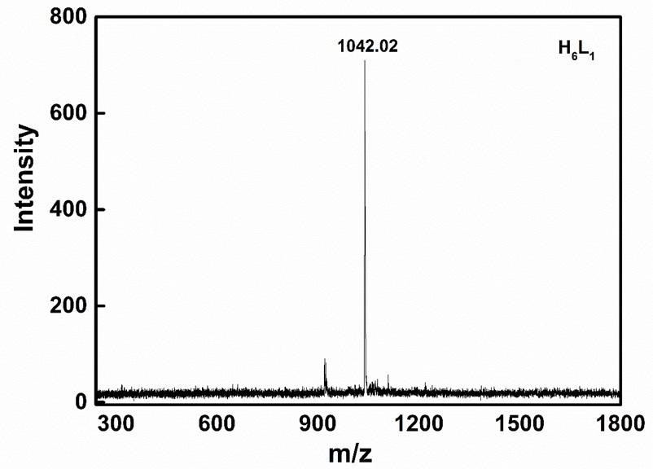
Fig. S3. MALDI MS Spectrum of H₆L₁.

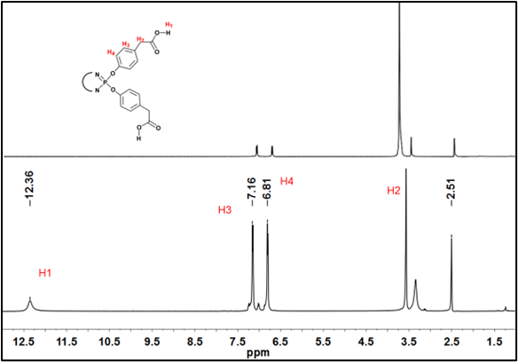
Fig. S4. ¹H-NMR spectra of compounds H₆L₁ in DMSO-d₆.

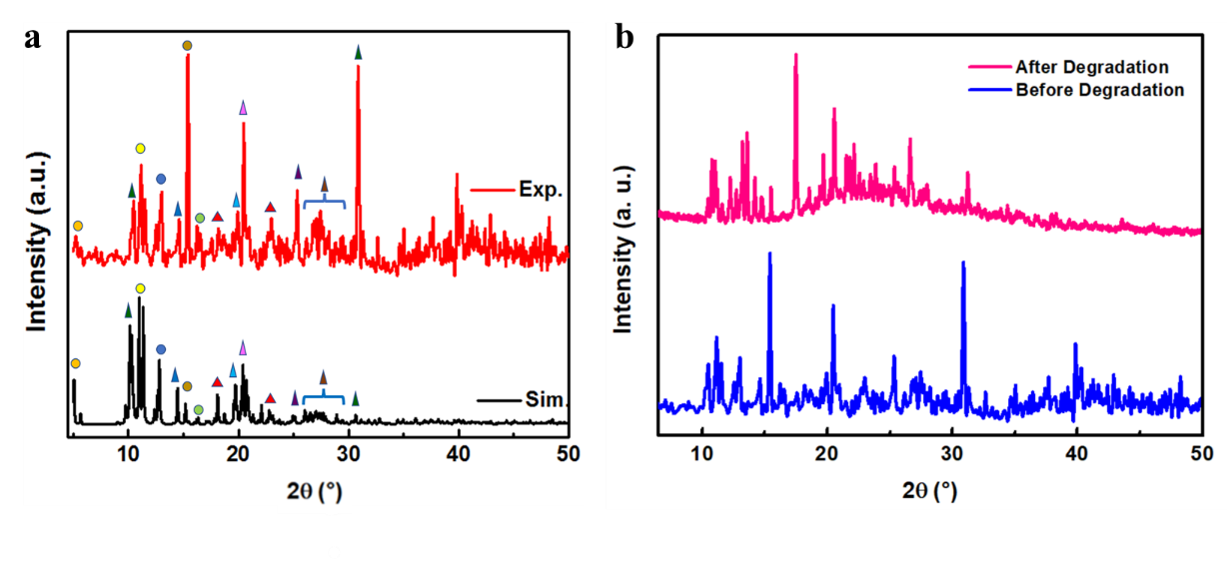
Fig. S5. (a) Simulated and experimental PXRD patterns of GTU-4, and (b) The comparison between the PXRD patterns of GTU-4 before and after the degradation process.

X-ray data collection and structure refinement
Intensity data collection was carried out on a Bruker APEX II QUAZAR three-circle diffractometer. Indexing was performed using APEX2 [APEX2, version 2014.11-0, Bruker (2014), Bruker AXS Inc., Madison, WI.]. Data integration and reduction were carried out with SAINT [SAINT, version 8.34A, Bruker (2013), Bruker AXS Inc., Madison, WI.]. Absorption correction was performed by a multi-scan method implemented in SADABS [SADABS, version2014/5, Bruker (2014), Bruker AXS Inc., Madison, WI]. The structure was solved using SHELXT [G. M. Sheldrick, Acta Crystallogr. Sect. A Found. Crystallogr. 2015, 71, 3–8] and then refined by full-matrix least-squares refinements on F2 using the SHELXL [G. M. Sheldrick, Acta Crystallogr. Sect. C Struct. Chem. 2015, 71, 3-8] in Olex2 Software Package [O.V. Dolomanov, L.J. Bourhis, R.J. Gildea, J.A.K. Howard, H. Puschmann, J. Appl. Cryst., 2009, 42, 339-341]. SQUEEZE [ A.L. Spek, PLATON SQUEEZE: a tool for the calculation of the disordered solvent contribution to the calculated structure factors, Acta Crystallogr. C, 71 (2015) 9-18] was also applied to remove electron density caused by highly disordered solvent molecules. The total potential solvent area for GTU-4 occupied 11.3% (700.1 Å3 / 6216.7 Å3). Analysis of solvent-accessible voids in the structure was performed using the CALC SOLV within the PLATON software package with a probe radius of 1.20 Å and grid spacing of 0.2 Å. Van der Waals (or ion) radii used in the analysis are C (1.70 Å), H (1.20 Å), Co (2.03 Å), Zn (2.25 Å), N (1.55 Å), O (1.52 Å), and P (1.80 Å), respectively. The positions of all H-atoms bonded to carbon, nitrogen, and oxygen atoms were geometrically optimized with the following HFIX instructions in SHELXL: HFIX 23 for the –CH2– moieties and HFIX 43 for the CH of the aromatic rings. Finally, their displacement parameters were set to isotropic thermal displacement parameters (Uiso(H) = 1.2×Ueq for CH and CH2 groups or (Uiso(H) = 1.5×Ueq (-OH). One pyridyl ring in GTU-4 is disordered over two positions with occupancies 0.54:0.46. Crystallographic data and refinement details of the data collection are given in Table 1. Crystal structure validations and geometrical calculations were performed using PLATON software [A. L. Spek, Acta Crystallogr. Sect. D Biol. Crystallogr. 2009, 65, 148-155]. Mercury software [C. F. Macrae, P. R. Edgington, P. McCabe, E. Pidcock, G. P. Shields, R. Taylor, M. Towler, J. Van De Streek, J. Appl. Crystallogr. 2006, 39, 453-445] was used for visualization of the CIF file. Bond lengths and angles are given in Table S2. Additional crystallographic data with CCDC reference numbers 2074444 (GTU-4) has been deposited within the Cambridge Crystallographic Data Center via www.ccdc.cam.ac.uk/deposit.

Table S1. Selected bond lengths (Å) and bond angles (°) for GTU-4.
Bond lengths (Å)
Co1—O9^{i} | 1.924 (13) | Co2—O7^{i} | 2.170 (12) | Co3—O14^{v} | 2.079 (9)
Co1—O12^{ii} | 1.944 (13) | Co2—O8^{i} | 2.199 (12) | Co3—O15^{ii} | 2.050 (9)
Co1—O13 | 1.957 (9) | Co2—O16^{ii} | 1.989 (9) | Co3—O18 | 2.051 (10)
Co1—O20^{iii} | 2.301 (10) | Co2—O17 | 1.986 (10) | Co3—O19 | 2.181 (9)
Co1—N4 | 2.111 (14) | Co2—O19 | 2.297 (9) | Co3—O20 | 2.125 (10)
P1—N1 | 1.563 (12) | Co2—N5 | 2.144 (11) | Co3—O11^{iv} | 2.053 (11)
P1—N3 | 1.588 (12) | P2—N2 | 1.595 (15) | P3—N1 | 1.573 (12)
P2—N3 | 1.535 (11) | P3—N2 | 1.551 (15)
Bond angles (°)
O9^{i}—Co1—O12^{ii} | 119.1 (6) | O7^{i}—Co2—O8^{i} | 59.9 (5) | O17—Co2—O7^{i} | 151.1 (5)
O9^{i}—Co1—O13 | 119.6 (6) | O7^{i}—Co2—O19 | 82.2 (4) | O17—Co2—O8^{i} | 91.5 (5)
O9^{i}—Co1—O20^{iii} | 86.5 (4) | O8^{i}—Co2—O19 | 84.7 (4) | O17—Co2—O16^{ii} | 109.5 (4)
O9^{i}—Co1—N4 | 90.7 (5) | O16^{ii}—Co2—O7^{i} | 98.6 (4) | O17—Co2—O19 | 92.0 (4)
O12^{ii}—Co1—O13 | 120.7 (5) | O16^{ii}—Co2—O8^{i} | 157.9 (5) | O17—Co2—N5 | 90.1 (5)
O12^{ii}—Co1—O20^{iii} | 86.5 (5) | O16^{ii}—Co2—O19 | 87.6 (3) | N5—Co2—O7^{i} | 94.6 (5)
O12^{ii}—Co1—N4 | 94.3 (5) | O16^{ii}—Co2—N5 | 94.2 (4) | N5—Co2—O8^{i} | 92.5 (5)
O13—Co1—O20^{iii} | 88.9 (4) | O14^{v}—Co3—O20 | 91.1 (4) | N5—Co2—O19 | 176.5 (4)
O13—Co1—N4 | 93.0 (5) | O15^{ii}—Co3—O11^{iv} | 178.8 (4) | N5—Co2—C40^{i} | 93.1 (5)
N4—Co1—O20^{iii} | 177.2 (5) | O15^{ii}—Co3—O14^{v} | 84.4 (4) | O15^{ii}—Co3—O20 | 90.6 (4)
O11^{iv}—Co3—O14^{v} | 95.8 (4) | O15^{ii}—Co3—O18 | 93.9 (4) | O18—Co3—O14^{v} | 177.9 (4)
O11^{iv}—Co3—O18 | 85.9 (4) | O15^{ii}—Co3—O19 | 90.4 (4) | O18—Co3—O19 | 96.2 (4)
O11^{iv}—Co3—O19 | 88.5 (4) | O14^{v}—Co3—O19 | 85.0 (4) | O18—Co3—O20 | 87.7 (4)
O11^{iv}—Co3—O20 | 90.5 (4) | O20—Co3—O19 | 175.9 (4) | N3—P2—N2 | 117.7 (7)
N1—P1—N3 | 115.9 (6) | N2—P3—N1 | 118.3 (7) | P1—N1—P3 | 122.0 (8)
P3—N2—P2 | 120.9 (8) | P2—N3—P1 | 121.1 (8)

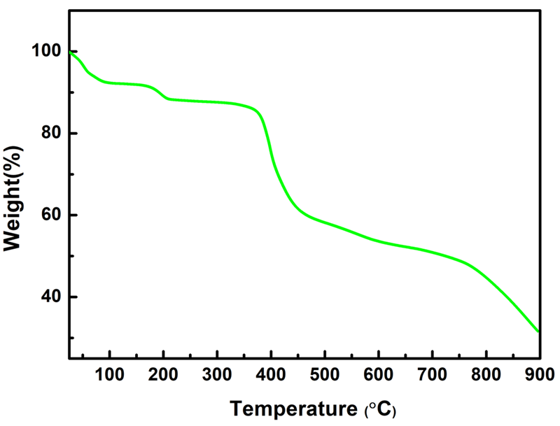
Fig. S6. TGA of the synthesized GTU-4 up to 900 ℃.
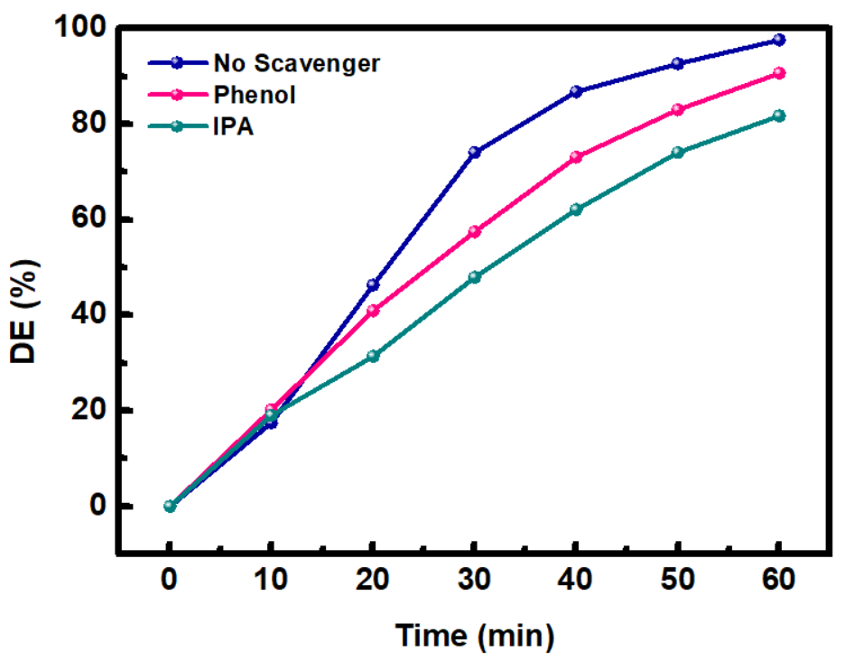
Fig. S7. Effect of scavenger on the DE% of RhB.

To investigate the effect of •OH and SO^{•-}₄ radicals on the degradation efficiency, we applied the scavengers of these two radicals, i.e. isopropanol alcohol (IPA) and phenol, respectively. As it is seen, the degradation efficiency is reduced in the presence of both scavengers which proves the effect of these radicals on the degradation process. A higher decrease in the presence of IPA implies that •OH radical has a more important role in the DE% process.

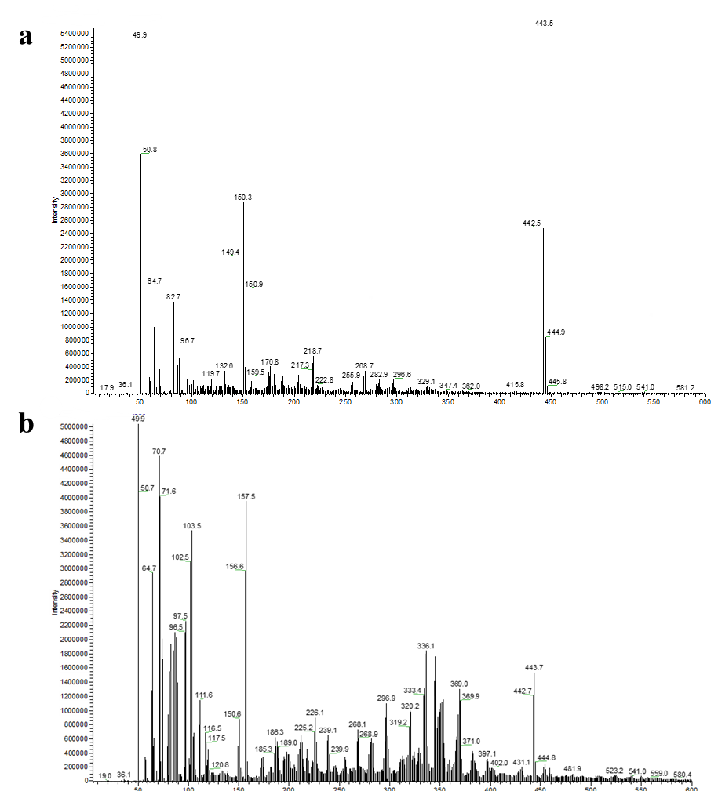
Fig. S8. Degradation Products of RhB at (a) t=0, and (b) t=60 min.
As seen in Fig. S8(a), a sharp peak is observed at the m/z point of 443.5, which belongs to the initial RhB. The intensity of this peak has decreased dramatically in Fig. S8(b), which is taken from the solution at the end of the degradation process. This decrease is due to the decomposition of the RhB structure, also, the evolution of some species with different m/z lower than 443.5 shows the presence of some intermediates in the medium. Some of the intermediates with high peak intensities are assumed to be as follows:
