SUPPLEMENTARY INFORMATION
Green synthesis of Mn-MOFs with tunable optical and structural properties through ligand functionality and framework design
M. J. Robles-Águila¹, J. A. Reyes-Avendaño², R. Silva³, J.M. Bravo-Arredondo^{1,4}*
¹ Benemérita Universidad Autónoma de Puebla, Instituto de Ciencias, Centro de Investigación en Dispositivos Semiconductores, Edificio 105 C, Boulevard 14 Sur y Av. San Claudio, Col. San Manuel, C. P. 72570, Puebla, Pue., México.
² Benemérita Universidad Autónoma de Puebla, Facultad de Ingeniería Química, Ciudad Universitaria, Av. San Claudio y 18 Sur, Col. Jardines de San Manuel, C. P. 72570, Puebla, Pue., México.
³ Benemérita Universidad Autónoma de Puebla, Instituto de Física, Ciudad Universitaria, Av. San Claudio y 18 Sur, Col. Jardines de San Manuel, C. P. 72570, Puebla, Pue., México.
⁴ Universidad Autónoma de Tlaxcala, Facultad de Ciencias Básicas, Ingeniería y Tecnología, De Apizaquito, 20 de Noviembre, 90401, Apizaco, Tlaxcala, México.

*Corresponding Author: josemanuel.bravo.a@uatx.mx

Table S1: Abbreviations, definitions and units used in this work.
Abbreviation | Definition
ATR-FTIR | Attenuated Total Reflectance –  Fourier-Transform Infrared Spectroscopy
BET | Brunauer–Emmett–Teller (surface area analysis)
BJH | Barret-Joyner-Halenda Method
DEF | Diethylformamide
DMF | Dimethylformamide
DoC | Degree of Crystallinity
DRS | Diffuse Reflectance Spectroscopy
DTA | Differential Thermal Analysis
Eg | Band Gap Energy
EDS | Energy-dispersive X-ray spectroscopy
FA | Fumaric Acid
FTIR | Fourier Transform Infrared Spectroscopy
LMCT | Ligand-to-Metal Charge Transfer
MA | Malic Acid
MOF | Metal–Organic Framework
Mn-FA | Manganese–Fumarate MOF
Mn-MA | Manganese–Malate MOF
Mn-MOFs | Manganese-based Metal–Organic Framework
Mn-SA | Manganese–Succinate MOF
Mn-TA | Manganese–Tartrate MOF
PXRD | Powder X-ray Diffraction
PL | Photoluminescence
SA | Succinic Acid
SBET | Specific Surface Area from BET
SEM | Scanning Electron Microscopy
TA | Tartaric Acid
TGA | Thermogravimetric Analysis
UV–Vis | Ultraviolet–Visible Spectroscopy
eV | Electron Volt
nm | Nanometer
nm-2 | Per Square Nanometer
Ả | Angstrom
μm | Micrometer

Table S2. MOFs synthesized with biogenic C4 dicarboxylic ligands.
Ligand | Reported MOFs  (Metal centers) | Structure Type / Properties | Reference
FA | Al, Zr, Ce, Ni, Fe | Rigid frameworks, good thermal stability, catalytic uses | [34], [35], [36], [37], [38]
SA | Zr, Fe, Co, Cu, Y, La | Flexible, biocompatible, water adsorption, catalysis | [35], [39], [40], [41], [42]
MA | Ca, Zr, Zn, Mg | Low symmetry structures, Proton conduction, H-bonded layers, | [35], [43], [44], [45], [46]
TA | Zr, La, Nd, Fe, Ce | Chiral frameworks, strong chelation, high functionalization | [43], [47], [48], [49]

Table S3. Lattice parameters (a, b, c), cell volume (V), average crystallite size from the Scherrer equation (L), dislocation density (δ), and micro-strain (ε) of pure synthetized Mn-MOFs.
Structural parameter | Mn-FA | Mn-SA | Mn-MA | Mn-TA
Crystal system | Monoclinic | Monoclinic | Triclinic | Monoclinic
a (Å) | 15.776 | 16.394 | 15.867 | 13.752
b (Å) | 12.945 | 8.498 | 12.689 | 11.413
c (Å) | 11.854 | 13.573 | 17.491 | 11.943
α (°) | --- | --- | 65.883 | ---
β (°) | 108.788 | 109.393 | 131.005 | 90.861
γ (°) | --- | --- | 145.287 | ---
V (Å³) | 2291.930 | 1783.750 | 1441.680 | 1874.250
L (nm) | 28.060 | 26.480 | 19.900 | 24.480
δ (nm⁻² × 10⁻³) | 1.270 | 1.427 | 1.668 | 2.524
ε (× 10⁻³) | 12.411 | 9.391 | 14.221 | 13.498
DoC (%) | 92.610 | 90.720 | 78.690 | 86.730

Table S4. Morphology, particle size and at.% of Mn-MOFs as-synthesized.
MOF | Morphology | Wide particle size distribution [μm] | Large particle size distribution [μm] | at% of Mn
Mn-FA | Irregular polyhedra aggregates | 0.49 ± 0.10 | 1.08 ± 0.03 | 9.87 ± 1.08
Mn-SA | Hexagonal rods | 9.78 ± 0.47 | 17.44 ± 0.53 | 10.15 ± 2.93
Mn-MA | Rounded grains | 5.11 ± 0.28 | 7.93 ± 0.08 | 8.79 ± 0.80
Mn-TA | Irregular polyhedra | 2.74 ± 0.07 | 5.52 ± 0.32 | 8.75 ± 0.98

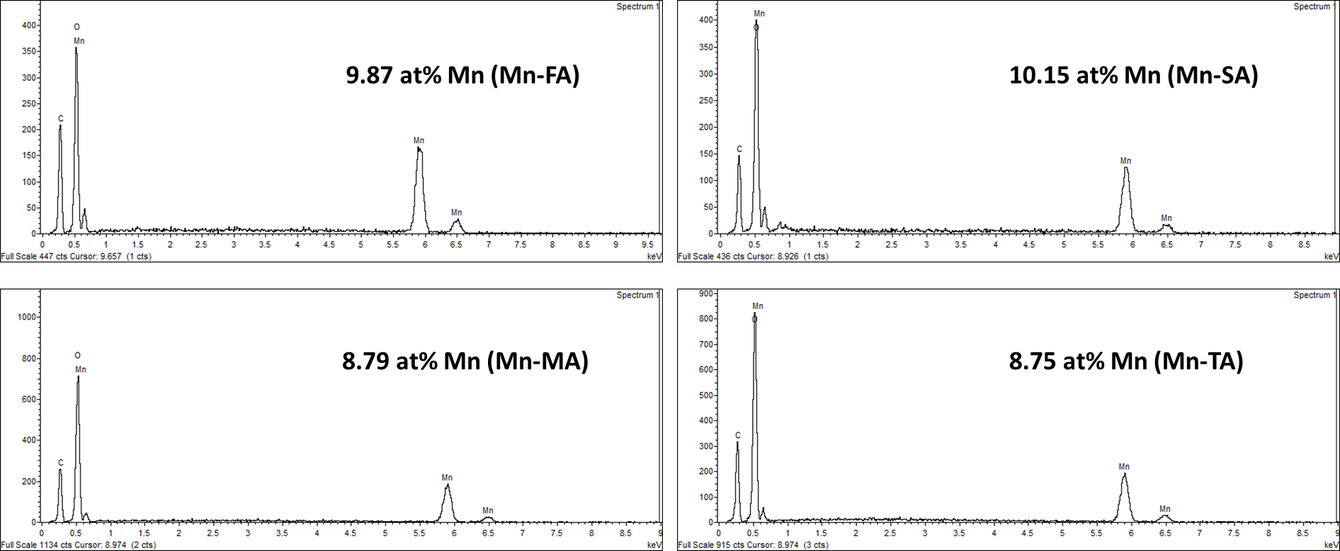
Figure S1. EDS element analysis of Mn-MOFs with at% of Mn.
Figure S2. N₂ adsorption isotherms of Mn-MOFs.
Table S5. Textural parameters of Mn-MOFs.
MOF | S_{BET} (m²/g) | V_{ads} (cm³/g) | V_{p} (cm³/g) | Average Pore Diameter (nm)
Mn-FA | 2.39 | 0.5499 | 9.93E-03 | 1.659
Mn-SA | 2.66 | 0.6116 | 2.07E-02 | 3.110
Mn-MA | 1.52 | 0.3488 | 1.13E-02 | 2.968
Mn-TA | 2.20 | 0.5047 | 1.88E-02 | 3.417

Figure S3. Pore size distribution of Mn-MOFs.

Table S6. Information summarized from TGA and DTA analysis of Mn-MOFs decomposition.
MOF | T_{onset} (°C) | T_{max} (°C) | % Total water (free, bound) | % Free Ligand | % Ligand decomposed | Residue (%) at 800 °C
Mn-FA | 350 | 530 | 1.00 | --- | 42.08 | 51.60
Mn-SA | 300 | 515 | 11.78 | 10.09 | 25.01 | 49.66
Mn-MA | 235 | 513 | 15.16 | 8.90 | 27.49 | 39.53
Mn-TA | 215 | 451 | 1.70 | --- | 55.86 | 39.70

Table S7. Information summarized from infrared analysis of Mn-MOFs.
MOF | ν_{as} (COO-) | ν_{s} (COO-) | Δν = ν_{as} - ν_{s} | Bonding mode [58]
Mn-FA | 1550 | 1358 | 192 | Monodentate
Mn-SA | 1546 | 1406 | 140 | Quelating Bidentate
Mn-MA | 1563 | 1420 | 143 | Quelating Bidentate
Mn-TA | 1579 | 1411 | 168 | Bridging Bidentate

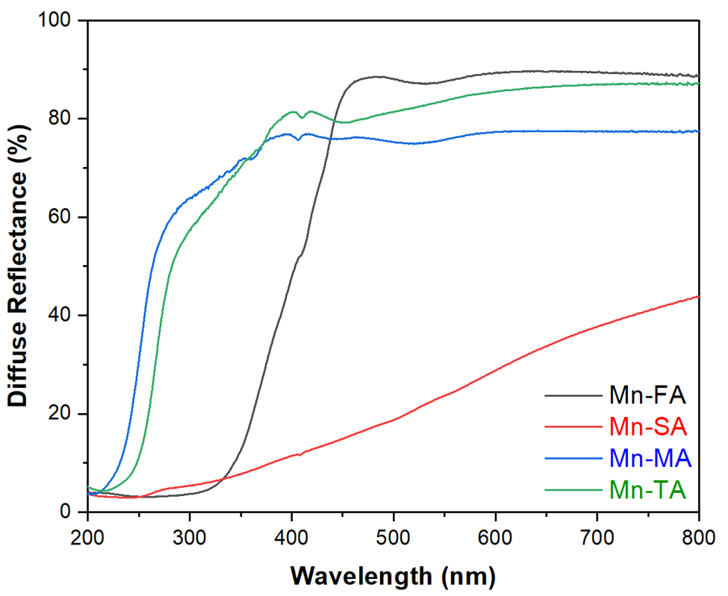

Figure S4. DRS spectra of Mn-FA (black), Mn-SA (red), Mn-MA (blue), and Mn-TA (green).

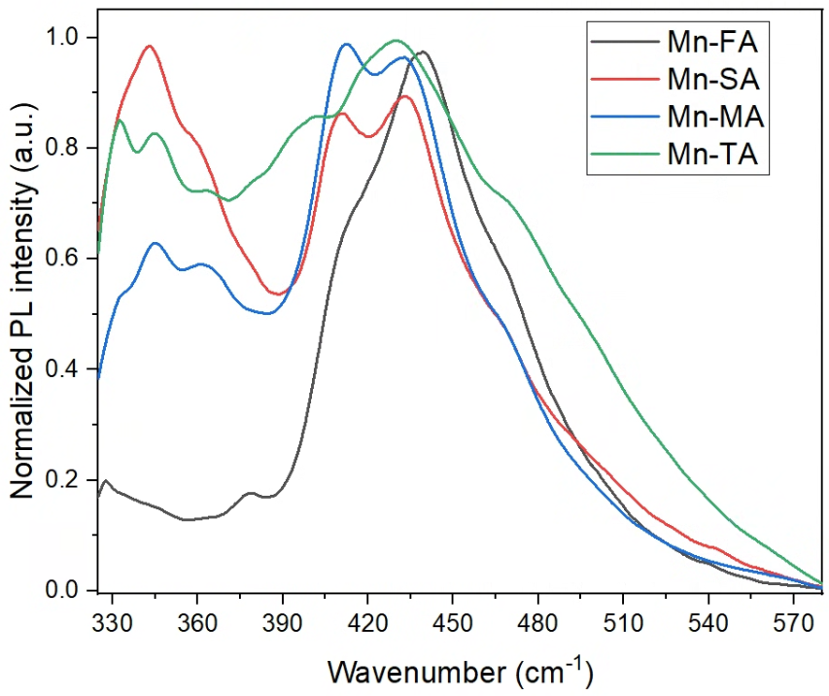

Figure S5. Normalized PL spectra of Mn-FA (black), Mn-SA (red), Mn-MA (blue), and Mn-TA (green) excited under UV light at 300 nm.

