Defect-Mediated Band Gap Narrowing in Vanadium-Doped Cerium Oxide Nanoparticles
(Chojnowski Memorial Issue)
B. Hangai¹, C. E. Macchi², G. Acero¹, A. Z. Simões¹, E. Longo³, L. S. R. Rocha⁴, L. I. Granone^{5,6}, J. R. Sambrano^{7*}, C. A. D. Mendoza⁸, D.C Amaral⁹, M. A. Ponce^{2,7,10}

¹ School of Engineering and Sciences, São Paulo State University (UNESP), Av. Ariberto Pereira da Cunha, 333 - Portal das Colinas, Postal code 12514-180, Guaratinguetá, Brazil.
² Materials Physics Institute–IFIMAT (UNCPBA) and Physics and Engineering Research Center –CIFICEN (UNCPBA-CICPBA-CONICET), Tandil, Argentina.
³ Center for Research and Development of Functional Materials, Federal University of São Carlos (UFSCar), Rodovia Washington Luis, Km 235, Postal code 13565-905, São Carlos, Brazil.
⁴ Chemical and Materials Engineering Department (DEQM), Pontifical Catholic University of Rio de Janeiro (PUC-Rio), Rua Marquês de São Vicente, 225, Gávea, Postal code 22451-900, Rio de Janeiro, Brazil.
⁵ Department of Chemistry and Biochemistry, Faculty of Exact and Natural Sciences (FCEyN), National University of Mar del Plata (UNMDP), Deán Funes 3350, Mar del Plata, Argentina.
⁶ Institute of Physical Research of Mar del Plata (IFIMAR), National University of Mar del Plata (UNMDP) and National Research Council (CONICET), Deán Funes 3350, Mar del Plata, Argentina.
⁷ Modeling and Molecular Simulation Group, São Paulo State University (UNESP), School of Sciences, Av. Eng. Luiz Edmundo Carrijo Coube, 14-01, Postal code 17033-360, Bauru, SP, Brazil.
⁸ Electrical Engineering Department (ELE), Rio de Janeiro State University (UERJ), Rua São Francisco Xavier, 524 Maracanã, Rio de Janeiro, RJ, 20550-900, Brazil.
⁹ Advanced Materials Interdisciplinary Laboratory (LIMAV), Federal University of Itajubá (UNIFEI), Itabira, MG, Brazil.
¹⁰ CISAG Center for Global Health Research, Faculty of Medicine, National University of Mar del Plata (UNMdP), Mar del Plata, Argentina.

*Corresponding author: jr.sambrano@unesp.br

Defect Structure
Table SI.1 - Characteristic positron lifetimes and their associated intensities obtained from the decomposition of PALS spectra (the numbers in parentheses indicate the statistical error of the obtained value). VM denotes the mean positron lifetime, defined as: VM = ∑I_{i}τ_{i}; with ∑I_{i} = 1
%V | τ₁  (ps) | I₁  (%) | τ₂  (ps) | I₂  (%) | VM  (ps)
0 | 191 (5) | 46 (1) | 370 (5) | 54 (1) | 287.0 (0.5)
0.5 | 216 (4) | 45 (1) | 380 (3) | 55 (1) | 309.5 (0.5)
1.0 | 227 (5) | 49 (1) | 390 (5) | 51 (1) | 309.2 (0.5)
1.5 | 218 (3) | 48 (1) | 377 (5) | 52 (1) | 300.0 (0.5)
2.0 | 207 (5) | 44 (1) | 377 (5) | 56 (1) | 302.7 (0.5)

EDS analysis
Energy Dispersive X-ray Spectroscopy (EDS), which probes a larger interaction volume within the particles, enabled the detection and semi-quantitative estimation of vanadium content. Although the analysis is subject to limitations such as peak overlap with cerium and oxygen signals, the experimentally determined compositions follow the same trend as the nominal values. The measured vanadium contents were: 0.5% (nominal) → 0.10% (experimental); 1.0% → 0.58%; 1.5% → 0.81%; and 2.0% → 1.16%. The corresponding EDS spectra and quantitative results, obtained with a JEOL JSM-6701F system, are presented below. The discrepancy between the nominal and EDS-measured vanadium concentrations can be attributed to several factors. First, EDS has intrinsic limitations for quantifying low-concentration dopants, particularly when the vanadium content is close to the detection limit, leading to significant uncertainties due to low X-ray counting statistics and matrix effects. Second, vanadium ions may be non-uniformly distributed within the CeO₂ particles, leading to local compositional variations that are not fully represented by the limited sampling volume of EDS. In addition, partial incorporation of V ions into the CeO₂ lattice through substitutional defects can reduce the apparent vanadium signal because the dopant becomes highly dispersed at the atomic scale. Finally, a fraction of vanadium may segregate as highly dispersed surface species or amorphous phases, beyond the spatial and compositional resolution of EDS, resulting in lower measured concentrations than the nominal values.

Figure SI.1 – EDS spectra indicating the experimental doping levels of each sample (a-d).

a) Sample doped with 0.5 at. % vanadium:
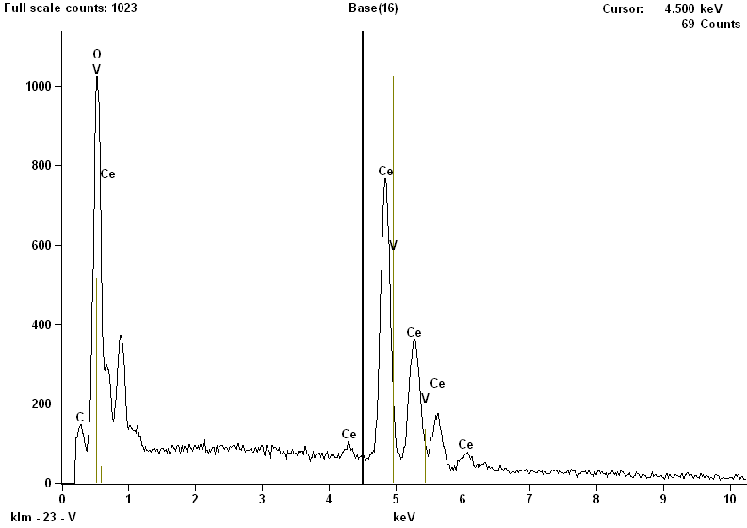
Live Time: 30.0 sec.
Acc. Voltage: 15.0 kV Take Off Angle: 25.5 deg.
Quantitative Results
Element  Line | Net  Counts | Weight % | Atom %
C K | 994 | 1.89 | 7.17
O K | 9642 | 24.18 | 68.75
V K | 43 | 0.11 | 0.10
V L | 0 | --- | ---
Ce L | 21176 | 73.82 | 23.97
Ce M | 6093 | --- | ---
Total |  | 100.00 | 100.00

b) Sample doped with 1.0 at. % vanadium:
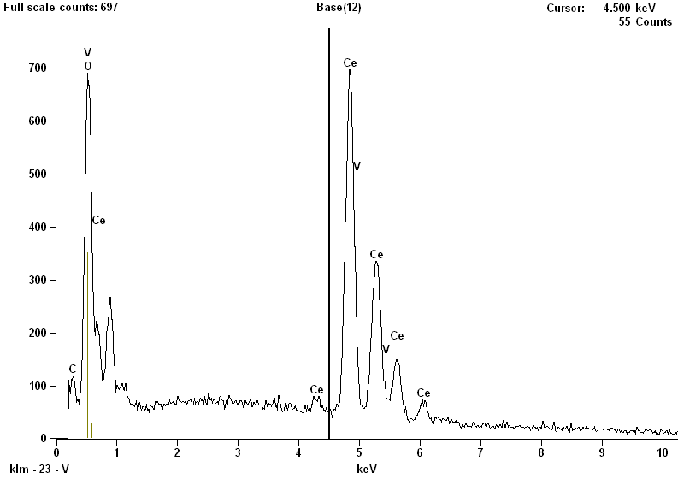
Live Time: 30.0 sec.
Acc. Voltage: 15.0 kV Take Off Angle: 25.1 deg.
Quantitative Results
Element  Line | Net  Counts | Weight % | Atom %
C K | 719 | 1.69 | 7.24
O K | 6152 | 19.74 | 63.53
V K | 177 | 0.58 | 0.58
V L | 0 | --- | ---
Ce L | 18530 | 77.99 | 28.65
Ce M | 3946 | --- | ---
Total |  | 100.00 | 100.00

c) Sample doped with 1.5 at. % vanadium:
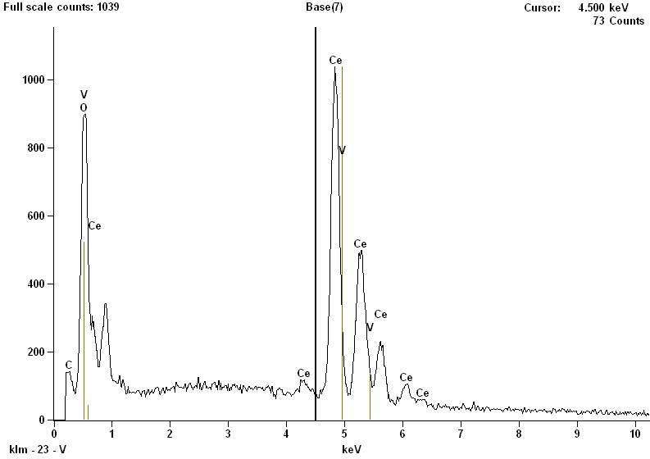
Live Time: 30.0 sec.
Acc. Voltage: 15.0 kV Take Off Angle: 25.1 deg.
Quantitative Results
Element  Line | Net  Counts | Weight % | Atom %
C K | 901 | 1.38 | 6.12
O K | 9027 | 19.00 | 63.15
V K | 367 | 0.78 | 0.81
V L | 0 | --- | ---
Ce L | 28769 | 78.84 | 29.92
Ce M | 5990 | --- | ---
Total |  | 100.00 | 100.00

d) Sample doped with 2.0 at. % vanadium:
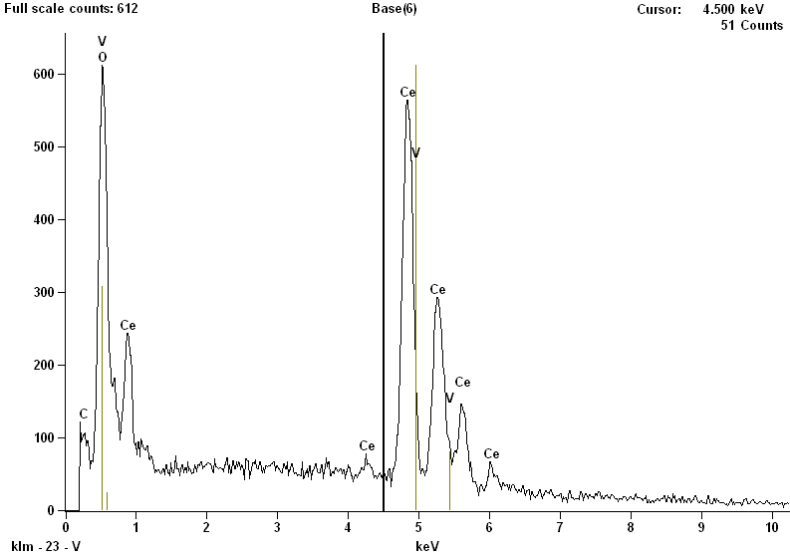
Live Time: 30.0 sec.
Acc. Voltage: 15.0 kV Take Off Angle: 25.1 deg.
Quantitative Results
Element  Line | Net  Counts | Weight % | Atom %
C K | 653 | 1.72 | 7.20
O K | 5555 | 20.34 | 64.04
V K | 321 | 1.17 | 1.16
V L | 0 | --- | ---
Ce L | 16327 | 76.77 | 27.60
Ce M | 4441 | --- | ---
Total |  | 100.00 | 100.00

