Supporting material
Figures

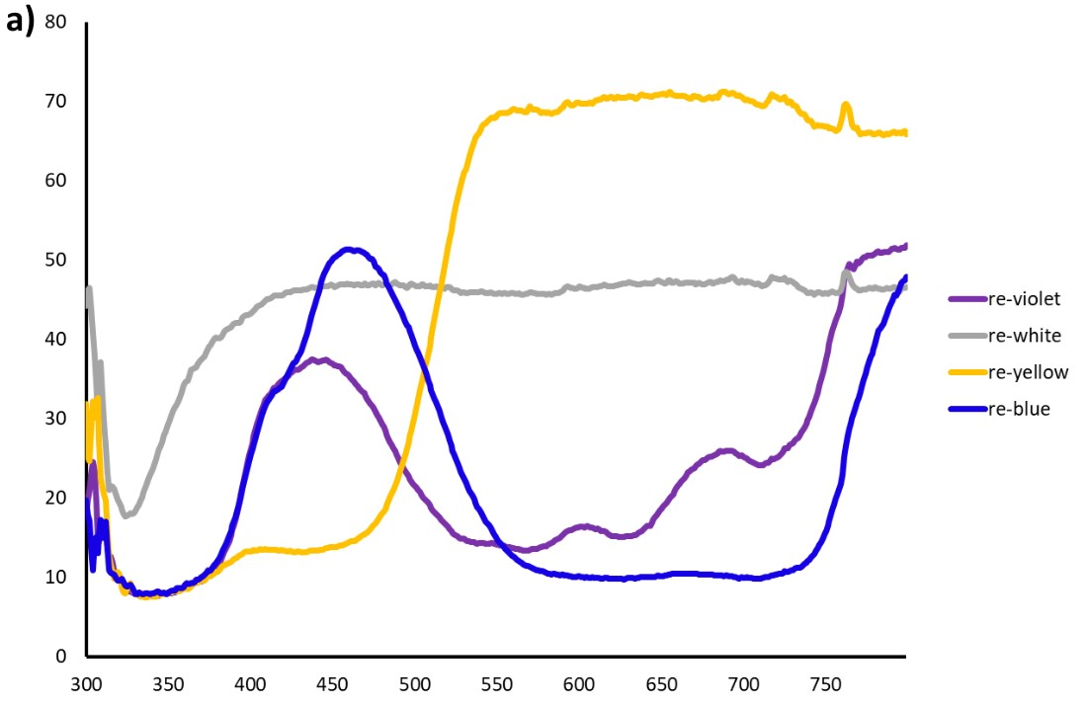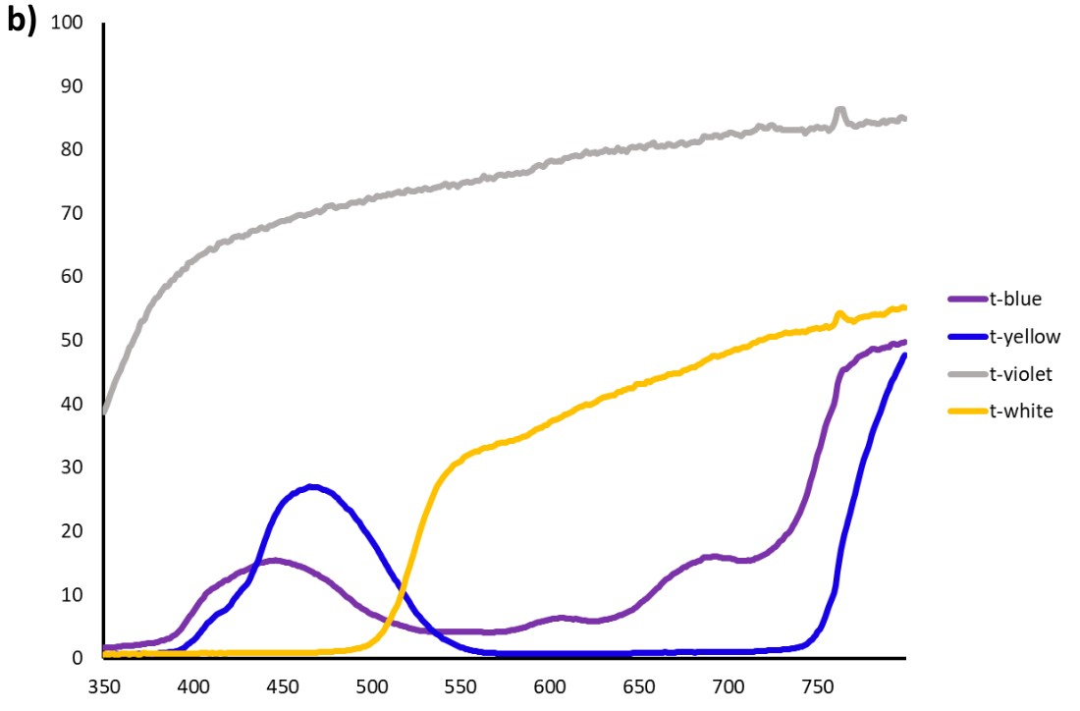
Fig. S1 a) Light reflectance spectrum and b) transmission of the different colors used for the vanes of the traps.
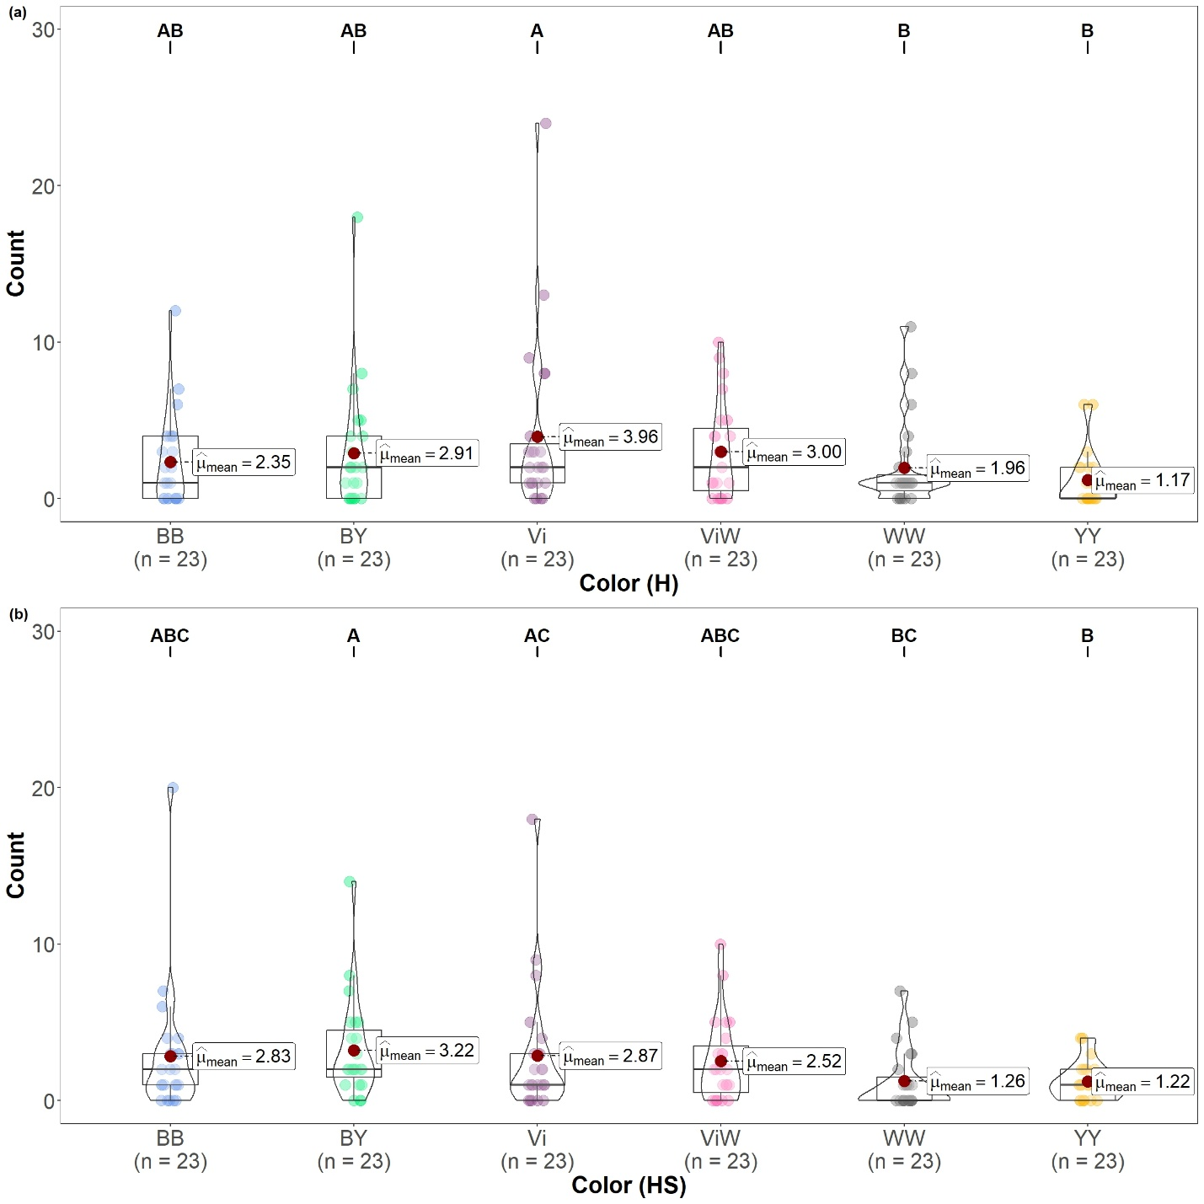

Fig. S2 Effectiveness of color traps in capturing bees. The number of bees collected (Count) by each individual vane trap is shown for the a) Haselberg habitat (H) and b) Haselberg-Slope habitat (HS) over the course of 23 weeks (n=26). Each violin plot presents the mean number of the collected bee count for that specific trap. Post-hoc comparisons from the Bayesian model are summarized by the letters above each group, groups sharing at least one letter are not significantly different.

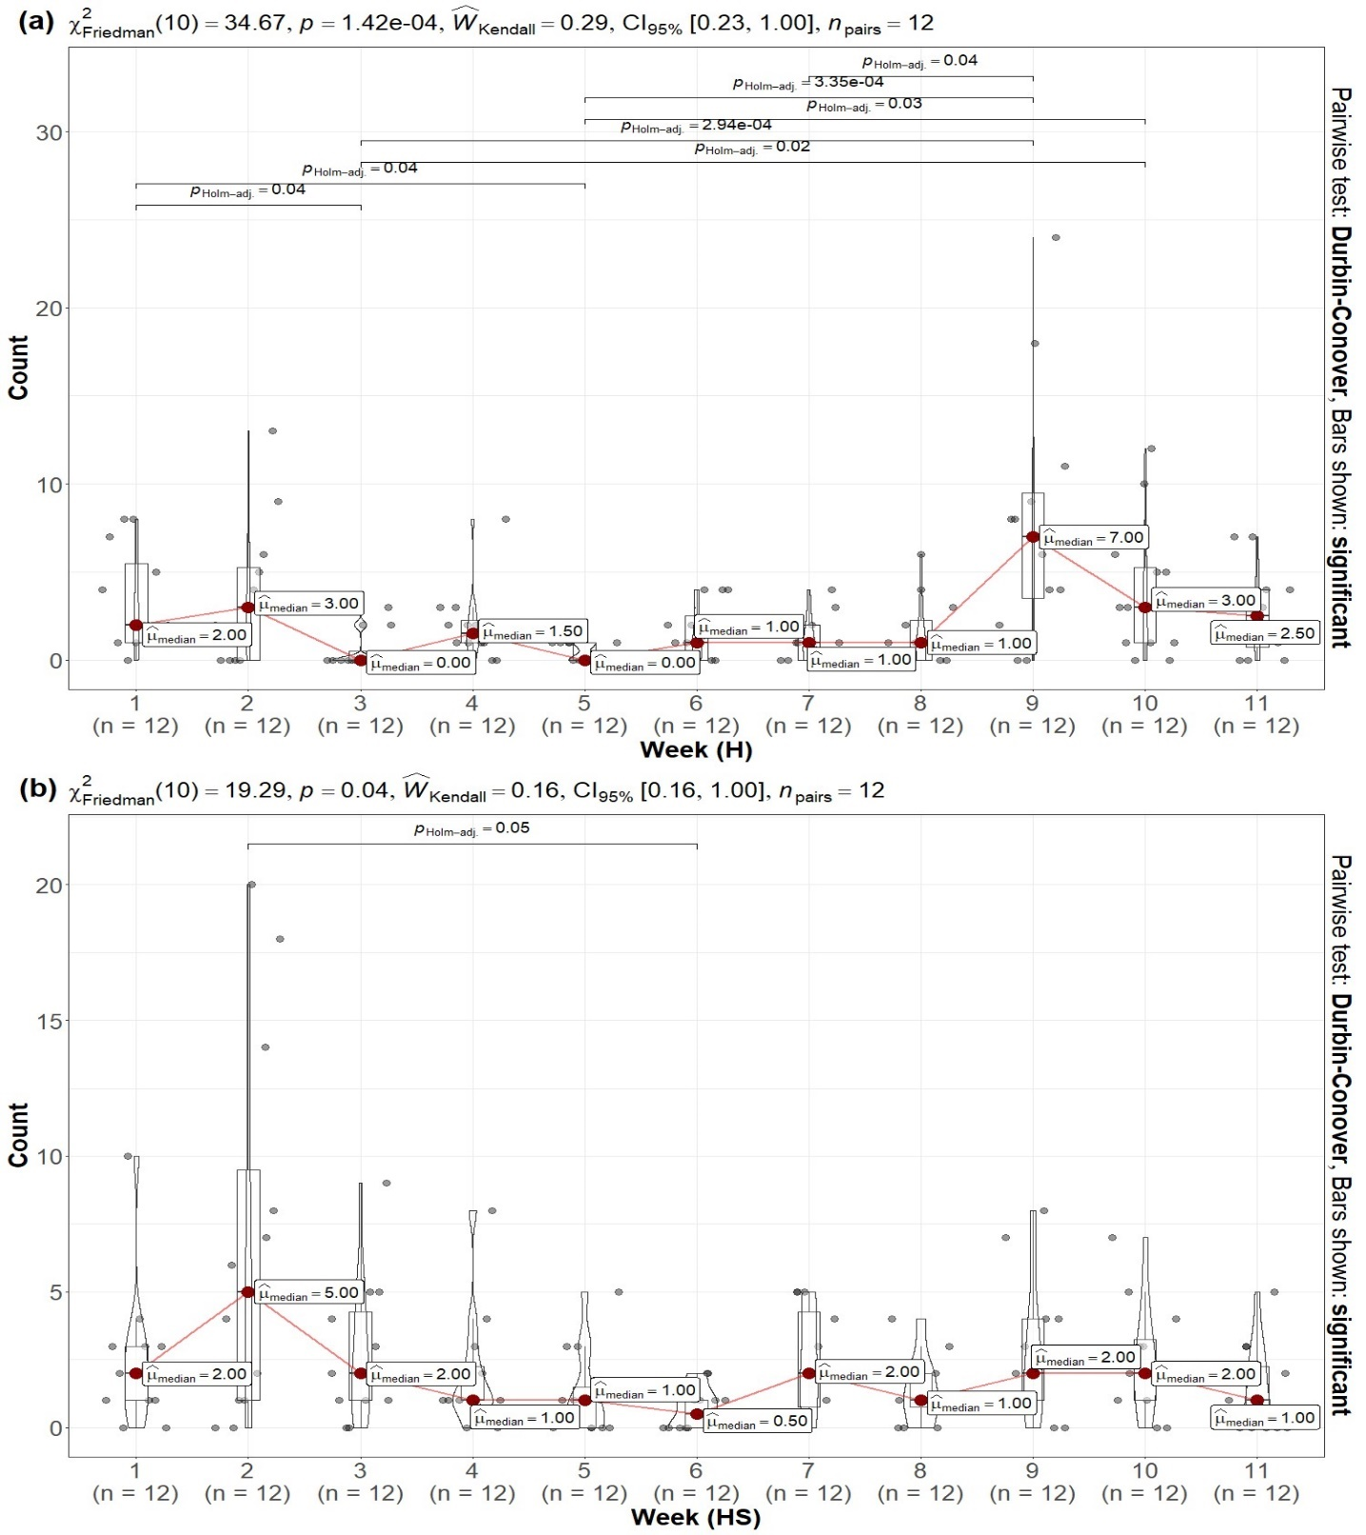Fig. S3 Overview of the overall performance during biweekly collecting intervals. The number of bees collected (Count) by each individual vane trap from the a) Haselberg habitat (H) and b) Haselberg-Slope habitat is depicted for each two-week interval (n=24). Each violin plot displays the median of the collected bee count for that specific period. The top section of the graph displays the Friedman statistics, revealing the p-value for the entire analysis and the Kendall coefficient of concordance along with 95% confidence intervals. These intervals help determine the effect size of the model. Brackets on the plot show Holm adjusted significant differences between week periods, determined using the pairwise test Durbin-Conover pairwise.
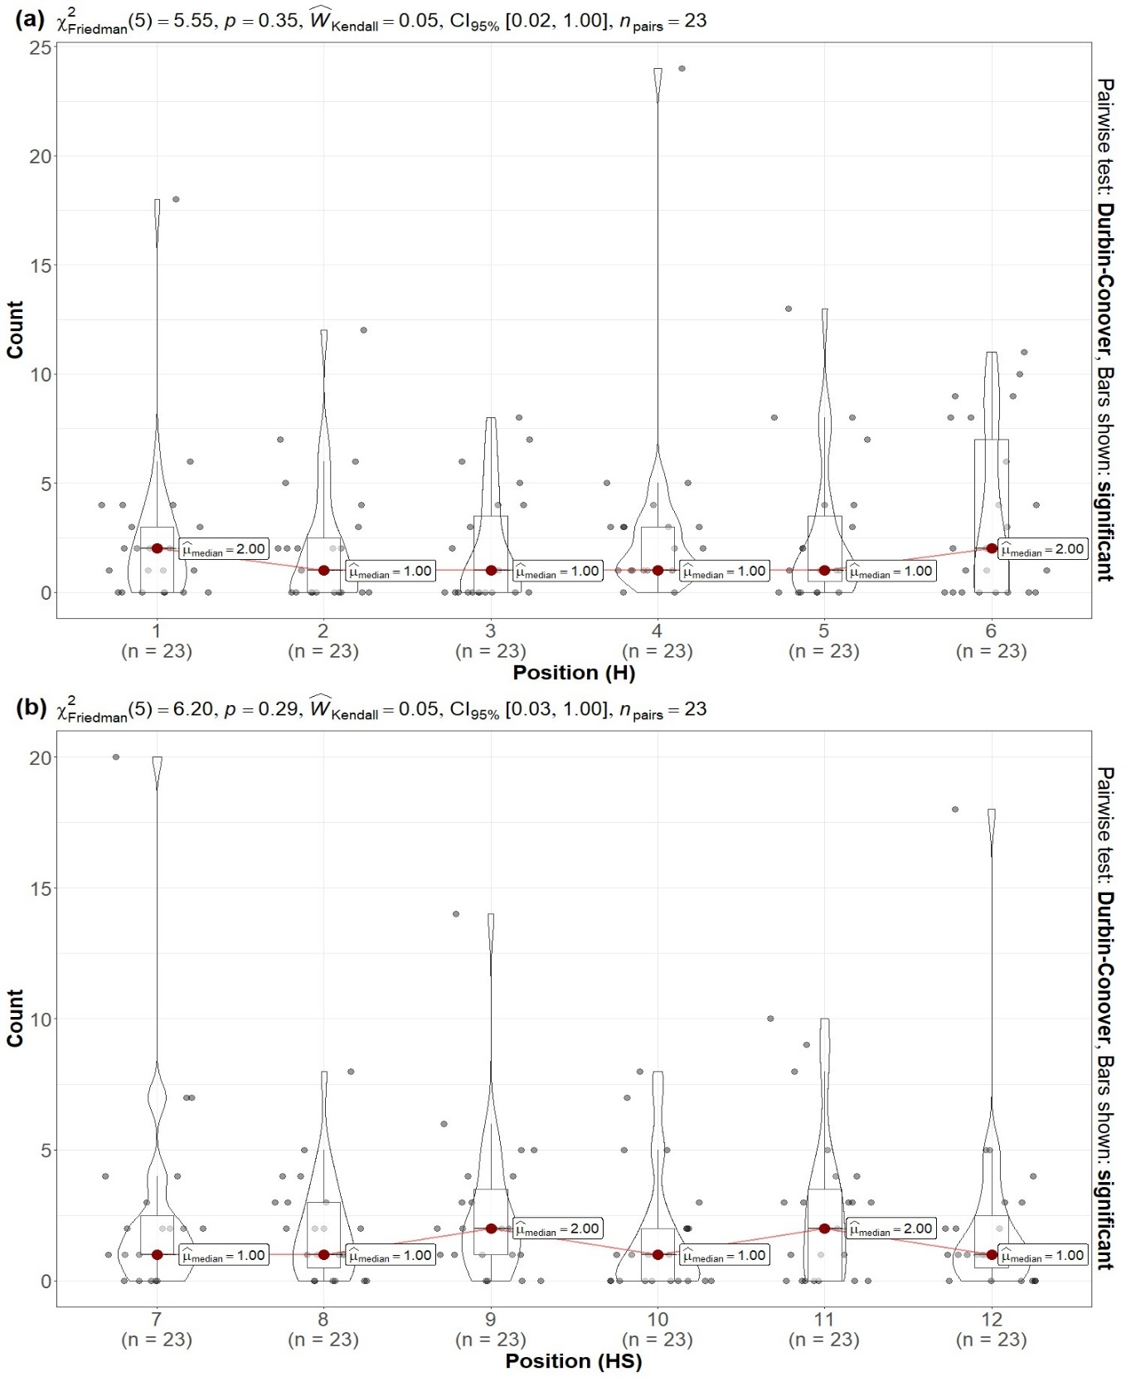
Fig. S4 Overview of the overall performance of each trap position in the a) Haselberg habitat (H) and b) Haselberg-Slope habitat (HS). The number of bees collected (Count) by each individual vane trap is depicted for each position during a 23-week period (n=23). Each violin plot displays the median of the collected bee count for that specific position. The top section of the graph displays the Friedman statistics, revealing the p-value for the entire analysis and the Kendall coefficient of concordance along with 95% confidence intervals. There was no significant result between positions, determined using the pairwise test Durbin-Conover pairwise.
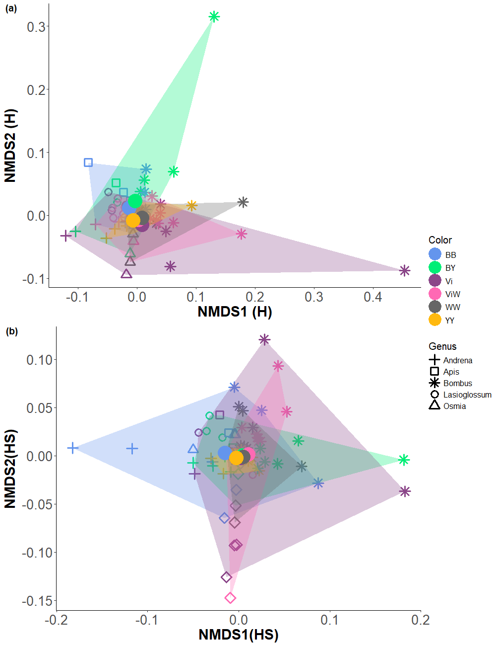
Fig. S5 Two-dimensional non-metric multidimensional scaling ordination of bee communities collected with six different color trap types from a) Haselberg habitat b) Haselberg-Slope habitat, using Bray-Curtis dissimilarities (Stress: H=0.13, HS=0. 14). The color dots represent the different color traps, and the shapes represent the main genus of bees found in the traps.

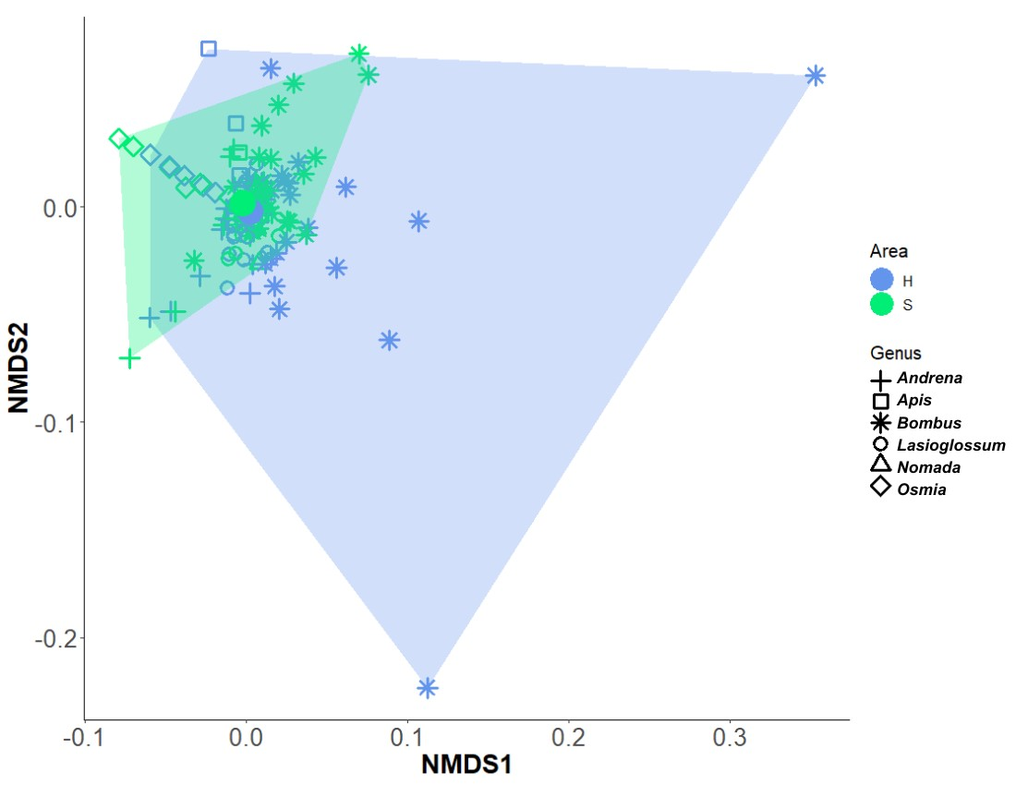
Fig. S6 Two-dimensional non-metric multidimensional scaling ordination of bee communities collected by the two habitats(H+HS), using Bray-Curtis dissimilarities (Stress: 0. 13). The color dots represent the different color traps, and the shapes represent the main genus of bees found in the traps.

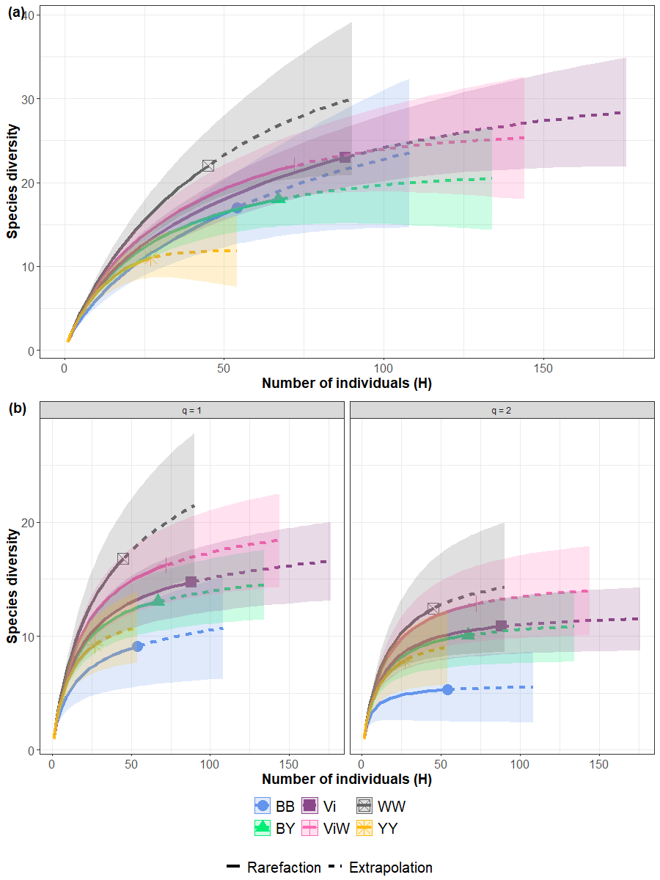
Fig. S7 Haselberg: Sample-size-dependent Hill´s numbers. a) Species richness (q=0), (b) Shannon diversity (q=1) and Simpson diversity (q=2) curves depicting rarefaction (solid line segment) and extrapolation (dotted line segments) sampling, accompanied by 95% confidence intervals (bootstrap 100 repetitions). Showcase the diversity of six different color trap combinations at H habitat. Each sample (color trap) is represented by one of six unique shapes.
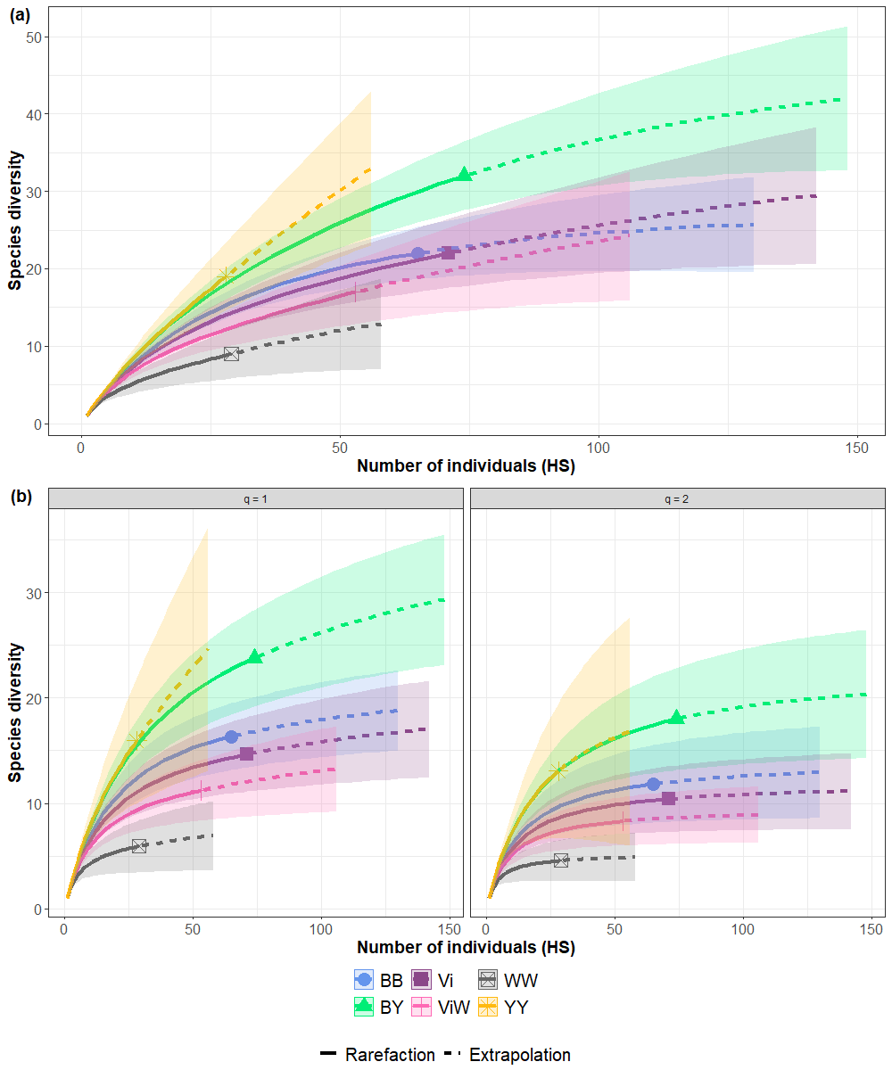
Fig. S8 Haselberg-slope: Sample-size-dependent Hill´s numbers. a) Species richness (q=0), (b) Shannon diversity (q=1) and Simpson diversity (q=2) curves depicting rarefaction (solid line segment) and extrapolation (dotted line segments) sampling, accompanied by 95% confidence intervals (bootstrap 100 repetitions). Each sample (color trap) is represented by one of six unique shapes.

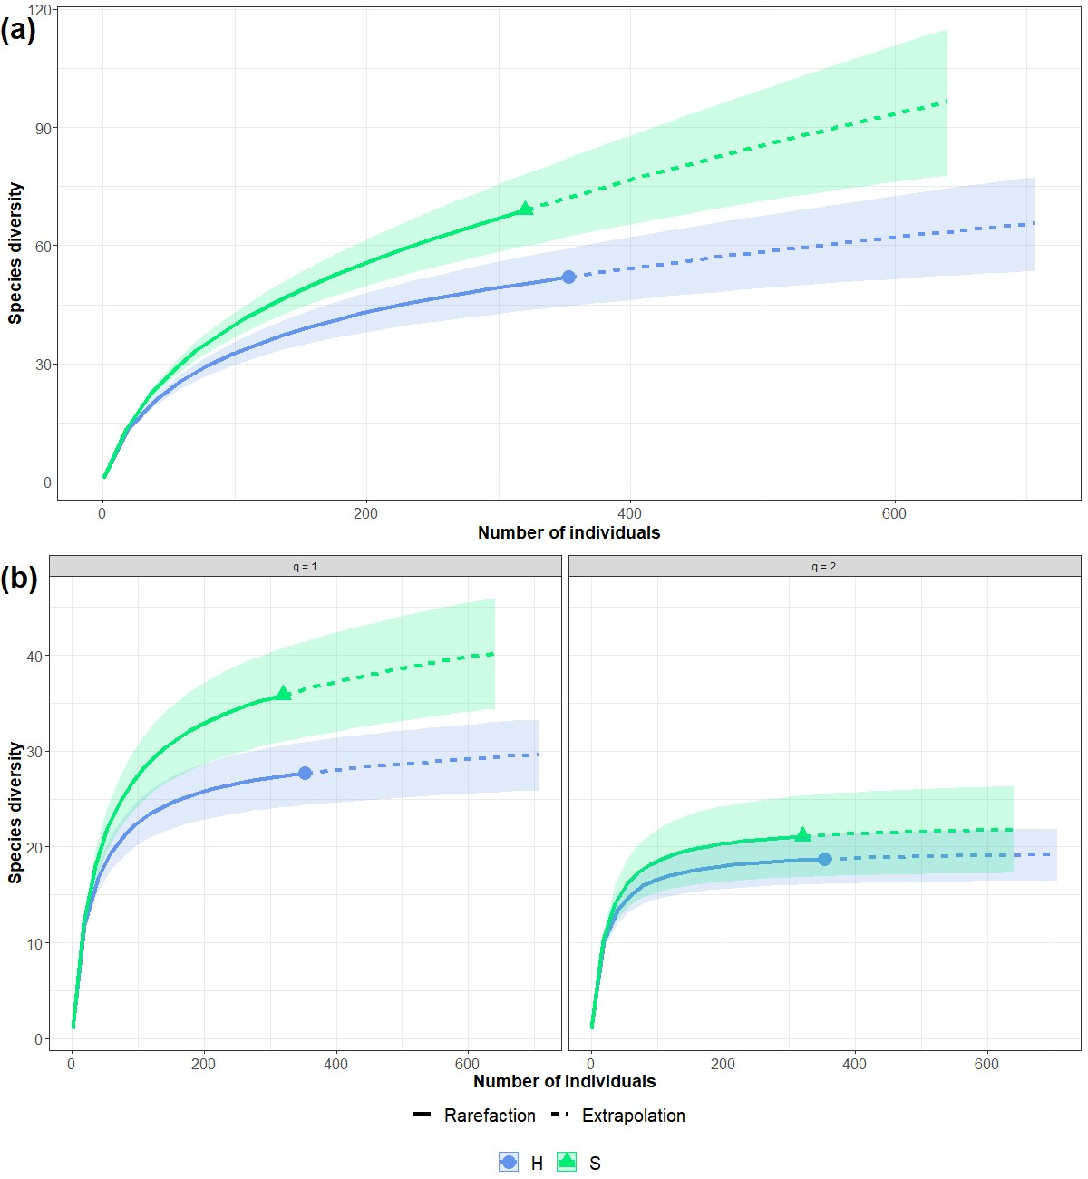
Fig. S9 Both habitats: Sample-size-dependent Hill´s numbers. a) Species richness (q=0), (b) Shannon diversity (q=1) and Simpson diversity (q=2) curves depicting rarefaction (solid line segment) and extrapolation (dotted line segments) sampling, accompanied by 95% confidence intervals (bootstrap 100 repetitions). Each sample (color trap) is represented by one of six unique shapes.

Tables

Table S1. Coordinates of trap positions of the Haselberg habitats and Haselberg-Slope habitats.

Position | Coordinates | Elevation
Haselberg 1 | 50.91888 N, 11.53122 E | 374 m
Haselberg 2 | 50.91898 N, 11.53117 E | 370 m
Haselberg 3 | 50.91913 N, 11.53112 E | 371 m
Haselberg 4 | 50.91925 N, 11.53097 E | 369 m
Haselberg 5 | 50.91932 N, 11.53093 E | 364 m
Haselberg 6 | 50.91939 N, 11.53089 E | 364 m
Has-Slope 7 | 50.91831 N, 11.52873 E | 350 m
Has-Slope 8 | 50.91824 N, 11.52887 E | 352 m
Has-Slope 9 | 50.91823 N, 11.52914 E | 351 m
Has-Slope 10 | 50.91820 N, 11.52935 E | 351 m
Has-Slope 11 | 50.91806 N, 11.52949 E | 349 m
Has-Slope 12 | 50.91801 N, 11.52962 E | 351 m

Table S2. Plant list of the Haselberg habitats and Haselberg-Slope habitats. See Excel file attached

Table S3. Total species number per trap, position, habitats, and week. See excel attached

Table S4. Significant differences between color traps. Post-hoc (emmeans function with tukey adjustment). In Bayesian models, significance is assessed with 95% HPD intervals: if the interval includes 1, there is no clear difference; if it lies entirely above or below 1, the difference is significant.
Significant contrasts | Ratio | 95% HPD interval | Observations
Total
BB > YY | 2.17 | 1.23 – 3.27
BY >WW | 1.82 | 1.06 – 2.78
BY > YY | 2.46 | 1.47 – 3.74
Vi > WW | 2.06 | 1.21 – 3.03
Vi >YY | 2.77 | 1.57 – 4.30
ViW > YY | 2.23 | 1.20 – 3.46
H site
Vi > WW | 1.92 | 0.95 – 3.32 | borderline (lower bound ~1)
Vi > YY | 2.94 | 0.99 – 6.32 | borderline (lower bound ~1)
HS site
BY > WW | 2.54 | 1.05 – 4.78
BY > YY | 2.26 | 1.11 – 3.97
Vi > WW | 2.38 | 1.20 – 4.21

Table S5. Multilevel pattern analysis showing species that are strongly associated with a specific color trap.

Site | Trap Color | Species | stat | p-value
H | BY | Bombus bohemicus (Seidl, 1837) | 0.477 | 0.0002
H | BY | Bombus barbutellus (Kirby, 1802) | 0.369 | 0.019
H | ViW | Lasioglossum lativentre (Schenck, 1853) | 0.333 | 0.0386
H | WW | Bombus soorensis (Fabricius, 1777) | 0.352 | 0.0241
H | WW | Osmia bicornis (Linnaeus, 1758) | 0.316 | 0.0322
H | YY | Andrena nitida (Müller, 1776) | 0.577 | 0.0001
H | YY | Andrena gravida (Imhoff, 1832) | 0.408 | 0.0087
H | YY | Andrena helvola (Linnaeus, 1758) | 0.386 | 0.0223
H | BB+BY | Apis mellifera (Linnaeus, 1758) | 0.446 | 0.0128
HS | BB | Andrena cineraria (Linnaeus, 1758) | 0.322 | 0.0322
HS | BB | Nomada panzeri (Lepeletier, 1841) | 0.322 | 0.0195
HS | BY | Bombus humilis (Illiger, 1806) | 0.455 | 0.0009
HS | BY | Andrena helvola (Linnaeus, 1758) | 0.322 | 0.021
HS | ViW | Bombus hypnorum (Linnaeus, 1758) | 0.473 | 0.0002
HS | ViW | Bombus jonellus (Kirby, 1802) | 0.426 | 0.0009
HS | ViW | Bombus pascuorum (Scopoli, 1763) | 0.391 | 0.0036
HS | WW | Bombus terrestris (Linnaeus, 1758) | 0.528 | 0.0001
HS | WW | Bombus rupestris (Fabricius, 1793) | 0.4 | 0.0014
HS | BB+BY | Andrena minutula (Kirby, 1802) | 0.371 | 0.013
HS | BB+YY | Andrena bicolor (Fabricius, 1775) | 0.418 | 0.0046
HS | BY+YY | Lasioglossum calceatum (Scopoli, 1763) | 0.334 | 0.0427

Table S6. Multilevel pattern analysis showing species that are strongly associated with a specific habitat.

Habitats | Species | stat | p-value
H | Bombus campestris (Panzer, 1801) | 0.245 | 0.0026
H | Andrena helvola (Linnaeus, 1758) | 0.235 | 0.0423
H | Lasioglossum laticeps (Schenck, 1869) | 0.229 | 0.0049
H | Bombus bohemicus (Seidl, 1837) | 0.194 | 0.0234
H | Bombus lucorum (Linnaeus, 1761) | 0.194 | 0.0215
HS | Bombus hypnorum (Linnaeus, 1758) | 0.218 | 0.0161
HS | Bombus humilis (Illiger, 1806) | 0.202 | 0.0297
HS | Nomada rupicornis (Linnaeus,1758) | 0.202 | 0.0303

Table S7. Bee diversity pairwise comparisons. See excel attached

Table S8. Observed and estimated number of species of H and HS according to species richness (q=0), Shannon diversity (q=1) and Simpson diversity (q=2) of the six different color trap combination. n is the total amount of individual observations; sample coverage is a is a metric used to measure the completeness of a sample.

Habitats | Trap color | n | Sample coverage | Observed sp. | Estimated q=0 | Estimated q=1 | Estimated q=2
H | BB | 54 | 0.84 | 17 | 30 | 12 | 6
H | BY | 67 | 0.93 | 18 | 21 | 15 | 12
H | Vi | 88 | 0.90 | 23 | 31 | 18 | 12
H | ViW | 72 | 0.91 | 22 | 26 | 20 | 15
H | WW | 45 | 0.74 | 22 | 36 | 26 | 17
H | YY | 27 | 0.90 | 11 | 12 | 12 | 11
HS | BB | 65 | 0.89 | 22 | 27 | 21 | 14
HS | BY | 74 | 0.79 | 32 | 48 | 34 | 24
HS | Vi | 71 | 0.86 | 22 | 38 | 19 | 12
HS | ViW | 53 | 0.83 | 17 | 37 | 16 | 10
HS | WW | 29 | 0.83 | 9 | 19 | 8 | 5
HS | YY | 28 | 0.47 | 19 | 127 | 60 | 24

Table S9. Observed and estimated number of species according to species richness (q=0), Shannon diversity (q=1) and Simpson diversity (q=2) of the two habitats H and HS. n is the total amount of individual observations; sample coverage is a is a metric used to measure the completeness of a sample.

Trap color | n | Sample coverage | Observed sp. | Estimated q=0 | Estimated q=1 | Estimated q=2
H | 65 | 0.9519 | 52 | 88.02266 | 31.31869 | 19.69816
S | 74 | 0.9001 | 69 | 171.08 | 45.41911 | 22.52427

