Supplementary Figure S1
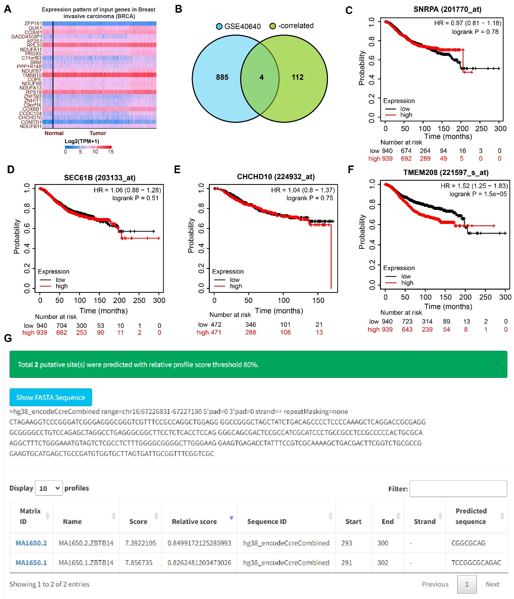
Supplementary Figure S1 The expression and prognostic value of TMEM208 in online algorithms. A, The top 25 genes negatively correlated with ZBTB14 were downloaded from the UALCAN database (ranked by the negative correlation coefficients). B, Genes negatively correlated with ZBTB14 expression were intersected with the differentially expressed genes (adj. p. < 0.05) in the GSE40640 dataset on Jvenn. Survival prognostic significance of SNRPA (C), SEC61B (D), CHCHD10 (E), and TMEM208 (F) in BC was analyzed by Kaplan-Meier Plotter. G, Prediction of ZBTB14 binding in the TMEM208 promoter region (chr:67226831-67227180) by the ChIP-seq database in JASPAR.

