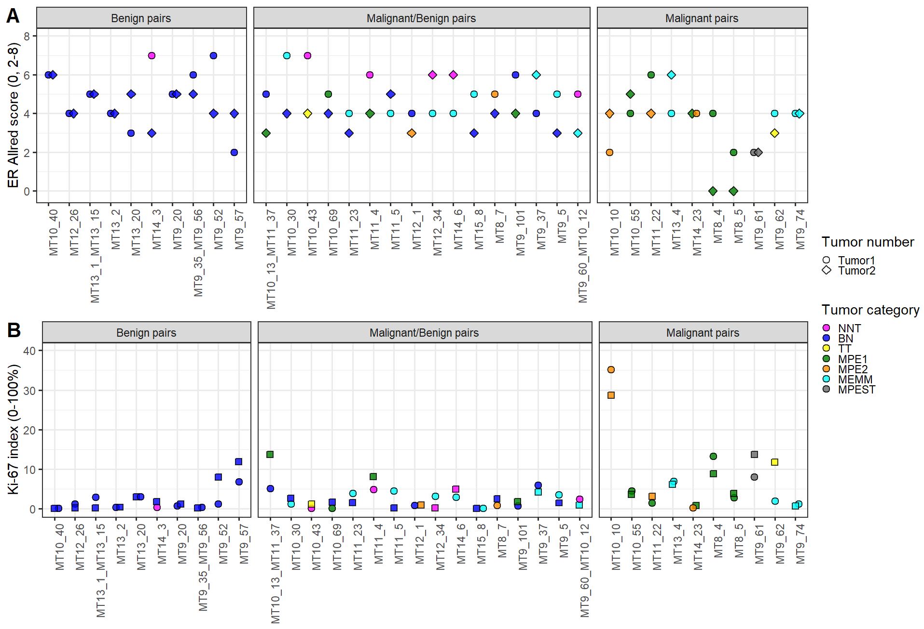
Suppl. Fig. 1 (A) ER Allred score and (B) Ki-67 index for the two tumors in each dog. Dog ID is shown on the x-axis and ER Allred score (A), Ki-67 index (B) on the y-axis. Each tumor-value is indicated by either a point (tumor 1) or a diamond (tumor 2) and colored by tumor category: Non-neoplastic tumors (NNT), Benign neoplasia (BN), Transitional tumors (TT), Malignant purely epithelial tumors with tubular formations (MPE1), Malignant purely epithelial tumors with loss of tubular formation and anaplasia (MPE2), Malignant epithelial tumors with myoepithelial and mesenchymal components (MEMM), Malignant purely epithelial tumors, special types (MPEST).
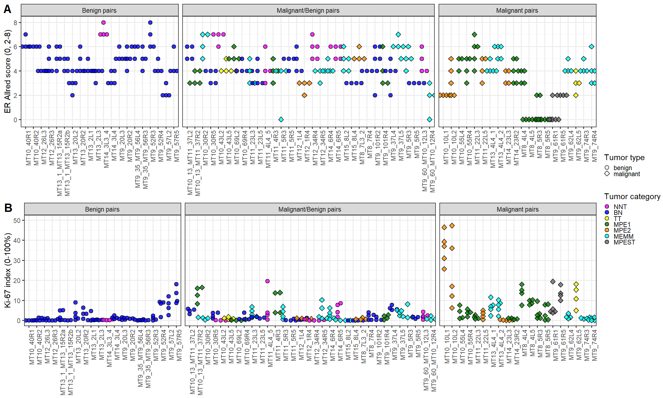
Suppl. Fig. 2 Intratumoral variations for ER Allred score and Ki-67 index. (A) ER Allred score and (B) Ki-67 index for the 3-5 regions of interest (ROIs) for the 72 tumors. Tumor ID on the x-axis and ER Allred score (A), Ki-67 index (B) on the y-axis. Each ROI value is indicated by a point. Form (point/diamond) indicates tumor type (benign/malignant) and color indicates tumor category: Non-neoplastic tumors (NNT), Benign neoplasia (BN), Transitional tumors (TT), Malignant purely epithelial tumors with tubular formations (MPE1), Malignant purely epithelial tumors with loss of tubular formation and anaplasia (MPE2), Malignant epithelial tumors with myoepithelial and mesenchymal components (MEMM), Malignant purely epithelial tumors, special types (MPEST).

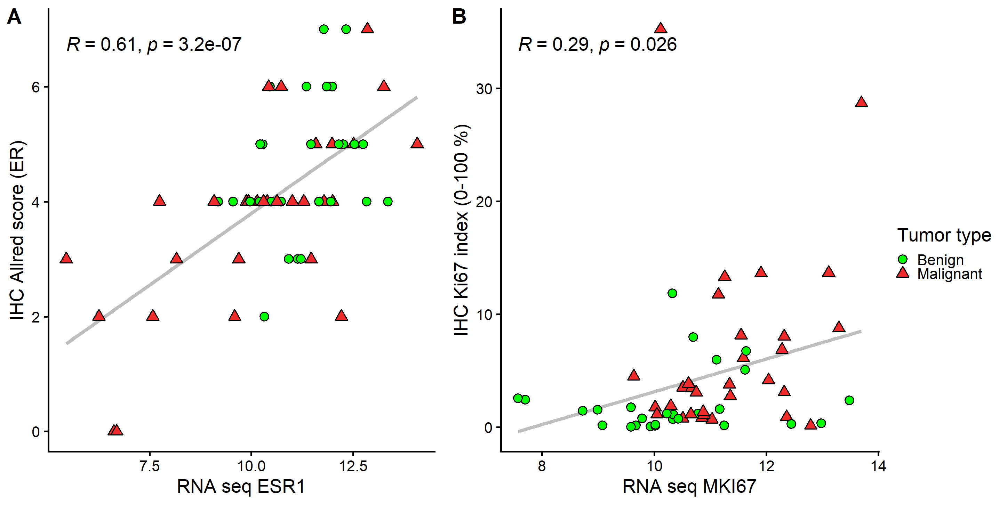
Suppl. Fig. 3 Correlation between ER and KI-67 protein detected by IHC and gene expression. There was a high correlation between gene expression and IHC for (A) ER Allred score, while only weak for (B) Ki-67. ESR1 gene expression on the x-axis and ER Allred score on the y-axis (A). MKI67 gene expression on the x-axis and Ki-67 index on the y-axis (B). Pearson’s correlation coefficient and p-values are indicated above. Tumor type is indicated by a red triangle (malignant) or a green point (benign).

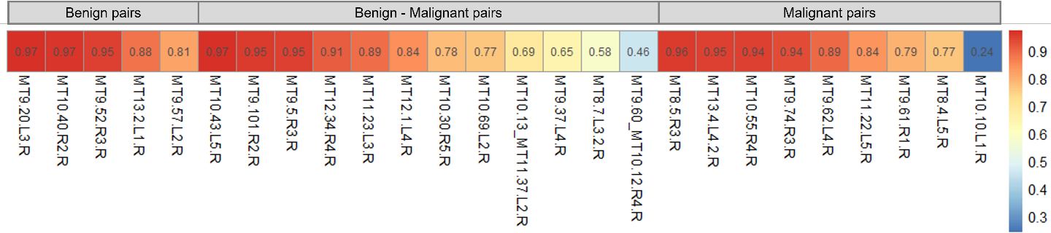
Suppl. Fig. 4 Based on gene expression of PAM50 genes, Pearson correlation was calculated between the two tumors in 26 tumor pairs. Tumor pairs are grouped based on tumor type (benign-benign, malignant-benign and malignant-malignant). Color indicates correlation coefficient which is also shown.

