Online Resource 1:

Supplementary Material

Evolution and drivers of long-distance vocal communication in mammals
Walker & Rogers

Supplementary Materials and Methods
Figure S1
Tables S1-12

Supplementary Materials and Methods – further notes

Data search and extraction

Literature search
We used the following Boolean search string to search for any papers related to animal sound propagation distance: “(long distanc* OR animal communication) AND (home rang* OR territor* OR spatial*) AND NOT (genome* OR geology OR soil OR food OR transport* OR agricultur* OR hygien* OR molecular biology)”. These results were then uploaded to Rayyan meta-analysis software (Ouzzani et al. 2016) where we initially pilot tested 100 abstracts to tailor Rayyan to our abstract database, before screening commenced on results from the WoS search (n = 3338 articles) (Fig. 2; n = 103 species). At the time of searching, Rayyan was not AI powered, but has since introduced new AI tools.

We used the following search string to find vocal information for each species both opportunistically and to achieve taxonomic/ecological diversity in the WoS, replacing “genus_species” with the name of the species: “TS=(genus_species) AND TS=("sound pressure level*" OR "source level*" OR "animal* communication" OR "vocal*" OR "spl")”. All results for each species were downloaded and we extracted call type and maximal propagation distance to build our dataset. We backward- and forward-searched within paper references using the WoS Citation Tool to further supplement any missing species information.

Body mass: Body mass (Log₁₀ kilograms) was used to account for the variance from differences in species body size. We derived 53 species body masses from Jones et al. (2009). Forty-eight of the remaining species came from Tucker et al. (2014). The one species, Chlorocebus pygerythrus, not available in these compiled datasets was found in Lubbe et al. (2014).

Home range: Home range (Log₁₀ kilometers²) was used to account for the variance from differences in size of species area use. Of the 103 species, the annual home ranges of 30 species were taken from Jones et al. (2009), 41 species from Tucker et al. (2014), and 32 species from the literature. For six aquatic species (Balaenoptera acutorostrata, Balaenoptera physalus, Erignathus barbatus, Globicephala melas, Lagenorhynchus obscurus, and Phoca groenlandica) where the home range value was not reported in-text, we extracted 95% kernel density estimate (KDE) home ranges from figures in the literature (Online Resource 2) using WebPlotDigitizer (https://automeris.io/WebPlotDigitizer/).

For a further five aquatic species (Delphinus delphis, Erignathus barbatus, Eubalaena glacialis, Stenella attenuata, and Feresa attenuata) where home ranges were not reported in-text and a KDE home range was not depicted in figures, a KDE home range could not be predicted. This was because isopleth information (i.e., the environment around the home ranges) did not exist – which is required for accurate KDE home range estimates. If isopleth information is not used for KDE home ranges (especially for those in aquatic systems), the KDE method over-estimates home range values because it includes areas which are not accessible by the animal being tracked (Boyle 2021). Consequently, we estimated home ranges for these species as 95% minimum convex polygons (MCP) using the mcp function of the adehabitatHR package (Calenge 2011) in R (Team 2013). We extracted location point data for the MCP home ranges from figures in the literature (Online Resource 2) via WebPlotDigitizer. Any differences in these home range values in subsequent analyses were accounted for because the home range variable was Log₁₀ transformed. The Log₁₀ transformation smooths small deviations between data points and instead shows magnitude changes. As MCP and KDE home range values are relatively similar tracked (compared by Boyle 2021), the comparison of both types of home ranges was deemed valid because home ranges were at the same magnitude once transformed to the same logarithmic scale.

When we found multiple home range values in the literature for a single species, we took the unique median of those means to give one data point per species (after Jones et al. 2009). Home range data points were otherwise the unique mean value for a species. Both the median and the mean converge on a central tendency, with the median often being the same value as the mean (Weisberg 1992). As such, species values from means and medians were deemed comparable for our analyses when used with a Log₁₀ transformation.

Call type: Call type (territorial, non-territorial) was used to account for the possible effect of the functional context in which species vocalise on propagation distance. Territorial call types included calls used to mediate inter-group confrontations and as part of male-female duetting for resource defence. Non-territorial calls included affiliative, agonistic, mother-pup, alert, and other calls not used in a territorial context. We searched for the presence or absence of the term “territorial” in the described behavioural context of each animal call. If this term was included by authors (i.e., they said the call was territorial) we included the call as territorial. If the term “territorial” was not present, we coded the call type as non-territorial. The associated behavioural context for the vocal emission with the greatest propagation distance was identified for all 103 species from the literature (Online Resource 2).

Diet: Dietary niche (carnivore, omnivore, herbivore) – and hereafter ‘diet’ – was used to determine its potential effect on maximal propagation distance. We followed the definitions of Kelt and Van Vuren (2001) and Tucker et al. (2014), where carnivore species’ diets were made of 90% meat or more, herbivore diets of 90% vegetation or more, and omnivore diets between 10% and 90% vegetation. The definition of Tucker et al. (2014) included insectivorous species as ‘carnivores’, and frugivorous and folivorous species as ‘herbivores’.

We derived 51 species diets from Tucker et al. (2014), 23 from Martin et al. (2017), and 18 from Jones et al. (2009). The remaining 11 species were found on the Animal Diversity website (https://animaldiversity.org/) (accessed August 2020) (Online Resource 2).

Habitat: To account for possible effects of habitat type on call propagation distance, habitats were binned into three very broad categories: aquatic – open (which included all marine and freshwater habitats); terrestrial – open (such as grasslands); or terrestrial – closed (including bushlands and forests). In aquatic habitats, the distance animal vocal emissions travel will depend on the water’s temperature, pressure, and salinity. Despite reflective and refractive boundaries in water (such as thermoclines (temperature), haloclines (salinity), pycnoclines (water density)) and sound absorption and scattering in shallow benthic habitats, sound energy loss is nevertheless likely lower in aquatic habitats than in terrestrial habitats (Ross and Kuperman 1989).

Terrestrial – open habitats such as grasslands have large open spaces with lower levels of overstory or foliage cover. Here, sound loss occurs due to absorption, reflection, and refraction with the ground, as well as wind and heat effects (Cosens and Falls 1984). Terrestrial – closed habitats, like bushland and forests, have a variety of three-dimensional structural surfaces (such as foliage, water droplets on leaves, branches, and trunks) from which sound reflects, refracts, and absorbs (Richards and Wiley 1980).

Two aquatic species (Arctocephalus gazella and Enhydra lutris) had emissions of mother-pup calls in air as opposed to vocalising underwater. As such, these two species were included in the terrestrial – open habitat grouping (Online Resource 2). For all 103 species, habitat type was determined from the literature (Online Resource 2) and confirmed using the International Union for Conservation of Nature Red List (https://www.iucnredlist.org/) (accessed August 2020).

Sociality: Sociality (solitary, social) was used to account for the variance from the potential effects of social system on the types of calls produced. Animals were defined as solitary including solitary mother-offspring pairs and mating pairs not in larger colonies or groups, or social when they lived in groups of three or more for most of their life (Martin et al. 2017).

We derived 55 species social systems from Martin et al. (2017), and 31 species from Jones et al. (2009). The remaining 17 species not available in these compiled datasets were found on the Animal Diversity website (https://animaldiversity.org/) (accessed August 2020) (Online Resource 2).

Method localisation: Method localisation (acoustic localisation, directly observed) was used to control for the different ways authors established the location of the vocalising animal, as methodological differences could influence maximal propagation distance values that are reported. Finding the animal which emitted sounds in the environment is a key issue within sound propagation studies. Where the sender can be directly seen, researchers can physically measure the straight-line distance between it and their receiving system (i.e., a microphone in air, or a hydrophone underwater). In habitats where it is impossible to see the sender (for instance in many aquatic environments below the surface) authors tend to use acoustic localisation methods.

Acoustic localisation approaches include those using classical cross-correlation time-delay of arrival methods (TDoA), angle of arrival methods (AOA), and ray tracing methods, in conjunction with hyperbolic localisation. Maximal propagation distance values of six species were estimated by transmission loss models. Since there were only six species with modelled propagation distance values, we included these under the acoustic localisation grouping. This was because a sample size of six was not statistically large enough to be considered a unique grouping. Additionally, these species were primarily aquatic species, as were most of the species which had maximal propagation distance values derived via acoustic localisation methods (Online Resource 2).

Directly observed localisation measurements were used by researchers who did not use acoustic localisation methods to find the vocalising animal. These measurements included a direct line-of-sight or a straight-line path from source (vocalising animal) to receiver. These distances were determined as either loss of signal to a human observer or to the detection threshold of recording equipment. Such studies relied on visual confirmation of the animal after it had vocalised, estimations of distance by experts, playback of a sound across a measured distance, use of GPS collars to locate animals, or combinations of these approaches. For example, a directly observed localisation measurement may be the distance between a vocalising animal and the human researcher who heard it in a forest, or the distance between a playback of a vocalising animal and the furthest distance of a recording device used in the playback experiment.

There was a collection bias for method localisation, as the 27 species with acoustic localisation values were predominantly aquatic species, while the remaining 76 species with directly observed localisation measurements were predominantly terrestrial species (Online Resource 2). We expected that differences in the ways authors measured the maximal propagation distance trait could have an influence on the trait itself. Thus, we expected that authors who used acoustic localisation methods (for example, time-delay of arrival calculations) to find vocalising animals will report species maximal propagation distance values much greater than directly observed localisation methods (for example, where the authors were in the field and physically sighted an animal that had been heard at some distance away). This is because mathematically modelling these distances is likely to be much more accurate than sighting or moving towards a supposed location of an animal (which has inherently greater methodological error because animals can move before measurement is complete, and workers over- or under-estimate the distance values as a result).

Interaction: We considered the effect of one logical interaction, call type with habitat (the AAH – Morton 1975). This interaction was selected because it was biologically relevant. This avoided testing biologically irrelevant interactions that lead to spurious results (Martins and Hansen 1997; Uyeda et al. 2018).

Statistical analysis

Phylogenetic generalised least squares (PGLS)
Phylogenetic Trees: Phylogenetic trees are hypotheses about the dependence of species through evolutionary history. Many consensus trees are generated using the mean values of composite tree branch lengths (sometimes known as mean path length; Lapointe and Cucumel 1997; Britton et al. 2002; Ho and Duchêne 2014) but the mean statistic is not robust to outliers or to estimates that converge on skewed data (Weisberg 1992). This violates the attempt of trees to account for independence among data points. The median statistic is a more appropriate calculation for consensus phylogenetic tree branch lengths since it is robust to skew (Barthélemy and McMorris 1986; Weisberg 1992; Bryant 2003).

Additionally, calibration method will affect how hypothesised trees converge on tree branch lengths (Ho and Duchêne 2014). Incorporating multiple types of calibration methods into a consensus tree increases resolution at different points along that tree, whereas one method may only provide one level of resolution but not finer detail, sensu Charlton and Reby (2016). Further, different calibration methods will have different arrangements of species, but not be robust to changes in species identities as new information is found using updated calibration methods (e.g., changes of species to different orders or clades). This makes comparisons across calibration methods difficult if the identity of species does not remain constant. However, the Open Tree of Life (OTL) taxon service (Hinchliff et al. 2015) provides constant species identities in the form of ‘OTT id’s’.

Phylogenetic Signal: Phylogenetic signal is the tendency for related species to be more similar to one another (Blomberg et al. 2003). Two metrics test this tendency in the residuals of models, Pagel’s λ (Pagel 1999) and Blomberg’s K (Blomberg et al. 2003). Both are relative to Brownian motion evolution, but Pagel’s λ assesses the correlation between species through the covariance structure of a model, whilst Blomberg’s K assesses where variance is partitioned, whether within clades (K < 1) or among clades (K >1). When both metrics are 0, this represents the null model of no effect of phylogeny. Pagel’s λ is also used as a branch-length transformation and as such can be incorporated into evolutionary hypothesis testing. Blomberg’s K can be incorporated into evolutionary hypothesis testing as an early burst evolutionary scenario but has been shown to be rare in comparative data of body size (Harmon et al. 2010). As such, we did not include it as one of our evolutionary hypotheses (Table S1).

We tested the Pagel’s λ phylogenetic signal of maximal propagation distance and each continuous variable separately using the pgls function of the caper package (Orme et al. 2013). We did this to determine if each variable contributed phylogenetic signal separate to our response variable, maximal propagation distance (Mundry 2014). For instance, body mass may exhibit different phylogenetic signal to maximal propagation distance (suggesting each variable evolved under different processes through time). We also tested the Blomberg’s K phylogenetic signal of maximal propagation distance using the phylosig function of the phytools package (Revell 2012) to assess variance within and among species.

Maximal propagation distance on its own had phylogenetic signal (Pagel’s λ = 0.901). Home range on its own was found to have almost the same phylogenetic signal (λ = 0.885). Since home range did not have a higher λ than maximal propagation distance, we concluded that including home range would not contribute more phylogenetic signal variance to models that explained maximal propagation distance.

Body mass was found to have a higher phylogenetic signal (λ = 0.998) and was initially included as another variance structure using the varFixed function of the nlme package (Pinheiro et al. 2017) in addition to the “Method localisation” variance structure but this produced negative λ values which were biologically irrelevant. Since body mass had marginally higher phylogenetic signal than maximal propagation distance, we were aware that some phylogenetic signal in the models including body mass may be explained by body mass itself. That said, inclusion of body mass as a covariate instead of a variance structure should still account for some variance of phylogenetic signal in each model (Revell 2010).

Evolutionary Hypotheses: Briefly, the first evolutionary scenario was non-phylogenetic ordinary least squares (OLS; where γ = 0). The next scenario was a pure Brownian Motion random walk (BM; where γ = 1). Another scenario was a maximum-likelihood (ML) test of the rate of evolutionary change using Brownian Motion + Grafen’s Rho (BM + ρ; ρ = < 1 is slow, ρ = > 1 is fast, ρ = 0 is a constant rate pure BM). Following this, the next scenario was a ML test of phylogenetic signal in the residuals using BM + λ (λ = 0 < 1 is weak to strong evolutionary dependence, λ = 0 is evolutionary independence). A further scenario was a fixed test of phylogenetic signal in the residuals of the trait (response variable) using BM + λ – Trait (λ = the trait-only ML-calculated value and in this instance, λ = 0.901). The final scenario was a test of the strength of a pull towards optimal trait values using an Ornstein-Uhlenbeck (OU; α = < 1 is a weak pull, α = > 1 is a strong pull, α = 0 is the same scenario as pure BM) covariance structure. Full details about the effects and likely outcomes of these scenarios are in Table S1.

The evolutionary rate of adaptation (the phylogenetic half-life; Hansen 1997; Uyeda and Harmon 2014 – the time it takes to move halfway to the trait optima from the ancestral state) was calculated using ln(2) / α, where α was parameterised in the OU evolutionary scenario.

Model Selection
For one group, aquatic mammals, the models including body mass and models including home range would not converge with unfixed λ initialiser values so we fixed the λ to values of 0, 0.25, 0.5, 0.75, and 1 (Ravignani and Garcia 2022). We then conducted model selection based on a delta AICc <2 cutoff (Burnham and Anderson 2002) to compare the evolutionary hypotheses and to find the best model from the model set. We calculated the conditional (normalised) probability of the best model as compared to the second-best model based on the AICc weights (after Wagenmakers and Farrell 2004; sensu Martin et al. 2017).

Our models were compared using ML instead of restricted-maximum likelihood (REML) because REML models calculate model-specific variance estimates which are not comparable across un-nested models using residual log-likelihoods (Verbeke and Molenberghs 2000; Yafune et al. 2005; Verbyla 2019). PGLS models calculated using REML have estimated residuals, and hence have information criterion (e.g., AICc) calculated based on residual log-likelihoods instead of the full log-likelihoods of ML models. As such, REML models are inappropriate for PGLS model selection unless using full log-likelihoods and deriving different information criteria from AIC and BIC criterion (Verbyla 2019). On the other hand, ML model estimates can be compared across models using existing criteria (Burnham and Anderson 2002) and have been used in comparative biology contexts (e.g., AICc used by Hensley et al. 2015).

Best Model Assumptions
We visually assessed the normality of the residuals and the homogeneity of the variance structure for each best model to ensure these assumptions were met. We also tested multicollinearity of the best models using the vif function of the car package (Fox et al. 2012) to assess the variance inflation factor (VIF) of variables in the model. VIF values over 10 indicated that multicollinearity of variables in the models required correction. We found that VIF values were less than 10 for all best models.
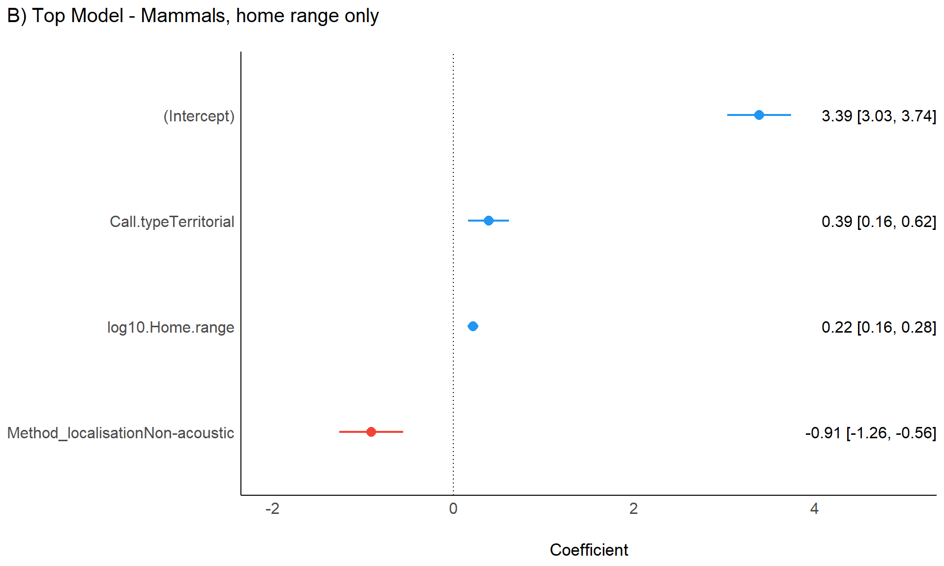
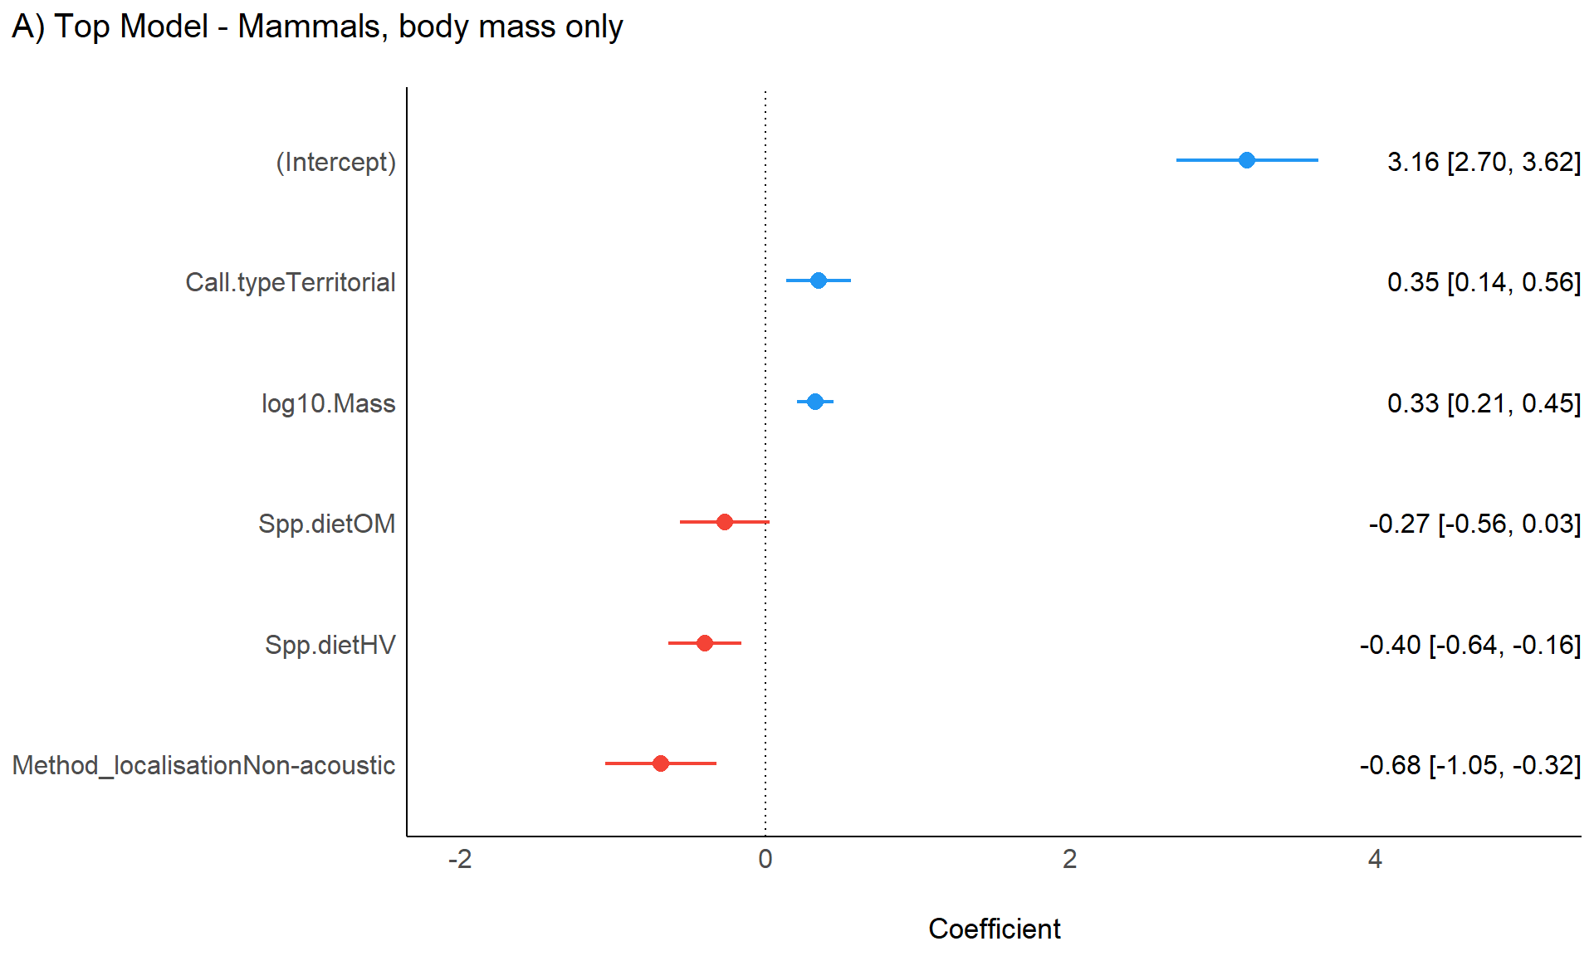
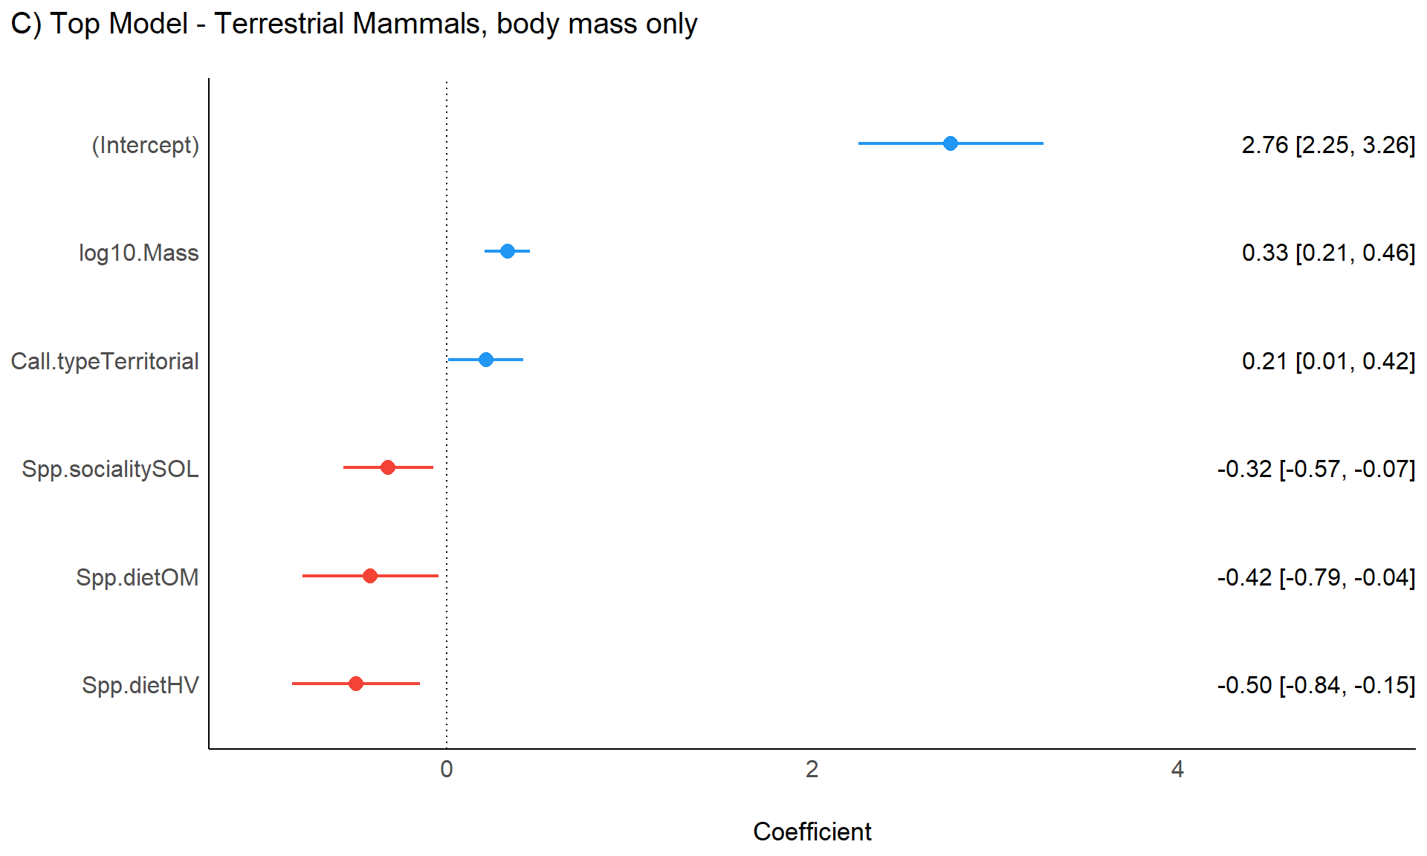
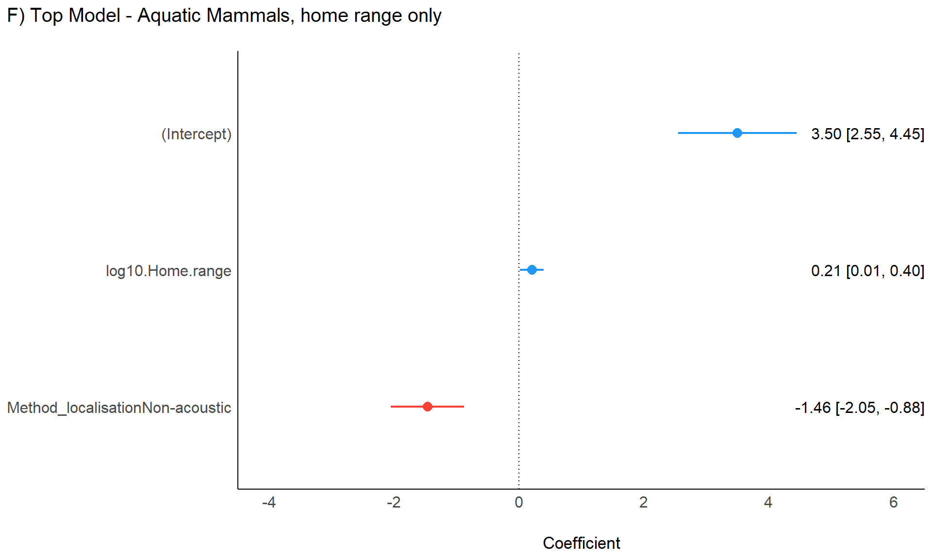

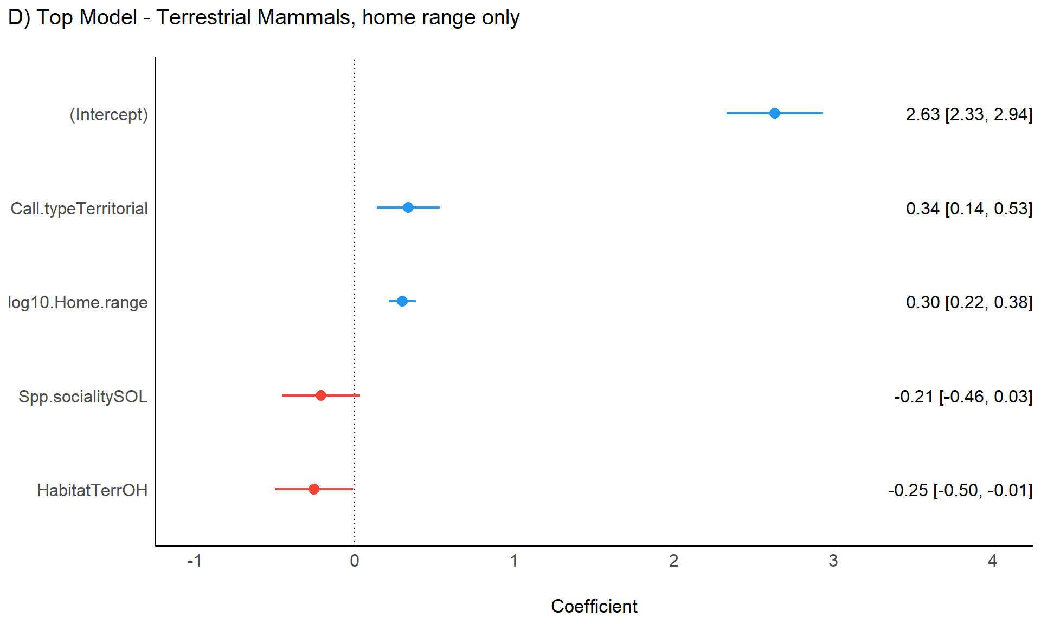

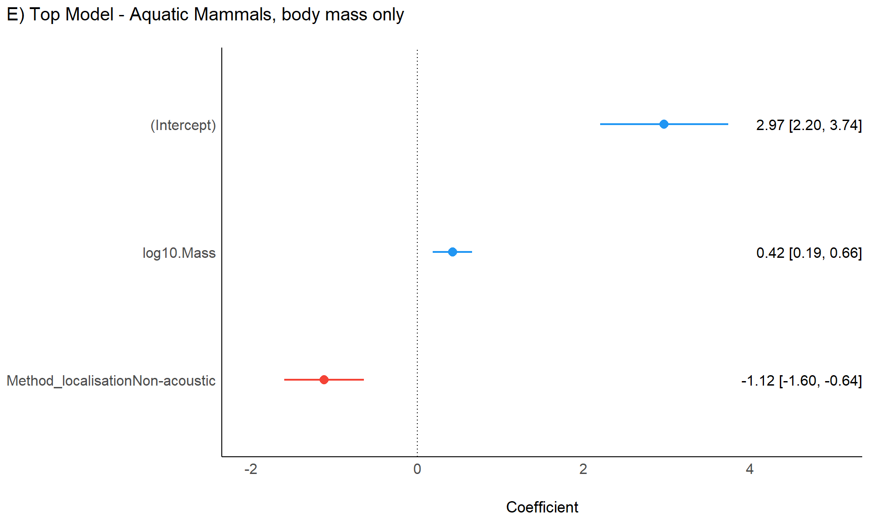

Fig. S1. Forest plots of the best models that explain the evolution and drivers of variance in Log₁₀ maximal propagation distance for 103 mammals. The best models are from (a, b) all mammals, (c, d) terrestrial mammals, and (e, f) aquatic mammals groups and the groups were split into (a, c, e) models including body mass and (b, d, f) models including home range analyses due to high multicollinearity between body mass and home range. Each dot represents the variable estimate and the coloured lines represent the confidence intervals for that variable. If coloured lines cross zero (the dotted vertical line), the variable is not significantly different from the null hypothesis for that variable.

Table S1. Hypotheses and predictions about the types of evolution that can affect maximal propagation distance.
Evolutionary Scenario | Evolutionary Parameter | Hypotheses | Predictions | Source
Ordinary Least Squares  (OLS) | N/A | H_{o} = No effect of phylogeny | Trait values of species are independent of one another (Null) | Felsenstein (1985); Martins and Hansen (1997)
Brownian Motion  (BM) | γ | H_{o} = No effect of phylogeny  H_{a} = Phylogeny affects species trait values | 1. Trait values of species are dependent on one another (Gamma = 1, same as BM + λ)  2. Trait values of species are independent of one another (Gamma = 0, same as OLS) | Felsenstein (1985); Martins and Hansen (1997)
Brownian Motion + Pagel's Lambda  (BM + λ) | λ | H_{o} = No effect of phylogeny  H_{a} = Phylogeny affects species trait values | 1. Trait values of species are dependent on one another towards similar values (Lambda = 0 < 1)  2. Trait values of species are independent of one another (Lambda = 0, same as OLS) | Pagel (1999); Freckleton et al. (2002)
Brownian Motion + Pagel's Lambda - Trait  (BM + λ - Trait) | λ | H_{o} = No phylogenetic signal in the residuals of trait values  H_{a} = Phylogenetic signal in the residuals of trait values, suggesting strong evolutionary latency of trait values | 1. Trait values of species are dependent on one another towards similar values of the overall phylogenetic signal (Lambda = 0 < 1)  2. Trait values of species are independent of one another (Lambda = 0, same as OLS) | Pagel (1999); Freckleton et al. (2002); Mundry (2014)
Brownian Motion + Grafen's Rho  (BM + ρ) | ρ | H_{o} = The rate of evolutionary change stays constant  H_{a} = The rate of evolutionary change is not constant | 1. Trait values of species are dependent on one another towards similar values and have a faster rate of evolutionary change (Rho = 1 < Inf)  2. Trait values of species are dependent on one another towards similar values and have a slower rate of evolutionary change (Rho = 0 < 1)  3. Trait values of species are dependent on one another towards similar values but the rate of evolutionary change stays constant (Rho = 0, same as BM + λ) | Grafen (1989)
Ornstein-Uhlenbeck  (OU) | α | H_{o} = Trait values are not pulled towards optimal values  H_{a} = Trait values are pulled towards optimal values | 1. Trait values of species are dependent on one another and have a stronger pull towards an optimal value (Alpha = 1 < Inf)  2. Trait values of species are dependent on one another and have a weaker pull towards an optimal value (Alpha = 0 < 1)  3. Trait values of species are dependent on one another and do not move towards an optimal value (Alpha = 0, same as BM + λ) | Martins and Hansen (1997); Garland and Ives (2000); Blomberg et al. (2003)

Table S2. Phylogenetic trees used for the hypothesised median induced consensus tree in our study, and their calibration methods.
Tree Source | Calibration Method | Most Recent Common Ancestor Age (Ma) | N Species
Toljagić et al. (2018) | Molecular and Fossil | 80.70 | 17
Wildman et al. (2003) | Molecular | 13.80 | 2
Roquet et al. (2014) | Molecular and Fossil | 85.41 | 4
Roquet et al. (2014) | Molecular and Fossil | 85.40 | 4
Uyeda et al. (2017) | Molecular | 186.68 | 16
Bininda-Emonds et al. (2007) | Molecular and Fossil | 147.70 | 98
Bininda-Emonds et al. (2007) | Molecular and Fossil | 142.20 | 98
Bininda-Emonds et al. (2007) | Molecular and Fossil | 153.20 | 98
Nyakatura and Bininda-Emonds (2012) | Molecular and Fossil | 105.70 | 20
Nyakatura and Bininda-Emonds (2012) | Molecular and Fossil | 93.90 | 20
Nyakatura and Bininda-Emonds (2012) | Molecular and Fossil | 105.70 | 20
Hedges et al. (2015) | Molecular | 163.67 | 102
Higdon et al. (2007) | Molecular and Fossil | 23.00 | 7
Higdon et al. (2007) | Molecular and Fossil | 20.30 | 7
Higdon et al. (2007) | Molecular and Fossil | 25.70 | 7
Steeman et al. (2009) | Molecular and Fossil | 35.86 | 24
Springer et al. (2012) | Molecular and Fossil | 62.77 | 44
Springer et al. (2012) | Molecular and Fossil | 66.71 | 44
Springer et al. (2012) | Molecular and Fossil | 70.50 | 44
Springer et al. (2012) | Molecular and Fossil | 71.35 | 44

The phylogenetic trees were downloaded from the Open Tree of Life (Hinchliff et al. 2015) API interface in the rotl package (Michonneau et al. 2016) and the datelife package (Reyes et al. 2024) using R (Team 2013) (v. 4.2.2). Ma refers to millions of years before present. N refers to number of species included in the hypothesised consensus tree from the downloaded phylogenetic trees.
Table S3. Results from the ten best explanatory PGLS regression models that describe the evolution and drivers of variance in Log₁₀ maximal propagation distance for 32 aquatic mammal species in the models including body mass analysis.
Evolutionary Scenario | (Intercept) | Log₁₀ body mass | Call type | Habitat | Sociality | Diet | Method localisation - control covariate | Call Type  *  Habitat | Evolutionary Parameter | Evol. Param. 95 % CI (Lower, Upper) | df | AICc
OU | 2.97*** | 0.42*** |  |  |  |  | +*** |  | 5.10 | NA, NA | 6 | 73.33
BM + ρ | 2.97*** | 0.42*** |  |  |  |  | +*** |  | 0.00 | NA, NA | 6 | 73.33
BM + λ | 3.04*** | 0.39** |  |  |  |  | +*** |  | 0.25 | NA, NA | 5 | 73.36
OU | 2.81*** | 0.45*** | + |  |  |  | +*** |  | 0.25 | -0.36, 0.87 | 7 | 74.80
BM + ρ | 2.83*** | 0.45*** | + |  |  |  | +*** |  | 0.00 | NA, NA | 7 | 75.04
BM + λ | 2.88*** | 0.43** | + |  |  |  | +** |  | 0.25 | NA, NA | 6 | 75.15
BM + λ | 3.07*** | 0.38** |  |  |  |  | +*** |  | 0.50 | NA, NA | 5 | 75.73
BM + λ | 2.89*** | 0.42** | + |  |  |  | +** |  | 0.50 | NA, NA | 6 | 77.61
BM + λ | 3.09** | 0.37* |  |  |  |  | +** |  | 0.75 | NA, NA | 5 | 78.94
BM + λ - Trait | 3.09** | 0.37* |  |  |  |  | +** |  | 0.77 | 0.11, 0.98 | 6 | 73.33

The results are produced from phylogenetic generalised least squares (PGLS) regression. The models are ordered by lowest AICc so the best explanatory model is first. CI refers to confidence intervals. “Method” is a control covariate to account for differences in literature-calculated versus literature-estimated Log₁₀ propagation distances. “Evol. Param.” refers to the maximum likelihood PGLS calculated evolutionary parameter under each evolutionary scenario. The “+” shows which variables are included in the models, with statistically significant variables denoted by asterisks (* = P < 0.05, ** = P < 0.01, and *** = P < 0.001). BM + λ = Brownian motion + Pagel’s Lambda. OU = Ornstein-Uhlenbeck. BM + ρ = Brownian motion + Grafen’s Rho. ΒM + λ – Trait = Brownian motion + Pagel’s Lambda calculated for the response variable to test the phylogenetic signal within the trait.
Table S4. Comparison of level of support for the ten best explanatory models that describe the evolution and drivers of variance in Log₁₀ maximal propagation distance for 32 aquatic mammals in the models including home range analysis.
Model | Evol. Scen. | ∆AICc | Weighted AICc | 95% CI of β₀ coefficient (intercept parameter)  (Lower, Upper) | Effect size (r) – calculated from Adj. LR Pseudo-R²
β₀ + βhome range + βmethod localisation | BM + λ | 0.00 | 0.2243 | 2.59, 4.41 | 0.73
β₀ + βhome range + βmethod localisation | OU | 0.48 | 0.1762 | 2.72, 4.02 | 0.76
β₀ + βhome range + βmethod localisation | BM + ρ | 0.48 | 0.1761 | 2.72, 4.02 | 0.76
β₀ + βmethod localisation | BM + λ | 0.60 | 0.1662 | 3.42, 4.95 | 0.69
β₀ + βmethod localisation | BM + λ | 1.80 | 0.0911 | 2.98, 5.32 | 0.68
β₀ + βhome range + βmethod localisation | BM + λ | 2.05 | 0.0806 | 2.32, 4.79 | 0.71
β₀ + βmethod localisation | BM + λ | 4.29 | 0.0263 | 2.35, 5.91 | 0.64
β₀ + βmethod localisation | BM + λ - Trait | 4.53 | 0.0233 | 2.30, 5.96 | 0.63
β₀ + βhome range + βmethod localisation | BM + λ | 5.00 | 0.0184 | 1.82, 5.33 | 0.67
β₀ + βhome range + βmethod localisation | BM + λ - Trait | 5.27 | 0.0161 | 1.77, 5.38 | 0.67
The results are produced from phylogenetic generalised least squares (PGLS) regression. “Evol. Scen.” refers to the evolutionary scenario included in each model’s covariance structure. CI refers to confidence intervals. Adj. LR Pseudo-R² = Likelihood-ratio based pseudo-adjusted-R-squared. BM + λ = Brownian motion + Pagel’s Lambda. OU = Ornstein-Uhlenbeck. BM + ρ = Brownian motion + Grafen’s Rho. ΒM + λ – Trait = Brownian motion + Pagel’s Lambda calculated for the response variable to test the phylogenetic signal within the trait.
Table S5. Results from the ten best explanatory PGLS regression models that describe the evolution and drivers of variance in Log₁₀ maximal propagation distance for 32 aquatic mammal species in the models including home range analysis.
Evolutionary Scenario | (Intercept) | Log₁₀ home range | Call type | Habitat | Sociality | Diet | Method localisation - control covariate | Call Type  *  Habitat | Evolutionary Parameter | Evol. Param. 95 % CI (Lower, Upper) | df | AICc
BM + λ | 3.50*** | 0.21* |  |  |  |  | +*** |  | 0.25 | NA, NA | 5 | 79.02
OU | 3.37*** | 0.26** |  |  |  |  | +*** |  | 0.91 | NA, NA | 6 | 79.50
BM + ρ | 3.37*** | 0.26** |  |  |  |  | +*** |  | 0.00 | NA, NA | 6 | 79.50
BM + λ | 4.18*** |  |  |  |  |  | +*** |  | 0.25 | NA, NA | 4 | 79.62
BM + λ | 4.15*** |  |  |  |  |  | +*** |  | 0.50 | NA, NA | 4 | 80.82
BM + λ | 3.55*** | 0.18 |  |  |  |  | +*** |  | 0.50 | NA, NA | 5 | 81.07
BM + λ | 4.13*** |  |  |  |  |  | +*** |  | 0.75 | NA, NA | 4 | 83.31
BM + λ - Trait | 4.13*** |  |  |  |  |  | +*** |  | 0.77 | 0.11, 0.98 | 4 | 83.55
BM + λ | 3.57*** | 0.17 |  |  |  |  | +*** |  | 0.75 | NA, NA | 5 | 84.02
BM + λ - Trait | 3.57*** | 0.17 |  |  |  |  | +*** |  | 0.77 | 0.11, 0.98 | 5 | 84.29

The results are produced from phylogenetic generalised least squares (PGLS) regression. The models are ordered by lowest AICc so the best explanatory model is first. CI refers to confidence intervals. “Method” is a control covariate to account for differences in literature-calculated versus literature-estimated Log₁₀ propagation distances. “Evol. Param.” refers to the maximum likelihood PGLS calculated evolutionary parameter under each evolutionary scenario. The “+” shows which variables are included in the models, with statistically significant variables denoted by asterisks (* = P < 0.05, ** = P < 0.01, and *** = P < 0.001). BM + λ = Brownian motion + Pagel’s Lambda. OU = Ornstein-Uhlenbeck. BM + ρ = Brownian motion + Grafen’s Rho. ΒM + λ – Trait = Brownian motion + Pagel’s Lambda calculated for the response variable to test the phylogenetic signal within the trait.
Table S6. Comparison of level of support for the ten best explanatory models that describe the evolution and drivers of variance in Log₁₀ maximal propagation distance for 71 terrestrial mammals in the models including body mass analysis.
Model | Evol. Scen. | ∆AICc | Weighted AICc | 95% CI of β₀ coefficient (intercept parameter)  (Lower, Upper) | Effect size (r) – calculated from Adj. LR Pseudo-R²
β₀ + βmass + βcall type + βdiet + βsociality | BM + ρ | 0.00 | 0.4098 | 2.21, 3.21 | 0.79
β₀ + βmass + βcall type + βhabitat + βdiet + βsociality | BM + ρ | 1.46 | 0.1974 | 2.33, 3.36 | 0.79
β₀ + βmass + βcall type + βsociality | BM + ρ | 1.77 | 0.1692 | 1.87, 2.45 | 0.74
β₀ + βmass + βcall type + βdiet + βsociality | BM + λ - Trait | 1.89 | 0.1590 | 2.03, 3.34 | 0.76
β₀ + βmass + βcall type + βdiet + βsociality | BM + λ | 4.50 | 0.0432 | 2.03, 3.34 | 0.76
β₀ + βmass + βhabitat + βdiet + βsociality | OU | 8.40 | 0.0061 | 2.72, 3.60 | 0.74
β₀ + βmass + βcall type + βhabitat + βdiet + βsociality | OU | 8.54 | 0.0057 | 2.45, 3.45 | 0.75
β₀ + βmass + βcall type + βdiet + βsociality | OU | 9.01 | 0.0045 | 2.25, 3.18 | 0.73
β₀ + βmass + βhabitat + βdiet | OU | 10.15 | 0.0026 | 2.60, 3.47 | 0.70
β₀ + βmass + βcall type + βhabitat + βdiet | OU | 10.24 | 0.0025 | 2.32, 3.31 | 0.72
The results are produced from phylogenetic generalised least squares (PGLS) regression. “Evol. Scen.” refers to the evolutionary scenario included in each model’s covariance structure. CI refers to confidence intervals. Adj. LR Pseudo-R² = Likelihood-ratio based pseudo-adjusted-R-squared. BM + ρ = Brownian motion + Grafen’s Rho. ΒM + λ – Trait = Brownian motion + Pagel’s Lambda calculated for the response variable to test the phylogenetic signal within the trait. BM + λ = Brownian motion + Pagel’s Lambda. OU = Ornstein-Uhlenbeck.
Table S7. Results from the ten best explanatory PGLS regression models that describe the evolution and drivers of variance in Log₁₀ maximal propagation distance for 71 terrestrial mammal species in the models including body mass analysis.
Evolutionary Scenario | (Intercept) | Log₁₀ body mass | Call type | Habitat | Sociality | Diet | Method localisation - control covariate | Call Type  *  Habitat | Evolutionary Parameter | Evol. Param. 95 % CI (Lower, Upper) | df | AICc
BM + ρ | 2.71*** | 0.34*** | +* |  | +* | H =+**, O = +* |  |  | 0.16 | 0.06, 0.45 | 9 | 92.18
BM + ρ | 2.85*** | 0.35*** | + | + | +* | H = +**, O = +* |  |  | 0.14 | 0.05, 0.42 | 10 | 93.64
BM + ρ | 2.16*** | 0.37*** | +*** |  | + |  |  |  | 0.16 | 0.06, 0.43 | 7 | 93.95
BM + λ - Trait | 2.69*** | 0.33*** | +** |  | +* | H = +**, O = +* |  |  | 0.72 | 0.37, 0.96 | 8 | 94.07
BM + λ | 2.68*** | 0.33*** | +** |  | +* | H = +**, O = +* |  |  | 0.75 | 0.46, 1.04 | 9 | 96.67
OU | 3.16*** | 0.35*** |  | +* | +* | H = +***, O = +** |  |  | 3.60 | NA, NA | 9 | 100.58
OU | 2.95*** | 0.36*** | + | + | +* | H = +**, O = +* |  |  | 30.66 | NA, NA | 10 | 100.71
OU | 2.72*** | 0.35*** | +* |  | +* | H = +**, O = + |  |  | 2.11 | NA, NA | 9 | 101.19
OU | 3.04*** | 0.35*** |  | +* |  | H = +**, O = +* |  |  | 8.55 | NA, NA | 8 | 102.33
OU | 2.81*** | 0.37*** | + | + |  | H = +**, O = +* |  |  | 34.91 | NA, NA | 9 | 102.41

The results are produced from phylogenetic generalised least squares (PGLS) regression. The models are ordered by lowest AICc so the best explanatory model is first. CI refers to confidence intervals. “Method” is a control covariate to account for differences in literature-calculated versus literature-estimated Log₁₀ propagation distances. “Evol. Param.” refers to the maximum likelihood PGLS calculated evolutionary parameter under each evolutionary scenario. The “+” shows which variables are included in the models, with statistically significant variables denoted by asterisks (* = P < 0.05, ** = P < 0.01, and *** = P < 0.001). The diet variable had different levels which were significant in the models, where the levels were C = Carnivore (set to the Intercept), H = Herbivore, and O = Omnivore. BM + ρ = Brownian motion + Grafen’s Rho. ΒM + λ – Trait = Brownian motion + Pagel’s Lambda calculated for the response variable to test the phylogenetic signal within the trait. BM + λ = Brownian motion + Pagel’s Lambda. OU = Ornstein-Uhlenbeck.
Table S8. Results from the ten best explanatory PGLS regression models that describe the evolution and drivers of variance in Log₁₀ maximal propagation distance for 71 terrestrial mammal species in the models including home range analysis.
Evolutionary Scenario | (Intercept) | Log₁₀ home range | Call type | Habitat | Sociality | Diet | Method localisation - control covariate | Call Type  *  Habitat | Evolutionary Parameter | Evol. Param. 95 % CI (Lower, Upper) | df | AICc
BM + ρ | 2.63*** | 0.30*** | +** | +* | + |  |  |  | 0.13 | 0.05, 0.36 | 8 | 90.40
BM + ρ | 2.60*** | 0.30*** | +** | +* |  |  |  |  | 0.12 | 0.04, 0.34 | 7 | 90.95
BM + λ - Trait | 2.38*** | 0.27*** | +*** |  | +* |  |  |  | 0.72 | 0.37, 0.96 | 6 | 91.46
BM + ρ | 2.52*** | 0.26*** | +*** |  | + |  |  |  | 0.15 | 0.05, 0.40 | 7 | 91.76
BM + ρ | 2.82*** | 0.28*** | +** | +* | +* | H = +, O = + |  |  | 0.14 | 0.05, 0.38 | 10 | 92.02
BM + λ - Trait | 2.47*** | 0.29*** | +*** | + | + |  |  |  | 0.72 | 0.37, 0.96 | 7 | 92.23
BM + λ - Trait | 2.69*** | 0.27*** | +*** | + | +* | H = +, O = + |  |  | 0.72 | 0.37, 0.96 | 9 | 93.00
BM + λ | 2.34*** | 0.28*** | +*** |  | +* |  |  |  | 0.79 | 0.53, 1.06 | 7 | 93.71
BM + λ | 2.51*** | 0.29*** | +*** | + | + |  |  |  | 0.68 | 0.25, 1.10 | 8 | 94.73
BM + λ | 2.53*** | 0.29*** | +*** | + |  |  |  |  | 0.57 | 0.12, 1.03 | 7 | 95.59

The results are produced from phylogenetic generalised least squares (PGLS) regression. The models are ordered by lowest AICc so the best explanatory model is first. CI refers to confidence intervals. “Method” is a control covariate to account for differences in literature-calculated versus literature-estimated Log₁₀ propagation distances. “Evol. Param.” refers to the maximum likelihood PGLS calculated evolutionary parameter under each evolutionary scenario. The “+” shows which variables are included in the models, with statistically significant variables denoted by asterisks (* = P < 0.05, ** = P < 0.01, and *** = P < 0.001). The diet variable had different levels which were significant in the models, where the levels were C = Carnivore (set to the Intercept), H = Herbivore, and O = Omnivore. BM + ρ = Brownian motion + Grafen’s Rho. ΒM + λ – Trait = Brownian motion + Pagel’s Lambda calculated for the response variable to test the phylogenetic signal within the trait. BM + λ = Brownian motion + Pagel’s Lambda.

Table S9. Comparison of level of support for the ten best explanatory models that describe the evolution and drivers of variance in Log₁₀ maximal propagation distance for 103 mammals in the models including body mass analysis.
Model | Evol. Scen. | ∆AICc | Weighted AICc | 95% CI of β₀ coefficient (intercept parameter)  (Lower, Upper) | Effect size (r) – calculated from Adj. LR Pseudo-R²
β₀ + βmass + βcall type + βdiet + βmethod localisation | OU | 0.00 | 0.2618 | 2.70, 3.62 | 0.88
β₀ + βmass + βcall type + βdiet + βsociality + βmethod localisation | OU | 0.23 | 0.2339 | 2.75, 3.68 | 0.89
β₀ + βmass + βcall type + βhabitat + βdiet + βmethod localisation | OU | 0.63 | 0.1907 | 2.62, 3.56 | 0.89
β₀ + βmass + βcall type + βhabitat + βdiet + βmethod localisation | BM + ρ | 2.74 | 0.0664 | 2.49, 3.61 | 0.89
β₀ + βmass + βcall type + βhabitat + βdiet + βsociality + βmethod localisation | BM + ρ | 2.87 | 0.0625 | 2.52, 3.67 | 0.89
β₀ + βmass + βcall type + βmethod localisation | BM + ρ | 2.94 | 0.0602 | 2.54, 3.58 | 0.87
β₀ + βmass + βcall type + βsociality + βmethod localisation | BM + ρ | 3.32 | 0.0498 | 2.56, 3.63 | 0.87
β₀ + βmass + βcall type + βdiet + βmethod localisation | BM + ρ | 3.86 | 0.0381 | 2.54, 3.64 | 0.88
β₀ + βmass + βcall type + βdiet + βsociality + βmethod localisation | BM + ρ | 3.98 | 0.0359 | 2.57, 3.71 | 0.88
β₀ + βmass + βcall type + βhabitat + βdiet + βsociality + βmethod localisation | BM + λ | 11.59 | 0.0008 | 2.43, 3.76 | 0.88

The results are produced from phylogenetic generalised least squares (PGLS) regression. “Evol. Scen.” refers to the evolutionary scenario included in each model’s covariance structure. CI refers to confidence intervals. Adj. LR Pseudo-R² = Likelihood-ratio based pseudo-adjusted-R-squared. OU = Ornstein-Uhlenbeck. BM + ρ = Brownian motion + Grafen’s Rho. BM + λ = Brownian motion + Pagel’s Lambda.
Table S10. Results from the ten best explanatory PGLS regression models that describe the evolution and drivers of variance in Log₁₀ maximal propagation distance for 103 mammal species in the models including body mass analysis.
Evol. Scen. | (Intercept) | Log₁₀ body mass | Call type | Habitat | Sociality | Diet | Method localisation - control covariate | Call Type  *  Habitat | Evol. Param. | Evol. Param. 95 % CI (Lower, Upper) | df | AICc
OU | 3.16*** | 0.33*** | +** |  |  | H =+**, O = + | +*** |  | 0.15 | 0.06, 0.24 | 9 | 160.49
OU | 3.21*** | 0.33*** | +*** |  | + | H = +***, O = + | +*** |  | 0.14 | 0.05, 0.23 | 10 | 160.72
OU | 3.09*** | 0.35*** | +** | TC = +*, TO = + |  | H = +***, O = +** | +*** |  | 0.13 | 0.05, 0.22 | 11 | 161.12
BM + ρ | 3.05*** | 0.35*** | +* | TC = +, TO = + |  | H = +*, O = + | +*** |  | 0.11 | 0.04, 0.30 | 11 | 163.23
BM + ρ | 3.10*** | 0.36*** | +* | TC = +, TO = + | + | H = +**, O = + | +*** |  | 0.12 | 0.05, 0.32 | 12 | 163.35
BM + ρ | 3.06*** | 0.35*** | +** |  |  |  | +*** |  | 0.11 | 0.04, 0.30 | 7 | 163.43
BM + ρ | 3.10*** | 0.36*** | +** |  | + |  | +*** |  | 0.12 | 0.04, 0.31 | 8 | 163.81
BM + ρ | 3.09*** | 0.34*** | +** |  |  | H = +, O = + | +*** |  | 0.11 | 0.04, 0.31 | 9 | 164.35
BM + ρ | 3.14*** | 0.34*** | +** |  | + | H = +, O = + | +*** |  | 0.13 | 0.05, 0.33 | 10 | 164.47
BM + λ | 3.09*** | 0.36*** | +* | TC = +*, TO = + | + | H = +**, O = + | +*** |  | 0.31 | -0.16, 0.77 | 12 | 172.08

The results are produced from phylogenetic generalised least squares (PGLS) regression. The models are ordered by lowest AICc so the best explanatory model is first. CI refers to confidence intervals. “Evol. Scenario” refers to the evolutionary scenario included in each model’s covariance structure. “Method” is a control covariate to account for differences in literature-calculated versus literature-estimated Log₁₀ propagation distances. “Evol. Param.” refers to the maximum likelihood PGLS calculated evolutionary parameter under each evolutionary scenario. The “+” shows which variables are included in the models, with statistically significant variables denoted by asterisks (* = P < 0.05, ** = P < 0.01, and *** = P < 0.001). The habitat variable had different levels which were significant in the models, where the levels were AO = Aquatic - Open (set to the Intercept), TC = Terrestrial - Closed, and TO = Terrestrial – Open. The diet variable had different levels which were significant in the models, where the levels were C = Carnivore (set to the Intercept), H = Herbivore, and O = Omnivore. OU = Ornstein-Uhlenbeck. BM + ρ = Brownian motion + Grafen’s Rho. BM + λ = Brownian motion + Pagel’s Lambda.
Table S11. Comparison of level of support for the ten best explanatory models that describe the evolution and drivers of variance in Log₁₀ maximal propagation distance for 103 mammals in the models including home range analysis.
Model | Evol. Scen. | ∆AICc | Weighted AICc | 95% CI of β₀ coefficient (intercept parameter)  (Lower, Upper) | Effect size (r) – calculated from Adj. LR Pseudo-R²
β₀ + βhome range + βcall type + βmethod localisation | OU | 0.00 | 0.2932 | 3.04, 3.73 | 0.86
β₀ + βhome range + βcall type + βsociality + βmethod localisation | OU | 0.28 | 0.2548 | 3.06, 3.77 | 0.87
β₀ + βhome range + βcall type + βhabitat + βmethod localisation | BM + ρ | 0.61 | 0.2157 | 2.73, 3.75 | 0.87
β₀ + βhome range + βcall type + βhabitat + βmethod localisation | OU | 1.74 | 0.1230 | 2.79, 3.62 | 0.87
β₀ + βhome range + βcall type + βhabitat + βsociality + βmethod localisation | BM + ρ | 2.20 | 0.0976 | 2.75, 3.79 | 0.87
β₀ + βhome range + βcall type + βhabitat + βmethod localisation | BM + λ | 6.57 | 0.0110 | 2.55, 3.90 | 0.86
β₀ + βhome range + βcall type + βhabitat + βsociality + βmethod localisation | BM + λ | 8.26 | 0.0047 | 2.56, 3.95 | 0.86
β₀ + βhome range + βcall type + βhabitat + βmethod localisation | BM + λ - Trait | 18.32 | 0.0000 | 1.85, 4.63 | 0.83
β₀ + βhome range + βcall type + βhabitat + βsociality + βmethod localisation | BM + λ - Trait | 19.94 | 0.0000 | 1.86, 4.68 | 0.83
β₀ + βhome range + βcall type + βhabitat + βdiet + βsociality + βmethod localisation | OLS | 56.81 | 0.0000 | 0.77, 5.80 | 0.75
The results are produced from phylogenetic generalised least squares (PGLS) regression. “Evol. Scen.” refers to the evolutionary scenario included in each model’s covariance structure. CI refers to confidence intervals. Adj. LR Pseudo-R² = Likelihood-ratio based pseudo-adjusted-R-squared. OU = Ornstein-Uhlenbeck. BM + ρ = Brownian motion + Grafen’s Rho. BM + λ = Brownian motion + Pagel’s Lambda. ΒM + λ – Trait = Brownian motion + Pagel’s Lambda calculated for the response variable to test the phylogenetic signal within the trait.
Table S12. Results from the ten best explanatory PGLS regression models that describe the evolution and drivers of variance in Log₁₀ maximal propagation distance for 103 mammal species in the models including home range analysis.
Evolutionary Scenario | (Intercept) | Log₁₀ home range | Call type | Habitat | Sociality | Diet | Method localisation - control covariate | Call Type  *  Habitat | Evol. Param. | Evol. Param. 95 % CI (Lower, Upper) | df | AICc
OU | 3.39*** | 0.22*** | +*** |  |  |  | +*** |  | 0.15 | 0.06, 0.25 | 7 | 166.41
OU | 3.42*** | 0.22*** | +*** |  | + |  | +*** |  | 0.14 | 0.06, 0.23 | 8 | 166.70
BM + ρ | 3.24*** | 0.25*** | +** | TC = +, TO = + |  |  | +*** |  | 0.11 | 0.04, 0.29 | 9 | 167.03
OU | 3.20*** | 0.27*** | +** | TC = +, TO = + |  |  | +*** |  | 0.15 | 0.06, 0.24 | 9 | 168.15
BM + ρ | 3.27*** | 0.25*** | +** | TC = +, TO = + | + |  | +*** |  | 0.11 | 0.04, 0.29 | 10 | 168.62
BM + λ | 3.22*** | 0.26*** | +** | TC = +, TO = + |  |  | +*** |  | 0.39 | -0.03, 0.81 | 9 | 172.99
BM + λ | 3.26*** | 0.26*** | +** | TC = +, TO = + | + |  | +*** |  | 0.40 | -0.01, 0.81 | 10 | 174.67
BM + λ - Trait | 3.24*** | 0.26*** | +*** | TC = +, TO = + |  |  | +*** |  | 0.90 | 0.71, 0.98 | 8 | 184.74
BM + λ - Trait | 3.27*** | 0.26*** | +*** | TC = +, TO = + | + |  | +*** |  | 0.90 | 0.71, 0.98 | 9 | 186.35
OLS | 3.29* | 0.24*** | +*** | TC = +***, TO = +** | + | H = +**, O = +** | +** |  | 0.00 | NA, NA | 11 | 223.22

The results are produced from phylogenetic generalised least squares (PGLS) regression. The models are ordered by lowest AICc so the best explanatory model is first. CI refers to confidence intervals. “Method” is a control covariate to account for differences in literature-calculated versus literature-estimated Log₁₀ propagation distances. “Evol. Param.” refers to the maximum likelihood PGLS calculated evolutionary parameter under each evolutionary scenario. The “+” shows which variables are included in the models, with statistically significant variables denoted by asterisks (* = P < 0.05, ** = P < 0.01, and *** = P < 0.001). The habitat variable had different levels which were significant in the models, where the levels were AO = Aquatic - Open (set to the Intercept), TC = Terrestrial - Closed, and TO = Terrestrial – Open. The diet variable had different levels which were significant in the models, where the levels were C = Carnivore (set to the Intercept), H = Herbivore, and O = Omnivore. OU = Ornstein-Uhlenbeck. BM + ρ = Brownian motion + Grafen’s Rho. BM + λ = Brownian motion + Pagel’s Lambda. ΒM + λ – Trait = Brownian motion + Pagel’s Lambda calculated for the response variable to test the phylogenetic signal within the trait.

References
Barthélemy J-P, McMorris FR (1986) The median procedure for n-trees. J Classif 3:329-334
Bininda-Emonds OR, Cardillo M, Jones KE, MacPhee RD, Beck RM, Grenyer R, Price SA, Vos RA, Gittleman JL, Purvis A (2007) The delayed rise of present-day mammals. Nature 446:507-12. https://doi.org/10.1038/nature05634
Blomberg SP, Garland T, Jr., Ives AR (2003) Testing for phylogenetic signal in comparative data: behavioral traits are more labile. Evolution 57:717-45. https://doi.org/10.1111/j.0014-3820.2003.tb00285.x
Boyle SA (2021) Home Range Analysis: Why the Methods Matter. In: Shaffer CA, Dolins FL, Hickey JR, Porter LM, Nibbelink NP (eds) Spatial Analysis in Field Primatology: Applying GIS at Varying Scales. Cambridge University Press, Cambridge, pp 129-151
Britton T, Oxelman B, Vinnersten A, Bremer K (2002) Phylogenetic dating with confidence intervals using mean path lengths. Mol Phylogenet Evol 24:58-65
Bryant D (2003) A classification of consensus methods for phylogenetics. DIMACS - Series in Discrete Math Theor Comput Sci 61:163-184
Burnham KP, Anderson DR (2002) Model Selection and Multimodel Inference: A Practical Information-Theoretic Approach. Springer New York
Calenge C (2011) Home range estimation in R: the adehabitatHR package. Office national de la classe et de la faune sauvage: Saint Benoist, Auffargis, France
Charlton BD, Reby D (2016) The evolution of acoustic size exaggeration in terrestrial mammals. Nat Commun 7:12739. https://doi.org/10.1038/ncomms12739
Cosens SE, Falls JB (1984) A comparison of sound propagation and song frequency in temperate marsh and grassland habitats. Behav Ecol Sociobiol 15:161-170
Felsenstein J (1985) Phylogenies and the comparative method. Am Nat 125:1-15. https://doi.org/10.1086/284325
Fox J, Weisberg S, Adler D, Bates D, Baud-Bovy G, Ellison S, Firth D, Friendly M, Gorjanc G, Graves S (2012) Package ‘car’. Vienna: R Foundation for Statistical Computing 16
Freckleton RP, Harvey PH, Pagel M (2002) Phylogenetic analysis and comparative data: a test and review of evidence. Am Nat 160:712-26. https://doi.org/10.1086/343873
Garland J, Theodore, Ives AR (2000) Using the past to predict the present: confidence intervals for regression equations in phylogenetic comparative methods. Am Nat 155:346-364
Grafen A (1989) The phylogenetic regression. Philos Trans R Soc Lond B Biol Sci 326:119-57. https://doi.org/10.1098/rstb.1989.0106
Hansen TF (1997) Stabilizing selection and the comparative analysis of adaptation. Evolution 51:1341-1351. https://doi.org/10.1111/j.1558-5646.1997.tb01457.x
Harmon LJ, Losos JB, Jonathan Davies T, Gillespie RG, Gittleman JL, Bryan Jennings W, Kozak KH, McPeek MA, Moreno-Roark F, Near TJ (2010) Early bursts of body size and shape evolution are rare in comparative data. Evolution 64:2385-2396
Hedges SB, Marin J, Suleski M, Paymer M, Kumar S (2015) Tree of life reveals clock-like speciation and diversification. Mol Biol Evol 32:835-45. https://doi.org/10.1093/molbev/msv037
Hensley NM, Drury JP, Garland Jr T, Blumstein DT (2015) Vivid birds do not initiate flight sooner despite their potential conspicuousness. Curr Zool 61:773-780
Higdon JW, Bininda-Emonds OR, Beck RM, Ferguson SH (2007) Phylogeny and divergence of the pinnipeds (Carnivora: Mammalia) assessed using a multigene dataset. BMC Evol Biol 7:216. https://doi.org/10.1186/1471-2148-7-216
Hinchliff CE, Smith SA, Allman JF, Burleigh JG, Chaudhary R, Coghill LM, Crandall KA, Deng J, Drew BT, Gazis R, Gude K, Hibbett DS, Katz LA, Laughinghouse HDt, McTavish EJ, Midford PE, Owen CL, Ree RH, Rees JA, Soltis DE, Williams T, Cranston KA (2015) Synthesis of phylogeny and taxonomy into a comprehensive tree of life. Proc Natl Acad Sci U S A 112:12764-9. https://doi.org/10.1073/pnas.1423041112
Ho SY, Duchêne S (2014) Molecular‐clock methods for estimating evolutionary rates and timescales. Mol Ecol 23:5947-5965
Jones KE, Bielby J, Cardillo M, Fritz SA, O'Dell J, Orme CDL, Safi K, Sechrest W, Boakes EH, Carbone C, Connolly C, Cutts MJ, Foster JK, Grenyer R, Habib M, Plaster CA, Price SA, Rigby EA, Rist J, Teacher A, Bininda-Emonds ORP, Gittleman JL, Mace GM, Purvis A, Michener WK (2009) PanTHERIA: a species‐level database of life history, ecology, and geography of extant and recently extinct mammals. Ecology 90:2648-2648. https://doi.org/10.1890/08-1494.1
Kelt DA, Van Vuren DH (2001) The ecology and macroecology of mammalian home range area. Am Nat 157:637-645
Lapointe FJ, Cucumel G (1997) The average consensus procedure: combination of weighted trees containing identical or overlapping sets of taxa. Syst Biol 46:306-312
Lubbe A, Hetem RS, McFarland R, Barrett L, Henzi PS, Mitchell D, Meyer LC, Maloney SK, Fuller A (2014) Thermoregulatory plasticity in free-ranging vervet monkeys, Chlorocebus pygerythrus. J Comp Physiol B 184:799-809. https://doi.org/10.1007/s00360-014-0835-y
Martin K, Tucker MA, Rogers TL (2017) Does size matter? Examining the drivers of mammalian vocalizations. Evolution 71:249-260. https://doi.org/10.1111/evo.13128
Martins EP, Hansen TF (1997) Phylogenies and the comparative method: a general approach to incorporating phylogenetic information into the analysis of interspecific data. Am Nat 149:646-667. https://doi.org/10.1086/286013
Michonneau F, Brown JW, Winter DJ, Fitzjohn R (2016) rotl: an R package to interact with the Open Tree of Life data. Methods Ecol Evol 7:1476-1481. https://doi.org/10.1111/2041-210x.12593
Morton ES (1975) Ecological sources of selection on avian sounds. Am Nat 109:17-34. https://doi.org/10.1086/282971
Mundry R (2014) Statistical issues and assumptions of phylogenetic generalized least squares. In: Garamszegi L (eds) Modern Phylogenetic Comparative Methods and Their Application in Evolutionary Biology: Concepts and Practice. Springer, Berlin, pp 131-153
Nyakatura K, Bininda-Emonds OR (2012) Updating the evolutionary history of Carnivora (Mammalia): a new species-level supertree complete with divergence time estimates. BMC Biol 10:12. https://doi.org/10.1186/1741-7007-10-12
Orme D, Freckleton R, Thomas G, Petzoldt T, Fritz S, Isaac N, Pearse W (2013) The caper package: comparative analysis of phylogenetics and evolution in R. R package version 5:1-36
Ouzzani M, Hammady H, Fedorowicz Z, Elmagarmid A (2016) Rayyan-a web and mobile app for systematic reviews. Syst Rev 5:210. https://doi.org/10.1186/s13643-016-0384-4
Pagel M (1999) Inferring the historical patterns of biological evolution. Nature 401:877-84. https://doi.org/10.1038/44766
Pinheiro J, Bates D, DebRoy S, Sarkar D, Heisterkamp S, Van Willigen B (2017) nlme: Linear and nonlinear mixed effects models. R package version 3
Ravignani A, Garcia M (2022) A cross-species framework to identify vocal learning abilities in mammals. Philos Trans R Soc B Biol Sci 377:20200394. https://doi.org/10.1098/rstb.2020.0394
Revell LJ (2010) Phylogenetic signal and linear regression on species data. Methods Ecol Evol 1:319-329
Revell LJ (2012) phytools: an R package for phylogenetic comparative biology (and other things). Methods Ecol Evol 3(2):217-223. https://doi.org/10.1111/j.2041-210X.2011.00169.x
Reyes LLS, McTavish EJ, O’Meara B (2024) DateLife: leveraging databases and analytical tools to reveal the dated Tree of Life. Syst Biol 73(2):470-485 https://doi.org/10.1093/sysbio/syae015
Richards DG, Wiley RH (1980) Reverberations and amplitude fluctuations in the propagation of sound in a forest: implications for animal communication. Am Nat 115:381-399
Roquet C, Lavergne S, Thuiller W (2014) One tree to link them all: a phylogenetic dataset for the European tetrapoda. PLoS Curr 6. https://doi.org/10.1371/currents.tol.5102670fff8aa5c918e78f5592790e48
Ross D, Kuperman W. 1989. Mechanics of underwater noise. J Acoust Soc Am
Springer MS, Meredith RW, Gatesy J, Emerling CA, Park J, Rabosky DL, Stadler T, Steiner C, Ryder OA, Janecka JE, Fisher CA, Murphy WJ (2012) Macroevolutionary dynamics and historical biogeography of primate diversification inferred from a species supermatrix. PLoS One 7:e49521. https://doi.org/10.1371/journal.pone.0049521
Steeman ME, Hebsgaard MB, Fordyce RE, Ho SY, Rabosky DL, Nielsen R, Rahbek C, Glenner H, Sorensen MV, Willerslev E (2009) Radiation of extant cetaceans driven by restructuring of the oceans. Syst Biol 58:573-85. https://doi.org/10.1093/sysbio/syp060
Team RC (2013) R: A language and environment for statistical computing.
Toljagić O, Voje KL, Matschiner M, Liow LH, Hansen TF (2018) Millions of years behind: slow adaptation of ruminants to grasslands. Syst Biol 67:145-157. https://doi.org/10.1093/sysbio/syx059
Tucker MA, Ord TJ, Rogers TL (2014) Evolutionary predictors of mammalian home range size: body mass, diet and the environment. Glob Ecol Biogeogr 23:1105-1114. https://doi.org/10.1111/geb.12194
Uyeda JC, Harmon LJ (2014) A novel Bayesian method for inferring and interpreting the dynamics of adaptive landscapes from phylogenetic comparative data. Syst Biol 63:902-18. https://doi.org/10.1093/sysbio/syu057
Uyeda JC, Zenil-Ferguson R, Pennell MW (2018) Rethinking phylogenetic comparative methods. Syst Biol 67:1091-1109. https://doi.org/10.1093/sysbio/syy031
Uyeda JC, Pennell MW, Miller ET, Maia R, McClain CR (2017) The evolution of energetic scaling across the vertebrate tree of life. Am Nat 190:185-199. https://doi.org/10.1086/692326
Verbeke G, Molenberghs G (2000) Linear Mixed Models for Longitudinal Data. Springer New York
Verbyla AP (2019) A note on model selection using information criteria for general linear models estimated using REML. Aust N Z J Stat 61:39-50
Wagenmakers EJ, Farrell S (2004) AIC model selection using Akaike weights. Psychon Bull Rev 11:192-6. https://doi.org/10.3758/bf03206482
Weisberg H (1992) Central Tendency and Variability. Sage
Wildman DE, Uddin M, Liu G, Grossman LI, Goodman M (2003) Implications of natural selection in shaping 99.4% nonsynonymous DNA identity between humans and chimpanzees: enlarging genus Homo. Proc Natl Acad Sci U S A 100:7181-8. https://doi.org/10.1073/pnas.1232172100
Yafune A, Funatogawa T, Ishiguro M (2005) Extended information criterion (EIC) approach for linear mixed effects models under restricted maximum likelihood (REML) estimation. Stat Med 24:3417-3429

