iNICU – Integrated Neonatal Care Unit: capturing neonatal journey in an intelligent data way

Authors: Harpreet Singh^{1,2}, Gautam Yadav³, Raghuram Mallaiah⁴, Preetha Joshi⁵, Vinay Joshi⁵, Ravneet Kaur², Suneyna Bansal², Samir K. Brahmachari^{1,6}

¹Academy of Scientific and Industrial Research, New Delhi, India
²Oxyent Medical Private Limited, New Delhi, India
³Kalawati Hospital, Shiv Chowk, Rewari, Haryana, India
⁴Fortis Le Femme, Greater Kailash -2, New Delhi, India
⁵Kokilaben Dhirubhai Ambani Hospital, Mumbai, India
⁶CSIR-Institute of Genomics and Integrated Biology, New Delhi, India

Corresponding author: ^{1,7}Samir K Brahmachari, PhD
CSIR-Institute of Genomics and Integrative Biology,
Mathura Road, New Delhi -110020, India
Email: skb@igib.res.in

Corresponding co-author: ^{1,2} Harpreet Singh
Oxyent Medical Private Limited,
801 DLF Tower B, New Delhi -110025, India
Email: harpreet_singh@oxyent.com

Supplementary Fig. 1 Medication Calculator Screen at iNICU.

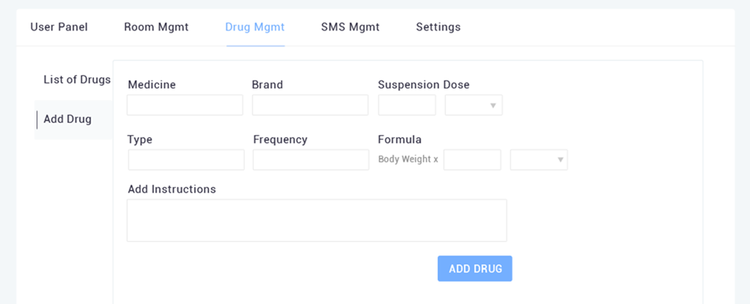

Supplementary Table 1 List of Vitals captured in iNICU, excluding laboratory based parameters

S.No. | Total Vitals
1 | BIRTH WEIGHT
2 | GESTATION
3 | TODAY WEIGHT
4 | INPUT\OUTPUT
5 | FEEDS
6 | AGE OF ONSET
7 | DURATION
8 | CAUSE
9 | DCT
10 | EXCHANGE TRANS
11 | PHOTOTHERAPY
12 | HEMOLYSIS
13 | IVIG
14 | HYPOGLYCEMIA
15 | MINIMUM DS
16 | DAY
17 | MAX. GDR
18 | CAUSE OF RDS
19 | SPO2
20 | MAX. RR
21 | APNEA
22 | SURFACTANT
23 | CLD
24 | REASON OF MV
25 | CPAP
26 | AIRVO
27 | NIV
28 | CRIED AT BIRTH
29 | POSTURE
30 | CT HEAD
31 | EEG
32 | NNR
33 | FEEDING
34 | TONE
35 | STAGE HIE
36 | GRADE IVH
37 | SEIZURES
38 | MRI HEAD
39 | ONSET
40 | RISK FACTORS
41 | PRESENTATION SYMPTOMS
42 | URINE CULTURE
43 | CSF CULTURE
44 | ANTIBIOTICS
45 | TLC
46 | CRP
47 | SEPSIS SCREEN
48 | BLOOD CULTURE
49 | ORGANISM
50 | UTI
51 | MENINGITIS
52 | BONE INFECTION
53 | PNEUMONIA
54 | TYPE
55 | PDA
56 | ASD
57 | VSD
58 | SHOCK
59 | INOTROPES
60 | TPN
61 | TROPIC FEEDS
62 | FEEDING INTOLERANCE
63 | CENTILE AT BIRTH
64 | CENTILE AT DISCHARGE
65 | RENAL FAILURE
66 | MIN WEIGHT
67 | ROP
68 | OAE RIGHT
69 | OAE LEFT
70 | METABOLIC SCREEN
71 | VACCINATION AT DISCHARGE
72 | DAYS OF LIFE
73 | LAST HEAD CURCUM
74 | CURRENT HEAD CURRCUM
75 | NICU DAY
76 | TODAY;S WEIGHT
77 | LAST WEIGHT
78 | WEEKS
79 | LAST LENGTH
80 | CURRENT LENGTH
81 | WEIGHT GAIN\LOSS
82 | POSITION
83 | HR
84 | SKIN TEMP.
85 | CORE TEMP
86 | SYS BP
87 | DIA. BP
88 | MEAN BP
89 | CVP
90 | RR
91 | LAX RAX
92 | ETCO2
93 | SEDATION SCORE
94 | GCS
95 | ICP
96 | CCP
97 | PUPIL REACTIVITY
98 | PUPIL SIZE
99 | PH
100 | PCO2
101 | HCO2
102 | PO2
103 | BE
104 | LACTATE
105 | VENT MODE
106 | PIP
107 | PEEP
108 | PRESS SUPP
109 | MAP
110 | FREQ RATE
111 | TIDAL VOL
112 | MIN VOL
113 | FIO2
114 | FLOW PER MIN
115 | PPM
116 | ETT (COLOR\QUANTITY)
117 | FEED METHOD
118 | HMF VALUE
119 | FEED TYPE
120 | FEED VOL
121 | IV\HR
122 | IV TYPE
123 | AA\HR
124 | LIPID\HR
125 | PN RATE
126 | IV TOTAL
127 | BLOOD PRODUCT
128 | START TIME
129 | BOLUS TYPE
130 | DOSE
131 | NG ASPIRATE(QUANTITY\TYPE)
132 | TOTAL URINE OUTPUT
133 | BLOOD LETTING
134 | DRAINS
135 | ABD GIRTH
136 | HGT
137 | PHOTOTHERAPY TYPE

