Self-Reflective Chest X-ray Report Generation with Clinical-Aware Detection and Multilevel Readability

Supplementary Materials
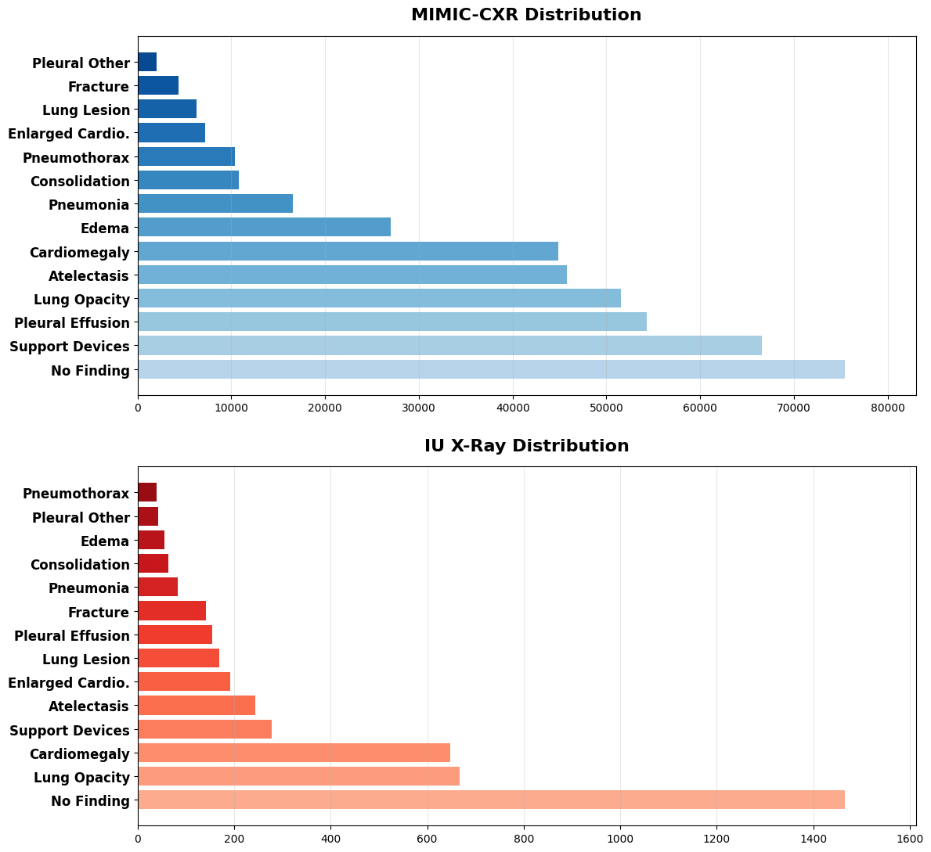
Supplementary Figure S1. Distributions of the 14 cardiopulmonary findings in the MIMIC-CXR (top) and IU X-Ray (bottom) datasets, illustrating a long-tailed pattern. The labels are sorted by their sample counts in ascending order. Note that “Enlarged Cardio.” is an abbreviation for “Enlarged Cardiomediastinum.”
- Consistency

A medical report is provided: the Generated Report.

Your task is to rate the report on one metric: Consistency.

Please make sure to read and understand these instructions carefully. Keep this document open while reviewing and refer to it as needed.
---
Evaluation Criteria:
Consistency (1-5)
- Evaluate the internal logical consistency of the Generated Report, focusing on:

- Terminology Usage: Consistent use of medical terms throughout the report.
- Logical Flow: Information and conclusions follow logically from the presented data.
- Absence of Contradictions: No conflicting statements or discrepancies within the report.

Scoring Guidelines:
- 5: The report is fully consistent with no contradictions. All sections align logically, and terminology is used uniformly.
- 3: The report is generally consistent but contains minor inconsistencies or unclear passages that do not significantly impede understanding.
- 1: The report has major inconsistencies or contradictions that could lead to misunderstandings or misinterpretations.
---

Evaluation Steps:
1. Read the Entire Report Carefully:
- Understand all sections, including findings, interpretations, and conclusions.
2. Check for Terminology Consistency:
- Ensure medical terms are used consistently and correctly throughout the report.
3. Assess Logical Flow:
- Verify that each section logically follows from the previous one.
- Ensure that conclusions are supported by the data presented.
4. Identify Contradictions:
- Look for any statements that contradict earlier information.
- Note any discrepancies in descriptions or interpretations.
5. Assign a Consistency Score (1-5):
- Use the Scoring Guidelines to determine the appropriate score.
---
Generated Report:
{{Ground_report}}
---
Evaluation Form (scores ONLY):

- Consistency: [Enter a score from 1 to 5]
- Coverage

Two medical reports are provided: the Ground Truth Report and the Generated Report.

Your task is to rate the Generated Report on one metric: Coverage.

Please make sure to read and understand these instructions carefully. Keep this document open while reviewing and refer to it as needed.
---
Evaluation Criteria:
Coverage (1-5) - Assess how thoroughly the Generated Report includes all relevant medical information from the Ground Truth Report, focusing on the following elements:

- Disease Name: The specific medical condition diagnosed.
- Anatomical Region: The exact location in the body where the disease is present.
- Description: Detailed characteristics of the disease, including severity, appearance, and any other pertinent observations.

For each disease mentioned in the Ground Truth Report, extract a (Disease Name, Anatomical Region, Description) triplet. Then, verify if the Generated Report includes corresponding triplets with matching information.

Minor differences in wording that do not alter the medical meaning should not significantly affect the score.

Scoring Guidelines:
- 5: The Generated Report includes all triplets from the Ground Truth Report with accurate and detailed information. All key diseases, anatomical regions, and descriptions are thoroughly and clearly presented.
- 3: The Generated Report includes most triplets but may omit some details or have slight discrepancies that do not significantly change the overall medical understanding.
- 1: The Generated Report is missing several key triplets or contains significant inaccuracies in diseases, anatomical regions, or descriptions, which greatly impact the report's medical usefulness.
---
Evaluation Steps:
1. Extract Triplets from Both Reports:
- From the Ground Truth Report, list all (Disease Name, Anatomical Region, Description) triplets.
- Do the same for the Generated Report.
2. Compare the Triplets:
- For each triplet in the Ground Truth Report, find the corresponding triplet in the Generated Report.
- Check for accuracy in the disease names, anatomical regions, and descriptions.
3. Assess Detail and Vocabulary:
- Evaluate the level of detail provided in the Generated Report.
- Consider the richness and precision of the medical vocabulary used.
4. Assign a Coverage Score (1-5):
- Use the Scoring Guidelines to determine the appropriate score.
---
Ground Truth Report:
{{Ground_report}}
Generated Report:
{{Generated_Report}}

---
Evaluation Form (scores ONLY):

- Coverage: [Enter a score from 1 to 5]

- Fluency

A medical report is provided: the Generated Report.

Your task is to rate the report on one metric: Fluency.

Please make sure to read and understand these instructions carefully. Keep this document open while reviewing and refer to it as needed.
---
Evaluation Criteria:

Fluency (1-5) - Evaluate the linguistic quality of the Generated Report, focusing on:

- Grammar and Syntax: Correct use of grammar, punctuation, and sentence structure.
- Clarity and Readability: Sentences are clear, concise, and easy to understand.
- Formatting: Proper use of medical report formatting conventions, including headings, sections, and bullet points where appropriate.
- Terminology Usage: Appropriate use of medical terminology in a way that is understandable to the intended audience.

Scoring Guidelines:
- 5: The report is fluent with excellent grammar and syntax. It is clear, well-organized, and free of errors. Formatting is correct, and medical terminology is used appropriately throughout.
- 3: The report is generally fluent but contains some grammatical errors, awkward phrasing, or minor formatting issues. These do not significantly impede understanding.
- 1: The report has frequent grammatical errors, unclear sentences, or major formatting problems that hinder comprehension.
---
Evaluation Steps:
1. Read the Entire Report Carefully:
- Pay attention to the overall flow and readability.
2. Check Grammar and Syntax:
- Identify any grammatical errors, such as incorrect verb tenses, subject-verb agreement, or punctuation mistakes.
- Note any awkward or confusing sentence structures.
3. Assess Clarity and Readability:
- Determine if the sentences convey information clearly and effectively.
- Evaluate the use of transition words and coherence between sentences and paragraphs.
4. Verify Formatting:
- Ensure that the report follows standard medical formatting conventions.
- Check for appropriate use of headings, subheadings, lists, and alignment.
5. Examine Terminology Usage:
- Confirm that medical terms are used correctly and consistently.
- Assess whether the terminology is appropriate for the intended audience.
6. Assign a Fluency Score (1-5):
- Use the Scoring Guidelines to determine the appropriate score based on your assessment.

Supplementary Figure S2. Prompts used to evaluate the three metrics—Consistency, Coverage, and Fluency—incorporating Chain of Thought (CoT) reasoning. Each prompt includes the detailed evaluation steps, scoring guidelines, and instructions for rating medical reports on these dimensions. In these prompts, Ground_Report refers to the actual report provided by the dataset, while Generated_Report is the report generated in this study that undergoes evaluation.
---
Generated Report:
{{Generated_Report}}
---
Evaluation Form (scores ONLY):
- Fluency: [Enter a score from 1 to 5]

- Radiology Report Understanding Level Assessment Scale
Scoring criteria (Ten-point scale):
1. Understanding of report structure
0) Unable to recognize the basic structure of the report (0 points).
1) Can recognize parts of the structure, but does not fully understand them (1 point).
2) Fully understands the report's structure (2 points).
2. Understanding of professional terminology
0) Cannot recognize or understand any professional terminology (0 points).
1) Can recognize and understand some basic medical imaging terms (1 point).
2) Accurately understands most of the professional terminology used in the report (2 points).
3. Interpretation of imaging results
0) Unable to derive any information from the imaging results (0 points).
1) Can basically identify images but has limited interpretation of results (1 point).
2) Can accurately understand the imaging results and has a basic ability to recognize health conditions displayed (2 points).
4. Understanding of report conclusion
0) Unable to understand the report's conclusion (0 points).
1) Can partially understand the report's conclusion but may misinterpret its significance (1 point).
2) Fully understands the report's conclusion, including its implications on patient health (2 points).
5. Overall understanding and application
0) Unable to relate the report content to health conditions (0 points).
1) Has a basic understanding of the report content and can relate some information to health conditions (1 point).
2) Not only understands all content of the report but can also effectively relate this information to personal or others' health conditions (2 points).
Scoring guide:
Level C (0 to 4 points): low level of understanding
Level B (5 to 7 points): indicating basic understanding capabilities
Level A (8 to 10 points): high level of understanding

- Artificial Intelligence Radiology Imaging Evaluation Scale
Scoring criteria (1-5 scale):
1. Image interpretation accuracy (The accuracy of model's interpretation of radiology
imaging, including the correct identification of imaging features and accurate description of radiological findings.)
1 point: interpretation significantly deviates from imaging features, with numerous errors.
2 points: several major misunderstandings or errors.
3 points: basically accurate, but with some misunderstandings or omissions.
4 points: high accuracy, with only minor errors or omissions.
5 points: very accurate, completely matching the radiological features shown in the images.
2. Report detail level (The level of detail in the report regarding the radiology imaging,
including descriptions of imaging features and clinical assessment.)
1 point: the report is very brief, lacking key information.
2 points: provides some basic information but is not detailed enough.
3 points: the report is reasonably detailed, covering most key points.
4 points: the report is very detailed, covering almost all relevant information.
5 points: the report is extremely detailed, comprehensively covering imaging features and assessments.
3. Interpretation depth and insightfulness (The depth and insightfulness of model's
interpretation of radiology imaging, including whether it provides an in-depth analysis of radiological features and an explanation of clinical significance.)
1 point: surface-level interpretation, lacking depth and insight.
2 points: some interpretation provided, but lacks in-depth analysis.
3 points: provides a certain depth and insight, but there is room for improvement.
4 points: deep interpretation, providing valuable insights.
5 points: extremely insightful, offering in-depth analysis and useful explanations of clinical significance.
4. Practicality and actionability (The practicality and actionability of the report, including the level of support for treatment decisions and whether the information provided has direct applicability to clinical practice.)
1 point: the report content is not helpful for clinical decision-making, lacking applicability.
2 points: provides some useful information, but with limited impact.
3 points: the report offers moderate support for treatment decisions and has practical value.
4 points: the report is very helpful for treatment decisions, offering actionable suggestions and specific guidance.
5 points: the report is extremely practical and actionable, providing significant support and clear direction for clinical practice.

Supplementary Figure S3. Validated assessment scales used for human evaluation. Non-medical participant scale (top) evaluates report comprehensibility; expert clinician scale (bottom) evaluates clinical accuracy and utility.

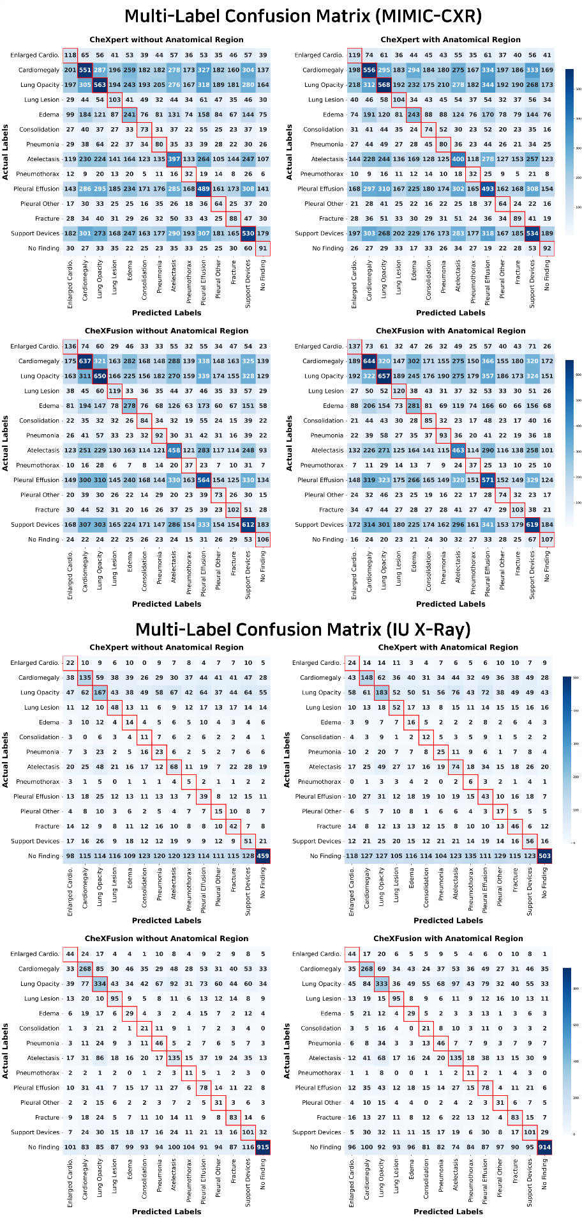
Supplementary Figure S4. Confusion matrices of initial medical report labels from the MIMIC-CXR and IU X-Ray datasets, as evaluated by the CheXbert labeler. Each matrix illustrates agreement and disagreement between predicted and reference labels across diagnostic categories. The abbreviation “Enlarged Cardio.” corresponds to “Enlarged Cardiomediastinum.”

- Ground Truth Report (Readability: 107.7129)

PA and lateral chest views were obtained with patient in upright position. Comparison is made with the next preceding portable AP single view chest examination of ___. The patient is now examined in standing upright position. There is status post sternotomy and significant cardiac enlargement as before. Within the cardiac shadow, metallic portions of three different valve prostheses can be identified. One is a circular metallic ring in the position of the aortic valve, the second one a similar oval-shaped ring formation in the mitral valve position, and the third one an open circle rather typical for a tricuspid valve annuloplasty. Correlating the position of these valves to the outer contours of the heart, one can state that there is remaining marked enlargement of the left atrium, but the increased distance between the tricuspid valvuloplasty and the anterior heart border speaks much in favor of a right ventricular enlargement as well as an enlarged right atrium. Prominence of the ascending aortic contour is moderate. The pulmonary vasculature is presently not congested, and on previous portable examination identified edema pattern as well as evidence of right-sided pleural effusion has normalized. No new parenchymal abnormalities are seen, and no pneumothorax is identified in the apical area. Again observed is a fractured second rib in the left apical area, apparently the result of previous sternotomy and intrathoracic cardiac intervention. When comparison is extended to the next preceding PA and lateral chest examination of ___, the patient is in better condition now as the cardiac enlargement has regressed and the pleural effusion has been absorbed completely.

- Initial Report (Readability: 23.297692)

The lungs are well expanded and clear. No pleural effusion or pneumothorax is seen. The heart size is top-normal. The mediastinal and hilar contours are unremarkable. The aortic valve is again seen to be dilated. The patient is status post median sternotomy with intact sternal wires. A prosthetic aortic valve is seen.

- Target Grade: 6th grade Report (Readability: 5.974885)
We're happy to tell you that your lungs are working well and look healthy. They're not too big or too small, and there's no extra fluid around them. Your heart is a normal size, which is great news. The parts around your heart, like the middle and the areas where the lungs connect, look fine too.

We also looked at your heart valves, and one of them, called the aortic valve, is a bit bigger than it should be. This is something we've seen before, and we'll keep an eye on it to make sure it doesn't cause any problems.

You had surgery on your chest a while back, and the wires that were used to close the cut are still in place. You also have a special artificial valve in your heart that was put there during the surgery. This valve is helping your heart work properly. Here are some important things we found:

1. Your Heart is a Bit Bigger Than Normal: This is called cardiomegaly. It means your heart is a little bigger than it should be. Don't worry, it's not a big problem, but we'll keep an eye on it to make sure it doesn't cause any issues.
2. Tools That Help Your Body Work: We call these support devices. The artificial valve in your heart is an example of a support device. It's like a tool that helps your heart work correctly.

What We Found:
- Your heart is a bit bigger than normal (this is called cardiomegaly).
- You have a special tool in your heart that helps it work properly (this is called a support device).

What We'll Do Next:
- We'll keep checking on your heart to make sure it's working well.
- We'll keep an eye on the aortic valve to make sure it doesn't cause any problems.
Important Things to Know:
- Cardiomegaly: When your heart gets a bit too big. It's not usually a problem, but we'll keep an eye on it.
- Support Devices: Tools that help your body work properly, like the artificial valve in your heart.

What You Should Do:
- If you have any questions or concerns, please don't hesitate to ask us.
- We'll keep you updated on how your heart is doing.

Changes Made:
- Simplified sentences and vocabulary to improve readability.
- Removed unnecessary words and phrases

- Target Grade: 11th grade Report (Readability: 11.3857)
We are pleased to share the results of your recent radiology exam, which show that your lungs and heart are functioning well. The good news is that there is no excess fluid around your lungs, and the space between your lungs and chest wall is clear, indicating that your lungs are in excellent condition.
Your heart is also performing optimally, with a normal size and a healthy appearance. This is a positive sign, as it suggests that your heart is working properly and efficiently.

We are pleased to share the results of your recent radiology exam, which show that your lungs and heart are functioning well. The good news is that there is no excess fluid around your lungs, and the space between your lungs and chest wall is clear, indicating that your lungs are in excellent condition.

Your heart is also performing optimally, with a normal size and a healthy appearance. This is a positive sign, as it suggests that your heart is working properly and efficiently.

During the exam, the doctor noticed that the valve between your heart's chambers is slightly larger than usual. This is something that we will continue to monitor in the future, as it may be a potential area of concern. You had a previous surgery on your chest, and the doctor can still see the wires that were used to close your chest. Additionally, you have a man-made valve in your heart, which is helping it function properly.
The doctor is keeping a close eye on the size of your heart valve because it is slightly larger than normal. We are also aware of the surgery you had and the devices that were used to help your heart work properly. These devices, known as support devices, are playing a crucial role in maintaining your heart's health.
The doctor also checked for a condition called cardiomegaly, which is characterized by an enlarged heart. Fortunately, your heart is a normal size, so you do not have this condition. This is excellent news, as it indicates that your heart is healthy and functioning properly.
We are glad to see that your heart is healthy and working well, thanks to the support devices that were put in place during your surgery. We will continue to monitor your heart and keep a close eye on the size of your heart valve to ensure that it remains healthy and functional.

Key Findings:
- Your lungs are healthy and working well.
- Your heart is a normal size and working properly.
- The doctor is monitoring the size of your heart valve because it's a bit bigger than usual.
- You don't have an enlarged heart, also known as cardiomegaly.
- You have support devices in your heart that are helping it work properly.
- Cardiomegaly: a condition characterized by an enlarged heart.
- Support Devices: artificial devices used to help the heart function properly.

What We'll Do Next:
We will continue to monitor your heart and keep a close eye on the size of your heart valve to ensure that it

- Target Grade: 18th grade Report (Readability: 17.8589)

We took a close look at your chest X-ray, and here's what we found:

Your lungs are working well and are nice and clear, which means you're breathing properly and there's no fluid buildup around your lungs. This is a great sign that your respiratory system is functioning correctly. Your lungs are also not collapsed, which is another positive indicator. Your heart is a normal size, which is fantastic news for your cardiovascular health. The area around your heart and the main blood vessels are also looking healthy.

However, we did notice that your aortic valve, which is one of the valves in your heart, is a bit larger than usual. This might be related to a previous surgery you had, where a new valve was put in. We can see the wires from that surgery are still in place and are holding strong. These wires and the new valve are like support beams for your heart, helping it work properly. They're essentially artificial structures that are assisting your heart in pumping blood efficiently.

We also checked for something called cardiomegaly, which refers to a condition where your heart is larger than usual. But in your case, your heart is a normal size, which is a positive sign for your heart health. This is excellent news, as it indicates that your heart is functioning correctly.
Overall, your chest X-ray looks good, and we don't see any major issues. We'll continue to monitor your heart health and make sure everything stays on track. We'll keep an eye on the support devices that are helping your heart, including the prosthetic aortic valve and the sternal wires from your previous surgery. These devices are doing their job, and we're happy to see that.

Diagnostic Lists:
- Cardiomegaly: This is a condition where your heart is larger than usual. Fortunately, in your case, your heart is a normal size, which is a positive sign for your heart health.
- Support Devices: These are the prosthetic aortic valve and the sternal wires from your previous surgery. They're artificial structures that are assisting your heart in pumping blood efficiently and keeping it working properly.
Note: We've rewritten the report to improve its readability to a higher grade level, meeting the target readability level of 17-18 grade.

Supplementary Figure S5. Example radiology reports demonstrating literacy adaptation across readability levels. Original MIMIC-CXR clinical report, initial automated report generated via CheXFusion with anatomical information, and literacy-adapted reports (6th, 11th, and 18th grade) produced through self-reflective LLM refinement. Flesch-Kincaid Grade Level scores confirm achieved readability targets for each adapted version.

Supplementary Table S1. Descriptions of the 14 clinical findings from MIMIC-CXR extracted by the CheXbert Labeler
Label number | Finding | Description
1 | Atelectasis | Partial or complete collapse of a portion of the lung, resulting from airway obstruction, compression, or post-surgical complications.
2 | Cardiomegaly | Enlargement of the cardiac silhouette, frequently associated with conditions such as hypertension, valvular disease, or heart failure.
3 |  | Replacement of air within the alveoli by fluid (exudate, pus, or blood), typically observed in pneumonia or pulmonary edema.
  Consolidation
4 | Edema | Abnormal fluid accumulation in the alveolar or interstitial spaces, commonly due to cardiac dysfunction (e.g., congestive heart failure) or acute lung injury.
5 | Enlarged Cardiomediastinum | Widening of the mediastinal silhouette, suggesting possible enlargement of cardiac or vascular structures, or the presence of mediastinal masses.
6 | Fracture | Disruption in bone continuity, most commonly involving the ribs, clavicle, or vertebrae within the thoracic region.
7 | Lung Lesion | Any discrete mass or nodule within the lung parenchyma, potentially indicating neoplastic, inflammatory, or infectious processes.
8 | Lung Opacity | Increased radiographic opacity within the lung fields, often indicative of an infiltration, consolidation, or other pathological processes.
9 | No Finding | No abnormal observations are noted on the chest X-ray.
10 | Pleural Effusion | Excessive fluid accumulation in the pleural cavity, caused by infections, malignancies, or systemic diseases such as congestive heart failure.
11 | Pleural Other | Other pleural abnormalities (e.g., pleural thickening) that may indicate previous infections, chronic inflammation, or malignancies.
12 | Pneumonia | Infectious inflammation of the lung tissue, often exhibiting consolidation or diffuse infiltrates along with clinical signs of infection.
13 | Pneumothorax | Presence of air in the pleural space leading to partial or complete collapse of the lung.
14 | Support Devices | Medical devices visible in the chest X-ray (e.g., pacemakers), included to confirm proper placement and identify any malposition
Region Number | Region Name | Region Number | Region Name
1 | abdomen | 20 | mediastinum
2 | aortic arch | 21 | right apical
3 | apex | 22 | right atrium
4 | cardiac silhouette | 23 | right clavicle
5 | carina | 24 | right costophrenic angle
6 | cavoatrial junction | 25 | right hemidiaphragm
7 | left apical | 26 | right hilar structures
8 | left clavicle | 27 | right hilum
9 | left costophrenic angle | 28 | right lower lobe
10 | left hemidiaphragm | 29 | right lower lung
11 | left hilar structures | 30 | right lung base
12 | left hilum | 31 | right middle lobe
13 | left lung base | 32 | right mid lung
14 | left lower lobe | 33 | right upper lobe
15 | left lower lung | 34 | right upper lung
16 | left mid lung | 35 | spine
17 | left upper lobe | 36 | svc
18 | left upper lung | 37 | trachea
19 | lungs | 38 | upper mediastinum
Supplementary Table S2. The 38 clinically relevant anatomical regions (set 𝐴) derived from the MIMIC-CXR training set. Each region serves as a standardized reference point for identifying and localizing radiological findings in chest X-ray interpretations.

Supplementary Table S3. Non-medical participant comprehensibility evaluation results. Average scores and standard deviations for original reports, initial automated reports, and literacy-adapted reports (6th, 11th, and 18th grade) across five assessment criteria using the Radiology Report Understanding Level Assessment Scale on MIMIC-CXR and IU X-Ray datasets.
Dataset | Report | Criteria | Mean | Standard Deviation | Median
MIMIC-CXR | Original | 1 | 0.78 | 0.7 | 1
MIMIC-CXR | Original | 2 | 0.6 | 0.63 | 1
MIMIC-CXR | Original | 3 | 0.78 | 0.77 | 1
MIMIC-CXR | Original | 4 | 0.88 | 0.76 | 1
MIMIC-CXR | Original | 5 | 0.72 | 0.6 | 1
MIMIC-CXR | Initial | 1 | 1 | 0.88 | 1
MIMIC-CXR | Initial | 2 | 0.55 | 0.64 | 0
MIMIC-CXR | Initial | 3 | 0.72 | 0.72 | 1
MIMIC-CXR | Initial | 4 | 0.82 | 0.75 | 1
MIMIC-CXR | Initial | 5 | 0.7 | 0.61 | 1
MIMIC-CXR | 6th grade | 1 | 1.77 | 0.42 | 2
MIMIC-CXR | 6th grade | 2 | 1.98 | 0.16 | 2
MIMIC-CXR | 6th grade | 3 | 1.48 | 0.68 | 2
MIMIC-CXR | 6th grade | 4 | 1.88 | 0.33 | 2
MIMIC-CXR | 6th grade | 5 | 1.65 | 0.48 | 2
MIMIC-CXR | 11th grade | 1 | 1.6 | 0.55 | 2
MIMIC-CXR | 11th grade | 2 | 1.8 | 0.46 | 2
MIMIC-CXR | 11th grade | 3 | 1.27 | 0.68 | 1
MIMIC-CXR | 11th grade | 4 | 1.75 | 0.49 | 2
MIMIC-CXR | 11th grade | 5 | 1.7 | 0.52 | 2
MIMIC-CXR | 18th grade | 1 | 1.35 | 0.58 | 1
MIMIC-CXR | 18th grade | 2 | 1.65 | 0.58 | 2
MIMIC-CXR | 18th grade | 3 | 1.2 | 0.69 | 1
MIMIC-CXR | 18th grade | 4 | 1.7 | 0.56 | 2
MIMIC-CXR | 18th grade | 5 | 1.38 | 0.59 | 1
IU X-Ray | Original | 1 | 0.65 | 0.7 | 1
IU X-Ray | Original | 2 | 0.4 | 0.5 | 0
IU X-Ray | Original | 3 | 0.6 | 0.63 | 1
IU X-Ray | Original | 4 | 0.68 | 0.66 | 1
IU X-Ray | Original | 5 | 0.4 | 0.55 | 0
IU X-Ray | Initial | 1 | 0.8 | 0.72 | 1
IU X-Ray | Initial | 2 | 0.35 | 0.48 | 0
IU X-Ray | Initial | 3 | 0.57 | 0.5 | 1
IU X-Ray | Initial | 4 | 0.7 | 0.76 | 1
IU X-Ray | Initial | 5 | 0.45 | 0.64 | 0
IU X-Ray | 6th grade | 1 | 1.62 | 0.63 | 2
IU X-Ray | 6th grade | 2 | 1.93 | 0.27 | 2
IU X-Ray | 6th grade | 3 | 1.52 | 0.51 | 2
IU X-Ray | 6th grade | 4 | 1.85 | 0.36 | 2
IU X-Ray | 6th grade | 5 | 1.57 | 0.59 | 2
IU X-Ray | 11th grade | 1 | 1.52 | 0.51 | 2
IU X-Ray | 11th grade | 2 | 1.85 | 0.36 | 2
IU X-Ray | 11th grade | 3 | 1.4 | 0.55 | 1
IU X-Ray | 11th grade | 4 | 1.9 | 0.3 | 2
IU X-Ray | 11th grade | 5 | 1.52 | 0.51 | 2
IU X-Ray | 18th grade | 1 | 1.45 | 0.55 | 1
IU X-Ray | 18th grade | 2 | 1.7 | 0.61 | 2
IU X-Ray | 18th grade | 3 | 1.4 | 0.67 | 1.5
IU X-Ray | 18th grade | 4 | 1.7 | 0.61 | 2
IU X-Ray | 18th grade | 5 | 1.5 | 0.68 | 2

Supplementary Table S4. Expert clinician quality evaluation results. Average scores and standard deviations for original reports, initial automated reports, and literacy-adapted reports (6th, 11th, and 18th grade) across four clinical dimensions (image interpretation accuracy, report detail level, interpretation depth, and practicality) using the Artificial Intelligence Radiology Imaging Evaluation Scale on MIMIC-CXR and IU X-Ray datasets.
Dataset | Report | Criteria | Mean | Standard Deviation | Median
MIMIC-CXR | Original | 1 | 4.00 | 1.07 | 4
MIMIC-CXR | Original | 2 | 3.47 | 0.74 | 3
MIMIC-CXR | Original | 3 | 3.80 | 0.77 | 4
MIMIC-CXR | Original | 4 | 4.00 | 0.93 | 4
MIMIC-CXR | Initial | 1 | 4.53 | 0.52 | 5
MIMIC-CXR | Initial | 2 | 3.47 | 1.13 | 4
MIMIC-CXR | Initial | 3 | 4.00 | 0.76 | 4
MIMIC-CXR | Initial | 4 | 3.93 | 0.96 | 4
MIMIC-CXR | 6th grade | 1 | 4.20 | 0.77 | 4
MIMIC-CXR | 6th grade | 2 | 4.07 | 1.03 | 4
MIMIC-CXR | 6th grade | 3 | 4.00 | 1.07 | 4
MIMIC-CXR | 6th grade | 4 | 3.40 | 0.99 | 3
MIMIC-CXR | 11th grade | 1 | 4.33 | 0.62 | 4
MIMIC-CXR | 11th grade | 2 | 4.40 | 0.74 | 4
MIMIC-CXR | 11th grade | 3 | 4.27 | 1.03 | 5
MIMIC-CXR | 11th grade | 4 | 4.13 | 1.06 | 5
MIMIC-CXR | 18th grade | 1 | 4.27 | 0.46 | 4
MIMIC-CXR | 18th grade | 2 | 4.40 | 0.74 | 5
MIMIC-CXR | 18th grade | 3 | 4.27 | 0.88 | 5
MIMIC-CXR | 18th grade | 4 | 3.93 | 0.80 | 4
IU X-Ray | Original | 1 | 4.27 | 1.03 | 5
IU X-Ray | Original | 2 | 3.20 | 1.57 | 4
IU X-Ray | Original | 3 | 3.33 | 1.40 | 4
IU X-Ray | Original | 4 | 3.20 | 1.47 | 4
IU X-Ray | Initial | 1 | 4.40 | 1.24 | 5
IU X-Ray | Initial | 2 | 3.27 | 1.71 | 3
IU X-Ray | Initial | 3 | 3.20 | 1.66 | 3
IU X-Ray | Initial | 4 | 3.33 | 1.50 | 3
IU X-Ray | 6th grade | 1 | 4.47 | 0.64 | 5
IU X-Ray | 6th grade | 2 | 3.80 | 1.15 | 4
IU X-Ray | 6th grade | 3 | 3.80 | 1.37 | 4
IU X-Ray | 6th grade | 4 | 4.20 | 0.94 | 5
IU X-Ray | 11th grade | 1 | 4.47 | 0.74 | 5
IU X-Ray | 11th grade | 2 | 4.07 | 1.28 | 5
IU X-Ray | 11th grade | 3 | 3.87 | 1.30 | 4
IU X-Ray | 11th grade | 4 | 3.67 | 1.23 | 3
IU X-Ray | 18th grade | 1 | 4.20 | 0.94 | 5
IU X-Ray | 18th grade | 2 | 3.93 | 1.33 | 5
IU X-Ray | 18th grade | 3 | 3.93 | 1.33 | 5
IU X-Ray | 18th grade | 4 | 4.00 | 1.36 | 5

Ablation Studies
To validate the contribution of our self-reflective mechanism, we conducted comprehensive ablation studies examining both system-level comparisons and component-specific contributions. We compared our complete self-reflective framework against static baseline generation and evaluated constrained variants with reduced functionality.

Static vs. Self-reflective Comparison: We compared our complete self-reflective framework against a static baseline (single-pass generation without iterative refinement) using identical sinput data and evaluation metrics. Results demonstrate that the self-reflective mechanism significantly improved readability alignment with target levels. For the MIMIC-CXR dataset, the deviation from target readability decreased by 5.62 points for 6th-grade reports, 2.74 points for 11th-grade reports, and 3.42 points for 18th-grade reports. For the IU X-Ray dataset, corresponding improvements were 3.59 points, 0.68 points, and 5.56 points, respectively. Critically, these readability improvements were achieved while maintaining equivalent clinical accuracy, demonstrating that our self-reflective approach successfully enhances patient comprehension without compromising diagnostic precision.

Component Contribution Analysis: Rather than complete module removal, which would fundamentally alter system functionality, we implemented constrained variants to assess component contributions: (a) converter-only baseline without self-reflection capabilities, (b) single-iteration processing without memory retention, and (c) fixed-template evaluation without adaptive feedback. These variants demonstrated substantial performance degradation in achieving target readability levels. On the MIMIC-CXR dataset, deviations from target readability increased by 84.01% (from 6.69 to 12.31 points), 61.73% (from 6.69 to 10.82 points), and 19.88% (from 6.69 to 8.02 points) for variants (a), (b), and (c), respectively. Similarly, on the IU X-Ray dataset, deviations increased by 47.24% (from 7.60 to 11.19 points), 69.47% (from 7.60 to 12.88 points), and 3.68% (from 7.60 to 7.88 points), respectively. These results validate that each component of our self-reflective mechanism contributes significantly to achieving target readability levels, with memory retention and self-reflection capabilities being particularly critical for performance.

Target Adherence Analysis: Our ablation studies provide direct quantitative validation of the self-reflective mechanism's effectiveness. Without self-reflection, reports failed to meet target readability specifications in 91.14%, 75.66%, and 65.32% of cases for 6th, 11th, and 18th-grade levels on MIMIC-CXR, and 96.03%, 89.98%, and 83.94% on IU X-Ray, respectively. In contrast, our complete framework achieved substantially higher adherence rates of 75.90% on MIMIC-CXR and 37.85% on IU X-Ray while maintaining diagnostic accuracy. Additionally, human expert evaluation (n=10 participants) confirmed superior readability ratings for self-reflective outputs compared to static generation.

These comprehensive ablation studies provide direct quantitative evidence that: (i) The self-reflective mechanism substantially improves readability alignment with target levels; (ii) Each component (reflection capability, memory retention, adaptive feedback) contributes significantly to performance; (iii) Iterative refinement with memory retention is particularly critical for convergence; (iv) Readability improvements are achieved without compromising clinical accuracy. The lower adherence rates on IU X-Ray compared to MIMIC-CXR may reflect dataset-specific characteristics, including smaller sample size and different report complexity distributions, warranting further investigation in future work.

Supplementary Table S5. Clinical accuracy (CA) and readability scores assessed at the 6th, 11th, and 18th-grade levels for reports generated on the MIMIC-CXR and IU X-Ray datasets. Results are reported for both the static baseline model (single-pass generation) and the proposed self-reflective framework (iterative refinement), highlighting differences in clinical reliability and linguistic accessibility.
Dataset | Metric | 6th |  | 11th |  | 18th
Dataset | Metric | Baseline | Self-reflective | Baseline | Self-reflective | Baseline | Self-reflective
MIMIC-CXR | CA | 0.9183 | 0.9588 | 0.9082 | 0.9542 | 0.9094 | 0.9529
MIMIC-CXR | Readability | 12.31 | 6.69 | 13.70 | 10.96 | 14.39 | 17.81
IU X-Ray | CA | 0.9733 | 0.9884 | 0.9224 | 0.9473 | 0.9210 | 0.9384
IU X-Ray | Readability | 11.19 | 7.60 | 11.67 | 10.99 | 12.20 | 17.76

Supplementary Table S6. Readability scores from the ablation study on the MIMIC-CXR and IU X-Ray datasets. Four experimental conditions are compared: (a) converter-only baseline without reflection capabilities, (b) single-iteration processing without memory retention, (c) fixed-template evaluation without adaptive feedback, and (d) the proposed self-reflective framework. These results highlight the contribution of iterative refinement and adaptive feedback to improved report readability.
Dataset |  | Ablation Settings |  |  |  |  | Readability
Dataset | Variant | Converter | Evaluation | Self-reflection | Memory | Iteration | Readability
MIMIC-CXR | (a) Converter-only | ✓ | ✗ | ✗ | ✗ | ✗ | 12.31
MIMIC-CXR | (b) Single-iteration | ✓ | ✓ | ✓ | ✓ | ✗ | 10.82
MIMIC-CXR | (c) Fixed-template | ✓ | ✓ | ✓ | ✗ | ✓ | 8.02
MIMIC-CXR | (d) Complete framework | ✓ | ✓ | ✓ | ✓ | ✓ | 6.69
IU X-Ray | (a) Converter-only | ✓ | ✗ | ✗ | ✗ | ✗ | 11.19
IU X-Ray | (b) Single-iteration | ✓ | ✓ | ✓ | ✓ | ✗ | 12.88
IU X-Ray | (c) Fixed-template | ✓ | ✓ | ✓ | ✗ | ✓ | 7.88
IU X-Ray | (d) Complete framework | ✓ | ✓ | ✓ | ✓ | ✓ | 7.60

