Appendix
Supplementary Materials 1
The analyses were performed based on raw signal values (with data points above 3 SD removed – see Method section for details), baseline-corrected and segmented into periods of 1 seconds across each of the 6 seconds of stimuli presentation.
Zygomaticus
The 2 (emotional display: anger vs happiness) x 2 (facial resemblance: self vs other) x 6 (time epochs: 1, 2, 3, 4, 5, and 6 seconds) ANOVA was conducted, Greenhouse-Geisser corrections were applied where necessary. The analysis showed a significant main effect of emotional display, F(1, 54) = 10.37; p = .002, η_{p}² = .16, and the main effect of time, F(1.44, 77.62) = 4.48; p =.025, η_{p}² = .08, while there was no significant effect of facial resemblance, F(1, 54) = 0.005; p = .94, η_{p}² < .01. Additionally there were significant interactions between emotional display and resemblance, F(1, 54) = 5.79; p = .020, η_{p}² = .10, and 3-way interaction between all factors, F(1.70, 91.62) = 3.61; p = .038, η_{p}² = .06.
To further decompose the 3-way interaction, analyses were conducted separately for each emotional display. For the angry displays, the main effect of facial resemblance was significant, F(1, 54) = 8.57; p = .005, η_{p}² = .14, as well as main effect of time, F(1.68, 90.87) = 4.69; p = .016, η_{p}² = .08, while the interaction was marginally insignificant, F(2.07, 111.62) = 2.91; p = .057, η_{p}² = .05. Simple main effect analysis showed significant effect of time for other-resembling faces, F(5, 270) = 4.65 p = .001, and self-resembling faces, F(5, 270) = 3.65; p = .003, with a significant differences between those two starting from the 2nd second (all Fs (1, 54) > 5.19; all ps < .028).
While for the happy expression there was a significant main effects of resemblance, F(1, 54) = 6.75; p = .012, η_{p}² = .11, and time F(1.37, 74.07) = 3.96, p = .039; η_{p}² = .07, while the interaction was marginally insignificant, F(1.90, 102.58) = 2.74; p = .072, η_{p}² = .05. Simple main effect analysis showed significant effect of time for other-resembling faces, F(5, 270) = 2.51 p = .030, and self-resembling faces, F(5, 270) = 4.22; p = .001, with significant differences between 2nd and 5th seconds (all Fs (1, 54) > 4.54; all ps < .038).
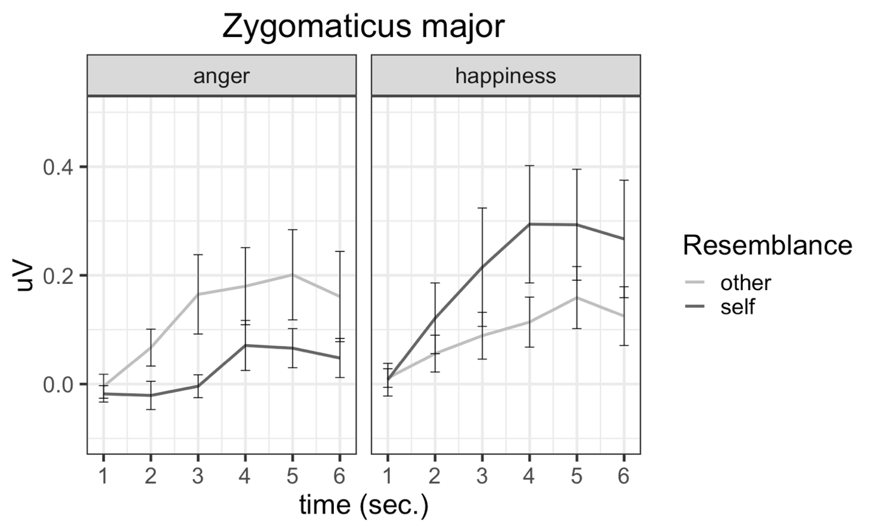

Figure S1. EMG changes (i.e., baseline corrected values) of Zygomaticus major activity as a function of observed face resemblance and emotional display. Error bars depict SE of the mean.

Corrugator
The 2 (emotional display: anger vs happiness) x 2 (facial resemblance: self vs other) x 6 (time epochs: 1, 2, 3, 4, 5, and 6 seconds) ANOVA, similarly to the Zygomaticus analysis, revealed significant effect of emotional display, F(1,54) = 22.79, p < .001, η_{p}² = .30, but not time, F(1.72, 93.12) = 0.77; p =.448, η_{p}² = .01, nor the facial resemblance, F(1,54) = 0.32; p = .572, η_{p}² = .01. Additionally, there were significant interactions between emotional display and facial resemblance, F(1, 54) = 12.25; p < .001, η_{p}² = .19, emotional display and time, F(3.11, 167.90) = 8.64; p < .001, η_{p}² = .14, as well as a 3-way interaction, F(1.64, 88.52) = 5.46; p = .009, η_{p}² = .09.
Separate analyses for each emotional display, i.e., 2 (facial resemblance) x 6 (time), in case of anger display showed a significant main effect of facial resemblance, F(1, 54) = 10.69, p = .002, η_{p}² = .17, as well as significant interaction, F(1.89, 101.99) = 5.14; p = .009, η_{p}² = .09, but the main effect of time was not significant time, F(1.75, 94.23) = 2.84; p = .071, η_{p}² = .05. Simple main effect analysis indicated significant effect of time for self-resembling faces, F(5, 270) = 4.31; p < .001, but no for other-resembling faces, F(5, 270) = 0.61 p = .669. Differences in muscle activation started from the 1st second of stimuli presentation (all Fs (1, 54) > 5.85; all ps < .020).
For displays of happiness, the analysis showed a significant main effect of facial resemblance, F(1, 54) = 15.90, p < .001, η_{p}² = .23, time F(2.19, 118.11) = 9.47; p < .001, η_{p}² = .15, and interaction, F(2.41, 118.11) = 9.84; p < .001, η_{p}² = .15. Simple main effect analysis revealed changes in muscle activation over time only in response to self-resembling faces, F(5, 270) = 8.81; p < .001, while significant differences between two conditions started from the 2nd second of stimuli presentation (all Fs (1, 54) > 4.34; all ps < .043).
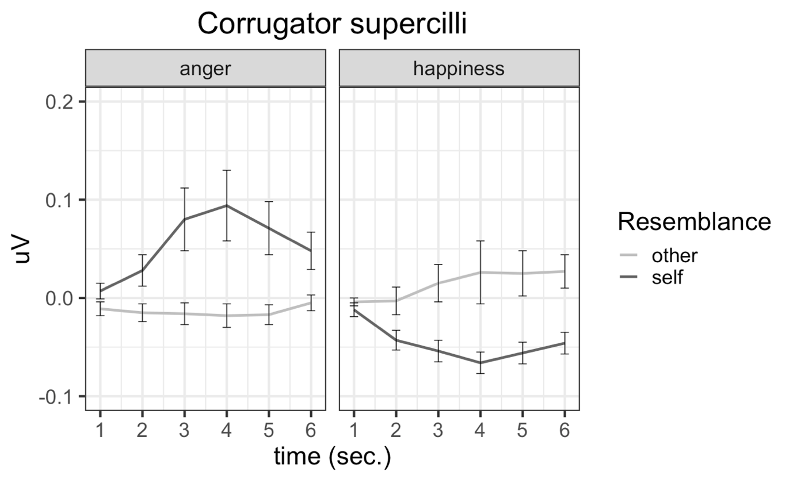
Figure S2. EMG changes (i.e., baseline corrected values) of Corrugator supercilli activity as a function of observed face resemblance and emotional display. Error bars depict SE of the mean.

