Appendix:
Supplemental Materials
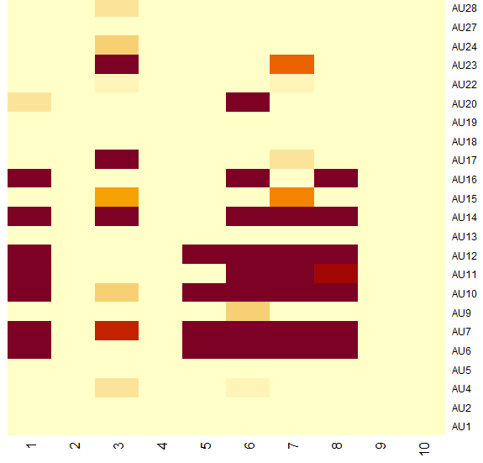
Supplemental Figure 1. The y-axis represents the type of AU, and the x-axis represents the type of AU pattern. Estimation of AU patterns from the EB+ dataset using the Beta–Dirichlet model with a collapsed Gibbs sampler. Estimated values of W are in the range 0–1. The darker the color, the stronger the factor loading. For example, for AU pattern 2 no factor loading occurs in any AU; thus, it can be interpreted as an unnecessary synergy for describing the observed facial expression pattern.

Supplemental Table 1. Results for all transition matrix cells obtained using a hierarchical model with a random intercept.
From | To | Fixed effects | Estimate | df | t | raw p
State 1 | State 1 | Intercept | 0.82 | 436.16 | 29.49 | 0.00
 |  | vs Emba | -0.03 | 376.94 | -0.97 | 0.34
 |  | vs Pain | -0.52 | 375.03 | -16.85 | 0.00
State 1 | State 2 | Intercept | 0.02 | 563.68 | 4.43 | 0.00
 |  | vs Emba | 0.01 | 388.25 | 1.27 | 0.20
 |  | vs Pain | 0.00 | 384.62 | -0.33 | 0.74
State 1 | State 3 | Intercept | 0.00 | 570.00 | 0.00 | 1.00
 |  | vs Emba | 0.00 | 570.00 | 1.21 | 0.23
 |  | vs Pain | 0.00 | 570.00 | 0.30 | 0.76
State 1 | State 4 | Intercept | 0.00 | 197.10 | 1.10 | 0.27
 |  | vs Emba | 0.00 | 375.10 | 0.61 | 0.54
 |  | vs Pain | 0.00 | 375.10 | -0.84 | 0.40
State 1 | State 5 | Intercept | 0.02 | 456.04 | 3.36 | 0.00
 |  | vs Emba | 0.00 | 383.87 | 0.58 | 0.56
 |  | vs Pain | -0.01 | 381.84 | -0.97 | 0.33
State 2 | State 1 | Intercept | 0.04 | 539.70 | 9.04 | 0.00
 |  | vs Emba | 0.00 | 380.10 | -0.11 | 0.91
 |  | vs Pain | -0.03 | 377.00 | -4.42 | 0.00
State 2 | State 2 | Intercept | 0.82 | 554.59 | 34.87 | 0.00
 |  | vs Emba | 0.02 | 377.52 | 0.73 | 0.47
 |  | vs Pain | -0.34 | 374.03 | -10.83 | 0.00
State 2 | State 3 | Intercept | 0.02 | 564.10 | 4.73 | 0.00
 |  | vs Emba | 0.00 | 387.30 | 0.87 | 0.39
 |  | vs Pain | 0.01 | 383.70 | 2.07 | 0.04
State 2 | State 4 | Intercept | 0.00 | 570.00 | 0.00 | 1.00
 |  | vs Emba | 0.00 | 570.00 | 0.35 | 0.73
 |  | vs Pain | 0.00 | 570.00 | 1.28 | 0.20
State 2 | State 5 | Intercept | 0.03 | 282.00 | 5.33 | 0.00
 |  | vs Emba | 0.01 | 357.80 | 1.66 | 0.10
 |  | vs Pain | 0.00 | 357.00 | 0.05 | 0.96
State 3 | State 1 | Intercept | 0.00 | 570.00 | 0.54 | 0.59
 |  | vs Emba | 0.00 | 570.00 | 0.80 | 0.42
 |  | vs Pain | 0.00 | 570.00 | -0.24 | 0.81
State 3 | State 2 | Intercept | 0.02 | 488.81 | 4.77 | 0.00
 |  | vs Emba | 0.01 | 351.92 | 2.55 | 0.01
 |  | vs Pain | -0.01 | 349.15 | -1.17 | 0.24
State 3 | State 3 | Intercept | 0.64 | 509.28 | 22.36 | 0.00
 |  | vs Emba | 0.09 | 382.06 | 2.66 | 0.01
 |  | vs Pain | 0.12 | 379.40 | 3.68 | 0.00
State 3 | State 4 | Intercept | 0.01 | 570.00 | 2.31 | 0.02
 |  | vs Emba | 0.00 | 570.00 | 0.64 | 0.52
 |  | vs Pain | 0.02 | 570.00 | 2.64 | 0.01
State 3 | State 5 | Intercept | 0.02 | 530.17 | 5.86 | 0.00
 |  | vs Emba | 0.01 | 384.63 | 3.37 | 0.00
 |  | vs Pain | -0.01 | 381.70 | -1.48 | 0.14
State 4 | State 1 | Intercept | 0.00 | 569.20 | 2.06 | 0.04
 |  | vs Emba | 0.00 | 389.70 | -1.13 | 0.26
 |  | vs Pain | 0.00 | 385.70 | -1.43 | 0.15
State 4 | State 2 | Intercept | 0.00 | 554.40 | 2.33 | 0.02
 |  | vs Emba | 0.00 | 387.60 | -1.30 | 0.20
 |  | vs Pain | 0.00 | 384.30 | -1.39 | 0.16
State 4 | State 3 | Intercept | 0.01 | 568.70 | 2.69 | 0.01
 |  | vs Emba | 0.01 | 388.80 | 2.03 | 0.04
 |  | vs Pain | 0.00 | 384.90 | 0.35 | 0.73
State 4 | State 4 | Intercept | 0.52 | 465.66 | 16.32 | 0.00
 |  | vs Emba | -0.02 | 380.02 | -0.63 | 0.53
 |  | vs Pain | 0.27 | 377.85 | 7.51 | 0.00
State 4 | State 5 | Intercept | 0.01 | 522.06 | 5.14 | 0.00
 |  | vs Emba | 0.01 | 383.88 | 2.65 | 0.01
 |  | vs Pain | 0.00 | 381.06 | -0.97 | 0.33
State 5 | State 1 | Intercept | 0.03 | 570.00 | 6.79 | 0.00
 |  | vs Emba | -0.01 | 570.00 | -0.92 | 0.36
 |  | vs Pain | -0.02 | 570.00 | -3.77 | 0.00
State 5 | State 2 | Intercept | 0.02 | 570.00 | 6.20 | 0.00
 |  | vs Emba | 0.00 | 570.00 | 0.31 | 0.76
 |  | vs Pain | -0.01 | 570.00 | -1.42 | 0.16
State 5 | State 3 | Intercept | 0.01 | 400.70 | 2.52 | 0.01
 |  | vs Emba | 0.00 | 197.60 | 0.42 | 0.68
 |  | vs Pain | 0.01 | 194.80 | 1.11 | 0.27
State 5 | State 4 | Intercept | 0.01 | 564.70 | 2.61 | 0.01
 |  | vs Emba | 0.00 | 371.30 | 0.46 | 0.65
 |  | vs Pain | 0.01 | 367.40 | 3.34 | 0.00
State 5 | State 5 | Intercept | 0.01 | 522.06 | 5.14 | 0.00
 |  | vs Emba | 0.01 | 383.88 | 2.65 | 0.01
 |  | vs Pain | 0.00 | 381.06 | -0.97 | 0.33

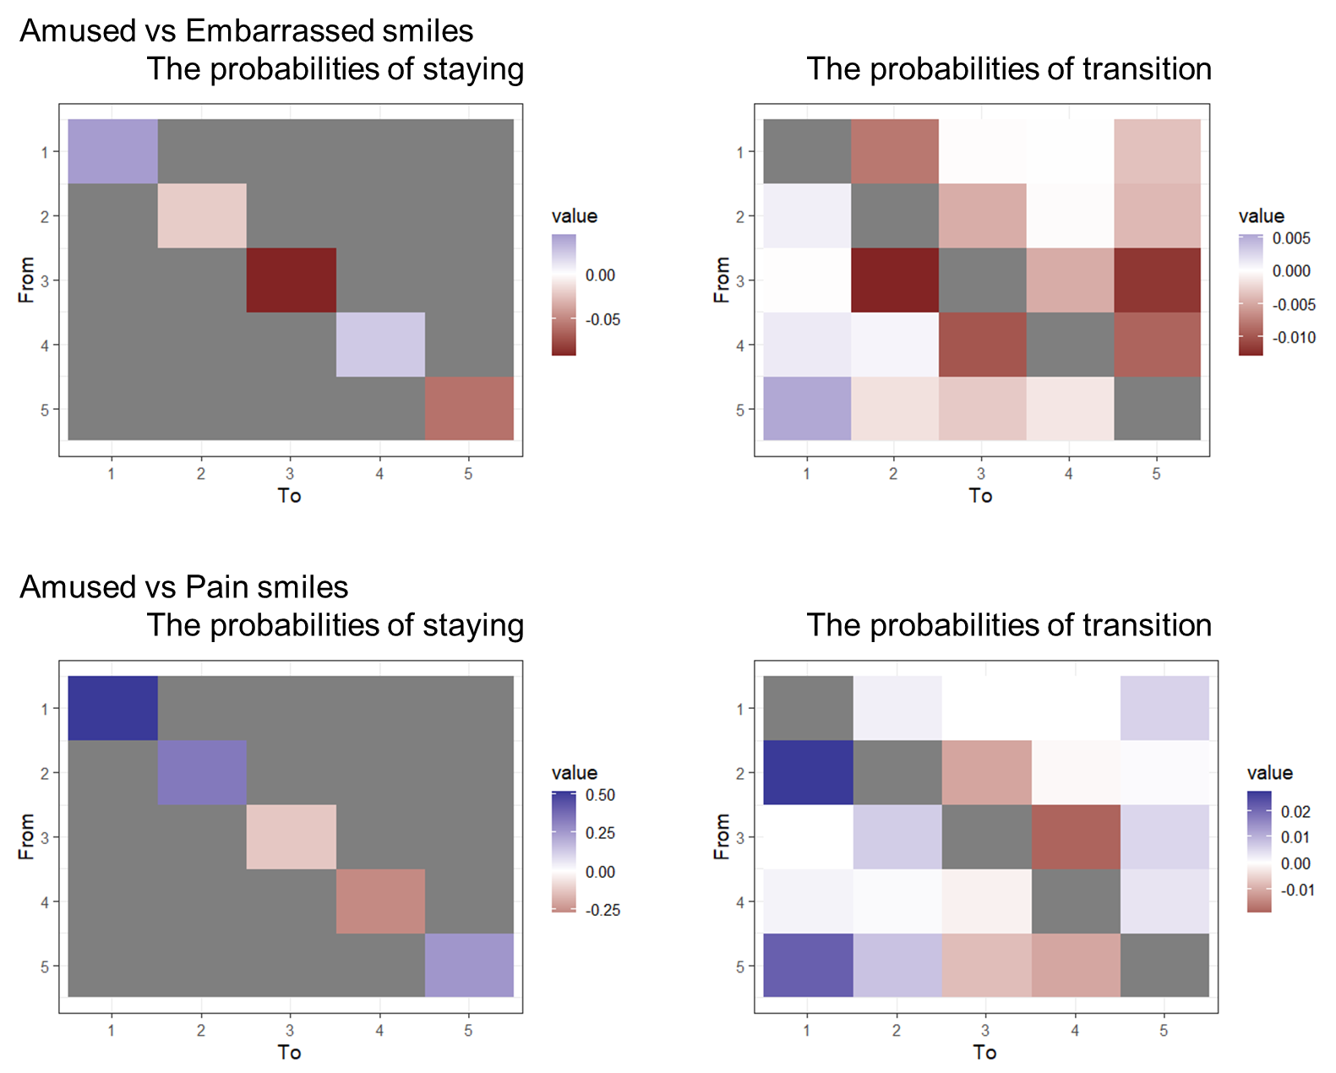

Supplemental Figure 2. Heatmap of the transition matrix for amused, embarrassed, and pained smiles. The upper row concerns the transition between amused and embarrassed smiles, and the lower row the transition between amused and pained smiles. The left column represents the probability of staying in a given state, and the right column represents the probability of transitioning. Blue and red colors indicate high and low probabilities, respectively, of an amused smile relative to other smile types.

