Supplemental Materials

The Role of Contextual Information in Classifying Spontaneous Social Laughter
Magdalena Rychlowska¹, Gary J McKeown¹, Ian Sneddon¹, & Will Curran¹
¹ School of Psychology, Queen’s University Belfast

Author note
The authors made the following contributions. Magdalena Rychlowska: Conceptualization, Writing - Original Draft Preparation, Writing - Review & Editing; Gary J McKeown: Conceptualization, Writing - Original Draft Preparation, Writing - Review & Editing; Ian Sneddon: Conceptualization, Writing - Review & Editing; Will Curran: Conceptualization, Writing - Review & Editing.
Correspondence concerning this article should be addressed to Magdalena Rychlowska, School of Psychology, Queen’s University Belfast, David Keir Building, 18-30 Malone Rd, Belfast BT9 5BN. E-mail: m.rychlowska@qub.ac.uk

Pilot Study – Laughter Induction Contexts

Fifty subjects (age M = 19.88, SD = 4.25; 44 females) completed the study (see https://osf.io/x4kgv/ for the questionnaire and data), evaluating the extent to which three laughter production contexts were associated with feelings of amusement, embarrassment, and being pleased (in line with the theoretical accounts of schadenfreude, Smith, 2013). The amusement vignette described a person whose teammate misreads a tongue twister. The embarrassment vignette described a person who has to draw the word “defecation” in a Pictionary game. The schadenfreude vignette describes a person seeing an opponent losing a round of a Bop It game. Participants used 100-point sliders to indicate the extent to which the person presented in the vignette was likely to feel amused, embarrassed, pleased, or to feel another emotion/ no emotion.

Ratings of emotions for the amusement vignette (tongue twister) were significantly affected by the emotion targeted in each question, F(3, 135) = 12.73, p < .001, ηp² = .22. Contrast 1, coding the difference of interest (3, amusement, -1, embarrassment, -1, pleasure, -1, other; ratings of amusement being higher than ratings of embarrassment, pleasure, or other emotion) was also significant, F(1, 45) = 39.64, p < .001, ηp² = .47. The other contrasts (Contrast 2: 0, 2, -1, -1; Contrast 3: 0, 0, 1, -1) were not significant, F(1, 45) < .001, p = .99, ηp² < .001 and F(1, 45) = 0.97, p = .33, ηp² = .02, respectively.

Ratings of emotions for the embarrassment vignette (Pictionary) were significantly affected by the emotion targeted in each question, F(3, 141) = 39.74, p < .001, ηp² = .46. Contrast 1, coding the difference of interest (3, embarrassment, -1, amusement, -1, pleasure, -1, other; ratings of embarrassment being higher than ratings of amusement, pleasure, or other emotion) was also significant, F(1, 47) = 51.81, p < .001, ηp² = .52. The other contrasts (Contrast 2: 0, 2, -1, -1; Contrast 3: 0, 0, 1, -1) were also significant, F(1, 47) = 46.57, p < .001, ηp² = .50 and F(1, 47) = 8.63, p = .005, ηp² = .15, respectively.

Ratings of emotions for the schadenfreude vignette (Bop It) were significantly affected by the emotion targeted in each question, F(3, 138) = 73.74, p < .001, ηp² = .62. Contrast 1, coding the difference of interest (3, pleasure, -1, amusement, -1, embarrassment, -1, other; ratings of pleasure being higher than ratings of amusement, pleasure, or other emotion) was also significant, F(1, 46) = 104.83, p < .001, ηp² = .69. The other contrasts (Contrast 2: 0, 2, -1, -1; Contrast 3: 0, 0, 1, -1) were also significant, F(1, 46) = 83.11, p < .001, ηp² = .64 and F(1, 46) = 22.74, p < .001, ηp² = .33, respectively.

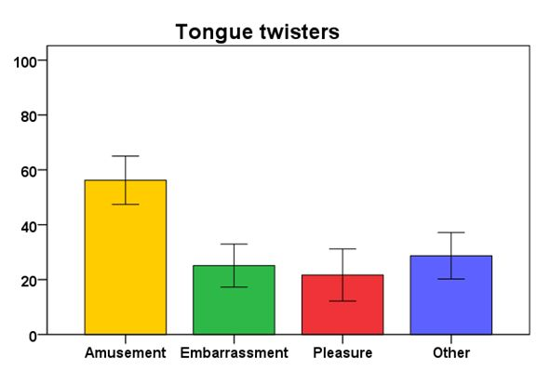

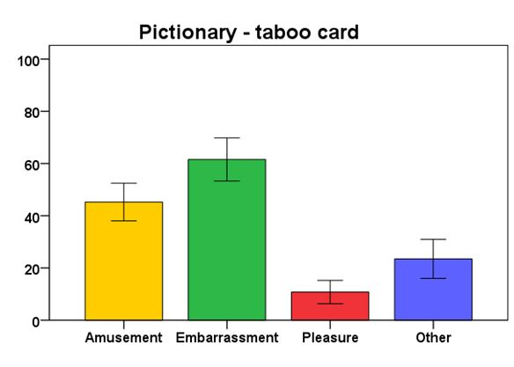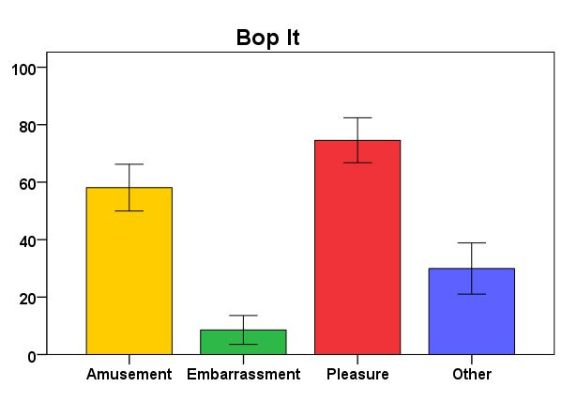

Effects of Experimental Condition and Laughter Production Context on Wagner’s Unbiased Hit Rates

As an alternative measure to using d prime we also provide the results of the experiment using Wagner’s Unbiased Hit Rates $H_{U}$ to classify participants’ classification accuracy. A problem arises in the calculation of $d'$ when the values of the hit rate or the false alarm rate are equal to one or zero. To overcome this issue Hautus (1995) suggested using a log-linear rule transformation. This correction is applied in the main analysis reported in the target article. In the case of Wagner’s unbiased hit rate there is no readily available correction for this problem, therefore participants with extreme proportions of either one or zero are excluded from the current analysis. The results were similar to those of $d'$ with some differences as detailed here. We again used a random-intercepts mixed-effects model, similar to a 4 (experimental condition: audio, audio-visual, side-by-side, vignette) x 3 (laughter production context: amusement, embarrassment, schadenfreude) mixed ANOVA. Both predictors were similarly coded using deviation coding (condition: 0.75, -0.25, -0.25, -0.25; laughter context: 0.66, -0.33, -0.33) and we used the maximal random effects structure for this design. Similar to the results reported in the main article, the analysis showed a significant main effect of the experimental condition, $F\left(3,187\right)=44.98,p<.001,η_{p}^{2}=0.42$, such that the unbiased hit rate was highest for the vignette condition $\left(M=0.30,SE=0.01\right)$ and the side-by-side condition $\left(M=0.27,SE=0.01\right)$, lower for the audio-visual condition $\left(M=0.15,SE=0.01\right)$, and lowest for the audio condition $\left(M=0.11,SE=0.01\right)$. In line with the analyses using the $d'$ sensitivity scores, accuracy also varied significantly across the three laughter production contexts, $F\left(2,317\right)=147.29,p<.001,η_{p}^{2}=0.48$, with $H_{U}$ values being highest for laughs produced in the embarrassment context $\left(M=0.32,SE=0.01\right)$ than for the amusement context $\left(M=0.23,SE=0.01\right)$ and the schadenfreude context $\left(M=0.08,SE=0.01\right)$. Again, there was a significant interaction between experimental condition and context, $F\left(6,315\right)=31.21,p<.001,η_{p}^{2}=0.37$. We therefore examined the effects of experimental condition separately for each laughter production context. Figure S1 shows the estimated marginal means of $H_{U}$ values as a function of experimental condition and laughter production context for the model.
Figure S1
Interaction Plot Showing the Estimated Marginal Means of Wagner’s Unbiased Hit Rate in Each Condition
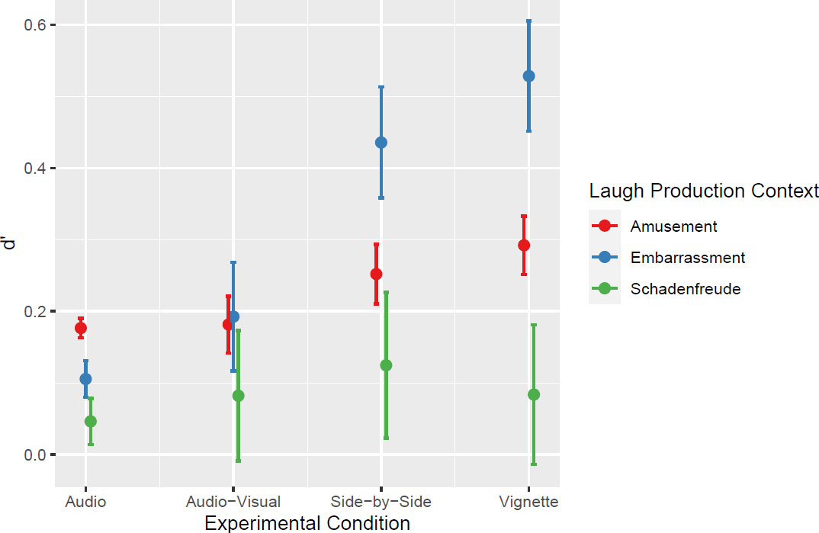

The classification of laughs produced in the amusement context was significantly affected by the experimental condition, $F\left(3,199\right)=12.27,p<.001,η^{2}=0.16$ such that $H_{U}$ values were highest in the vignette condition $\left(M=0.29,SE=0.02\right)$, intermediate in the side-by-side condition $\left(M=0.25,SE=0.02\right)$, and lowest in the audio-visual $\left(M=0.18,SE=0.02\right)$, and audio $\left(M=0.18,SE=0.02\right)$ conditions. The differences between audio and side-by-side and audio and vignette conditions were significant, t(199) = -3.27, p =.007 and t(199) = -5.11, p < .001, respectively. The differences between the audio-visual and side-by-side conditions and audio-visual and vignette conditions were significant, t(199) = -3.06, p =.013 and t(199) =-4.91, p < .001, respectively. Table S1 below shows all pairwise comparisons across experimental conditions for the amusement context. All comparisons were calculated using Tukey adjustments.
Table S1
Pairwise Comparisons between the Estimated Marginal Means for Hu Across Experimental Conditions in the Amusement Laughter Production Context.
Comparison | Difference | SE | df | t | p
Audio – Audio-visual | 0.00 | 0.02 | 199 | -0.22 | 1.00
Audio - Side by Side | -0.07 | 0.02 | 199 | -3.27 | 0.01
Audio - Vignette | -0.12 | 0.02 | 199 | -5.11 | < 0.001
Audio-visual - Side by Side | -0.07 | 0.02 | 199 | -3.06 | 0.01
Audio-visual - Vignette | -0.11 | 0.02 | 199 | -4.91 | < 0.001
Side by Side - Vignette | -0.04 | 0.02 | 199 | -1.83 | 0.26

A similar trend was observed for laughs produced in the embarrassment context, $F\left(3,198\right)=77.16,p<.001,η^{2}=0.54$ with more marked differences between experimental conditions. Again, accuracy was highest in the vignette condition $\left(M=0.53,SE=0.02\right)$, followed by the side-by-side condition $\left(M=0.44,SE=0.02\right)$, and the audio-visual condition $\left(M=0.19,SE=0.02\right)$, and lowest in the audio condition $\left(M=0.11,SE=0.02\right)$. The differences between audio and side-by-side conditions and audio and vignette conditions were significant, t(198) = -10.30, p < .001 and t(198) = -13.17, p < .001, respectively. The same was true for the differences between audio-visual and side-by-side and vignette conditions, t(198) = -7.62, p < .001, and t(198) = -10.48, p < .001, respectively. The difference between side-by-side and vignette was also significant, t(198) = -2.85, p =.025). Table S2 shows all pairwise comparisons across experimental conditions for the embarrassment context.
Table S2
Pairwise Comparisons between the Estimated Marginal Means for Hu Across Experimental Conditions in the Embarrassment Laughter Production Context.
Comparison | Difference | SE | df | t | p
Audio – Audio-visual | -0.09 | 0.03 | 198 | -2.70 | 0.04
Audio - Side by Side | -0.33 | 0.03 | 198 | -10.30 | < 0.001
Audio - Vignette | -0.42 | 0.03 | 198 | -13.17 | < 0.001
Audio-visual - Side by Side | -0.24 | 0.03 | 198 | -7.62 | < 0.001
Audio-visual - Vignette | -0.34 | 0.03 | 198 | -10.48 | < 0.001
Side by Side - Vignette | -0.09 | 0.03 | 198 | -2.85 | 0.02

In the schadenfreude context, there was a significant main effect of experimental condition, $F\left(3,112\right)=5.73,p=.001,η^{2}=0.13$. This time, the side-by-side condition showed the highest level of accuracy $\left(M=0.13,SE=0.02\right)$, with the vignette $\left(M=0.07,SE=0.01\right)$ and audio-visual $\left(M=0.07,SE=0.01\right)$, conditions having lower accuracy than side-by-side. Accuracy was lowest in the audio condition $\left(M=0.04,SE=0.01\right)$. The differences between audio and side-by-side were significant, t(112) =-4.14, p < .001. The differences between audio-visual and side-by-side were also significant t(112) =-2.62, p = .049. Table S3 shows all pairwise comparisons across experimental conditions for the schadenfreude context.
Table S3
Pairwise Comparisons between the Estimated Marginal Means for Hu Across Experimental Conditions in the Schadenfreude Laughter Production Context.
Comparison | Difference | SE | df | t | p
Audio – Audio-visual | -0.03 | 0.02 | 112 | -1.57 | 0.40
Audio - Side by Side | -0.08 | 0.02 | 112 | -4.14 | < 0.001
Audio - Vignette | -0.03 | 0.02 | 112 | -1.59 | 0.39
Audio-visual - Side by Side | -0.05 | 0.02 | 112 | -2.62 | 0.05
Audio-visual - Vignette | 0.00 | 0.02 | 112 | -0.10 | 1.00
Side by Side - Vignette | 0.05 | 0.02 | 112 | 2.40 | 0.08

References
Smith, R. (2013). The joy of pain. Oxford University Press.
Wagner, H. (1993). On measuring performance in category judgment studies of nonverbal behavior. Journal Of Nonverbal Behavior, 17(1), 3-28. doi: 10.1007/bf00987006

