Appendix A: Accuracy Rating Analysis in Direct Replies, Lie Replies, and Neutral Replies

Accuracy Rating Analysis in Direct Replies
A 2 (rater: British, Chinese) x 2 (model: British, Chinese) ANOVA was conducted on the categorization accuracy of direct replies. There was no main effect of rater culture (F (1, 158) = 0.35, p = .557, η_{p}² = 0.002), or model culture (F (1, 158) = 1.09, p = .298, η_{p}² = 0.01), and no significant interaction between rater and model culture (F (1, 158) = .49, p = .487, η_{p}² = 0.003; see Figure 1 for descriptive statistics).
Figure 1
Mean accuracy of direct categorization of British and Chinese models from British and Chinese raters. Error bars represent standard errors.
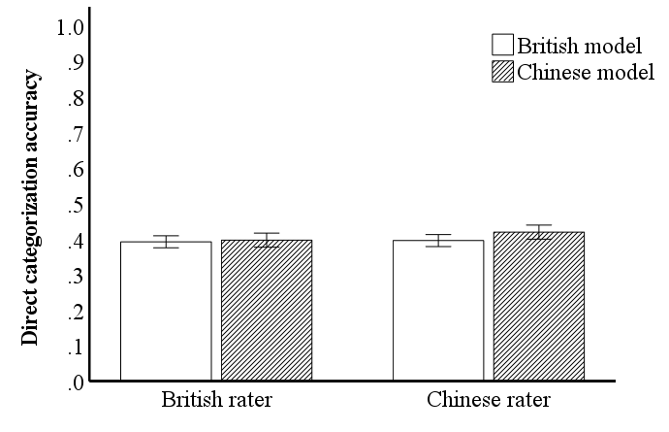

Accuracy Rating Analysis in Lie Replies
A 2 (rater: British, Chinese) x 2 (model: British, Chinese) ANOVA was conducted on the categorization accuracy of lie replies. There was a main effect of rater culture (F (1, 158) = 12.89, p < .001, η_{p}² = 0.08). There was no main effect of model culture (F (1, 158) = 2.85, p = .093, η_{p}² = 0.02). There was a significant interaction between rater and model culture (F (1, 158) = 10.75, p = .001, η_{p}² = 0.06; see Figure 2 for descriptive statistics). Bonferroni corrected posthoc t-tests, with a corrected alpha level at p =.013, showed that British raters were more accurate in identifying lie replies from British models compared to Chinese models (p < .001), whereas Chinese raters performed equally well in categorizing lie replies of British and Chinese models (p = .262). Additionally, British raters' accuracy in identifying lie replies of British models was significantly higher than that of Chinese raters for both British models (p < .001) and Chinese models (p < .001).

Figure 2
Mean accuracy of lie categorization of British and Chinese models from British and Chinese raters. Error bars represent standard errors.
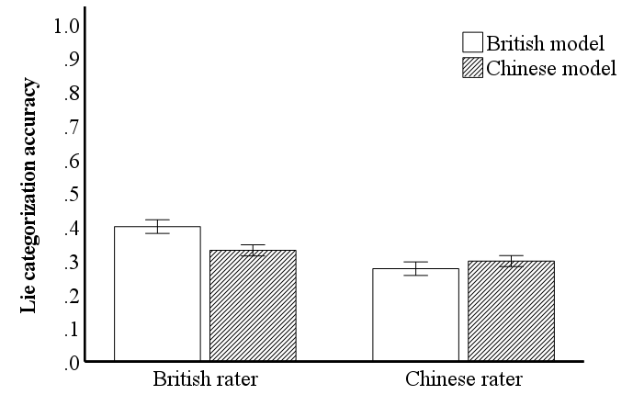

Accuracy Rating Analysis in Neutral Replies
A 2 (rater: British, Chinese) x 2 (model: British, Chinese) ANOVA was conducted on the categorization accuracy of neutral replies. There was a main effect of rater culture (F (1, 158) = 5.47, p = .021, η_{p}² = 0.03), where Chinese raters were more accurate in identifying neutral replies than British raters. There was a main effect of model culture (F (1, 158) = 10.45, p = .001, η_{p}² = 0.06), where neutral replies of Chinese models were categorized more accurately than those of British models. There was no significant interaction between rater and model culture (F (1, 158) = .94, p = .334, η_{p}² = 0.006; see Figure 3 for descriptive statistics).
Figure 3
Mean accuracy of neutral categorization of British and Chinese models from British and Chinese raters. Error bars represent standard errors.
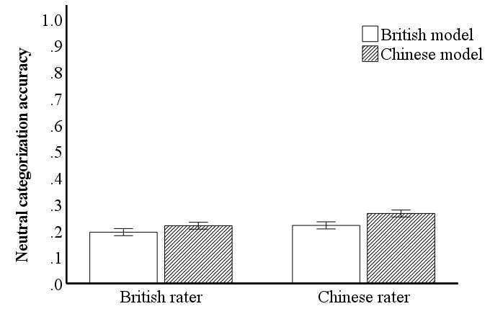

Appendix B: Confidence Rating Analysis in Direct Replies, Lie Replies, and Neutral Replies

Confidence Rating Analysis in Direct Replies
A 2 (rater: British, Chinese) x 2 (model: British, Chinese) ANOVA was conducted on the mean confidence rating of correct direct categorizations. There was a main effect of rater culture (F (1, 156) = 8.31, p = .004, η_{p}² = 0.05) and a main effect of model culture (F (1, 156) = 11.26, p = .001, η_{p}² = 0.07). There was a significant interaction between rater and model culture (F (1, 156) = 18.49, p < .001, η_{p}² = 0.11; see Figure 4 for descriptive statistics). Bonferroni corrected posthoc t-tests, with a corrected alpha level at p =.013, showed that British raters were more confident in identifying direct replies from British models compared to Chinese models (p < .001), whereas Chinese raters were equally confident in categorizing direct replies of British and Chinese models (p = .563). Additionally, British raters were more confident in identifying direct replies of British models compared to Chinese raters for both British models (p < .001) and Chinese models (p < .001).

Figure 4
Mean confidence rating of direct categorization of British and Chinese models from British and Chinese raters. Error bars represent standard errors.
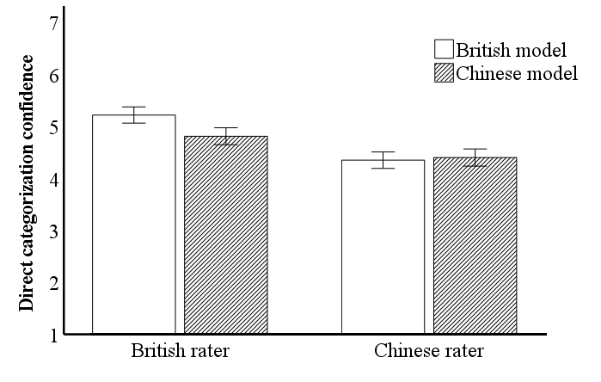

Confidence Rating Analysis in Lie Replies
A 2 (rater: British, Chinese) x 2 (model: British, Chinese) ANOVA was conducted on the mean confidence rating of correct lie categorizations. There was a main effect of rater culture (F (1, 153) = 12.24, p = .001, η_{p}² = 0.07), where British raters were more confident in identifying lie replies than Chinese raters. There was a main effect of model culture (F (1, 153) = 30.24, p < .001, η_{p}² = 0.17), where lie replies of British models were categorized with higher confidence level than those of Chinese models. There was no significant interaction between rater and model culture (F (1, 153) = 3.06, p = .082, η_{p}² = 0.02; see Figure 5 for descriptive statistics).

Figure 5
Mean confidence rating of lie categorization of British and Chinese models from British and Chinese raters. Error bars represent standard errors
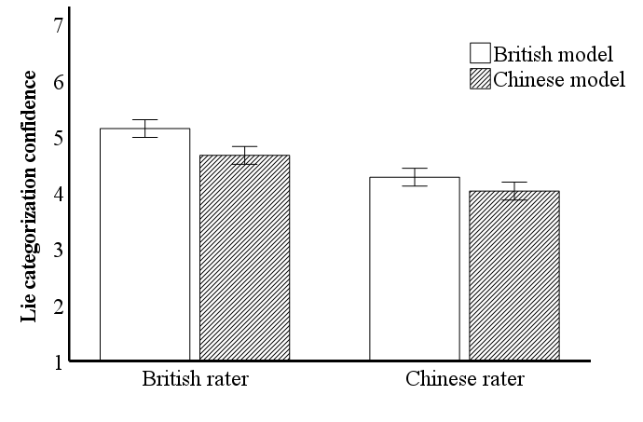

Confidence Rating Analysis in Neutral Replies
A 2 (rater: British, Chinese) x 2 (model: British, Chinese) ANOVA was conducted on the mean confidence rating of correct neutral categorizations. There was no main effect of rater culture (F (1, 144) = 2.91, p = .090, η_{p}² = 0.02). There was a main effect of model culture (F (1, 144) = 9.69, p = .002, η_{p}² = 0.06), where neutral replies of British models were categorized with higher confidence level than those of Chinese models. There was no significant interaction between rater and model culture (F (1, 144) = 2.72, p = .101, η_{p}² = 0.02; see Figure 6 for descriptive statistics).

Figure 6
Mean confidence rating of neutral categorization of British and Chinese models from British and Chinese raters. Error bars represent standard errors
