Supplemental Materials for:
People Attribute a Range of Highly-Varied and Socially-Bound Meanings to Naturalistic Sad Facial Expressions

Sarah de la Harpe¹, Romina Palermo¹, Emily Brown², Nicolas Fay¹, and Amy Dawel²
- School of Psychological Science, The University of Western Australia, WA 6009, Australia.
- School of Medicine and Psychology, The Australian National University, ACT 2600, Australia.

Supplemental Materials Contents
Supplement S1 – Emotion Labelling and Perceived Genuineness Ratings for the Selected ANU Real Facial Expression Database and Radboud Faces Database Stimuli ………………2
Supplement S2 – Additional Details about the ANU Real Facial Expression Database ……..5
Supplement S3 – Full Participant Instructions ………………………………………………...6
Supplement S4 – Details about the Current Thematic Analysis Process………………....…...7
Supplement S5 – Estimates of Intercoder Reliability for each Parent Theme in the Final Thematic Framework ………………………………………………………………………….8
Supplement S6 – Process for Splitting Stimuli into Groups Based on Perceived Genuineness…………………………………………………………………………………...9
Supplement S7 – Differences in the Coding Frequencies for the Genuine and Posed Stimuli... ………………………………………………………………………………………………10

Supplement S1 – Emotion Labelling and Perceived Genuineness Ratings for the Selected ANU Real Facial Expression Database and Radboud Faces Database Stimuli
To be selected, stimuli from the ANU Real Facial Expression Database (ANU RealFED) and Radboud Faces Database (RaFD) were required to be categorised as “sad” by at least 50% of participants in past research. The ANU RealFED stimuli were also selected to vary widely in ratings of perceived genuineness. In the emotion labelling task, participants (ANU RealFED: N = 245, 169 women, 76 men, M_{age} = 27.4 years, SD_{age} = 3.6, range_{age} = 18-32; RaFD: N = 16, 11 women, 5 men, M_{age} = 26.8 years, SD_{age} = 6.7, range_{age} = 20-38) selected the emotion shown on each face from nine emotion labels (anger, contempt, disgust, fear, happy, sad, surprise, other) and, in the perceived genuineness rating task, participants rated the genuineness of the emotion displayed on each face from -7 (“completely fake”) to +7 (“completely genuine”) around a neutral midpoint of 0 (“don’t know”). We also used these mean perceived genuineness ratings to split both the ANU RealFED and RaFD stimuli into groups based on perceived genuineness: genuine (rated > +1), posed (rated < -1), ambiguous (rated between -1 and + 1). Emotion labelling and perceived genuineness ratings for the selected ANU RealFED stimuli are shown in Table S1, and these ratings are shown for the selected RaFD stimuli in Table S2 below.

Table S1
Mean "sad" emotion labelling agreement and perceived genuineness ratings for the selected ANU RealFED stimuli
Stimulus code | % Participants labelled as "sad" | Mean genuineness rating (-7 to +7)
0047_01_hf015 | 50 | 0.69
0152_02_hf045 | 73 | 2.80
0167_02_hf062 | 92 | -0.71
0175_01_hf016 | 82 | -2.77
0317_01_hf083 | 100 | 3.00
0321_01_cf092 | 100 | 2.73
0345_01_hf023 | 67 | 0.13
0347_02_hf036 | 94 | 1.50
0350_01_hf011 | 91 | -1.86
0403_01_hf024 | 100 | 3.22
0404_01_hf026 | 72 | 2.08
0467_01_cf051 | 88 | -2.63
0470_01_hf020 | 85 | 1.80
0472_01_hf021 | 93 | 0.93
0473_01_hf032 | 94 | -3.41
0512_01_hf040 | 72 | 1.50
0529_01_hf013 | 94 | 2.76
0529_02_cf073 | 100 | 4.60
0589_01_hf016 | 53 | 0.59
0611_01_hf030 | 53 | -2.88
0620_01_hf025 | 75 | -0.31
0647_03_hf018 | 73 | -4.93
0648_01_cf835 | 94 | 1.44
0653_03_hf026 | 73 | 0.50
0746_03_hf031 | 100 | 3.81
0819_01_hf024 | 83 | 1.87
0820_01_hf008 | 78 | 2.72
0821_01_hf052 | 85 | 1.05
0823_02_cf019 | 70 | 2.25
0823_03_hf014 | 100 | 4.13
0855_02_hf013 | 74 | 0.00
0884_02_hf010 | 83 | -0.89
0885_05_hf027 | 71 | 2.47
0886_01_hf052 | 95 | 2.43
0923_02_hf038 | 76 | -0.62
0925_03_hf005 | 94 | 0.11
0930_06_hf040 | 92 | 2.00
0987_02_hf028 | 56 | -0.33
1014_01_hf018 | 55 | 1.65
1015_01_hf007 | 86 | 3.77
1016_03_hf033 | 71 | 2.00
1017_02_hf004 | 65 | 2.65
1064_04_hf021 | 63 | 3.06
1065_01_hf011 | 52 | -1.00
1078_03_hf018 | 100 | -5.69
1080_03_hf018 | 93 | -4.67
1082_03_hf016 | 100 | -6.63
1083_03_hf016 | 94 | -4.81
1084_03_hf021 | 53 | -3.24
1100_01_hf012 | 63 | -1.26
1100_05_hf411 | 95 | 0.32
1103_01_cf000 | 87 | 1.33
1114_02_hf000 | 91 | -0.22
1120_02_hf029 | 95 | -5.11
1142_04_hf016 | 94 | 2.82
1143_01_cf105 | 100 | -3.94
1145_01_cf003 | 68 | -3.82
1172_03_cf004 | 89 | -1.16
1173_01_cf002 | 52 | 1.00
1215_02_hf017 | 100 | 3.38
1215_04_cf063 | 89 | 3.42
1216_05_hf064 | 53 | -2.93
1217_02_hf015 | 91 | -1.00
1217_10_hf027 | 82 | -4.50
1233_01_hf031 | 57 | 0.43

Table S2
Mean "sad" emotion labelling agreement and perceived genuineness ratings for the selected RaFD stimuli
Stimulus code | % Participants labelled as "sad" | Mean genuineness rating (-7 to +7)
Rafd045_01_Caucasian_female_sad_frontal | 81 | 1.69
Rafd045_03_Caucasian_male_sad_frontal | 100 | -0.44
Rafd090_07_Caucasian_male_sad_frontal | 88 | 0.94
Rafd090_10_Caucasian_male_sad_frontal | 100 | -3.19
Rafd135_16_Caucasian_female_sad_frontal | 88 | 0.81
Rafd135_20_Caucasian_male_sad_frontal | 88 | -2.38
Rafd045_23_Caucasian_male_sad_frontal | 100 | -3.75
Rafd090_26_Caucasian_female_sad_frontal | 69 | -2.50
Rafd090_31_Caucasian_female_sad_left | 100 | 1.06
Rafd090_36_Caucasian_male_sad_right | 88 | -2.25
Rafd090_37_Caucasian_female_sad_frontal | 100 | 0.50
Rafd090_46_Caucasian_male_sad_frontal | 100 | -0.25
Rafd135_49_Caucasian_male_sad_frontal | 69 | -2.19
Rafd090_57_Caucasian_female_sad_frontal | 69 | -0.06
Rafd090_61_Caucasian_female_sad_right | 100 | -0.69

Supplement S2 – Additional Details about the ANU RealFED
The ANU RealFED is a newly developed facial expression stimuli database, comprised of 2,924 images. These stimuli are naturalistic, taken from a wide range of YouTube video clips that show expressors in a variety of naturalistic settings. Human coders or Affectiva, an automated emotion recognition program (iMotions, 2015), identified and extracted the still-frame images from these videos, with the final database comprised of images showing a range of facial expressions that vary in physical form. Stimuli were selected for the ANU RealFED to show a wide range of natural physical variation, although preference were given to images with expressors’ eyes open, features unobscured, and where faces were front facing. Only ANU RealFED stimuli that were validated as sad by consensus labelling and had clarity ratings of at least “satisfactory” were extracted for use in the current study (see Figure S1 for example images).

Figure S1
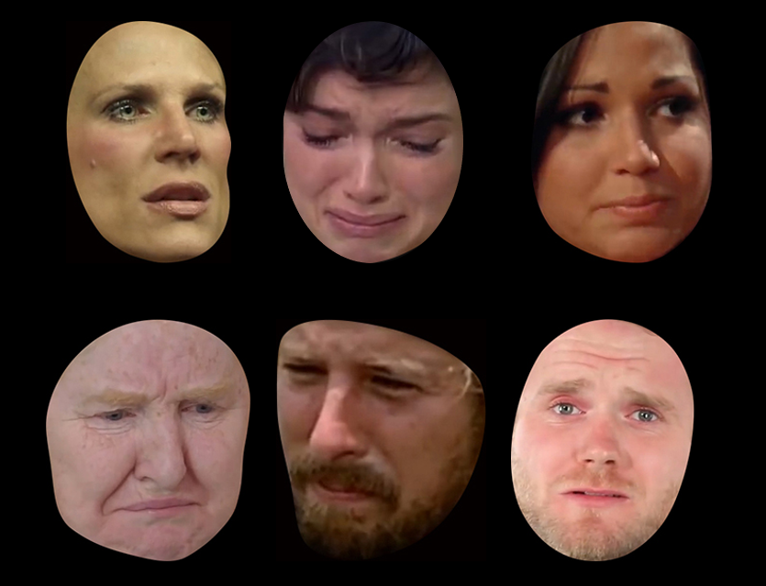
Example Sad Facial Expression Stimuli from the Naturalistic ANU RealFED

Reference:
iMotions. (2015). Affectiva iMotions Biometric Research Platform. Smart Eye. https://imotions.com/affectiva/.
Supplement S3 – Full Participant Instructions
Participants were instructed:
In this experiment, your task is to describe what some different facial expressions tell you about what people are thinking, feeling, and/or intending to do.
For example, different types of smiles can mean different things, like "I'm being polite, in a hurry, please don't stop me" or "I'm genuinely friendly and want to chat" or "I'm disappointed but hiding it" or "I'm available and want to be approached" or "that's really funny" or "I'm just acting happy".
Here, the people will be showing negative expressions, rather than smiling. We are interested in finding out about all of the different meanings these negative expressions have.
For some faces, you might have just one idea about what the expression means. For other faces, you might have several ideas.
Please report ALL of the different ideas you have for each expression, writing as much or as little as you need to.
One final point: these faces come from lots of different sources, so there is a small chance you may know one or two of the people. If you recognise someone, please just write "I KNOW WHO THIS PERSON IS" and move on to the next face.
Pilot research found participants provided single emotion words (e.g., “sadness”, “disappointment”, etc.) when they were asked a narrower question without examples (i.e., “What is this facial expression communicating?”; N = 5, 1 woman, 4 men, M_{age} = 26.2 years, SD_{age} = 2.8, range_{age} = 22-38, recruited from Prolific). For this reason, we gave participants example responses for smiling expressions, which demonstrated the appropriate response style and level of detail, without priming them on possible answers for the sad expressions.

Supplement S4 – The Present Thematic Analysis Process
Figure S2 displays the different stages in the present process of thematic analysis.

Figure S2
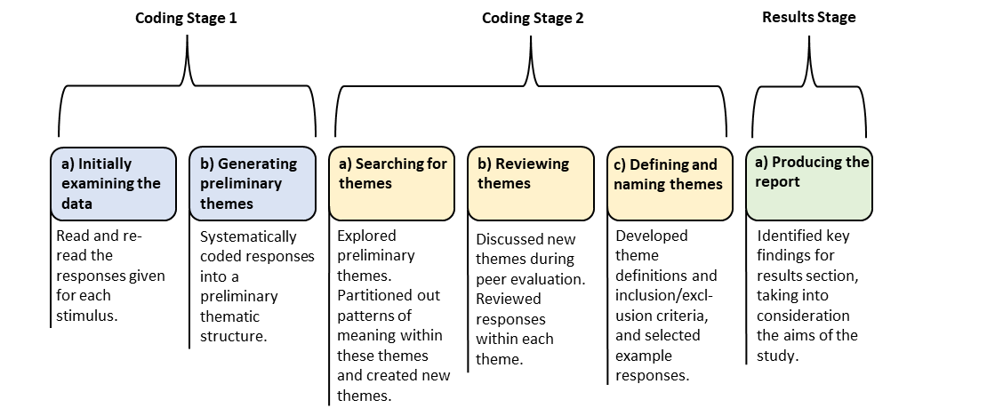
An Overview of the Stages Involved in Data Coding and Analysis. The Six Phases of Thematic Analysis Proposed by Braun & Clarke (2006), Divided into Three Broader Coding Stages

Reference:
Braun, V., & Clarke, V. (2006). Using thematic analysis in psychology. Qualitative Research in Psychology, 3(2), 77–101. https://doi.org/10.1191/1478088706qp063oa
Supplement S5 – Estimates of Intercoder Reliability for each Parent Theme in the Final Thematic Framework
Table S3 lists the Cohen’s kappa coefficients, measures of intercoder reliability, for each parent theme included in the final thematic framework.

Table S3
Cohen’s Kappa Coefficients for each Parent Theme in the Thematic Framework
 | κ
1. Emotion Words | .92
2. Physical Descriptions of the Face | .82
3. Emotional Suppression and Masking | .91
4. Emotional Genuineness | .87
5. Emotional Exaggeration | .83
6. Emotional Intensity | .85
7. Precipitants | .86
8. Thoughts | .87
9. Social Needs | .93
10. Social Interactions and Intentions | .81
11. Other-Directed Sentiments | .88
12. Current and Intended Behaviours | .85

Supplement S6 – Process for Splitting Stimuli into Groups Based on Perceived Genuineness
To explore the impact of perceived genuineness on the attributed meanings, we used pilot data to determine whether the selected stimuli were perceived as genuine, posed, or ambiguous (see Figure S2 for example stimuli). We created stimuli groups using the mean genuineness ratings from two previous pilot studies (ANU RealFED: N = 245, 169 women, 76 men, M_{age} = 27.4 years, SD_{age} = 3.6, range_{age} = 18-32; RaFD: N = 16, 11 women, 5 men, M_{age} = 26.8 years, SD_{age} = 6.7, range_{age} = 20-38), in which participants were asked to rate the genuineness of the emotion displayed on each face from -7 (“completely fake”) to +7 (“completely genuine”) around a neutral midpoint of 0 (“don’t know”). Of the 80 selected images, 31 had mean ratings between +1 to +7 (perceived as genuine) and 24 had mean ratings between -1 to -7 (perceived as posed). Images with ratings between -1 and +1 were deemed ambiguous and excluded from these analyses (n = 15 ANU RealFED + 10 RaFD = 25).

Figure S3
Example Sad Expression Stimuli: (A) Naturalistic Expressions from the ANU Real Facial Expression Database, Including Stimuli Perceived as (i) Genuine and (ii) Posed; (B) Posed Expressions from the Radboud Faces Database, Including Stimuli Rated as (i) Genuine and (ii) Posed (Langner et al., 2010)
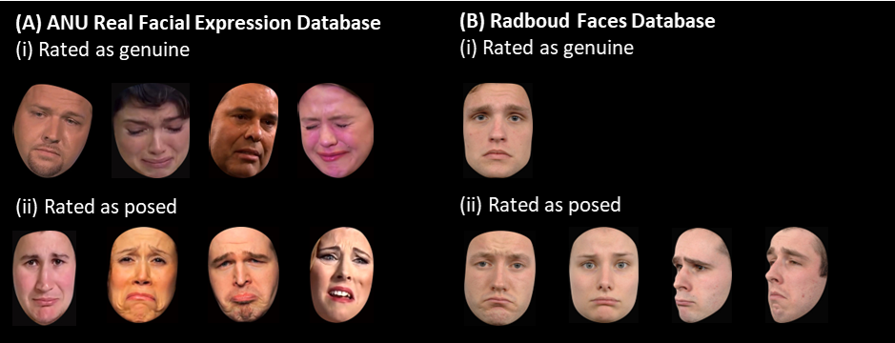
Reference:
Langner, O., Dotsch, R., Bijlstra, G., Wigboldus, D. H., Hawk, S. T., & Van Knippenberg, A. D. (2010). Presentation and validation of the Radboud Faces Database. Cognition and Emotion, 24(8), 1377–1388. https://doi.org/10.1080/02699930903485076
Supplement S7 – Differences in the Coding Frequencies for the Genuine and Posed Stimuli
We computed raw coding frequencies for the genuine and posed stimuli for each theme in the framework. We then weighted the raw frequencies to account for the uneven number of stimuli across the two groups. To determine the group weights, we first calculated the proportion of stimuli in each group by dividing the number of genuine (n = 31) and posed (n = 24) stimuli by the total number of stimuli (genuine and posed stimuli combined; N =55). These proportions (genuine = 0.56; posed = 0.44) were then divided by 0.50 to calculate the group weights (genuine, ω = 0.89; posed, ω = 1.15). We weighted the raw coding frequencies by multiplying them by their group weight. Table S4 reports the weighted frequencies and percentages of coding attributed to the genuine and posed sad expression stimuli for each theme in the final thematic framework.

Table S4
Weighted Frequencies and Percentages of Coding Attributed to the Genuine and Posed Stimuli by Parent Theme
 | Perceived as Genuine (n = 31) | Perceived as Posed  (n = 24)
1. Emotion Words | 52% (929) | 48% (870)
2. Physical descriptions of the Face | 53% (257) | 47% (233)
3. Emotional Suppression and Masking | 63% (49) | 37% (29)
4. Emotional Genuineness | 16% (24) | 84% (121)
5. Emotional Exaggeration | 3% (1) | 97% (33)
6. Emotional Intensity | 50% (175) | 50% (176)
7. Precipitants | 55% (376) | 45% (308)
8. Thoughts | 62% (224) | 38% (138)
9. Social Needs | 59% (44) | 41% (31)
10. Social Interactions and Intentions | 45% (130) | 55% (158)
11. Other-Directed Sentiments | 44% (59) | 56% (77)
12. Current and Intended Behaviours | 54% (207) | 46% (173)
Note. Weighted frequencies are reported in brackets next to the weighted percentages. Significant differences are in bold (see text).

We then used the weighted frequencies to calculate the percentage of coding references attributed to genuine and posed stimuli for each theme in the framework. There were notable differences in the frequencies of coding attributed to both groups. For example, 33 references were coded under the theme Emotional Exaggeration for the posed stimuli, but only one reference was coded under this theme for the genuine stimuli. We then ran Chi-Square adjusted standardised residual analyses to determine if there were significant differences in the coding frequencies attributed to the genuine and posed stimuli. Fisher’s expected frequency rule was satisfied as the expected frequencies of all cells exceeded 5 (Fisher, 1992). We applied a Bonferroni correction to avoid inflating the familywise error rate above .05, given that multiple comparisons were conducted across the themes (Andrade, 2019). We report statistically significant differences in the coding frequencies for the genuine and posed stimuli below.
We found significant differences in the coding frequencies for the Emotional Exaggeration parent theme (χ² = 31.81, p <.001), with a significantly greater number of coding references attributed to posed stimuli, and a significantly lower number of references attributed to genuine stimuli. This suggests the meanings captured by the Emotional Exaggeration parent theme were more frequently attributed to the posed stimuli than genuine stimuli and, therefore, that people are more likely describe sad expressions they perceive as socially posed as exaggerated, over-the-top, amplified, or overdramatised.
We found similar results for the Posed child theme (χ² = 88.36, p <.001) under the Emotional Genuineness parent theme (χ² = 71.23, p <.001), with significantly more references attributed to the posed stimuli, and significantly fewer references attributed to the genuine stimuli. This suggests that, as expected, the meanings captured by the Posed child theme were more frequently attributed to the posed than genuine stimuli, and that people are more likely to describe sad expressions they perceive as socially posed as acted, fake, unreal, or intentionally put on. However, the meanings captured by the Genuine child theme were not more frequently attributed to the genuine than posed stimuli (χ² = 0.64, p = 1), indicating that participants did not describe the genuine stimuli as being authentic, real, or sincere more frequently than the posed stimuli. This suggests people may focus less on the authenticity of genuine sad expressions than the ‘fakeness’ of posed sad expressions.
We also found significant differences in the coding frequencies for the Contemplation (χ² = 17.39, p = .001) and Remorse/Regret (χ² = 14.36, p = .003) child themes under the Thoughts parent theme (χ² = 17.98, p <.001), with significantly more coding references attributed to the genuine stimuli, and significantly fewer coding references attributed to the posed stimuli. This suggests the meanings captured by the Thoughts parent theme, particularly those coded under the Contemplation and Remorse/Regret child themes, were more frequently attributed to the genuine than posed stimuli. Therefore, people are more likely describe sad expressions they perceive as genuine by making inferences about the expressors’ thought processes, such as being deep in thought or reflecting on past experiences, and describing feelings of shame, regret, and remorse.

