Supplementary materials
Table S1. Prompts used to create the dressed bodies for the different study conditions.
Gender | Dress | Prompt
Man | Casual business dress | The image shows a young man wearing a blue V-neck sweater and blue jeans, with a blue dress shirt underneath. The man is standing with his hands alongside his body looking directly at the camera with a serious expression. The background is plain white.
Woman | Casual business dress | The image shows a young woman wearing a long-sleeved, blue t-shirt and light blue jeans. Her hair is pulled back in a low bun. The woman is standing with her hands alongside her body looking directly at the camera with a serious expression. The background is plain white.
Man | Formal business dress | The image shows a young man wearing a navy blue suit. The suit has a single-breasted design with a notched lapel. The man is also wearing a white collared shirt underneath the suit. The man is standing with his hands alongside his body looking directly at the camera with a serious expression. The background is plain white.
Woman | Formal business dress | The image shows a young woman wearing a navy blue blazer and trousers. The blazer has a single-breasted design with a notched lapel collar and two flap pockets on the front. She is wearing a white collared shirt underneath the blazer. The trousers are fitted and have a slim fit. The woman is standing with her hands alongside her body looking directly at the camera with a serious expression. She has short dark hair and. The background is plain white.
Man | Formal party dress | The image shows a young man wearing a dark blue tuxedo with a black lapel and a bow tie, paired with fitted trousers. The suit is tailored to fit him perfectly and includes a single-breasted jacket. Underneath the suit, he is wearing a white shirt. The man is standing with his hands alongside his body, looking directly at the camera with a serious expression. The background is plain white
Woman | Formal party dress | The image shows a young woman wearing a blue cocktail satin sheath dress with a blazer-style top. The dress had long sleeves, a notched lapel, and a v-neckline. The waist is cinched with a matching belt, and the skirt is knee-length. The woman is standing with her hands alongside her body looking directly at the camera with a serious expression. She has short dark hair and. The background is plain white.
Man | Casual party dress | The image shows a young man wearing a light blue button-down shirt with a collar and long sleeves paired with dark blue jeans. The man is standing with his hands alongside his body, looking directly at the camera with a serious expression. The background is plain white
Woman | Casual party dress | The image shows a young woman wearing a light blue belted shirt dress. The dress has a collar and long sleeves. The belt is tied in a bow at the front. The man is standing with his hands alongside his body, looking directly at the camera with a serious expression. The background is plain white

Perceived Emotions
Separate 3 (emotion expression: anger, sadness, neutral) x 2 (expresser gender: male, female) x 2 (attire: casual, formal) x 2 (context: business, leisure) analyses of variance on the perceived emotion scales were conducted to assess the effect of attire both on the focal emotions anger, sadness and neutrality ratings and on ratings of the secondary emotions, happiness, fear and disgust.
Focal emotions
In line with our predictions, significant main effects of emotion expression emerged for all ratings (see Table S1 for F-statistics, Figure 1 for means and standard errors). Post-hoc analyses confirmed that anger expressions were rated as most angry, sadness expression as most sad, and neutral expression as most neutral (see markdown for Study 1 in the supplementary materials for more detail). Interestingly, neutral expressions were rated as more angry than sad expressions and as more sad than angry expressions. This fits with the notion that nominally neutral expressions are not perceived as neutral (Hess et al., 2023; Lee et al., 2008).
For sadness ratings, an emotion by context interaction, F(2, 825) = 3.22, p = .041, η_{p}² = .01, emerged, such that only for sad expressions individuals in the leisure context were rated as sadder (M_{leisure} =4.95, SD = 1.44; M_{business} =4.53, SD = 1.52). For neutrality ratings, an emotion by context, F(2, 825) = 4.87, p = .008, η_{p}² = .01, and an expresser gender x context interaction, F(1, 825) = 4.41, p = .036, η_{p}² = .01, emerged significantly. Specifically, men who showed an angry expression in the leisure context (M = 1.53, SD = 1.57) were perceived as more neutral than those showing the same expression in the business context (M = 1.21, SD = 1.33).
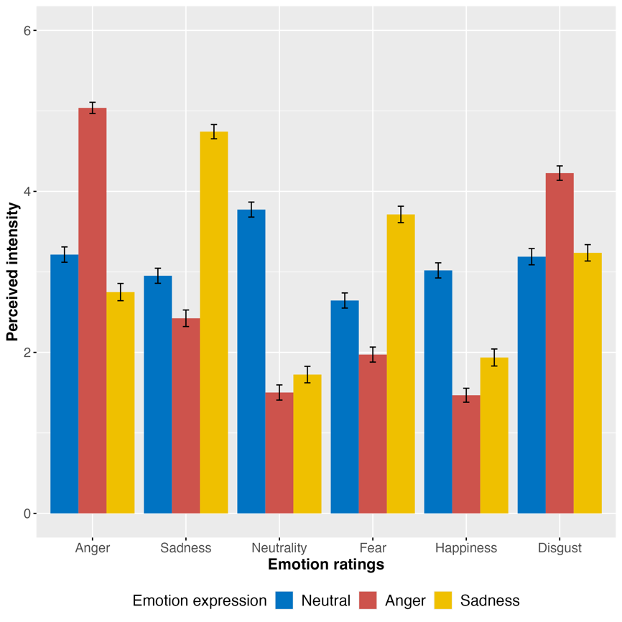
Table S2. Means, standard deviations and F-statistics for the effect of emotion expression on emotion ratings
Rating | Expression | F (2,825) | p | η_{p}² | M | SD | CI95%
Anger | Anger | 183.88 | <.001 | .31 | 5.04_{a} | 1.20 | [4.90, 5.18]
 | Sadness |  |  |  | 2.75_{b} | 1.80 | [2.54, 2.96]
 | Neutral |  |  |  | 3.21_{c} | 1.57 | [3.02, 3.40]
Sadness | Anger | 159.59 | <.001 | .28 | 2.42_{a} | 1.77 | [2.22, 2.62]
 | Sadness |  |  |  | 4.74_{b} | 1.77 | [4.57, 4.91]
 | Neutral |  |  |  | 2.95_{c} | 1.54 | [2.77, 3.13]
Neutrality | Anger | 167.52 | <.001 | .29 | 1.51_{a} | 1.62 | [1.32, 1.70]
 | Sadness |  |  |  | 1.72_{a} | 1.72 | [1.52, 1.92]
 | Neutral |  |  |  | 3.77_{b} | 1.53 | [3.59, 3.95]
Happiness | Anger | 69.17 | <.001 | .14 | 1.47_{a} | 1.49 | [1.30, 1.64]
 | Sadness |  |  |  | 1.94_{b} | 1.78 | [1.73, 2.15]
 | Neutral |  |  |  | 3.02_{c} | 1.55 | [2.83, 3.21]
Fear | Anger | 84.42 | <.001 | .17 | 1.97_{a} | 1.60 | [1.79, 2.15]
 | Sadness |  |  |  | 3.71_{b} | 1.72 | [3.51, 3.91]
 | Neutral |  |  |  | 2.64_{c} | 1.54 | [2.46, 2.82]
Disgust | Anger | 39.57 | <.001 | .09 | 4.43_{a} | 1.54 | [4.05, 4.41]
 | Sadness |  |  |  | 3.24_{b} | 1.71 | [3.04, 3.44]
 | Neutral |  |  |  | 3.19_{b} | 1.66 | [2.99, 3.39]
NB: Values that share a subscript are not significantly different
Secondary emotions
As expected, participants perceived secondary emotions in the validated emotion expressions we used (Hess & Kafetsios, 2022; Kafetsios & Hess, 2023), such that significant effects of emotion expression emerged for ratings of happiness, fear and disgust (see Table 1 for F-statistics, Figure 6 for means and standard errors).
In addition, a number of effects of context and gender emerged. For happiness, a main effect of context, F(1,825) = 4.38, p = .037, η_{p}² = .01, was found such that individuals in the business context were rated as happier (M=2.25; SD=1.73) than those in the leisure context (M=1.99; SD=1.72), irrespective of the expression shown. A significant context by expresser gender interaction emerged for disgust, F(1,825) = 4.59, p = .033, η_{p}² = .01, such that men in the business context were rated as more disgusted (M=3.68; SD=1.65) than men showing the same expression in the leisure context (M=3.29; SD=1.80, t₈₂₅ = 2.80, p = .005), whereas no difference emerged for women (M_{business}=3.63; SD=1.67; M_{leisure}=3.68; SD=1.68 t₈₂₅ = 0.21, p = .833).
Main effects of expresser gender emerged for happiness, F(1,825) = 7.32, p = .007, η_{p}² = .01, and fear F(1,825) = 4.77, p = .029, η_{p}² = .01, such that men were perceived as happier and less fearful (M_{happiness}=2.27; SD=1.78; M_{fear}=2.66; SD=1.79) than women (M_{happiness} =1.97; SD=1.67; M_{fear}=2.87; SD=1.75), irrespective the expression shown.

