Supplementary Materials:
Laughter indicates perceived similarity among friends and strangers
Note: Section 1 provides additional methods information and Section 2 provides the complete output for all models reported in the main manuscript.
Table of content for Supplementary Materials
1. Methods 2
1.1 Icebreaker prompts 2
1.2 Friendship style checklist 2
2. Results 3
2.1 Predicting laughter from friendship status and conversation type (RQ1) 3
2.2 Predicting laughter from perceived interpersonal similarity at baseline (RQ2) 4
2.3 Predicting post-conversation self-reported similarity, enjoyment, and shared reality from laughter (RQ3) 5
2.4 Predicting shared reality behaviors from laughter (RQ4) 8
2.5 Predicting friends’ laughter from their perceived and actual friendship style similarity (RQ5) 12
2.6 Predicting laughter from separate baseline similarity measures 13

1. Methods

1.1 Icebreaker prompts
Stranger dyads first had an icebreaker conversation using the following prompts, adapted from Kardas et al. (2022).
- What is your name?
- Where are you from?
- What is your major or intended major?
- When was the last time you walked for more than an hour? Describe where you went and what you saw.
- Do you like to get up early or stay up late? Why?

1.2 Friendship style checklist
Participants indicated whether they expected each of the following behaviors of their friend, as well as whether they thought their friend expected the following behaviors from them.
- Let the other borrow money if needed
- Remember the other's birthday
- Help the other with moving
- Keep the other's secrets
- Work through the other's personal problems with them
- Defend the other when someone mistreats or hurts them
- Help the other feel better when they are upset
- Maintain a relationship even after a big fight
- Empathize with the other's experiences
- Would never intentionally try to hurt the other
- Spend a lot of time with the other
- Can talk about anything with the other
- Never judge the other
- Will not talk badly about one behind the other's back
- Share uncomfortable/ difficult experiences with the other
- Check in on the other periodically
- Listen carefully to the other
- Be able to sit in silence with the other without it feeling awkward
- Call the other out on their mistakes
- Be in tune with the other's emotions
- Feel like a member of the other's family
- Forgive the other when they make a mistake
- Sacrifice time for the other
- Joke around with the other
- Buy the other things (e.g., gifts, food)
- Be someone the other can go to for advice during a hard time
- Send the other memes/funny videos
- Like the other's photos/posts on social media

2. Results

2.1 Predicting laughter from friendship status and conversation type (RQ1)
 | Num. Laughs |  |  | Laughter Duration |  |  | Num. Colaughs |  |  | Colaughter Duration
Predictors | Incidence Rate Ratios | CI | p | Estimates | CI | p | Incidence Rate Ratios | CI | p | Estimates | CI | p
(Intercept) | 1.32 | 1.13 – 1.54 | <0.001 | 1.68 | 1.40 – 2.02 | <0.001 | 0.54 | 0.39 – 0.75 | <0.001 | 0.48 | 0.32 – 0.71 | <0.001
Strangers v. Friends | 1.25 | 1.13 – 1.38 | <0.001 | 1.66 | 1.47 – 1.86 | <0.001 | 1.54 | 1.14 – 2.08 | 0.005 | 2.15 | 1.47 – 3.13 | <0.001
Differences v. Similarities Conversation | 1.01 | 0.92 – 1.11 | 0.768 | 1.02 | 0.91 – 1.14 | 0.781 | 1.05 | 0.86 – 1.30 | 0.618 | 1.04 | 0.81 – 1.33 | 0.774
Duration of conversation | 1.07 | 1.06 – 1.08 | <0.001 | 1.08 | 1.07 – 1.09 | <0.001 | 1.07 | 1.04 – 1.09 | <0.001 | 1.07 | 1.05 – 1.10 | <0.001
Friends*Conversation Type | 0.83 | 0.69 – 1.00 | 0.050 | 0.75 | 0.60 – 0.95 | 0.014 | 0.91 | 0.60 – 1.37 | 0.654 | 0.82 | 0.50 – 1.34 | 0.432
Random Effects
σ² | 0.24 |  |  | 0.31 |  |  | 0.50 |  |  | 0.56
τ₀₀ | 0.06 _{partnerID} |  |  | 0.33 _{actorID} |  |  | 0.29 _{dyadID:groupID} |  |  | 0.52 _{dyadID:groupID}
 | 0.22 _{actorID} |  |  | 0.06 _{partnerID} |  |  | 0.17 _{groupID} |  |  | 0.26 _{groupID}
ICC | 0.54 |  |  | 0.56 |  |  | 0.48 |  |  | 0.58
N | 127 _{actorID} |  |  | 127 _{actorID} |  |  | 126 _{dyadID} |  |  | 126 _{dyadID}
 | 128 _{partnerID} |  |  | 128 _{partnerID} |  |  | 32 _{groupID} |  |  | 32 _{groupID}
Observations | 508 |  |  | 508 |  |  | 252 |  |  | 252
Marginal R² / Conditional R² | 0.328 / 0.688 |  |  | 0.323 / 0.699 |  |  | 0.207 / 0.592 |  |  | 0.228 / 0.676

2.2 Predicting laughter from perceived interpersonal similarity at baseline (RQ2)
 | Num. Laughs |  |  | Laughter Duration
Predictors | Incidence Rate Ratios | CI | p | Estimates | CI | p
(Intercept) | 1.25 | 1.05 – 1.49 | 0.011 | 1.82 | 1.47 – 2.26 | <0.001
Baseline participant perceived similarity | 1.04 | 0.98 – 1.10 | 0.257 | 1.09 | 1.01 – 1.18 | 0.025
Baseline partner perceived similarity | 1.05 | 0.99 – 1.11 | 0.105 | 1.07 | 0.99 – 1.15 | 0.080
Participant*Partner Similarity | 0.98 | 0.96 – 1.00 | 0.030 | 0.97 | 0.95 – 1.00 | 0.038
Duration of conversation | 1.07 | 1.06 – 1.09 | <0.001 | 1.07 | 1.06 – 1.09 | <0.001
Random Effects
σ² | 0.28 |  |  | 0.24
τ₀₀ | 0.05 _{partnerID} |  |  | 0.14 _{partnerID}
 | 0.13 _{actorID} |  |  | 0.33 _{actorID}
ICC | 0.39 |  |  | 0.66
N | 127 _{partnerID} |  |  | 127 _{partnerID}
 | 127 _{actorID} |  |  | 127 _{actorID}
Observations | 416 |  |  | 416
Marginal R² / Conditional R² | 0.379 / 0.623 |  |  | 0.310 / 0.766

 | Num. Colaughs |  |  | Colaughter Duration
Predictors | Incidence Rate Ratios | CI | p | Estimates | CI | p
(Intercept) | 0.53 | 0.39 – 0.72 | <0.001 | 0.55 | 0.37 – 0.80 | 0.002
Baseline perceived similarity (both partners) | 1.14 | 1.06 – 1.21 | <0.001 | 1.25 | 1.14 – 1.37 | <0.001
Duration of conversation | 1.07 | 1.04 – 1.09 | <0.001 | 1.07 | 1.04 – 1.10 | <0.001
Random Effects
σ² | 0.56 |  |  | 0.47
τ₀₀ | 0.19 _{dyadID:groupID} |  |  | 0.65 _{dyadID:groupID}
 | 0.11 _{groupID} |  |  | 0.19 _{groupID}
ICC | 0.35 |  |  | 0.64
N | 125 _{dyadID} |  |  | 125 _{dyadID}
 | 32 _{groupID} |  |  | 32 _{groupID}
Observations | 250 |  |  | 250
Marginal R² / Conditional R² | 0.243 / 0.507 |  |  | 0.250 / 0.729

2.3 Predicting post-conversation self-reported similarity, enjoyment, and shared reality from laughter (RQ3)
2.3.1. Number of laughs as predictors
 | Similarity (PC) |  |  | Enjoyment |  |  | Shared Reality
Predictors | Estimates | CI | p | Estimates | CI | p | Estimates | CI | p
(Intercept) | -0.01 | -0.35 – 0.33 | 0.954 | 5.88 | 5.64 – 6.13 | <0.001 | 4.69 | 4.41 – 4.96 | <0.001
Strangers v. Friends | 0.15 | -0.27 – 0.58 | 0.481 | 0.07 | -0.24 – 0.39 | 0.643 | 0.52 | 0.19 – 0.86 | 0.002
Number of Laughs (Participant) | 0.02 | -0.06 – 0.10 | 0.689 | 0.06 | 0.00 – 0.12 | 0.040 | 0.01 | -0.06 – 0.07 | 0.853
Number of Laughs*Friends | -0.02 | -0.16 – 0.13 | 0.817 | -0.06 | -0.16 – 0.05 | 0.292 | -0.05 | -0.17 – 0.06 | 0.334
Number of Laughs (Partner) | 0.02 | -0.06 – 0.09 | 0.668 | -0.01 | -0.07 – 0.04 | 0.635 | 0.04 | -0.02 – 0.10 | 0.218
Number of Laughs (Partner)*Friends | -0.05 | -0.19 – 0.10 | 0.506 | 0.09 | -0.01 – 0.20 | 0.080 | 0.01 | -0.10 – 0.12 | 0.857
Duration of conversation | 0.01 | -0.02 – 0.04 | 0.640 | 0.02 | -0.00 – 0.04 | 0.070 | 0.02 | -0.00 – 0.05 | 0.092
Baseline Perceived Similarity | 0.78 | 0.68 – 0.88 | <0.001 | 0.13 | 0.06 – 0.20 | 0.001 | 0.26 | 0.18 – 0.33 | <0.001
Random Effects
σ² | 0.84 |  |  | 0.48 |  |  | 0.53
τ₀₀ | 0.21 _{actorID} |  |  | 0.10 _{actorID} |  |  | 0.17 _{actorID}
 | 0.04 _{partnerID} |  |  | 0.00 _{partnerID} |  |  | 0.00 _{partnerID}
ICC | 0.22
N | 125 _{partnerID} |  |  | 127 _{actorID} |  |  | 127 _{actorID}
 | 126 _{actorID} |  |  | 127 _{partnerID} |  |  | 127 _{partnerID}
Observations | 221 |  |  | 227 |  |  | 225
Marginal R² / Conditional R² | 0.752 / 0.808 |  |  | 0.277 / NA |  |  | 0.571 / NA

2.3.2 Duration of laughter as predictors
 | Similarity (PC) |  |  | Enjoyment |  |  | Shared Reality
Predictors | Estimates | CI | p | Estimates | CI | p | Estimates | CI | p
(Intercept) | 0.04 | -0.28 – 0.37 | 0.796 | 5.85 | 5.61 – 6.08 | <0.001 | 4.68 | 4.42 – 4.94 | <0.001
Strangers v. Friends | 0.08 | -0.35 – 0.52 | 0.705 | 0.05 | -0.27 – 0.37 | 0.750 | 0.46 | 0.12 – 0.80 | 0.009
Laughter Duration (Participant) | 0.03 | -0.02 – 0.07 | 0.286 | 0.04 | 0.01 – 0.07 | 0.024 | -0.01 | -0.04 – 0.03 | 0.782
Laughter Duration*Friends | -0.06 | -0.15 – 0.02 | 0.145 | -0.07 | -0.13 – -0.00 | 0.037 | -0.04 | -0.11 – 0.03 | 0.271
Laughter Duration (Partner) | 0.01 | -0.04 – 0.05 | 0.733 | -0.02 | -0.05 – 0.01 | 0.222 | 0.03 | -0.00 – 0.06 | 0.089
Laughter Duration (Partner)*Friends | 0.00 | -0.08 – 0.09 | 0.935 | 0.06 | 0.00 – 0.13 | 0.047 | -0.00 | -0.07 – 0.07 | 0.917
Duration of conversation | 0.01 | -0.02 – 0.03 | 0.714 | 0.03 | 0.01 – 0.05 | 0.013 | 0.02 | 0.00 – 0.05 | 0.030
Baseline Perceived Similarity | 0.78 | 0.68 – 0.88 | <0.001 | 0.13 | 0.06 – 0.20 | <0.001 | 0.26 | 0.18 – 0.34 | <0.001
Random Effects
σ² | 0.84 |  |  | 0.49 |  |  | 0.54
τ₀₀ | 0.21 _{actorID} |  |  | 0.00 _{partnerID} |  |  | 0.00 _{partnerID}
 | 0.02 _{partnerID} |  |  | 0.09 _{actorID} |  |  | 0.15 _{actorID}
ICC | 0.22
N | 125 _{partnerID} |  |  | 127 _{partnerID} |  |  | 127 _{partnerID}
 | 126 _{actorID} |  |  | 127 _{actorID} |  |  | 127 _{actorID}
Observations | 221 |  |  | 227 |  |  | 225
Marginal R² / Conditional R² | 0.754 / 0.808 |  |  | 0.276 / NA |  |  | 0.569 / NA

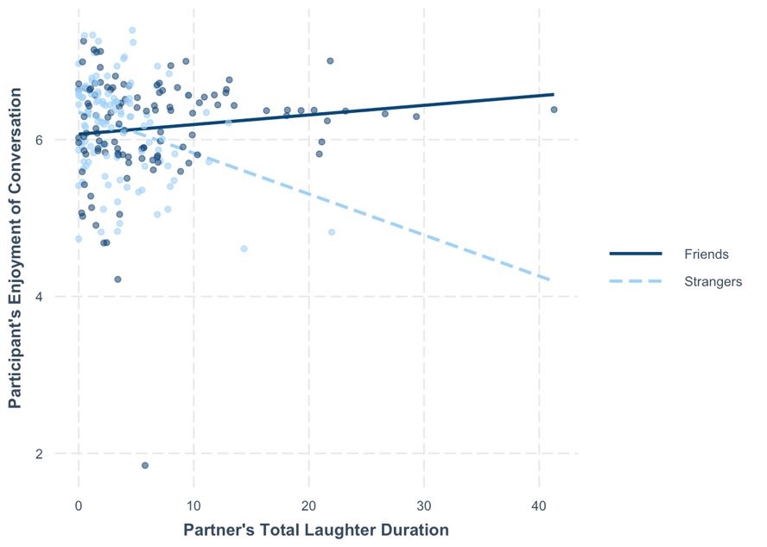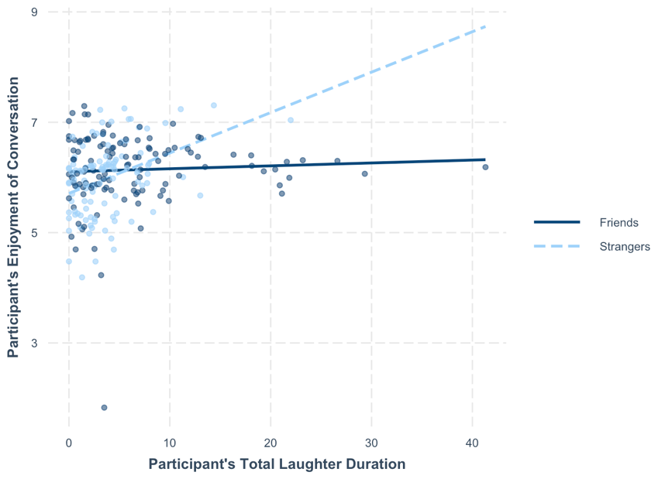
Figure S1. The more a stranger laughed, the less their partner reported enjoying the conversation (above) but the more they reported enjoying the conversation (below; controlling for partner laughter).
2.3.3 Number of colaughs as predictor
 | Similarity (PC) |  |  | Enjoyment |  |  | Shared Reality
Predictors | Estimates | CI | p | Estimates | CI | p | Estimates | CI | p
(Intercept) | -0.07 | -0.36 – 0.22 | 0.649 | 5.82 | 5.60 – 6.03 | <0.001 | 4.65 | 4.42 – 4.88 | <0.001
Strangers v. Friends | 0.14 | -0.28 – 0.56 | 0.513 | 0.09 | -0.23 – 0.40 | 0.587 | 0.51 | 0.18 – 0.85 | 0.003
Number of Colaughs | 0.02 | -0.10 – 0.14 | 0.771 | 0.04 | -0.05 – 0.12 | 0.413 | 0.07 | -0.03 – 0.16 | 0.166
Number of Colaughs*Friends | -0.10 | -0.29 – 0.10 | 0.342 | 0.03 | -0.12 – 0.18 | 0.673 | -0.13 | -0.28 – 0.03 | 0.107
Duration of conversation | 0.01 | -0.01 – 0.04 | 0.265 | 0.03 | 0.01 – 0.05 | 0.002 | 0.03 | 0.01 – 0.05 | 0.008
Baseline Perceived Similarity | 0.79 | 0.69 – 0.89 | <0.001 | 0.13 | 0.05 – 0.20 | 0.001 | 0.25 | 0.18 – 0.33 | <0.001
Random Effects
σ² | 0.84 |  |  | 0.51 |  |  | 0.53
τ₀₀ | 0.19 _{actorID} |  |  | 0.00 _{partnerID} |  |  | 0.00 _{partnerID}
 | 0.03 _{partnerID} |  |  | 0.09 _{actorID} |  |  | 0.16 _{actorID}
ICC | 0.21
N | 126 _{partnerID} |  |  | 128 _{partnerID} |  |  | 128 _{partnerID}
 | 127 _{actorID} |  |  | 127 _{actorID} |  |  | 127 _{actorID}
Observations | 223 |  |  | 229 |  |  | 227
Marginal R² / Conditional R² | 0.752 / 0.805 |  |  | 0.244 / NA |  |  | 0.570 / NA

2.3.4 Duration of colaughter as predictor
 | Similarity (PC) |  |  | Enjoyment |  |  | Shared Reality
Predictors | Estimates | CI | p | Estimates | CI | p | Estimates | CI | p
(Intercept) | 0.01 | -0.28 – 0.30 | 0.961 | 5.83 | 5.62 – 6.05 | <0.001 | 4.69 | 4.46 – 4.92 | <0.001
Strangers v. Friends | 0.06 | -0.38 – 0.49 | 0.803 | 0.04 | -0.29 – 0.37 | 0.797 | 0.43 | 0.09 – 0.78 | 0.014
Duration of Colaughter | 0.06 | -0.02 – 0.14 | 0.148 | 0.04 | -0.03 – 0.10 | 0.260 | 0.07 | 0.00 – 0.13 | 0.047
Duration of Colaughter*Friends | -0.12 | -0.28 – 0.03 | 0.124 | -0.05 | -0.16 – 0.07 | 0.431 | -0.13 | -0.25 – -0.01 | 0.037
Duration of conversation | 0.01 | -0.01 – 0.03 | 0.370 | 0.03 | 0.01 – 0.05 | 0.001 | 0.03 | 0.01 – 0.05 | 0.004
Baseline Perceived Similarity | 0.78 | 0.68 – 0.88 | <0.001 | 0.13 | 0.06 – 0.20 | 0.001 | 0.25 | 0.18 – 0.33 | <0.001
Random Effects
σ² | 0.82 |  |  | 0.51 |  |  | 0.53
τ₀₀ | 0.21 _{actorID} |  |  | 0.00 _{partnerID} |  |  | 0.00 _{partnerID}
 | 0.03 _{partnerID} |  |  | 0.08 _{actorID} |  |  | 0.15 _{actorID}
ICC | 0.22
N | 126 _{partnerID} |  |  | 128 _{partnerID} |  |  | 128 _{partnerID}
 | 127 _{actorID} |  |  | 127 _{actorID} |  |  | 127 _{actorID}
Observations | 223 |  |  | 229 |  |  | 227
Marginal R² / Conditional R² | 0.754 / 0.809 |  |  | 0.243 / NA |  |  | 0.572 / NA

2.4 Predicting shared reality behaviors from laughter (RQ4)

2.4.1 Number of laughs as predictors
 | Shared Reality Behavior
Predictors | Estimates | CI | p
(Intercept) | -1.65 | -2.28 – -1.03 | <0.001
Strangers v. Friends | 0.65 | -0.16 – 1.46 | 0.118
Number of Laughs (Participant) | 0.17 | 0.03 – 0.32 | 0.021
Number of Laughs*Friends | 0.04 | -0.23 – 0.30 | 0.788
Number of Laughs (Partner) | 0.18 | 0.04 – 0.32 | 0.015
Number of Laughs (Partner)*Friends | 0.23 | -0.04 – 0.49 | 0.090
Duration of conversation | 0.17 | 0.11 – 0.23 | <0.001
Baseline Perceived Similarity | 0.20 | 0.01 – 0.39 | 0.035
Random Effects
σ² | 3.06
τ₀₀ _{actorID} | 0.41
τ₀₀ _{partnerID} | 0.12
ICC | 0.15
N _{actorID} | 127
N _{partnerID} | 127
Observations | 223
Marginal R² / Conditional R² | 0.555 / 0.620

2.4.2 Duration of laughter as predictors
 | Shared Reality Behavior
Predictors | Estimates | CI | p
(Intercept) | -2.18 | -2.80 – -1.56 | <0.001
Strangers v. Friends | 0.57 | -0.28 – 1.43 | 0.188
Laughter Duration (Participant) | 0.05 | -0.04 – 0.14 | 0.243
Laughter Duration*Friends | -0.03 | -0.20 – 0.14 | 0.725
Laughter Duration (Partner) | 0.03 | -0.05 – 0.12 | 0.429
Laughter Duration (Partner)*Friends | 0.07 | -0.09 – 0.24 | 0.395
Duration of conversation | 0.23 | 0.18 – 0.28 | <0.001
Baseline Perceived Similarity | 0.22 | 0.03 – 0.41 | 0.027
Random Effects
σ² | 3.20
τ₀₀ _{partnerID} | 0.21
τ₀₀ _{actorID} | 0.50
ICC | 0.18
N _{partnerID} | 127
N _{actorID} | 127
Observations | 223
Marginal R² / Conditional R² | 0.517 / 0.604

2.4.3 Number of colaughs as predictor
 | Shared Reality Behavior
Predictors | Estimates | CI | p
(Intercept) | -1.94 | -2.45 – -1.43 | <0.001
Strangers v. Friends | 0.63 | -0.15 – 1.41 | 0.112
Number of Colaughs | 0.59 | 0.38 – 0.80 | <0.001
Number of Colaughs*Friends | 0.28 | -0.07 – 0.64 | 0.117
Duration of conversation | 0.20 | 0.16 – 0.25 | <0.001
Baseline Perceived Similarity | 0.17 | -0.01 – 0.35 | 0.065
Random Effects
σ² | 2.75
τ₀₀ _{partnerID} | 0.19
τ₀₀ _{actorID} | 0.47
ICC | 0.19
N _{partnerID} | 128
N _{actorID} | 127
Observations | 225
Marginal R² / Conditional R² | 0.573 / 0.656

2.4.4 Duration of colaughter as predictor
 | Shared Reality Behavior
Predictors | Estimates | CI | p
(Intercept) | -2.15 | -2.69 – -1.62 | <0.001
Strangers v. Friends | 0.40 | -0.46 – 1.26 | 0.362
Duration of Colaughter | 0.26 | 0.10 – 0.42 | 0.001
Duration of Colaughter*Friends | -0.23 | -0.52 – 0.07 | 0.137
Duration of conversation | 0.24 | 0.20 – 0.28 | <0.001
Baseline Perceived Similarity | 0.21 | 0.02 – 0.40 | 0.033
Random Effects
σ² | 3.37
τ₀₀ _{partnerID} | 0.04
τ₀₀ _{actorID} | 0.37
ICC | 0.11
N _{partnerID} | 128
N _{actorID} | 127
Observations | 225
Marginal R² / Conditional R² | 0.529 / 0.579

2.4.5 Lagged time series analyses
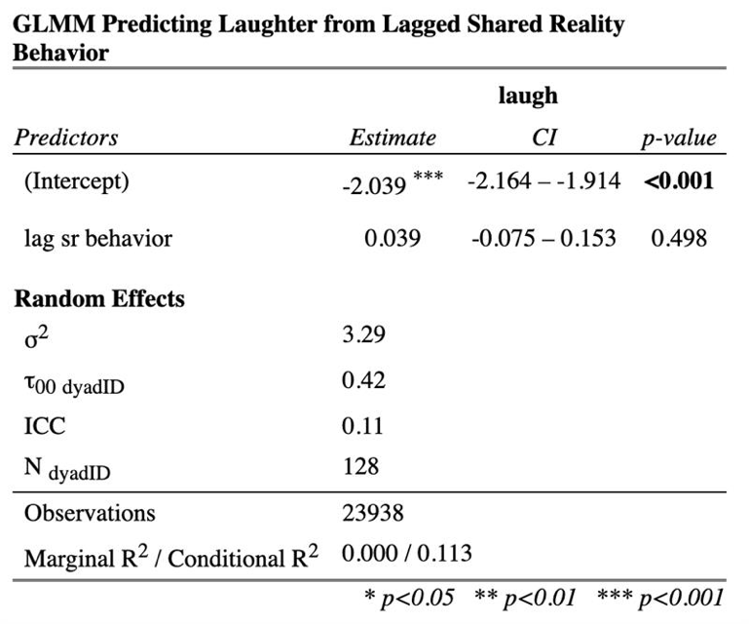
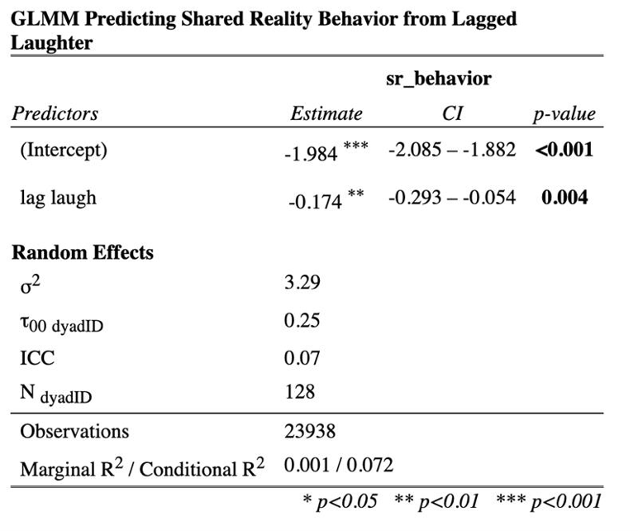
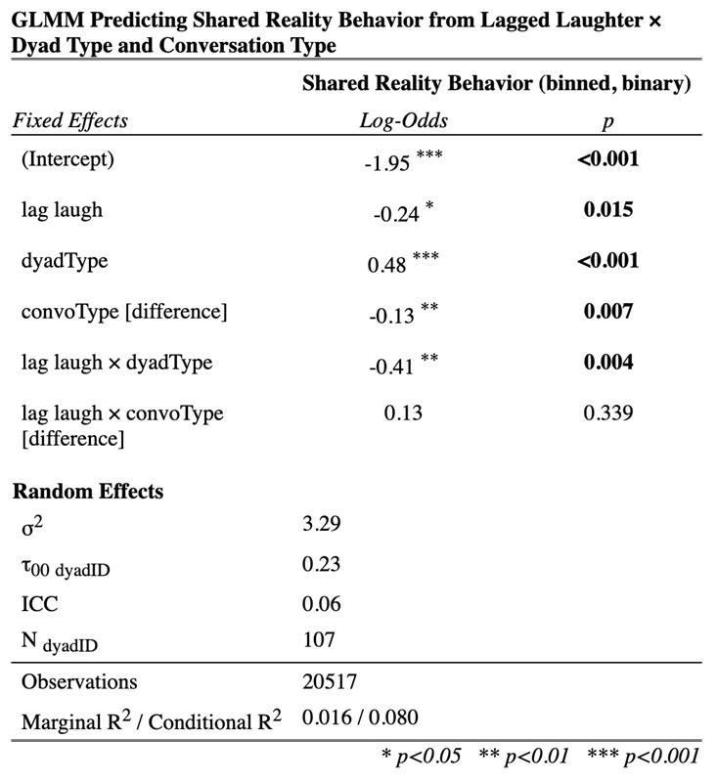

2.5 Predicting friends’ laughter from their perceived and actual friendship style similarity (RQ5)
 | Num. Laughs |  |  | Laughter Duration |  |  | Num. Colaughs |  |  | Colaughter Duration
Predictors | Incidence Rate Ratios | CI | p | Estimates | CI | p | Incidence Rate Ratios | CI | p | Estimates | CI | p
(Intercept) | 0.70 | 0.47 – 1.04 | 0.080 | 0.70 | 0.42 – 1.17 | 0.178 | 0.23 | 0.10 – 0.51 | <0.001 | 0.22 | 0.07 – 0.68 | 0.008
Actual friendship style similarity | 1.06 | 0.76 – 1.48 | 0.722 | 1.03 | 0.57 – 1.86 | 0.916 | 1.16 | 0.65 – 2.06 | 0.611 | 0.81 | 0.35 – 1.88 | 0.629
Perceived friendship style similarity | 1.53 | 1.06 – 2.23 | 0.025 | 1.74 | 1.17 – 2.60 | 0.007 | 3.09 | 1.29 – 7.44 | 0.012 | 4.41 | 1.29 – 15.09 | 0.018
Duration of conversation | 1.10 | 1.08 – 1.12 | <0.001 | 1.14 | 1.10 – 1.17 | <0.001 | 1.08 | 1.05 – 1.11 | <0.001 | 1.09 | 1.06 – 1.13 | <0.001
Random Effects
σ² | 0.16 |  |  | 0.47 |  |  | 0.50
τ₀₀ | 0.00 _{actorID:dyadID} |  |  | 0.07 _{actorID:dyadID} |  |  | 0.18 _{dyadID} |  |  | 0.55 _{dyadID}
 | 0.03 _{dyadID} |  |  | 0.41 _{dyadID}
ICC |  |  |  | 0.72 |  |  | 0.28 |  |  | 0.53
N | 126 _{actorID} |  |  | 126 _{actorID} |  |  | 63 _{dyadID} |  |  | 63 _{dyadID}
 | 63 _{dyadID} |  |  | 63 _{dyadID}
Observations | 126 |  |  | 126 |  |  | 126 |  |  | 126
Marginal R² / Conditional R² | NA |  |  | 0.524 / 0.868 |  |  | 0.345 / 0.526 |  |  | 0.312 / 0.675

2.6 Predicting laughter from separate baseline similarity measures

2.6.1 Laughter variables
 | Num. Laughs |  |  | Laughter Duration
Predictors | Incidence Rate Ratios | CI | p | Estimates | CI | p
(Intercept) | 0.72 | 0.47 – 1.09 | 0.123 | 0.73 | 0.44 – 1.22 | 0.234
Closeness | 1.00 | 1.00 – 1.01 | 0.079 | 1.01 | 1.00 – 1.01 | <0.001
Global Similarity | 1.00 | 0.99 – 1.00 | 0.039 | 0.99 | 0.99 – 1.00 | 0.004
Personality Similarity | 1.14 | 1.04 – 1.26 | 0.007 | 1.15 | 1.03 – 1.29 | 0.011
Hobbies Similarity | 0.97 | 0.90 – 1.04 | 0.410 | 0.97 | 0.89 – 1.05 | 0.418
Values Similarity | 1.02 | 0.93 – 1.12 | 0.688 | 1.08 | 0.97 – 1.20 | 0.167
Behavior Similarity | 1.04 | 0.95 – 1.14 | 0.415 | 1.07 | 0.97 – 1.19 | 0.186
Lifestyle Similarity | 0.94 | 0.87 – 1.02 | 0.122 | 0.88 | 0.80 – 0.97 | 0.008
Similarity Checklist | 1.01 | 0.96 – 1.07 | 0.644 | 1.02 | 0.96 – 1.08 | 0.502
Conversation Duration | 1.07 | 1.06 – 1.08 | <0.001 | 1.07 | 1.06 – 1.08 | <0.001
Random Effects
σ² | 0.29 |  |  | 0.26
τ₀₀ | 0.02 _{partnerID} |  |  | 0.04 _{partnerID}
 | 0.15 _{actorID} |  |  | 0.36 _{actorID}
ICC | 0.38 |  |  | 0.61
N | 128 _{partnerID} |  |  | 128 _{partnerID}
 | 127 _{actorID} |  |  | 127 _{actorID}
Observations | 458 |  |  | 458
Marginal R² / Conditional R² | 0.379 / 0.616 |  |  | 0.359 / 0.748

2.6.2 Colaughter variables
 | Num. Colaughs |  |  | Colaughter Duration
Predictors | Incidence Rate Ratios | CI | p | Estimates | CI | p
(Intercept) | 0.15 | 0.06 – 0.40 | <0.001 | 0.07 | 0.02 – 0.24 | <0.001
Closeness | 1.01 | 1.00 – 1.02 | 0.014 | 1.02 | 1.01 – 1.03 | 0.001
Global Similarity | 0.98 | 0.97 – 0.99 | 0.001 | 0.97 | 0.95 – 0.98 | <0.001
Personality Similarity | 1.68 | 1.32 – 2.14 | <0.001 | 2.09 | 1.53 – 2.84 | <0.001
Hobbies Similarity | 0.92 | 0.77 – 1.11 | 0.395 | 0.88 | 0.70 – 1.11 | 0.286
Values Similarity | 0.82 | 0.66 – 1.01 | 0.061 | 0.93 | 0.70 – 1.22 | 0.591
Behavior Similarity | 1.18 | 0.91 – 1.52 | 0.208 | 1.18 | 0.85 – 1.64 | 0.318
Lifestyle Similarity | 0.86 | 0.70 – 1.05 | 0.144 | 0.77 | 0.59 – 1.01 | 0.061
Similarity Checklist | 1.10 | 0.98 – 1.23 | 0.118 | 1.09 | 0.94 – 1.26 | 0.274
Conversation Duration | 1.07 | 1.05 – 1.09 | <0.001 | 1.07 | 1.05 – 1.10 | <0.001
Random Effects
σ² | 0.56 |  |  | 0.47
τ₀₀ | 0.06 _{dyadID:groupID} |  |  | 0.35 _{dyadID:groupID}
 | 0.12 _{groupID} |  |  | 0.17 _{groupID}
ICC | 0.24 |  |  | 0.53
N | 125 _{dyadID} |  |  | 125 _{dyadID}
 | 32 _{groupID} |  |  | 32 _{groupID}
Observations | 250 |  |  | 250
Marginal R² / Conditional R² | 0.384 / 0.535 |  |  | 0.450 / 0.739

