EVA-PLA-SMMA blends: Study of mechanical properties under hydrolytic degradation and cytotoxic evaluation

Mónica Elvira Mendoza-Duarte*^{1,2}, Jorge Alberto Roacho Pérez³, Adriana G Quiroz Reyes³, Elsa N Garza Treviño³, Celia N Sánchez Domínguez³, Perla Elvia García-Casillas^{2,}, and Alejandro Vega-Rios^{1,}*.

1 Centro de Investigación en Materiales Avanzados, S.C. Av. Miguel de Cervantes #120, Chihuahua, Mexico, 31136; M.E.M.D. monica.mendoza@cimav.edu.mx
2 Instituto de Ingeniería y Tecnología, Universidad Autónoma de Ciudad Juárez, Chihuahua, Mexico, 32310 2; P.E.G.C. pegarcia@uacj.mx
3 Departamento de Bioquímica y Medicina Molecular. Facultad de Medicina, Universidad Autónoma de Nuevo León; alberto.roachoprz@uanl.edu.mx
* Correspondence: M.E.M.D. monica.mendoza@cimav.edu.mx, A.V.R. alejandro.vega@cimav.edu.mx

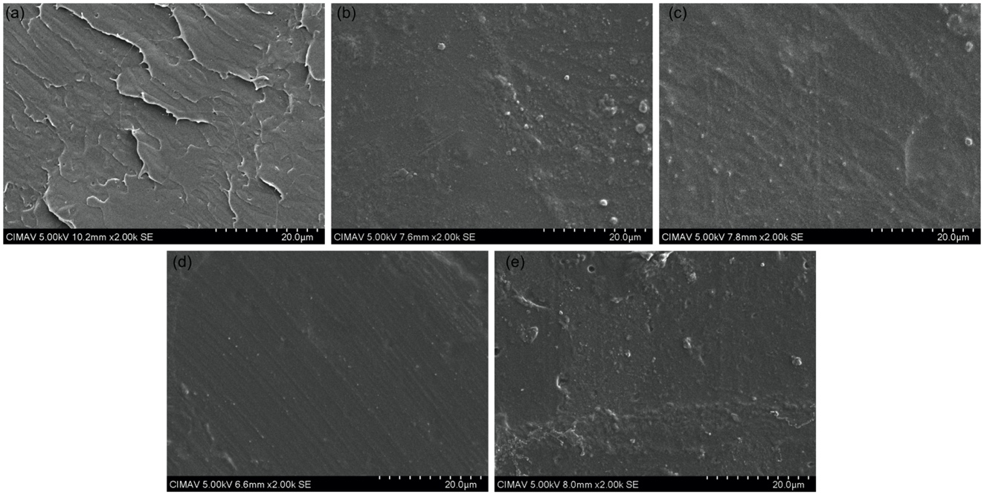
Figure S1. Surface scanning electron micrographs of PLA and EPS blends at 0 days. (a) PLA5; (b) PLA15; (c) EPS1; (d) EPS2; (e) EPS3.
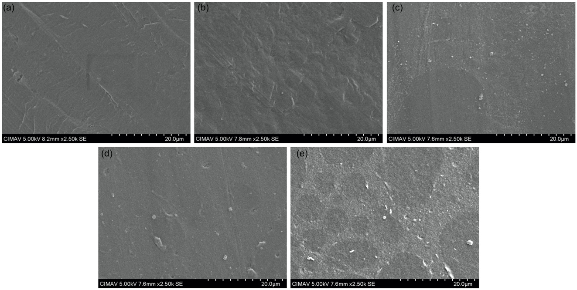
Figure S2. Surface scanning electron micrographs of PLA and EPS blends at 7 days. (a) PLA5; (b) PLA15; (c) EPS1; (d) EPS2; (e) EPS3.

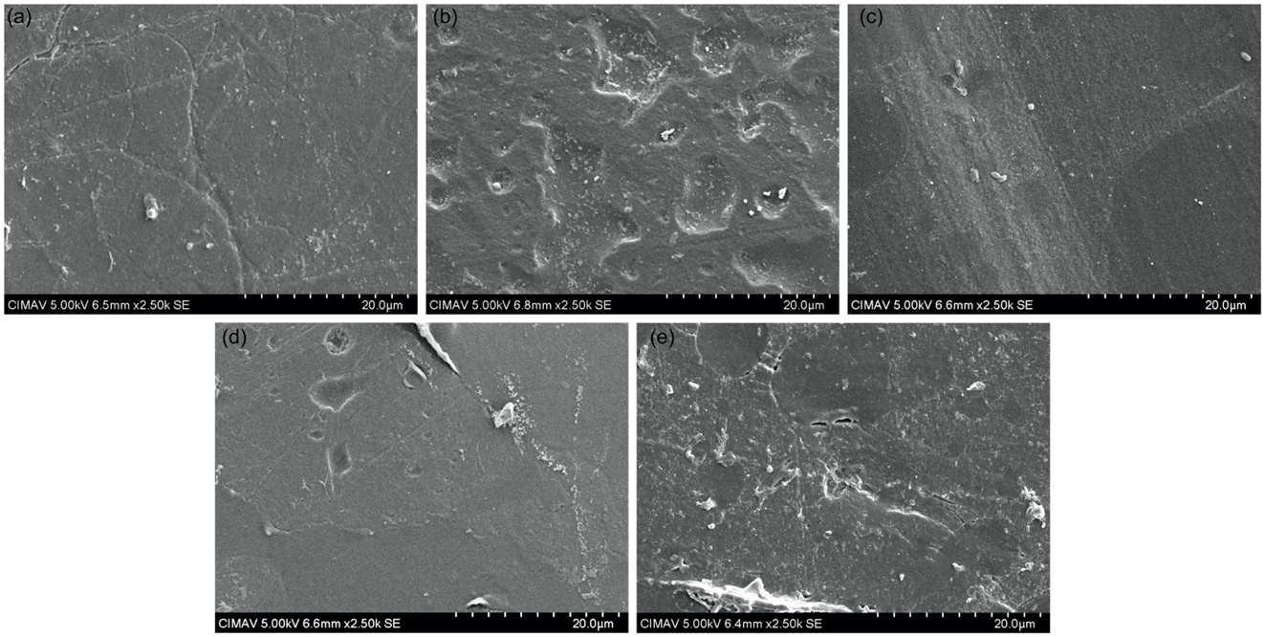
Figure S3. Surface scanning electron micrographs of PLA and EPS blends at 21 days. (a) PLA5; (b) PLA15; (c) EPS1; (d) EPS2; (e) EPS3.

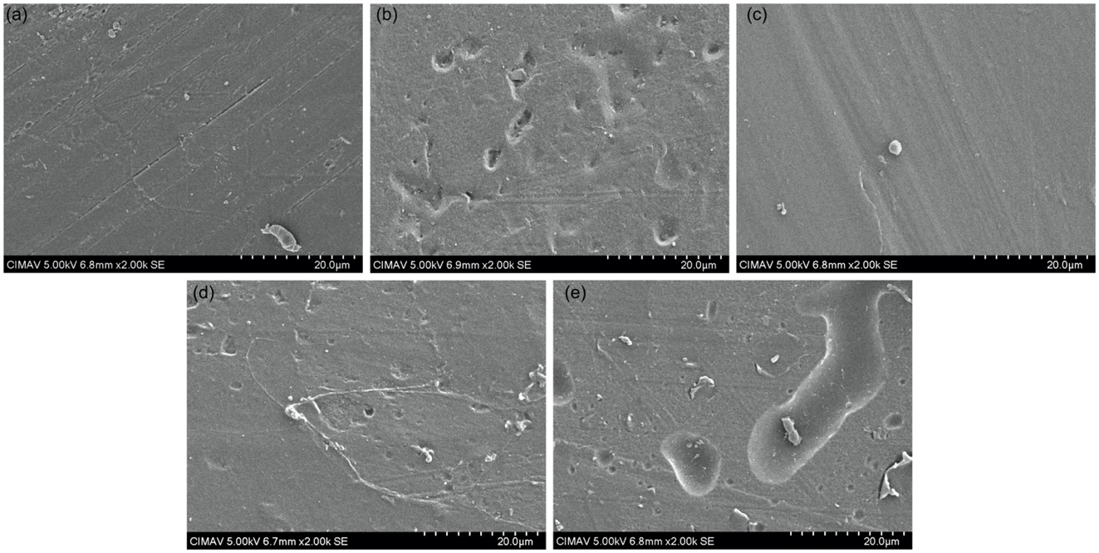
Figure S4. Surface scanning electron micrographs of PLA and EPS blends at 49 days. (a) PLA5; (b) PLA15; (c) EPS1; (d) EPS2; (e) EPS3.

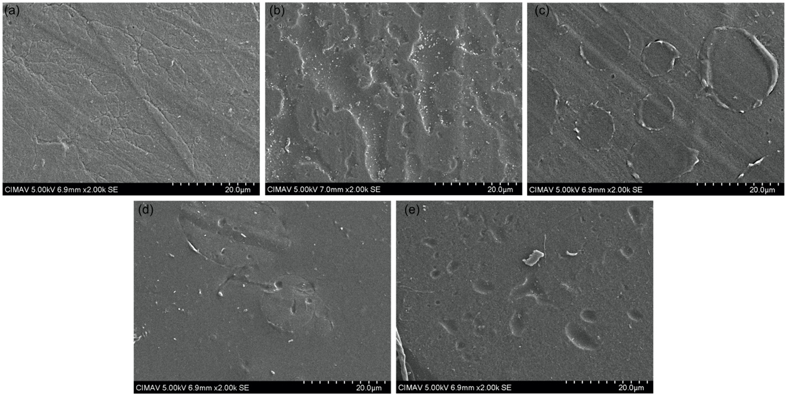

Figure S5. Surface scanning electron micrographs of PLA and EPS blends at 84 days. (a) PLA5; (b) PLA15; (c) EPS1; (d) EPS2; (e) EPS3.

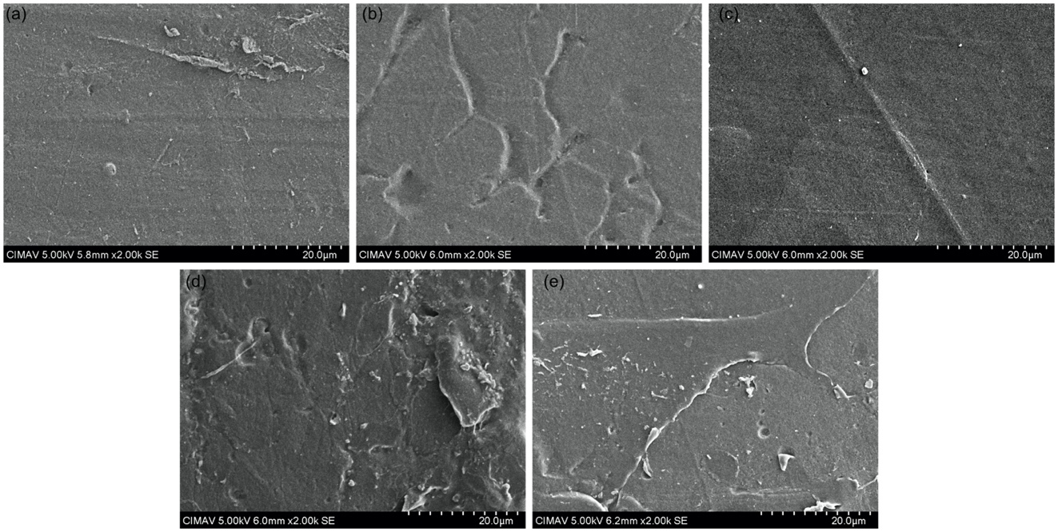
Figure S6. Surface scanning electron micrographs of PLA and EPS blends at 168 days. (a) PLA5; (b) PLA15; (c) EPS1; (d) EPS2; (e) EPS3.

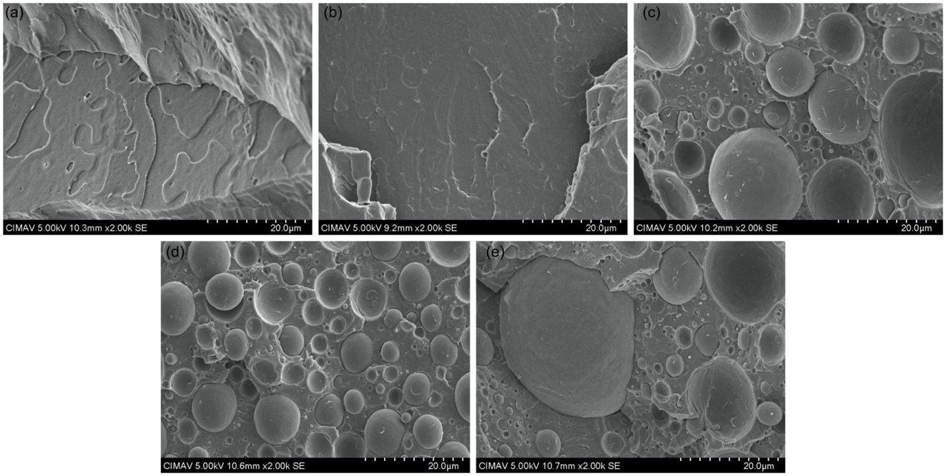

Figure S7. Cross-section scanning electron micrographs of PLA and EPS blends at 0 days. (a) PLA5; (b) PLA15; (c) EPS1; (d) EPS2; (e) EPS3.

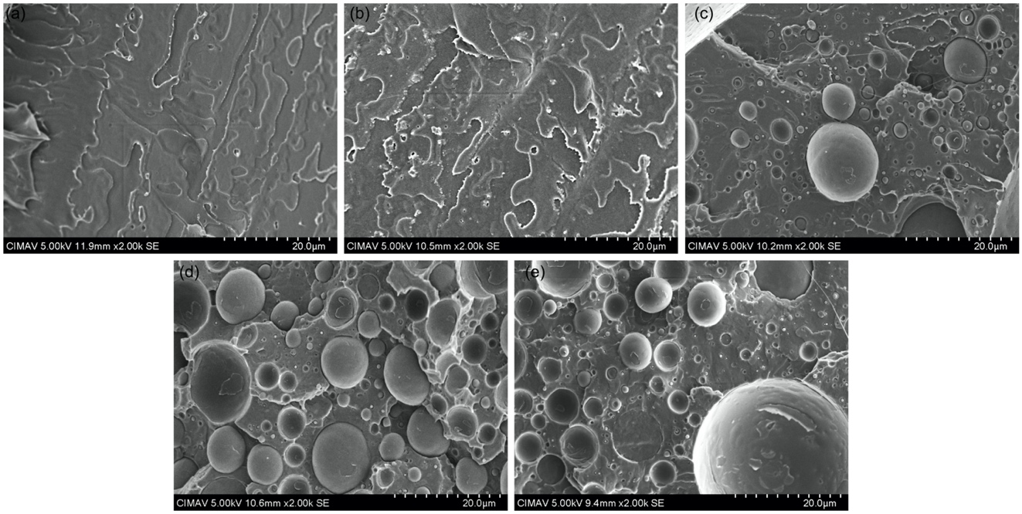
Figure S8. Cross-section scanning electron micrographs of PLA and EPS blends at 7 days. (a) PLA5; (b) PLA15; (c) EPS1; (d) EPS2; (e) EPS3.

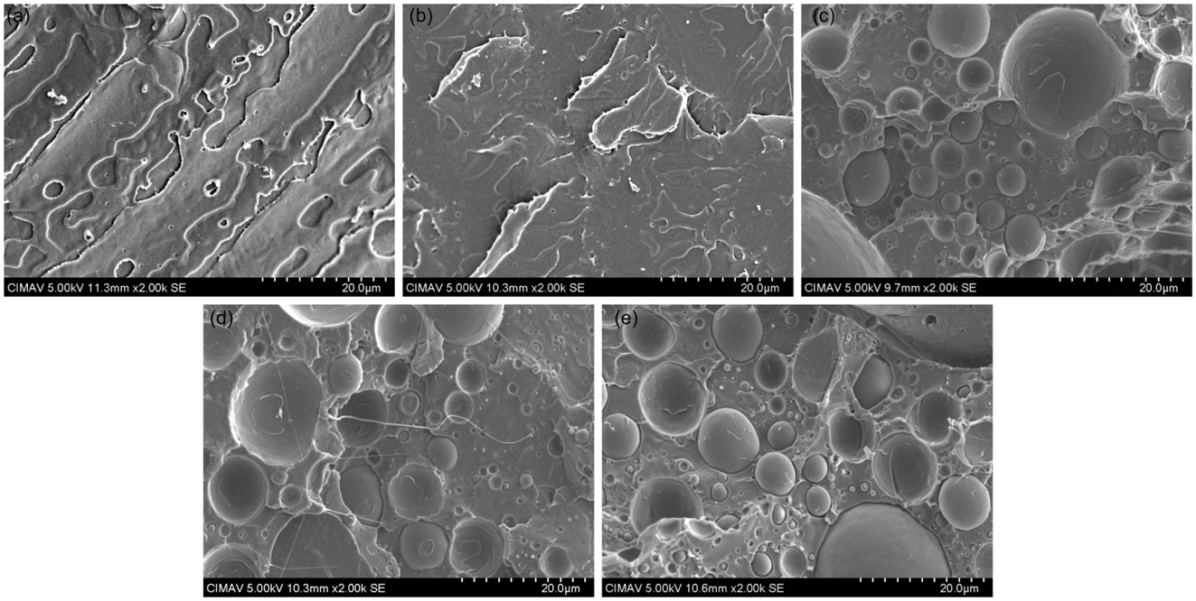

Figure S9. Cross-section scanning electron micrographs of PLA and EPS blends at 21 days. (a) PLA5; (b) PLA15; (c) EPS1; (d) EPS2; (e) EPS3.
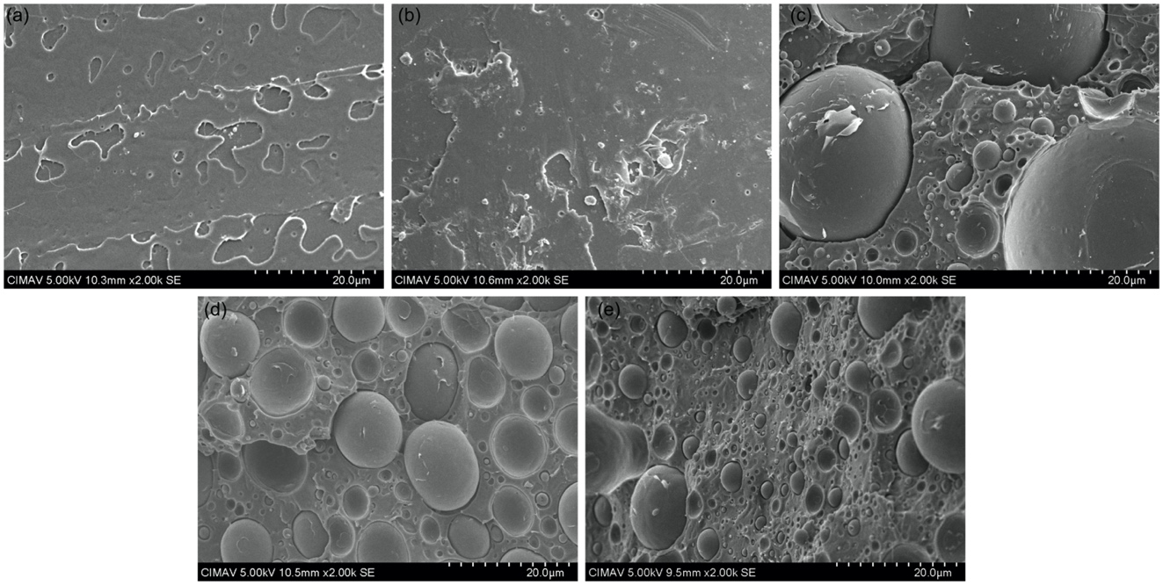

Figure S10. Cross-section scanning electron micrographs of PLA and EPS blends at 49 days. (a) PLA5; (b) PLA15; (c) EPS1; (d) EPS2; (e) EPS3.

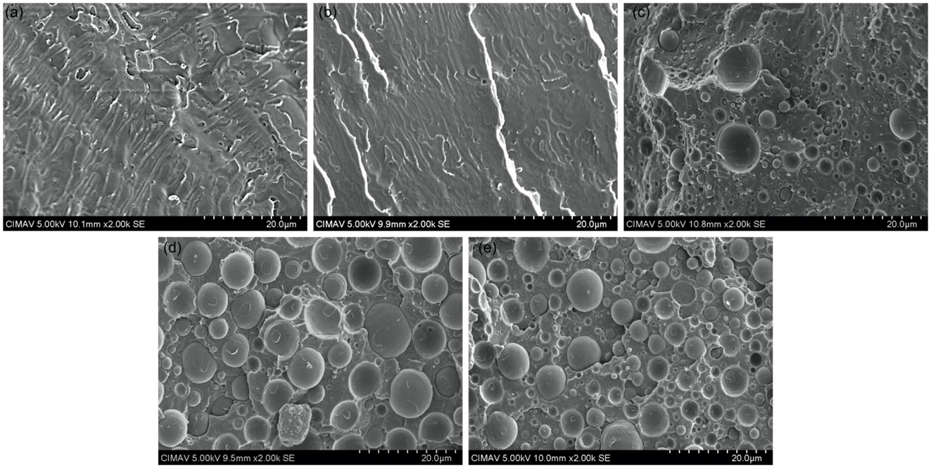

Figure S11. Cross-section scanning electron micrographs of PLA and EPS blends at 84 days. (a) PLA5; (b) PLA15; (c) EPS1; (d) EPS2; (e) EPS3.

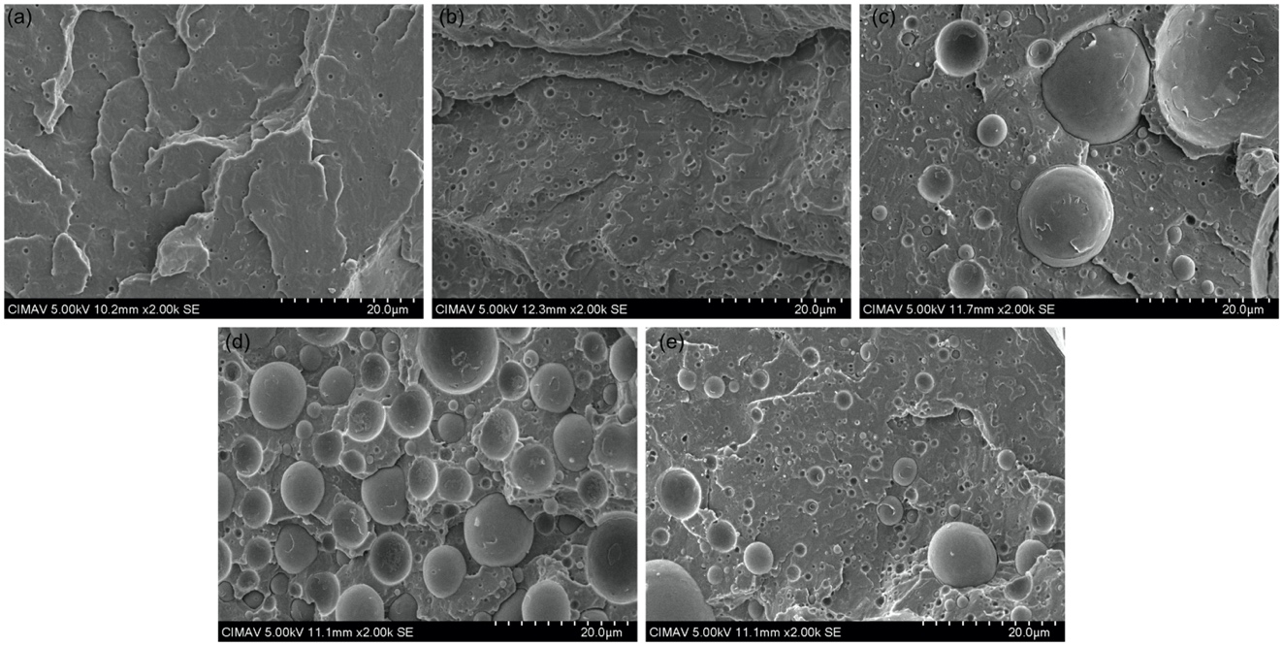

Figure S12. Cross-section scanning electron micrographs of PLA and EPS blends at 168 days. (a) PLA5; (b) PLA15; (c) EPS1; (d) EPS2; (e) EPS3.

