Novel physically-crosslinked hydrogel membranes based on PVA/Aloevera loading caffeine and vitamin C: Synthesis, characterization and In-vivo wound healing experiment
El-Refaie Kenawy^{1*}, Mahmoud A. El-Meligy², Zeinab S. Ghaly¹, Marwa E. Kenawy¹, Elbadawy A. Kamoun^{3,4*}
¹Polymer Research Group, Department of Chemistry, Faculty of Science, University of Tanta, Tanta 31527, Egypt.
²Polymer Institute of the Slovak Academy of Sciences, Dúbravská cesta 9, 845 41, Bratislava, Slovakia.
³Nanotechnology Research Center (NTRC), The British University in Egypt (BUE), El-Sherouk City, Cairo 11837, Egypt.
⁴Polymeric Materials Research Dep., Advanced Technology and New Materials Research Institute (ATNMRI), City of Scientific Research and Technological Applications (SRTA-City), New Borg Al-Arab City, Alexandria 21934, Egypt.

*Corresponding authors: E. Kenawy, ekenawy@yahoo.com; E.A. Kamoun, E-mail: e-b.kamoun@tu-bs.de, badawykamoun@yahoo.com, Tel: +20-1283320302.

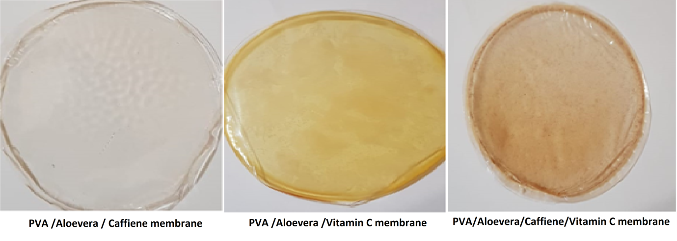

Fig. 1S Photos of PVA/Aloevera/ caffeine, PVA/ Aloevera/ vitamin C and PVA/Aloevera/ caffeine/ vitamin C hydrogel membranes formed physically by hydrolyzation of PVA using propanol.

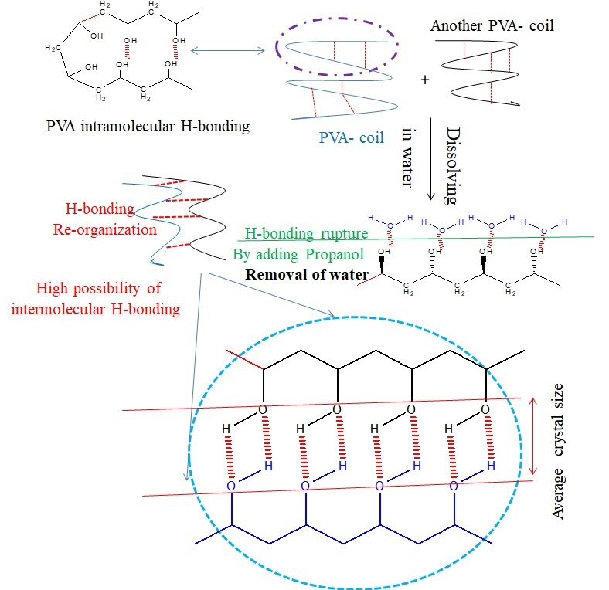

Fig. 2S Reaction mechanism of entanglement of PVA/Aloevera in presence of propanol.

Fig. 3S Chart of caffeine standard curve.

Fig. 4S Influence of caffeine incorporation into 60 %PVA/ 40%Aloe vera hydrogel membranes on the wound closure %.

Fig. 5S Influence of vitamin C incorporation into 100% PVA hydrogel membranes on the wound closure %.

Fig. 6S Influence of vitamin C incorporation into 60% PVA/ 40% Aloevera hydrogel membranes on the wound closure %.

Fig. 7S Influence of both caffeine and vitamin C incorporation into 60%PVA/ 40%Aloevera hydrogel membranes on the wound closure %.

