Supplementary Information for
“Novel Fluoroboric Acid Additive for Blend Membrane to be Used in PEM Fuel Cell, Characterization Studies, and Performance Test”

Yavuz Yagizatli^{a,*}, Irfan Arª
ª Gazi University, Graduate School of Natural and Applied Sciences, Faculty of Engineering, Department of Chemical Engineering,
Eti Mahallesi, Yükseliş Sokak, No:5, Maltepe, Ankara, 06570, Turkey
* E-mail: yavuzyagizatli@gazi.edu.tr

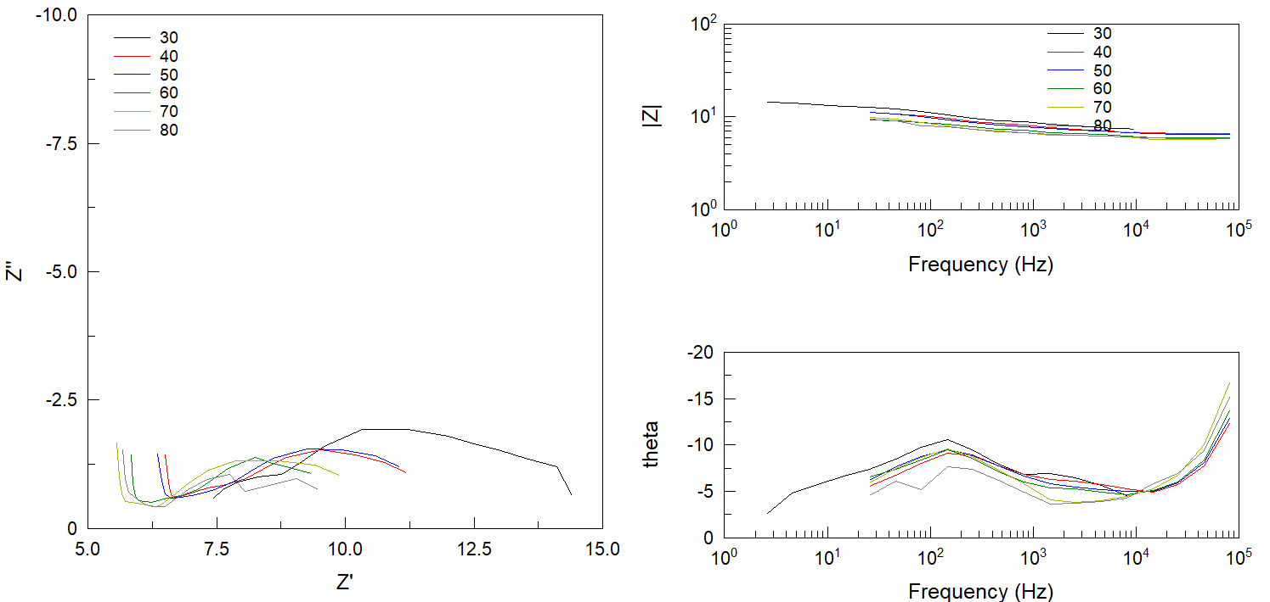
Fig. S1. SP-%1F Nquist and Bode Diagram

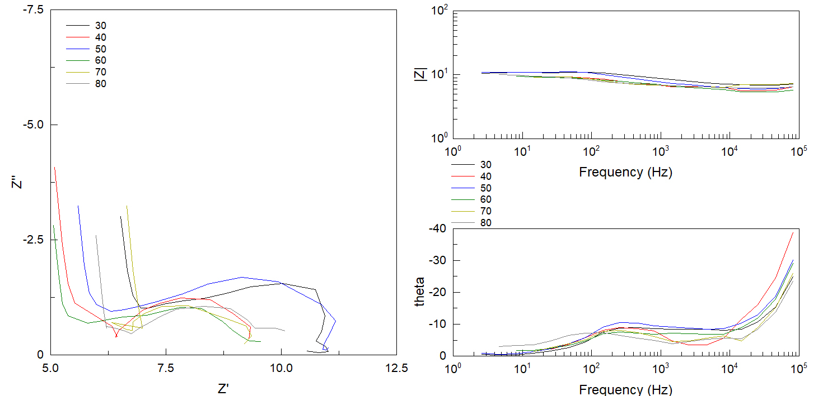
Fig. S2. SP-%5F Nquist and Bode Diagram

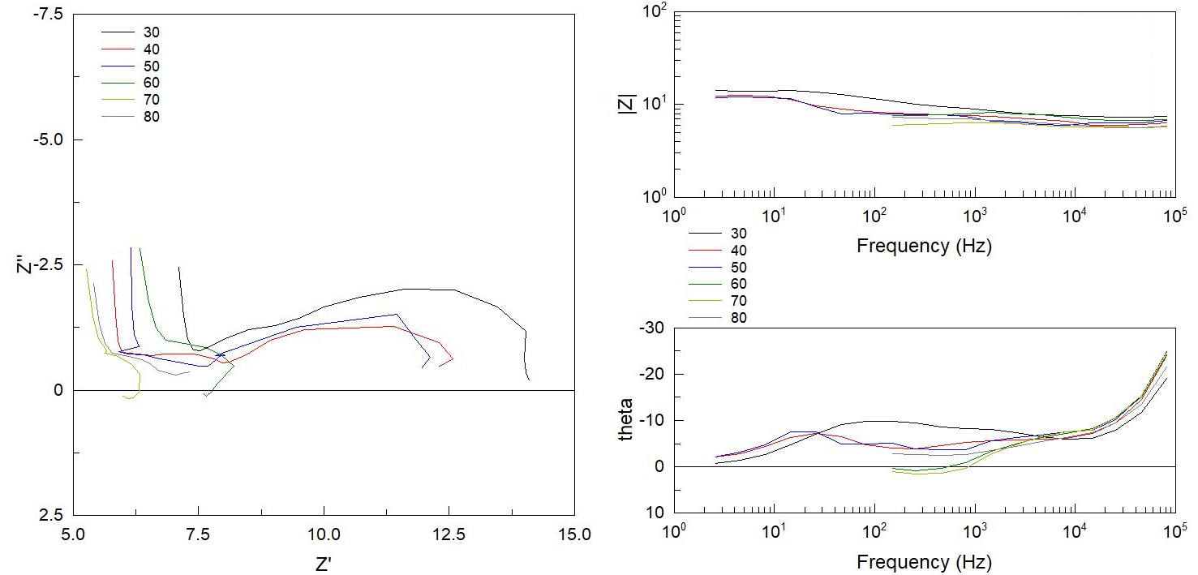
Fig. S3. SP-%7.5F Nquist and Bode Diagram

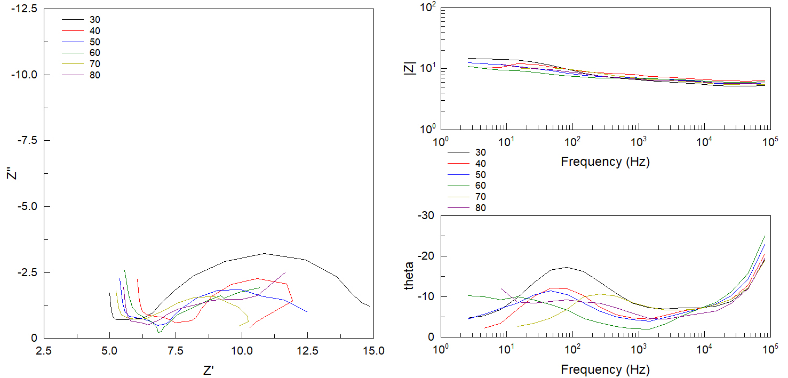
Fig. S4. SP-%10F Nquist and Bode Diagram

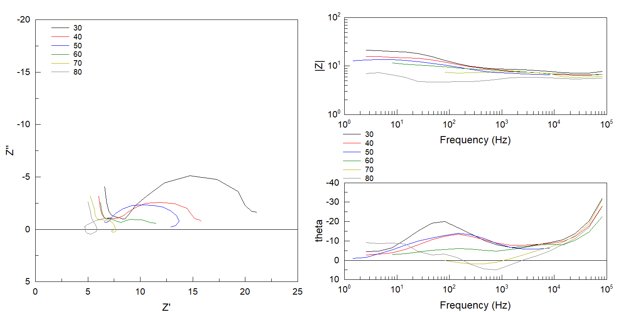
Fig. S5. SP-%12.5F Nquist and Bode Diagram

