SUPPLEMENTARY INFORMATION

A novel qPCR-guided screening of levansucrase: levan characterization and genomic insights.

Pınar AYTAR ÇELİK^{1,2*}, Dilan BARUT¹, Özlem ERDAL ALTINTAŞ³, Blaise Manga ENUH⁴, Belma NURAL YAMAN,^{1,5} Mehmet Burçin MUTLU⁶, Ahmet ÇABUK^{1,7}, Ebru TOKSOY ÖNER⁸

¹ Department of Biotechnology and Biosafety, Eskisehir Osmangazi University, Eskisehir, Turkey
² Environmental Protection and Control Program, Eskisehir Osmangazi University, Eskisehir, Turkey
³ Medical Services and Techniques Department, Afyonkarahisar Health Sciences University, Afyonkarahisar, Turkey
⁴ Great Lakes Bioenergy Research Centre (GLBRC), University of Wisconsin-Madison, United States
⁵ Department of Biomedical Engineering, Eskisehir Osmangazi University, Eskisehir, Turkey
⁶ Department of Biology, Eskisehir Technical University, Eskisehir, Turkey
⁷ Department of Biology, Eskisehir Osmangazi University, Eskisehir, Turkey
⁸ IBSB, Department of Bioengineering, Marmara University, RTE Campus, Istanbul, Turkey

*Corresponding Author: Dr. Pınar Aytar Celik
E-posta: paytar@ogu.edu.tr
Tel: +902222393750/2757111
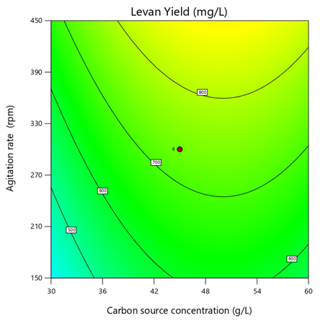 | 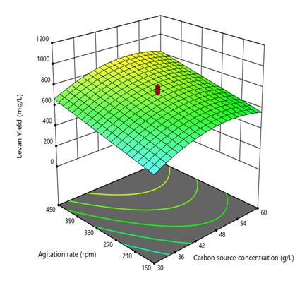

(a)
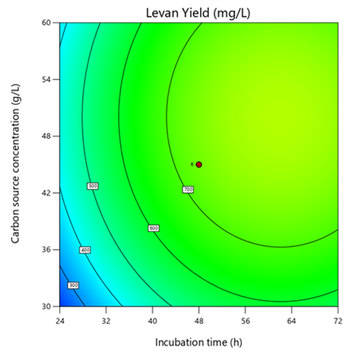 | 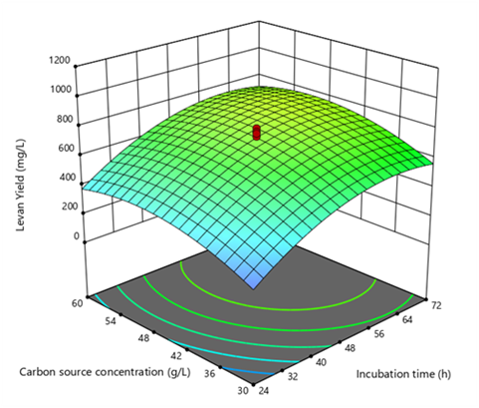

(b)
Figure S1(a) Isohips curve and surface plot of initial carbon source concentration and agitation rate at constant incubation time (48 hours)
(b) Isohips curve and surface plot of initial carbon source concentration and incubation time at constant agitation rate (300 rpm)

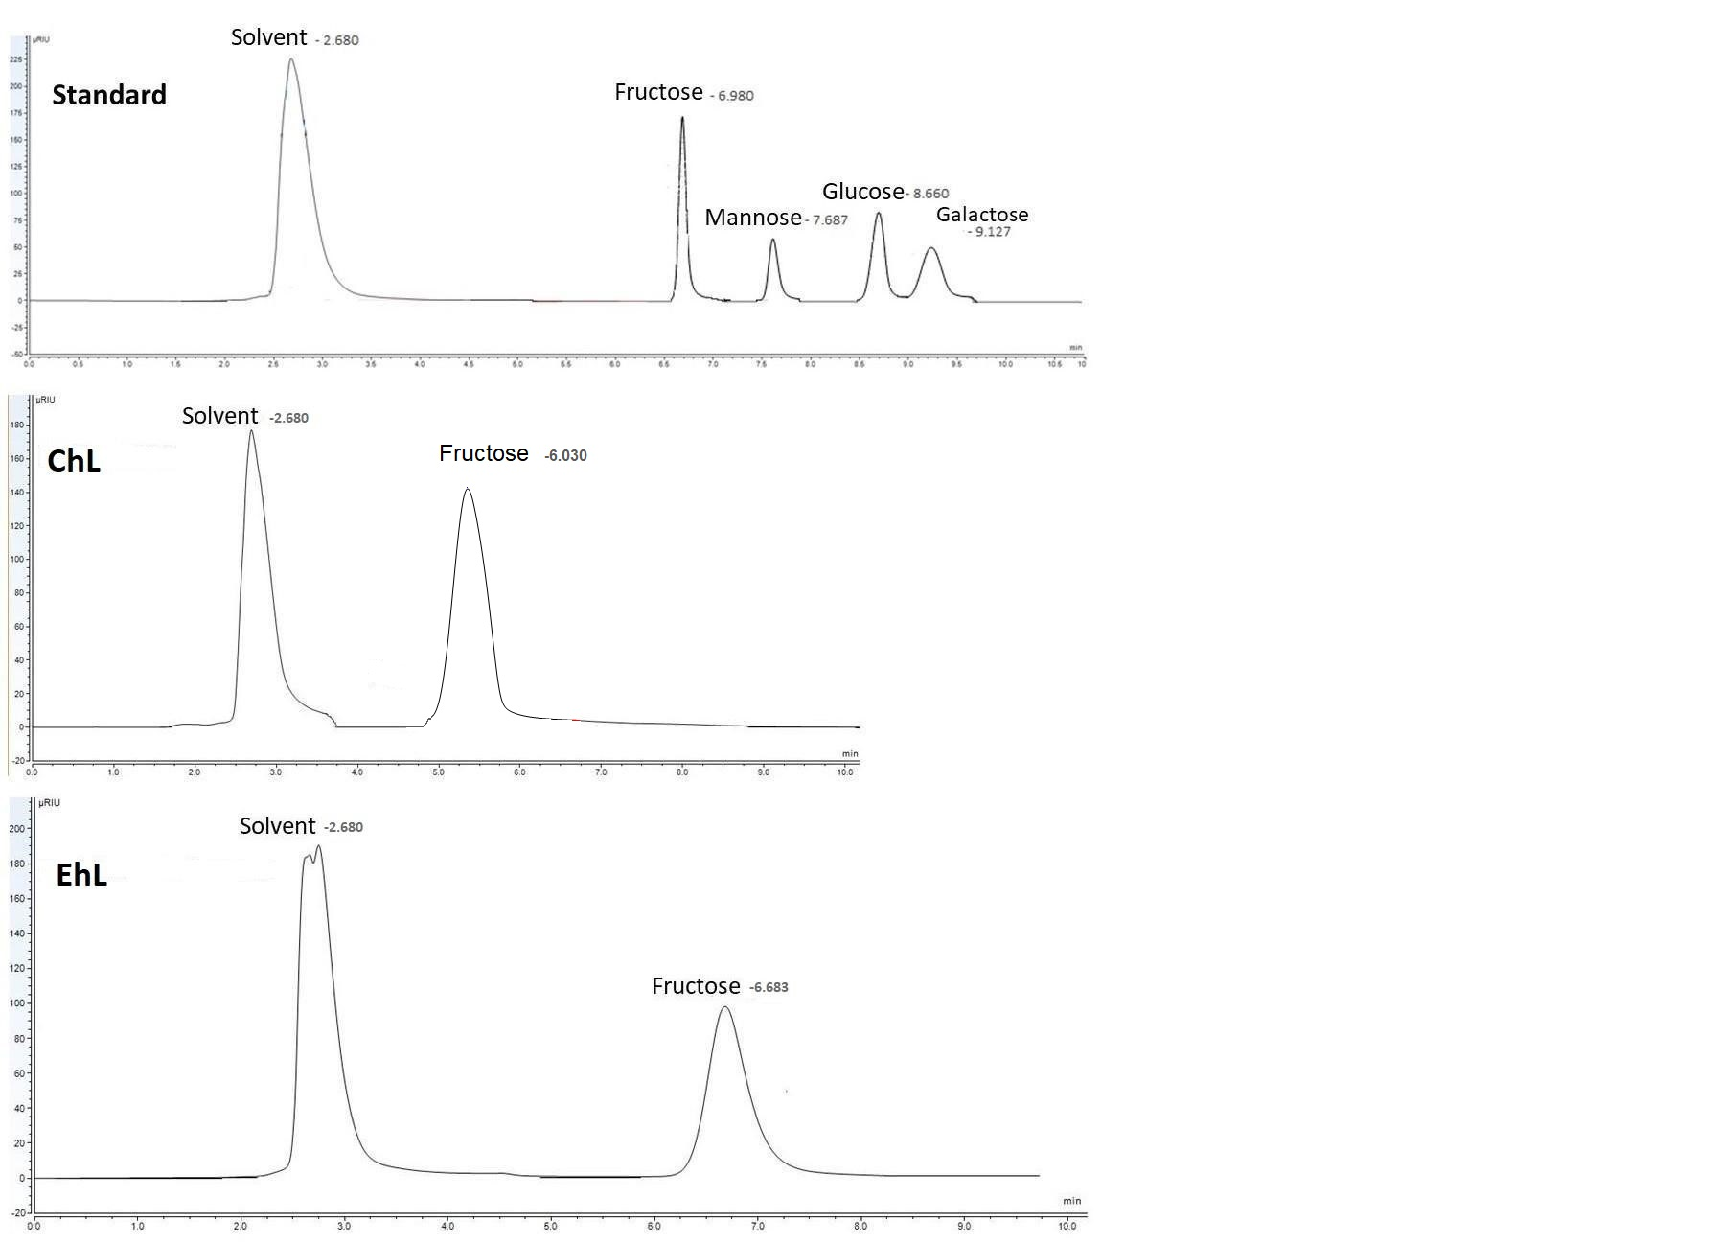
b)
c)
Figure S2 Comparison of HPLC chromatograms by sugar standards (a), C. salexigensis P19-1 levan (ChL) (b), and commercial E. herbicola levan (EhL) (c).
a)

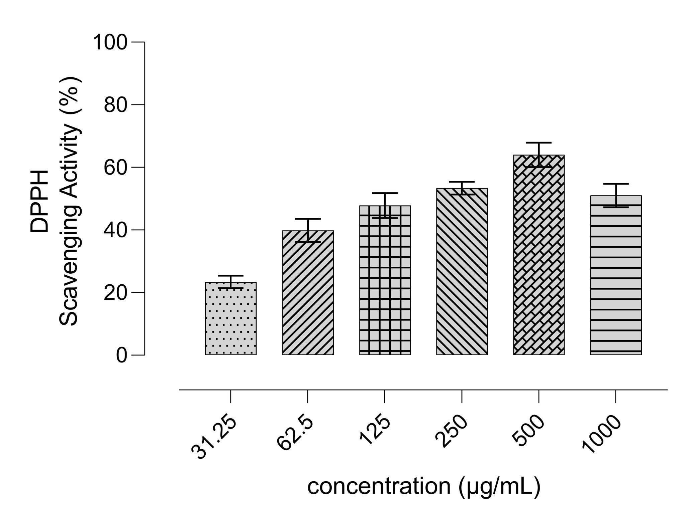
Figure S3 Dose-dependent DPPH scavenging activity of ChL against ascorbic acid.

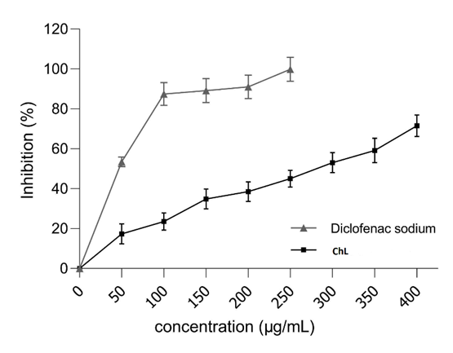
Figure S4 Anti-inflammatory activity ChL and standard Diclofenac sodium

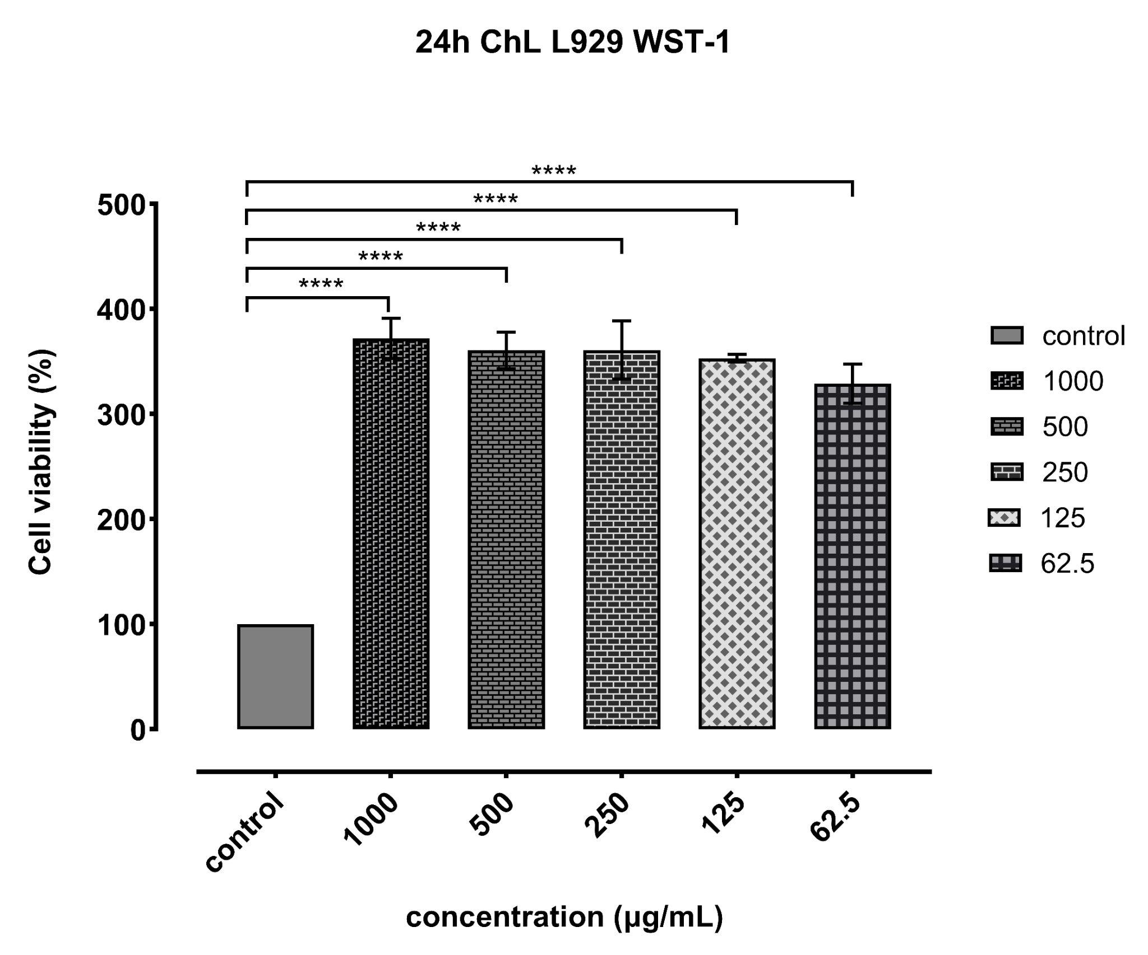 | 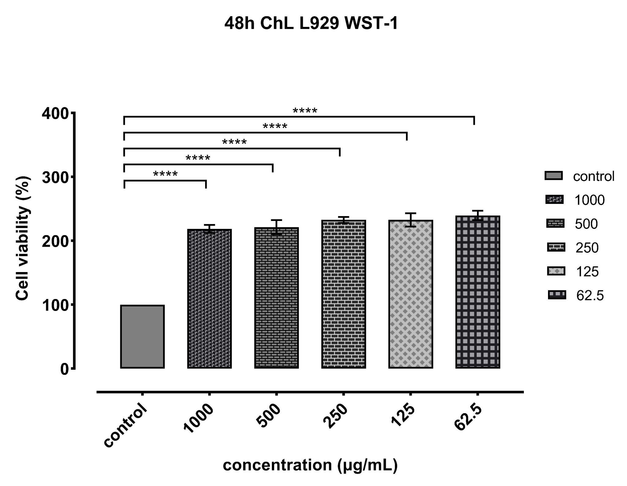
Figure S5 Viability results of the L929 cell line after being cultivated with ChL (AP value below 0.05 is represented as ( ****; <0.0001)

Table S1 Design matrix and results of experiments
Run | Factor 1  Carbon source concentration (g/L) | Factor 2  Agitation rate (rpm) | Factor 3  Incubation time (h) | Response  Levan Yield  (mg/L) | Levansucrase activity  (mM glucose/min)
1 | 60 | 150 | 24 | 319.657±2.349 | 0.130±0.012
2 | 45 | 300 | 48 | 775.186±3.008 | 0.185±0.024
3 | 60 | 150 | 72 | 528.892±2.169 | 0.172±0.031
4 | 67.5 | 300 | 48 | 715.635±3.014 | 0.179±0.019
5 | 60 | 450 | 72 | 758.742±2.506 | 0.163±0.027
6 | 60 | 450 | 24 | 349.449±2.006 | 0.156±0.053
7 | 45 | 300 | 12 | 167.513±1.805 | 0.124±0.074
8 | 30 | 450 | 72 | 701.938±3.227 | 0.179±0.048
9 | 22.5 | 300 | 48 | 358.333±2.553 | 0.172±0.011
10 | 45 | 300 | 48 | 742.662±3.505 | 0.263±0.028
11 | 45 | 300 | 48 | 798.494±2.996 | 0.171±0.031
12 | 45 | 300 | 48 | 619.346±2.744 | 0.309±0.022
13 | 45 | 525 | 48 | 1101.730±3.408 | 0.174±0.029
14 | 30 | 150 | 24 | 182.917±1.960 | 0.142±0.039
15 | 30 | 450 | 24 | 255.681±2.352 | 0.169±0.048
16 | 45 | 300 | 48 | 762.926±3.001 | 0.152±0.032
17 | 30 | 150 | 72 | 367.312±1.932 | 0.152±0.064
18 | 45 | 300 | 48 | 655.548±2.443 | 0.270±0.037
19 | 45 | 75 | 48 | 456.592±1.859 | 0.222±0.052
20 | 45 | 300 | 48 | 773.550±2.877 | 0.148±0.069

Table S2 ANOVA analysis and estimated regression coefficients for levan yield
Anova Analysis
Source | Adj SSª | Adj MS^{b} | F | p
Model | 1035701.33 | 207140.26 | 18.56 | <0.0001
X₁ | 77593.61 | 77593.61 | 6.95 | 0.0195
X₂ | 213791.57 | 213791.57 | 19.16 | 0.0006
X₃ | 372638.45 | 372638.45 | 33.40 | <0.0001
X₁² | 142275.33 | 142275.33 | 12.75 | 0.0031
X₃² | 222805.16 | 222805.16 | 19.971 | 0.0005
Residual error | 156184.13 | 11156.00
Lack of fit | 130530.40 | 14503.37 | 2.82 | 0.1325
Pure error | 25653.734 | 5130.74
Estimated regression coefficients
Term | Coefficient |  |  | p
Constant | -1753.673 |  |  | <0.0001
X₁ | 52.243 |  |  | 0.0195
X₂ | 0.871 |  |  | 0.0006
X₃ | 31.696 |  |  | <0.0001
X₁² | -0.522 |  |  | 0.0031
X₃² | -0.255 |  |  | 0.0005
ªAdjusted sum of squares ^{b}Adjusted mean square

