Supplementary Material
Enhanced Microencapsulation of Quercetin-Rich Onion (Allium cepa) Peel Extract in Ethyl Cellulose using a W/O/W Double Emulsion: Optimised Production, Characterisation, and Controlled Release
Sara M. Ferreira ^{1,2}, Loleny Tavares^{3,4,5} and Lúcia Santos ^{1,2,}*
¹ LEPABE - Laboratory for Process Engineering, Environment, Biotechnology and Energy, Faculty de Engineering, University of Porto, Rua Dr. Roberto Frias, 4200-465 Porto, Portugal;
² ALiCE - Associate Laboratory in Chemical Engineering, Faculty de Engineering, University of Porto, Rua Dr. Roberto Frias, 4200-465 Porto, Portugal;
³ ESAN - School of Design, Management and Production Technologies Northern Aveiro, University of Aveiro, Estrada do Cercal 449, 3720-509, Oliveira de Azeméis, Santiago de Riba-UI, Portugal
⁴ CICECO-Aveiro - Institute of Materials, Campus Universitário de Santiago, University of Aveiro, 3810-193 Aveiro, Portugal;
⁵ EMaRT Group - Emerging: Materials, Research, Technology, School of Design Management and Production Technologies Northern Aveiro, University of Aveiro, Estrada do Cercal, 449, 3720-509 Oliveira de Azeméis, Portugal;
*Corresponding author: Tel.: +351 225 081 682, Fax: +351 225 081 440, lsantos@fe.up.pt
Results and Discussion
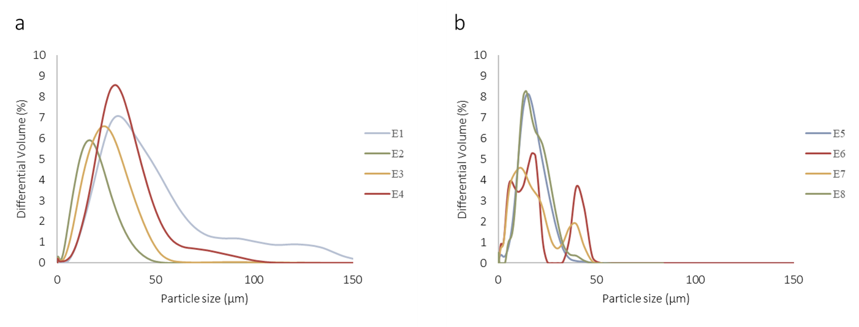
Fig. S.1 Particle Size Distribution for the eight experiments using different solvents, ethyl acetate (a) and dichloromethane (DCM)(b)

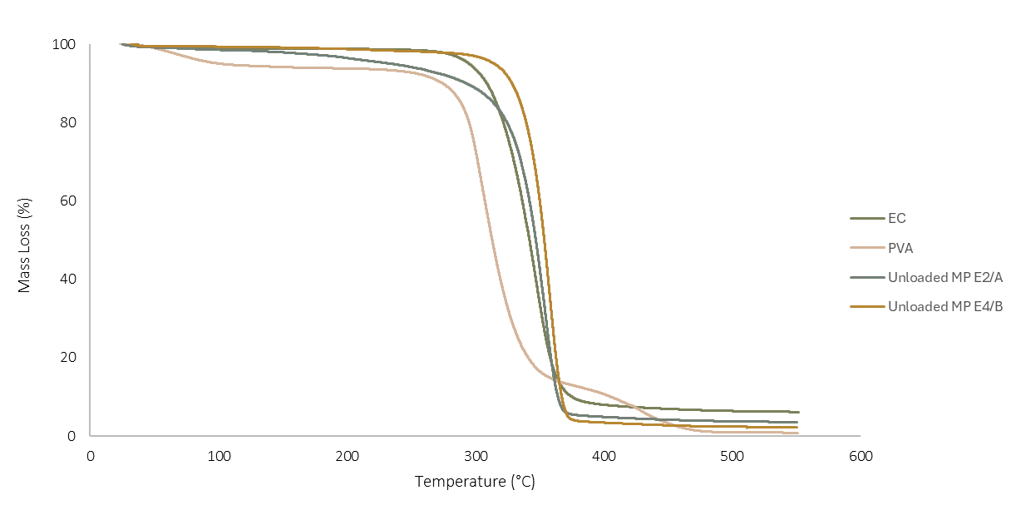
Fig. S.2 TGA curves for ethyl cellulose (EC), (PVA) and unloaded microparticles (formulations E2/A and E4/B)

Table S.1. Results from the regression analysis for quercetin and OP extract quantification in ultrapure water and octanol.
 | Medium | λ (nm) | Regression Equation | Correlation Coefficient
Quercetin | UPW | 315 | Abs = (0.013 ± 0.000)C + (0.028 ± 0.008) | 0.997
Quercetin | Octanol | 215 | Abs = (0.078 ± 0.001)C + (0.07 ± 0.005) | 0.999
OP extract | UPW | 290 | Abs = (0.008 ± 0.000)C + (0.031 ± 0.016) | 0.992
OP extract | Octanol | 300 | Abs = (0.015 ± 0.000)C + (-0.202 ± 0.020) | 0.997
Abs: Absorbance; C: Concentration of bioactive compound (mg∙mL⁻¹); OP: Onion peel; UPW: Ultrapure water.

