Supplemental Information (SI):
Aminated Phenolated Lignin for Effective Anionic Dye Removal for Water Remediation
Journal of Polymers and the Environment
David Chemª, Samantha Glidewellª, Fatema Tarannumª, and Keisha B. Waltersª
ªRalph E. Engineering Department of Chemical Engineering, University of Arkansas
3202 Bell Engineering Center, 800 W. Dickson Street, Fayetteville, AR 72703

Corresponding author email: keishaw@uark.edu

Anionic Dye Calibration Curves
Congo red (CR) and methyl orange (MO) dye solutions were prepared at seven concentrations, such as 0.03, 0.05, 0.07, 0.08, 0.09, 0.10, and 0.14 mM. The maximum absorbance values of each solution concentration were measured using a UV-vis spectrometer. The concentration (Conc) vs. absorbance (ABS) data were plotted, and the data were fit to provide a calibration curve for CR and MO aqueous dye solution concentration. These calibration curves were used to determine the amount of dye remaining in solution at a given time during the adsorption experiments.
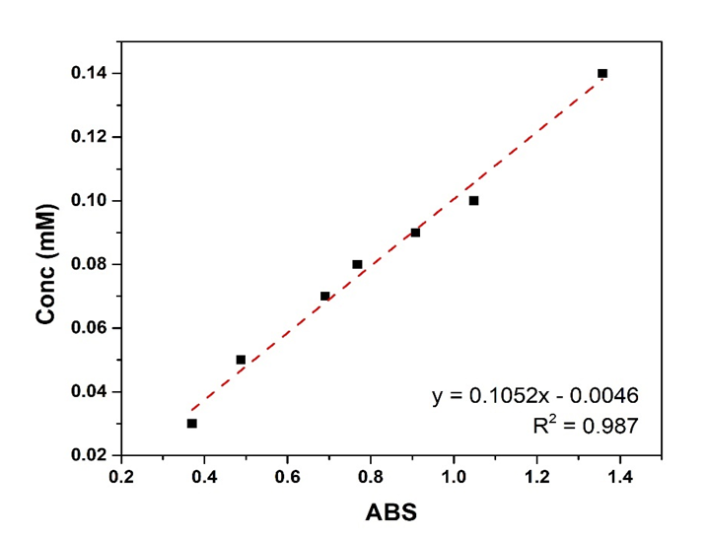
Fig. S1 CR dye UV-vis calibration curve
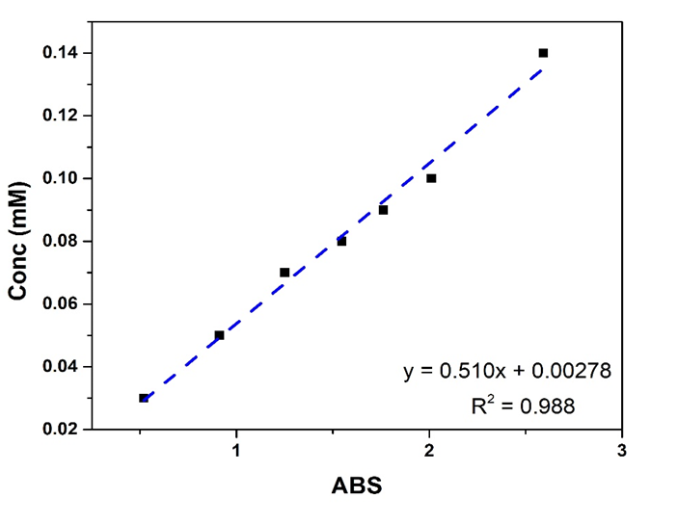
Fig. S2 MO dye UV-vis calibration curve
The linear fits for CO and MO dye concentration using UV-vis spectroscopy are presented in Fig. S1 and Fig. S2, respectively. The calibration curve is plotted to determine the unknown concentrations of MO and CR after pH adjustment and dye adsorption processes. Based on the value of the corresponding absorbance, the concentration of each dye can be determined using the fitted linear curve.

Dye adsorption testing
Below are the UV-Vis spectra of purified alkaline lignin (AL) in deionized water, aminated phenolated lignin (Am-PL) in CR solution (at pH 3.84, 8.86-native, and 9.98), and Am-PL in MO (at pH 3.88, 9.16-native, and 10.06) at different times from 0 to 96 h.
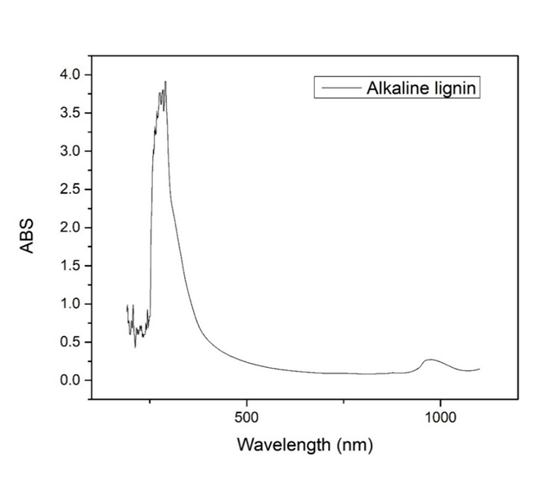
Fig. S3 UV-vis spectrum of purified AL in deionized water
Fig. S4 UV-vis spectra of aqueous Am-PL/CR solution at pH 3.84 from 0 to 96 h. At 0 h, the maximum wavelength occurs at 545 nm, shifting from 498 nm due to the color change of a pH indicator at pH 3-4. However, the UV-vis curve gradually returns to the expected maximum wavelength at 15 h. After 96 h of dye adsorption, the UV-vis curve is nearly flat, indicating that almost all of the CR dye has been adsorbed from the aqueous solution.
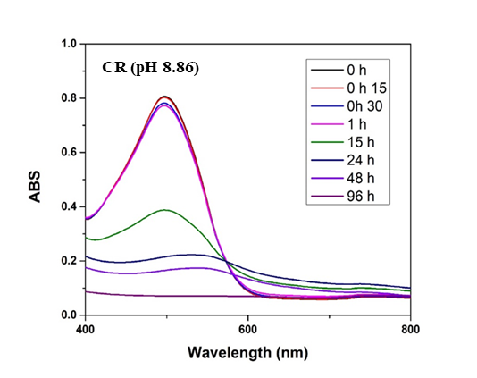
Fig. S5 UV-vis spectra of aqueous Am-PL/CR solution at pH 8.86 from 0 to 96 h. The UV-vis peaks gradually decrease as the time increases from 0 to 96 h. At 96 h, the UV-vis curve is nearly flat, indicating that Am-PL is a suitable candidate for CR dye removal from aqueous solution under basic conditions.
Fig. S6 UV-vis spectra of aqueous Am-PL/CR solution at pH 9.98 from 0 to 96 h. The UV-vis peaks gradually decrease as time increases from 0 to 96 h. At 96 h, the UV-vis curve is nearly flat, indicating that Am-PL is a suitable candidate for CR dye removal from aqueous solution under basic conditions.
Fig. S7 UV-vis spectra of aqueous Am-PL/MO solution at pH 3.88 from 0 to 96 h. At 0 h, the maximum wavelength is at 475 nm, shifting from 464 nm due to the color change of a pH indicator at pH 3-4. However, the UV-vis curve gradually returns to the expected maximum wavelength at 15 h. After 96 h of dye adsorption, the UV-vis curve is nearly flat, indicating that nearly all of the MO dye has been adsorbed from the aqueous solution.
Fig. S8 UV-vis spectra of aqueous Am-PL/MO solution at pH 9.98 from 0 to 96 h. The UV-vis peak heights gradually decrease as time increases from 0 to 96 h. This result indicates that Am-PL is capable of removing MO dye from an aqueous solution, although not as well as CR.
Fig. S9 UV-vis spectra of aqueous Am-PL/MO solutions at pH 10.06 from 0 to 96 h. The UV-vis peaks gradually decrease as the time increases from 0 to 96 h. This result indicates that Am-PL is capable of removing MO dye from an aqueous solution, although not as well as CR.

