Supplementary Information

Synthesis and Characterization of Eco-Friendly Chitin-Based Superabsorbent Polymers for Fertilizer Slow Release, Water Absorption Kinetics, and Plant Growth Enhancement
ª Refilwe Mogale,^{a, b} Janine Blignaut, ª Elham Jalali,ª Marietjie Schutte-Smith,ª Hendrik. G. Visser,^{a*} and Elizabeth Erasmusª

Table S1: The zeta potential (mV) values at different pHs.
 | Zeta Potential (mV)
pH | 3 | 5 | 7 | 11
Shellfish-chitin-No Urea (SCNU) | -6.19 | -11.12 | -24.87 | -40.21
Shellfish-chitin-Urea (SCU) | -5.59 | -15.67 | -22.66 | -43.25

Figure S1: Urea slow-release behaviour of SCNU in deionised water, as measured by UV/Vis spectroscopy over 24 hours.

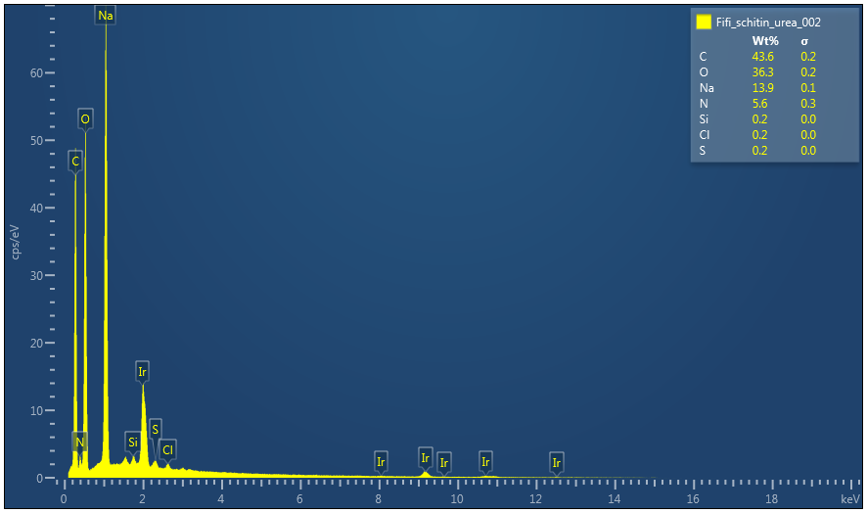
Figure S2: The EDS of SCU.
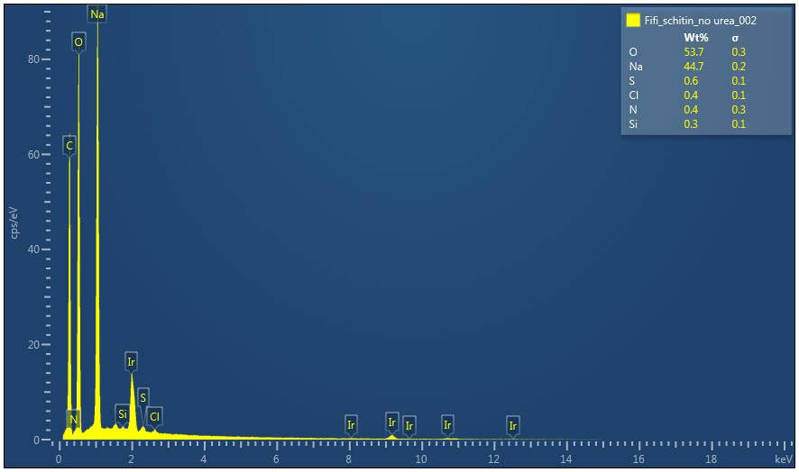
Figure S3: The EDS od SCNU.
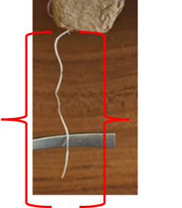
Figure S4: Root development of radish seedlings grown in soil mixed with SCU enriched with indole butyric acid, observed on day 7 after planting.

