Effects of thermal annealing on the structure–properties relationship of plasticized polylactic acid with citrates
Carlos Lazaro-Hdez^{1*}, Mario Miranda-Pinzon¹, Rafael Balart¹, Teodomiro Boronat¹,
Juan Ivorra-Martinez¹
¹ Instituto Universitario de Investigación de Tecnología de Materiales (IUITM), Universitat Politècnica de València (UPV), Plaza Ferrándiz y Carbonell 1, 03801, Alcoy, Alicante, Spain.
Corresponding author: Carlos Lazaro-Hdez (carlaher@epsa.upv.es)
Polymer and plasticizer solubility parameters
A close match between the solubility parameters of a polymer and a plasticizer generally favors the formation of an effective plasticized system. This concept serves as a basis for assessing the suitability of an organic compound as a plasticizer for a given polymer. In this study, the compatibility between PLA and selected plasticizers is analyzed using the Hoftyzer and Van Krevelen group contribution method [1], which calculates the solubility parameter (δ) based on molecular structure. The total δ is composed of three primary components: the dispersion term (δ_{d}), representing Van der Waals forces; the polar term (δ_{p}), reflecting dipole–dipole interactions; and the hydrogen bonding term (δ_{h}), associated with specific interactions such as hydrogen bonding. These components are determined using group contribution values, where F_{di} corresponds to the molar attraction constant for polar interactions, F_{pi} for dispersion forces, E_{hi} for the hydrogen bonding cohesive energy, and V denotes the molar volume of the compound.
$$δ_{d}= \frac{\sum{F_{di}}}{V}$$ | Eq S1
$$δ_{p}= \frac{\sqrt{\sum{F_{pi}^{2}}}}{V}$$ | Eq S2
$$δ_{h}= \sqrt{\frac{\sum{E_{hi}}}{V}}$$ | Eq S3
$$δ= \sqrt{δ_{d}^{2}+ δ_{p}^{2}+δ_{h}^{2}}$$ | Eq S4
To assess the solubility parameters of two materials and ensure good miscibility. Relative Energy Difference (RED) is defined as the ratio between the solubility distance (R_{a}) of the additive under evaluation and the Hansen solubility sphere radius (R_{o}) of the base polymer. This approach provides a quantitative estimation of compatibility, where values of RED below 1 generally indicate good miscibility. The following equations are used to calculate both R_{a} and R_{o}, based on the contributions of dispersion, polar, and hydrogen bonding interactions within Hansen solubility theory.
$$R_{a}=\sqrt{4×{\left(δ_{d plast}-δ_{d poly}\right)}^{2}+{\left(δ_{p plast}-δ_{p poly}\right)}^{2}+{\left(δ_{h plast}-δ_{h poly}\right)}^{2}}$$ | Eq S5
$$RED= \frac{R_{a}}{R_{o}}$$ |  | Eq S6
To verify the miscibility between the materials, the Hansen solubility space is employed. This method defines a three-dimensional sphere specific to the base polymer, PLA in this case, where the center of the sphere is represented by the individual solubility components: δ_{d}, δ_{p}, and δ_{h}.
The R_{o}, corresponds to the interaction limit of PLA and has a reported value of 10.7 (MJ·m⁻³)^{1/2} [2]. Although the Hansen model is inherently three-dimensional, it can be projected onto a two-dimensional system by calculating the δ_{v} parameter. In this simplified system, the coordinates are redefined using δ_{v} and δ_{h} as the x and y axes, respectively, while maintaining the original radius. This 2D visualization, known as a Bagley plot, facilitates a clearer graphical interpretation of solubility and compatibility between PLA and the evaluated additives.
$$δ_{v}= \sqrt{δ_{d}^{2}+ δ_{p}^{2}}$$ | Eq S7
Results of polymer and plasticizers solubility parameters
The solubility evaluation between PLA and the selected plasticizers confirms favorable miscibility and compatibility, which are essential for effective plasticization. The extent of this compatibility is governed by the strength of the intermolecular interactions between the components. Table S1 shows the δ parameters of PLA and of the plasticizers used in this study, as well as their δ_{d}, δ_{p}, and δ_{h} contributions, calculated using the Hoftyzer–Van Krevelen group contribution method [3].
Table S1: Solubility parameter values and component properties of the different materials studied.
Reference | δ_{d}  (MJ·m⁻³)^{1/2} | δ_{p}  (MJ·m⁻³)^{1/2} | δ_{h}  (MJ·m⁻³)^{1/2} | δ  (MJ·m⁻³)^{1/2} | R_{a}  (MJ·m⁻³)^{1/2} | RED
PLA | 15.33 | 8.44 | 10.98 | 20.66 | - | -
TEC | 17.49 | 4.80 | 10.24 | 20.83 | 5.70 | 0.53
ATBC | 16.02 | 2.56 | 8.55 | 18.33 | 6.51 | 0.61
As shown in Table S1, a solubility parameter of 20.66 (MJ·m⁻³)¹ᐟ² was obtained for PLA, which is consistent with values reported in the literature for this polymer [4, 5]. TEC and ATBC exhibit values close to that reported for PLA, in agreement with the literature, with values of
20.83 (MJ·m⁻³)¹ᐟ² [6], and 18.33 (MJ·m⁻³)¹ᐟ² [7], respectively. For solubility quantification, it is necessary to use the RED parameter as a reference, since values below 0.6 indicate that the evaluated plasticizers exhibit high miscibility with PLA.
To further support this observation, Figure S1 presents a two-dimensional representation of Bagley’s space. The coordinates of each plasticizer (δ_{v}, δ_{h}) are located within Hansen’s solubility space, further confirming the excellent miscibility between the polymer and the various plasticizers [8].
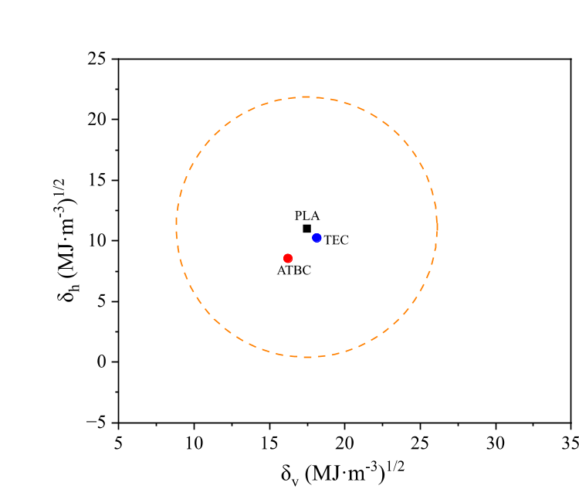
Figure S1: Bagley plot representing the solubility space of PLA.
Mechanical characterization
Mechanical characterization was conducted through three standardized testing methods. Tensile properties were measured using a universal testing machine, model IBERTEST ELIB-50 from S.A.E. Ibertest (Madrid, Spain), equipped with a 10 kN load cell and operating at a constant crosshead speed of 20 mm/min. Test specimens were prepared in accordance with
ISO 527-2:2012, employing type 1B geometry. Charpy impact strength was determined following ISO 179-1:2010, using notched samples of 80 mm × 10 mm × 4 mm, with a V-notch radius of 0.25 mm, tested on a 6-J pendulum impact tester manufactured by Metrotec S.A. (San Sebastian, Spain). Shore D hardness was evaluated using a model 637-D durometer from Instruments J. Bot S.A. (Barcelona, Spain), in compliance with ISO 868. Each measurement was taken after a 30 s stabilization period, and reported values represent the mean of five individual tests.
Results of mechanical characterization of the samples subjected to different annealing treatments
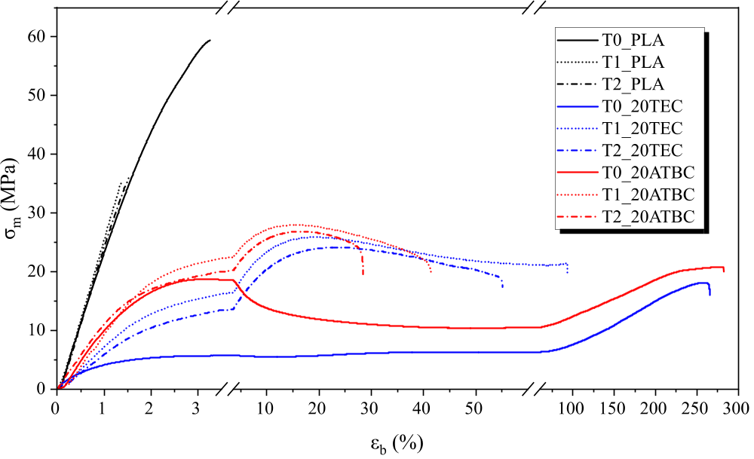
Figure S2: Stress–strain curves of neat and plasticized PLA subjected to different annealing treatments.
Thermal characterization
Thermal transitions of the processed samples were evaluated using differential scanning calorimetry (DSC) on a DSC 25 system from TA Instruments (Delaware, DE, USA). Isothermal characterization underwent a thermal test beginning with heating from 30 °C to 210 °C at 10 °C/min to eliminate previous thermal history. The molten samples were then rapidly cooled to 0 °C at a rate of 80 °C/min and held for 1 minute to stabilize. Subsequently, they were reheated from 0 °C to the selected T1 or T2 temperatures at 80 °C/min and maintained isothermally for 30 min to allow crystallization. All formulation were performed in triplicate under a nitrogen atmosphere with a flow rate of 50 mL/min.
Thermal characterization of isothermal crystallization kinetics of different annealing treatments
The isothermal step was set to 30 min for all experiments. However, for the kinetic analysis, the fitting time window was individually selected for each sample, since the crystallization process was completed at different times depending on the formulation and annealing condition. Therefore, only the time interval corresponding to the primary crystallization stage was considered for the Avrami fitting. The selected fitting time window for each tested sample is shown in Figure S3.
The induction time was excluded from the calculations. A high heating rate of 80 °C/min was applied to reach the isothermal temperature as quickly as possible and to prevent premature crystallization at lower temperatures. Consequently, the time was corrected by subtracting the induction period prior to applying the Avrami model.
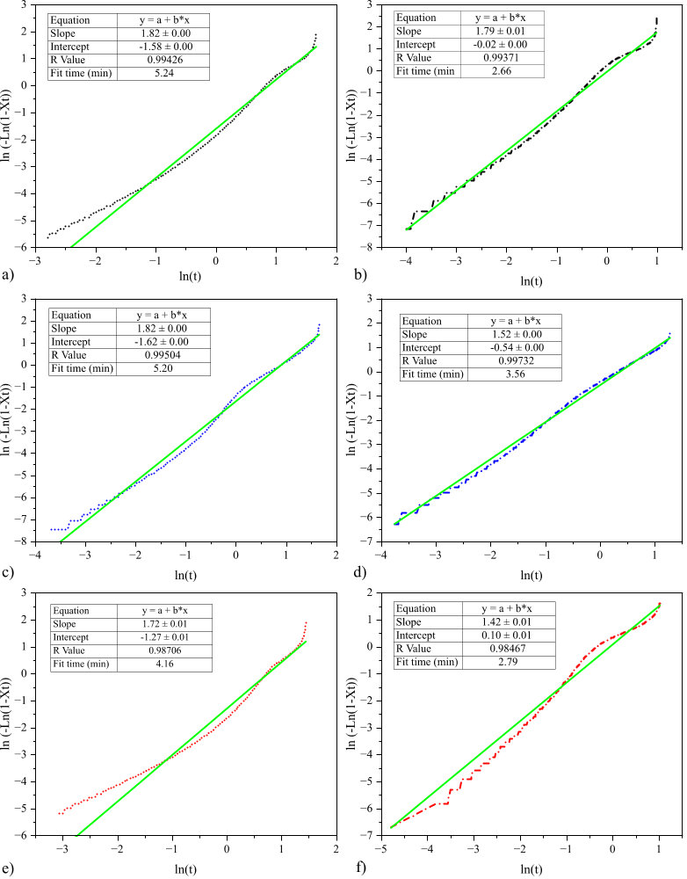
Figure S3: Avrami plots for the isothermal crystallization of the different samples are presented as follows: a) T1_PLA, b) T2_PLA, c) T1_20TEC d) T2_20TEC, e) T1_20ATBC, and f) T2_20ATBC.

Chemical characterization
FTIR analysis was performed using a Bruker Vector 22 spectrometer from Bruker S.A. (Madrid, Spain) equipped with a PIKE MIRacle single-reflection diamond ATR accessory from PIKE Technologies (Madison, WI, USA). Spectra were collected in the range of 4000–600 cm⁻¹ with a resolution of 4 cm⁻¹, averaging 10 scans per sample to improve the signal-to-noise ratio.
Result of chemical characterization of the samples subjected to different annealing treatments
The FTIR spectra of all formulations show the characteristic absorption bands of PLA, including the intense carbonyl (C=O) stretching band at approximately 1750 cm⁻¹ and the C–O–C stretching bands in the 1180–1080 cm⁻¹ region [9, 10]. No new absorption bands were detected after annealing, indicating that the thermal treatment did not cause chemical degradation or secondary reactions in the samples.
The annealed samples (T1 and T2) exhibited slightly sharper and narrower bands, particularly in the carbonyl and C–O–C regions. In the 1750–1730 cm⁻¹ interval, a slight reduction in the carbonyl band width and improved spectral definition were observed after annealing, suggesting a more homogeneous molecular environment [9, 11, 12]. This behavior indicates a reduced amorphous contribution and increased structural order, consistent with the higher crystallinity (X_{c}) determined by DSC and the improved crystalline organization evidenced by XRD.
For the plasticized formulations (20TEC and 20ATBC), minor variations in the relative intensity of the bands in the 1000–1200 cm⁻¹ region were observed, which may be attributed to intermolecular interactions between the plasticizer and PLA chains [13]. After annealing, these formulations also showed improved band definition, indicating that thermal treatment promotes structural reorganization even in the presence of plasticizers [14].
Overall, the FTIR analysis confirms that annealing primarily induces physical reorganization of the material structure associated with increased crystalline order, without causing chemical modifications in the polymer matrix.

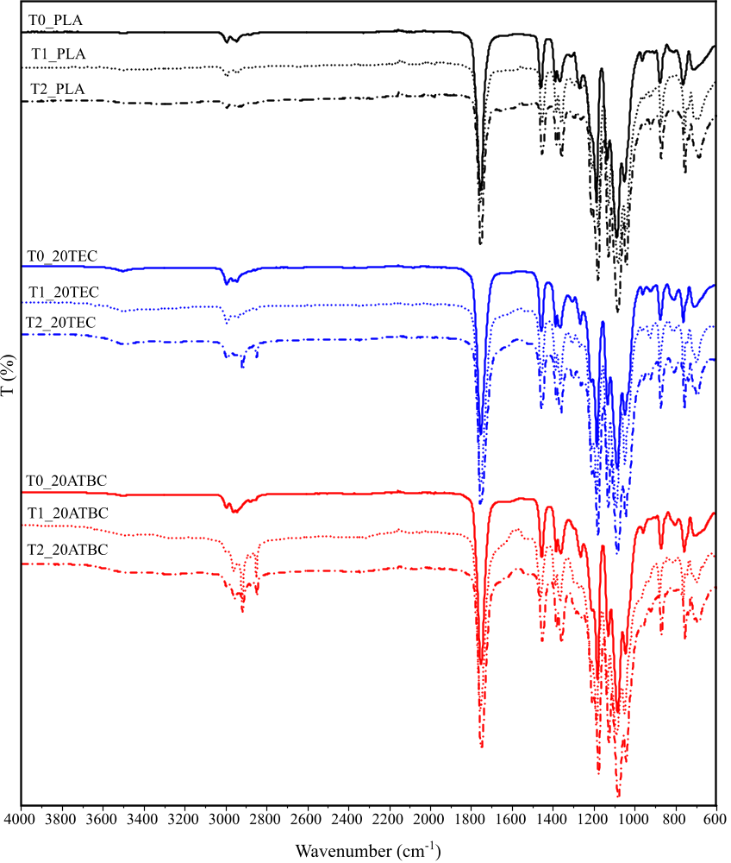
Figure S4: FTIR spectra of neat and plasticized PLA before and after annealing treatments.
References
1. Van Krevelen, D., Cohesive properties and solubility. Properties of polymers, 1990: p. 189-225.
2. Gomez-Caturla, J., et al., Development of biodegradable PLA composites and tangerine peel flour with improved toughness containing a natural-based terpenoid. Express Polymer Letters, 2023. 17: p. 789-805. DOI: 10.3144/expresspolymlett.2023.59.
3. Van Krevelen, D.W. and K. Te Nijenhuis, Cohesive properties and solubility, in Properties of polymers. 2009. p. 189-227.
4. Adamska, K., A. Voelkel, and A. Berlińska, The solubility parameter for biomedical polymers—Application of inverse gas chromatography. Journal of pharmaceutical and biomedical analysis, 2016. 127: p. 202-206.
5. Gomez‐Caturla, J., et al., Improvement of poly (lactide) ductile properties by plasticization with biobased tartaric acid ester. Macromolecular Materials and Engineering, 2023. 308(7): p. 2200694.
6. Lazaro-Hdez, C., et al., Tuning polylactic acid performance using green citrate plasticizers of varying chain lengths. International Journal of Biological Macromolecules, 2025: p. 144252.
7. Aliotta, L., I. Canesi, and A. Lazzeri, Study on the preferential distribution of acetyl tributyl citrate in poly (lactic) acid-poly (butylene adipate-co-terephthalate) blends. Polymer Testing, 2021. 98: p. 107163.
8. Brüster, B., et al., Plasticization of Polylactide with Myrcene and Limonene as Bio-Based Plasticizers: Conventional vs. Reactive Extrusion. Polymers, 2019. 11(8): p. 1363.
9. Meaurio, E., N. López-Rodríguez, and J. Sarasua, Infrared spectrum of poly (L-lactide): Application to crystallinity studies. Macromolecules, 2006. 39(26): p. 9291-9301.
10. Anshari, R., et al., Raman and ATR-FTIR unmask crystallinity changes and carboxylate group and vinyl group accumulation in natural weathering polypropylene microplastics. Scientific Reports, 2025. 15(1): p. 2518.
11. Zhu, Z., et al., Study of Crystallinity and Conformation of Poly (lactic acid) by Terahertz Spectroscopy. Analytical chemistry, 2022. 94(31): p. 11104-11111.
12. Phillipson, K., J.N. Hay, and M.J. Jenkins, Thermal analysis FTIR spectroscopy of poly(ε-caprolactone). Thermochimica Acta, 2014. 595: p. 74-82.
13. Yu, J., N. Wang, and X. Ma, Fabrication and characterization of poly (lactic acid)/acetyl tributyl citrate/carbon black as conductive polymer composites. Biomacromolecules, 2008. 9(3): p. 1050-1057.
14. Elnabawy, E., et al., The role of annealing in enhancing crystallinity, mechanical properties, piezoelectricity, and air filtration performance of polylactic acid nanofibers. Materials Chemistry and Physics, 2025. 343: p. 131000.

