pH-Responsive κ-Carrageenan–Egg Albumin Hydrogels Reinforced with Curcumin–Aloe vera Composite for Drug Delivery and Tissue Engineering Applications
Likhith K. ^{1, #}, Tarun Mateti ^{2, #}, Goutam Thakur ^{1, *}, S. Supriya Bhatt ³, Manasa Nune ³
¹ Department of Biomedical Engineering, Manipal Institute of Technology, Manipal Academy of Higher Education, Manipal–576104, Udupi, Karnataka, India
² Department of Mechanical Engineering & Materials Science, Yale School of Engineering & Applied Science, Yale University, 17 Hillhouse Avenue, New Haven, Connecticut–06520, United States of America
³ Manipal Institute of Regenerative Medicine, Manipal Academy of Higher Education, Manipal–576104, Udupi, Karnataka, India
# Authors contributed equally, * Correspondence: goutam.thakur@manipal.edu, Phone: +91 820-292-4214

Corresponding Author Details
Dr. Goutam Thakur
Professor
Manipal Institute of Technology
Manipal Academy of Higher Education
Manipal, India
Email Address: goutam.thakur@manipal.edu

Supplementary Figures
Curcumin Release Kinetic Model Fitting at pH 6.5, 7.4, and 8.5:

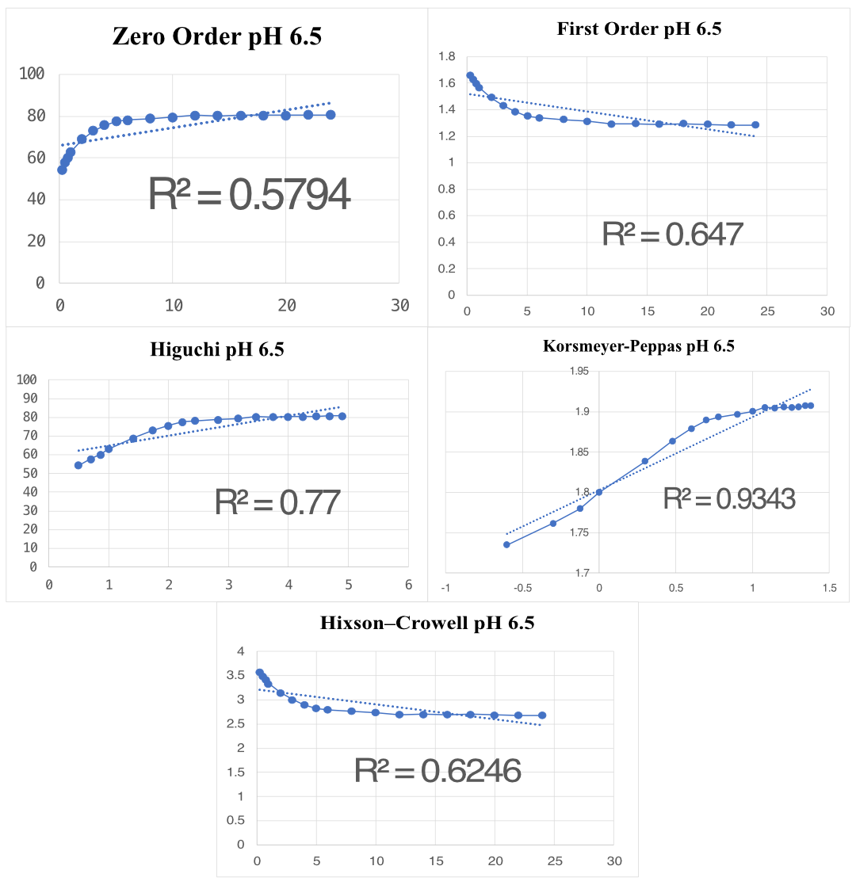
Figure 1. Kinetic model fitting of curcumin release from CUR–ALV-loaded KC–EA hydrogels at pH 6.5 using zero-order (R² = 0.5794), first-order (R² = 0.647), Higuchi (R² = 0.77), Korsmeyer–Peppas (R² = 0.9343), and Hixson–Crowell (R² = 0.6246) models. The Korsmeyer–Peppas model provided the best fit, suggesting anomalous non-Fickian transport as the predominant release mechanism under mildly acidic conditions.
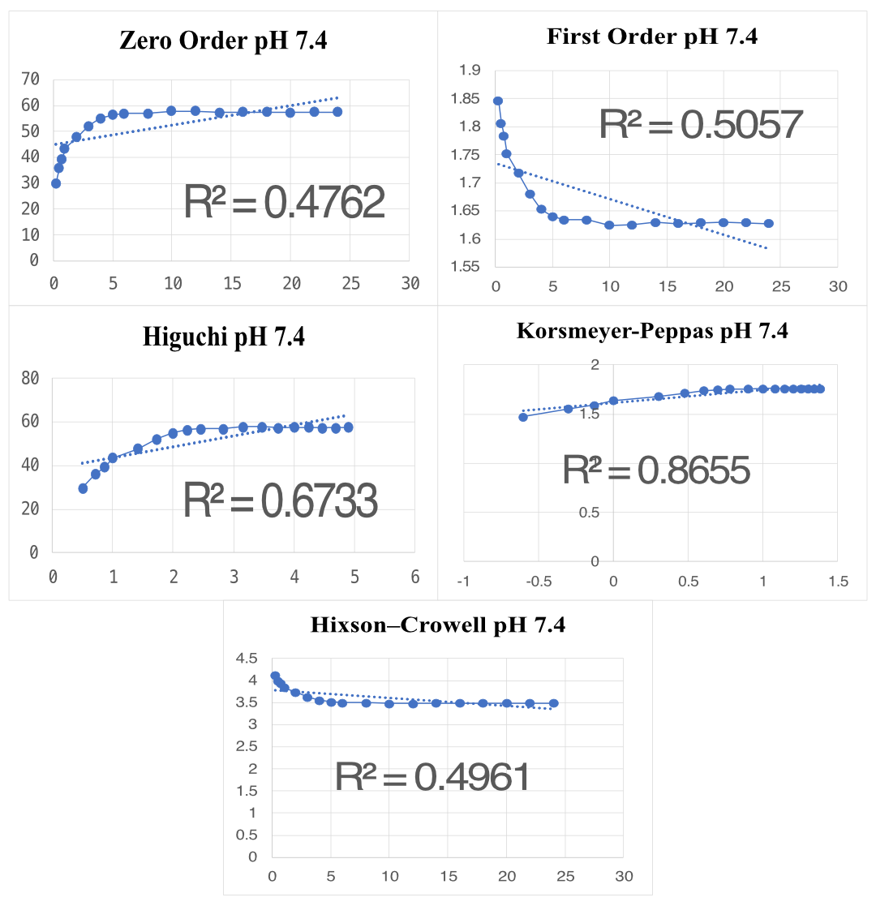
Figure 2. Kinetic model fitting of curcumin release from CUR–ALV-loaded KC–EA hydrogels at pH 7.4 using zero-order (R² = 0.4762), first-order (R² = 0.5057), Higuchi (R² = 0.6733), Korsmeyer–Peppas (R² = 0.8655), and Hixson–Crowell (R² = 0.4961) models. The Korsmeyer–Peppas model provided the best fit, suggesting a mixed release mechanism involving diffusion, polymer swelling, and chain relaxation under physiological conditions.
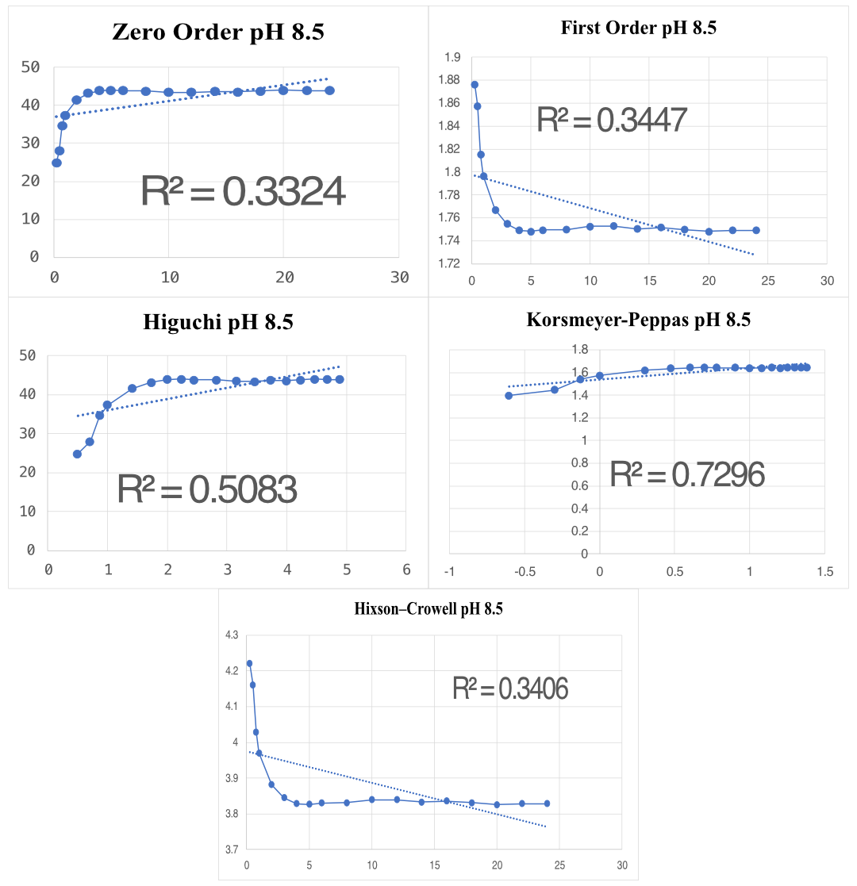
Figure 3. Kinetic model fitting of curcumin release from CUR–ALV-loaded KC–EA hydrogels at pH 8.5 using zero-order (R² = 0.3324), first-order (R² = 0.3447), Higuchi (R² = 0.5083), Korsmeyer–Peppas (R² = 0.7296), and Hixson–Crowell (R² = 0.3406) models. The Korsmeyer–Peppas model provided the best fit, suggesting a mixed release mechanism involving diffusion, polymer swelling, and chain relaxation; the comparatively lower R² relative to pH 6.5 and 7.4 likely reflects partial destabilization of the hydrogel network under alkaline conditions.

