Mental health stigma in the workplace and its association with possible actions of managers to prevent sickness absence of employees with mental health problems in the Swedish private sector: a video vignette study

Journal of Occupational Rehabilitation
Sofie Schuller^{a,b} (https://orcid.org/0000-0002-3306-3601), Angelique de Rijkª, Linda Corin^{c}, Monica Bertilsson^{d} (https://orcid.org/0000-0003-2365-2522)
ªDepartment of Social Medicine, Primary Care and Public Health Research Institute, Faculty of Health, Medicine and Life Sciences, Maastricht University, the Netherlands
^{b}Department of Public Administration and Sociology, School of Social and Behavioural Sciences, Erasmus University, Rotterdam, the Netherlands
^{c}Institute of Stress Medicine, Region Västra Götaland, Gothenburg, Sweden
^{d}School of Public Health and Community Medicine, Institute of Medicine, The Sahlgrenska Academy, University of Gothenburg, Gothenburg, Sweden
Short title: Mental health stigma in the workplace and sickness absence prevention
Correspondence: Sofie Schuller, MSc, Department of Public Administration and Sociology, Erasmus University, PO Box 1738, 3000 DR Rotterdam, the Netherlands. Tel: +49 157 71980846. E-mail: schuller@essb.eur.nl

Supplementary material
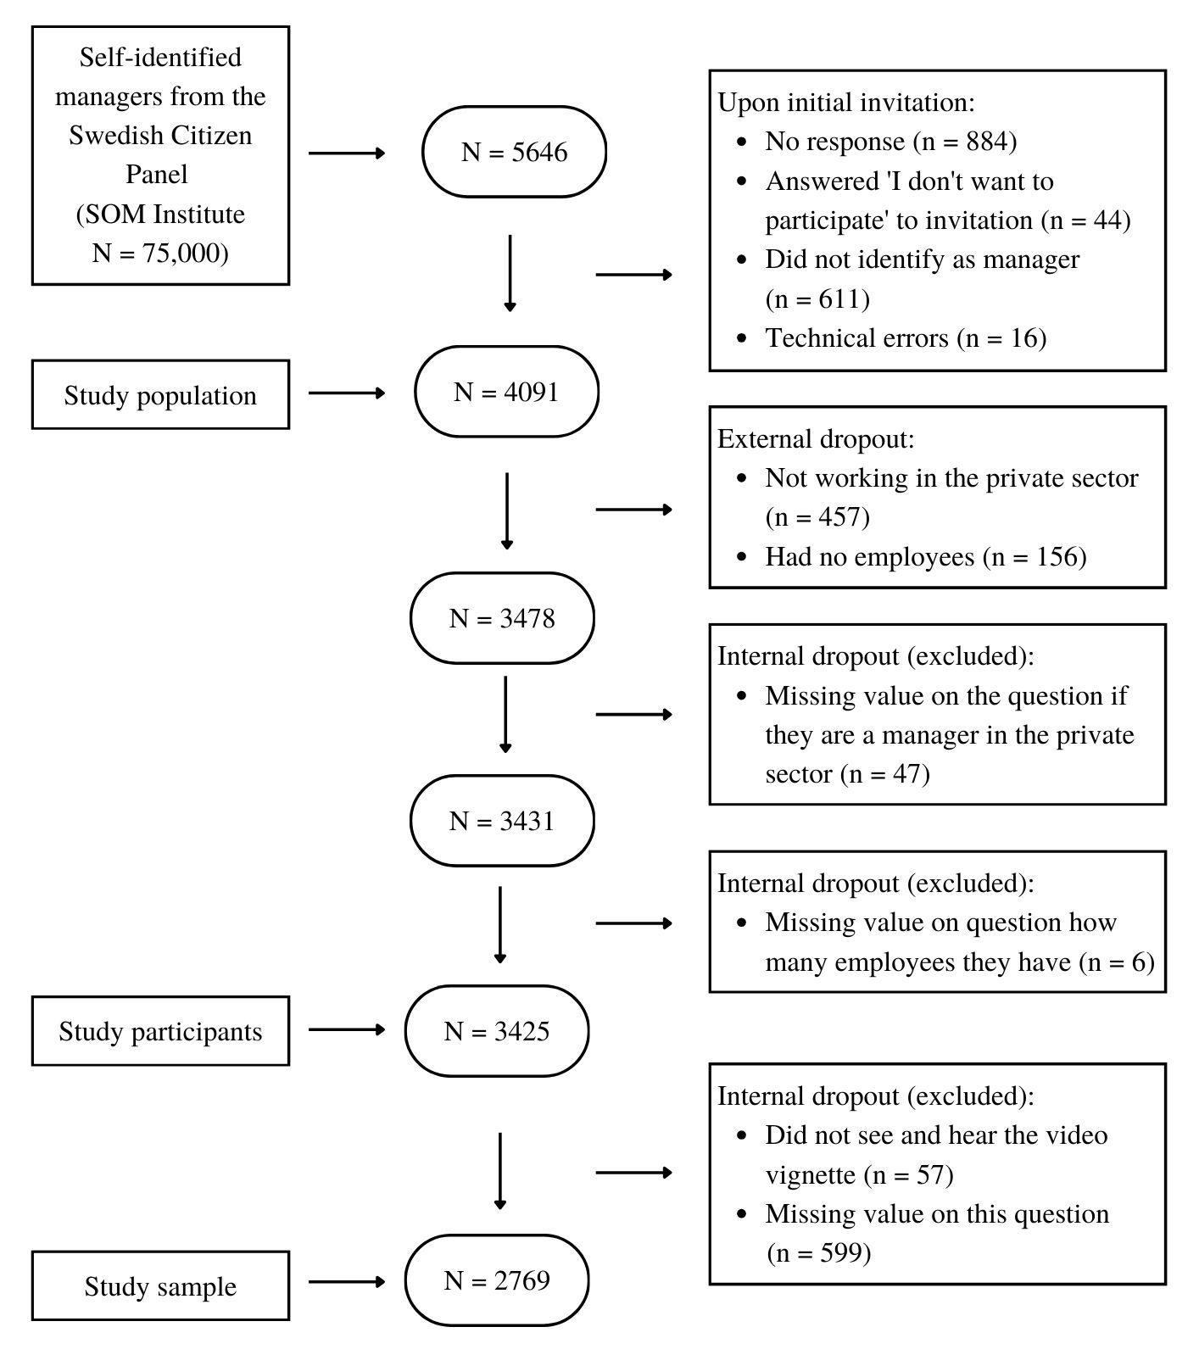
Supplementary Figure 1. Flowchart from invited participants to study sample.

Supplementary Table 1. Revised MSEDª items reflecting several MHPs.
Manager’s affective stigma | Manager’s cognitive stigma | Manager’s behavioural stigma
(1) I feel very confident when I have to deal with employees with exhaustion, anxiety or depression | (5) If an employee suffers from exhaustion, anxiety or depression, this mainly depends on himself/herself | (9) I would avoid talking with an employee with exhaustion, anxiety or depression in order not to have to deal with their problem
(2) It feels frightening having employees with exhaustion, anxiety or depression | (6) Employees with exhaustion, anxiety or depression are a burden on the workplace | (10) I would not employee someone who I knew had suffered from exhaustion, anxiety or depression
(3) It’s stressful working with employees with exhaustion, anxiety or depression | (7) Employees who use medication for exhaustion, anxiety or depression should not work | (11) I would make temporary changes to the job to help an exhausted, anxious or depressed employee to recover
(4) I feel ill at ease when working with an employee who is exhausted, anxious or depressed | (8) Employees with exhaustion, anxiety or depression can get out of this if only they want to | (12) I would wish that I could get rid of an employee who has suffered from exhaustion, anxiety or depression^{b}
MSED, Managerial Stigma towards Employee Depression; CMD, common mental disorder.
ªMartin A. Individual and contextual correlates of managers' attitudes toward depressed employees. Hum Resour Manage. 2010;49(4):647–668. https://doi.org/10.1037/t49300-000
^{b}Item was adapted to the Swedish legislative context and used in a previous study (Mangerini I, Bertilsson M, de Rijk A, et al. Gender differences in managers' attitudes towards employees with depression: a cross-sectional study in Sweden. BMC Public Health. 2020;20:1744. https://doi.org/10.1186/s12889-020-09848-2.

Supplementary Table 2. Industrial sectors and their associated work fields.
Industrial sector | Field
White | IT, information and communications activities
White | Finance and insurance
White | Public administration and defence
White | Legal, economic, scientific and technological activities
White | Property
Blue | Agriculture, foster, fishing
Blue | Mining and quarrying
Blue | Manufacturing industry
Blue | Construction and craftsmanship
Blue | Provision of electricity, heat, water, sewage, waste
Blue | Transport and warehousing
Pink | Trade/commerce
Pink | Hospitality
Pink | Education
Pink | Health care, social services
Pink | Rental, property service, travel, and other support services
Pink | Gainful employment in households and other service operations
Other | Culture entertainment, recreation
Other | Other type of activity
Supplementary Table 3. Script of video vignettes per industrial sector (each vignette is one minute).
Industrial sector | Vignette script
White | Manager: You wanted to talk about something.  Employee: Yesterday when I was going to finish that report, I got stuck... I read through our notes several times but... I couldn't get it right. I have such a hard time getting it right. It just doesn't work. I've already had to ask the others loads of times.  And it’s not just that, I don't remember things. Even things I've done a hundred times before, I can just forget how to do them.  And I... Well, the other day, I couldn't remember how to get into the staff system on the computer.  And I forget things I’m supposed to do, just like that... I think you already know that I forgot about some meetings last week that I’d promised to arrange.  Manager: Yes, I heard about that.  Employee: Well, I don't know what to do. I find it so hard that I can't trust myself, and that I miss things all the time. I mean... maybe I need to take sick leave?
Blue | Manager: You wanted to talk about something.  Employee: Yes, yesterday when I went to start up our new machine, I got stuck... I read the manual several times but... I couldn’t get it right. I have such a hard time getting it right. It just doesn't work. I've already had to ask the others loads of times.  And it’s not just that, I don't remember things. Even things I've done a hundred times before, I can just forget how to do. The other day... I didn't know how to get into the staff system on the computer.  And I forget things I'm supposed to do... just... like that. I think you may already know that I... forgot about the tools last week which I’d promised to fix.  Manager: Yes, I heard about that.  Employee: Well, I don't know what to do. I find it so hard that I can't trust myself, and that I miss things all the time. I mean... maybe I need to take sick leave?
Pink | Manager: You wanted to talk about something?  Employee: Yesterday, when we were looking after the new participants, I got stuck... I tried several times to get into the conversation but... no, I couldn't get it right. And I have such a hard time getting it right. It just doesn't work. I've already had to ask the others loads of times.  And it’s not just that, I don't remember things. Even things I've done a hundred times before, I can just forget... how to do them. The other day I didn't know how to get into the staff system on the computer.  I forget about things I’m supposed to do, just like that... I think you already know that I forgot about both Sara and Simon last week, which I’d promised to address.  Manager: Yes, I heard about that.  Employee: Well, I don't know what to do. I find it so hard that I can't trust myself, and that I miss things all the time. I mean... maybe I need to take sick leave?
Supplementary Table 4. Types of actions: items per component based on principal component analysis
Component 1: Actions to adapt tasks and setting | Component 2: Actions to involve experts | Component 3: Social support actions
1) Take away duties from employee | 1) Involve HR for the employee | 1) Support employee actively in everyday work (e.g. via test message reminder)
2) Assign employee easier work duties | 2) Involve corporate healthcare or equivalent for the employe | 2) Hold regular, planned follow-up meetings with employee
3) Give employee more time to carry out work duties | 3) Contact employee’s union and/ or safety representative | 3) Draw up a concrete action plan together with employee
4) Offer employee more breaks during the work day |  | 4) Draw up checklist together with employee to help them cope with work duties that they normally have to carry out completely independently
5) Give employee access to a calm space for relaxation and recovery |  | 5) By agreement with employee, talk with the work group about their situation
6) Change working hours for employee |  | 6) Appoint colleague to provide support for the employee
7) Allow employee to work from home
8) Assign employee’s work duties to other employees
9) Increase staffing to compensate for employee’s reduced work capacity
10) Reassign employee to other work
11) Review the workplace in general, and make changes that benefit both the employee and the work group

Supplementary Table 5. Correlation matrix of all variables of interest.
Variables | Age | Gender (female) | Organizational size | Industrial sector (white) | Gender distribution of subordinates (male) | Number of actions (transformed) | Actions to adapt tasks and setting | Actions to involve experts | Social support actions | Personal stigmatizing attitudes | Employee stigma | Collegial stigma | Organizational stigma
Age | 1 | −0.099** | −0.198** | −0.062** | −0.022 | −0.49* | −0.008 | −0.107** | −0.044* | 0.042* | −0.094** | −0.030 | −0.095**
Gender (female) |  | 1 | 0.024 | −0.029 | −0.037 | −0.029 | 0.037 | 0.012 | 0.092 | −0.183** | −0.025 | 0.005 | 0.027
Organizational size |  |  | 1 | −0.036 | 0.016 | 0.259** | 0.123** | 0.459** | 0.096** | −0.096** | 0.138** | 0.064** | 0.137**
Industrial sector (white) |  |  |  | 1 | −0.079** | 0.153** | 0.243** | 0.000 | 0.113** | −0.045* | −0.043* | −0.089** | −0.041*
Gender distribution of subordinates (male) |  |  |  |  | 1 | −0.048* | −0.066** | 0.006 | −0.054** | 0.018 | 0.065** | 0.035 | 0.037
Number of actions (transformed) |  |  |  |  |  | 1 | 0.712** | 0.547** | 0.567** | −0.310** | −0.219** | −0.263** | −0.222**
Task and setting oriented strategies |  |  |  |  |  |  | 1 | 0.377** | 0.645** | −0.338** | −0.262** | −0.281** | −0.271**
Actions to involve experts |  |  |  |  |  |  |  | 1 | 0.435** | −0.227** | −0.062** | −0.160** | −0.086**
Social support actions |  |  |  |  |  |  |  |  | 1 | −0.397** | −0.310** | −0.325** | −0.298**
Personal stigmatizing attitudes |  |  |  |  |  |  |  |  |  | 1 | 0.212** | 0.206** | 0.210**
Employee stigma |  |  |  |  |  |  |  |  |  |  | 1 | 0.671** | 0.720**
Collegial stigma |  |  |  |  |  |  |  |  |  |  |  | 1 | 0.682**
Organizational stigma |  |  |  |  |  |  |  |  |  |  |  |  | 1
*Two-tailed significance at the 0.05 level.
**Two-tailed significance at the 0.01 level.

