Supplementary Material
S1: Preprocessing and data preparation
Pre-processing and variable description
The time when the emotional exhaustion survey was filled in was taken as starting and end point (time between survey of previous day and current day) and applied to all predictors. E.g., when emotional exhaustion on 19-11-2025 was filled in at 17:00 and on 20-11-2025 was filled in at 17:04, then everything later than 17:00 on 19-11-2025 up until 20-11-2025 17:04 gets counted as 20-11-2025
Oura ring
The pre-processing of the OURA data was performed in RStudio (version 2024.12.1 Build 563) using R (version 4.4.1). Daily missing values of Oura-derived features were replaced with each participant’s own mean for that variable, as missingness typically occurred on days when the ring was not worn consistently (e.g. during charging or activities requiring removal). Multiple sleep observations during one night were combined into one observation (e.g. taking the bedtime start point of observation 1 and the end time of the last observation). The sleep duration (TST) and awake time were summed up across both phases. Other variables such as heart rate, heart rate variability and minutes to lowest heart rate were averaged across both episodes, taking into account the length/proportion of each sleep episode. The sleep start hour difference to midnight and sleep end hour were extracted from the whole sleep episode (sleep start episode 1 and sleep end episode 2 in cases of multiple observations during one night). Sleep episodes during the day were counted and stored separately as naps but excluded in the current analyses.

Sleep predictors
sleep_start_hourdiftomidnight: The numeric hour difference (e.g., 1 hour and 15 minutes is expressed as 1,25 hours) between the start of the sleep episode and midnight. Negative values therefore reflect a starting time of the sleep episode before midnight, whereas positive values a starting time of the sleep episode past midnight.
- M = -2.0; SD = 1.2; range = [-13.4] – [13.1]

sleep_end_hour: Hour of the day on which the sleep episode ended, expressed in numerical hours (e.g. 10.8 equal 10:48 a.m.).
- M = 8.2; SD = 1.0; range = [4.5] – [18.6]

sleep_sol: Sleep Onset Latency (SOL), the time between the start of sleep episode and the moment of falling asleep. Originally formatted in seconds by Oura, recalculated to minutes for the paper.
- M = 18.9; SD = 6.4; range = [1.4] – [88.0]

sleep_tst: Total Sleep Time (TST), the duration of the sleep episode (bedtime end minus bedtime start) without SOL and Wake-time After Sleep Onset (WASO). Originally formatted in seconds by Oura, recalculated to hours.
- M = 7.2; SD = 0.8; range = [1.7] – [10.7]

sleep_se: Sleep Efficiency (SE), the percentage of duration that the participant was asleep during a sleep episode.
- M = 84.7; SD = 4.6; range = [44.6] – [94.9]

sleep_tstcv: A 7-day rolling Coefficient of Variation (CV) of the TST, which reflects the intra-individual variation in the TST (based on Veeramacheni, 2019; doi: 10.1016/j.sleh.2019.07.009).
- M = 0.3; SD = 0.1; range = [0.1] – [0.9]

sleep_secv: A 7-day rolling Coefficient of Variation (CV) of the SE, which reflects the intra-individual variation in the SE (based on Veeramacheni, 2019; doi: 10.1016/j.sleh.2019.07.009).
- M = 8.5; SD = 3.7; range = [1.9] – [23.2]

sleep_minsstolowesthr: Time in minutes between the start of a sleep episode and the start of the 5-minute block with the lowest averaged heartrate.
- M = 305.3; SD = 37.7; range = [10.0] – [688.5]

sleep_hravg: The average heart rate during the sleep episode, based on the average of all 5-minutes blocks that are labelled as 'valid' (e.g., containing sufficient data) by the Oura ring.
- M = 60.8; SD = 5.1; range = [52.3] – [78.8]

sleep_lowest_hr: The lowest heart rate during the sleep episode, determined based on the 5-minute block with the lowest average heart rate.
- M = 53.9; SD = 4.6; range = [46.3] – [71.6]

sleep_lnrmssd: The log-transformed root mean square of successive differenced (between P-P intervals) during the sleep episode, also termed heart-rate variability (HRV).
- M = 49.7; SD = 26.6; range = [19.7] – [83.2]

sleep_lnrmssd_last30min: The lnrMSSD, calculated as the averaged rMSSD of the last six 5-minutes blocks during the sleep episode (= last 30 minutes) and log-transformed afterwards.
- M = 53.0; SD = 26.4; range = [19.3] – [95.3]

sleep_lnrmssdcv: A 7-day rolling Coefficient of Variation (CV) of the lnrMSSD values, which reflects the amount of fluctuations in the daily lnrMSSD values during the last 7 days.
- M = 6.5; SD = 1.7; range = [2.1] – [13.7]

Physical activity predictors
pa_sed: Time spent at a sedentary Metabolic Equivalent of Task (MET) level (activity level <1.05 MET). Originally expressed in seconds by Oura, recalculated to minutes.
- M = 522.9; SD = 87.5; range = [149.2] – [1504.0]

pa_mvpa: Daytime Moderate-to-Vigorous Physical Activity (MVPA) in minutes. Calculated by the sum of variables “medium” and ”high”. ACSM guideline recommendation: a total of 150 minutes per week.
- M = 87.8; SD = 42.4; range = [12.3] – [323.9]

pa_met: Total sum of all MET-minutes (minutes*MET-intensity). ACSM guideline recommendation: 1000 minutes per week (based on the to 150 minutes per week MVPA recommendation). (low+medium+high)
- M = 536.1; SD = 162.6; range = [115.6] – [1760.4]

daily_hr_avg: The average heart rate during the day, based on the average of all 5-minutes blocks that are labelled as ‘valid’ (e.g., containing sufficient data) by the Oura ring.
- M = 93.1; SD = 5.7; range = [67.3] – [114.0]

daily_hr_sd: The standard deviation of the heart rate during the day, based on the standard deviations of all 5-minutes blocks that are labelled as ‘valid’ (e.g., containing sufficient data) by the Oura ring
- M = 17.7; SD = 1.6; range = [6.4] – [30.8]

Avicenna
Smartphone usage predictors
The data about smartphone usage was exported immediately from Avicenna and was pre-processed and transformed into features in RStudio. For each variable, values were aggregated to a daily level and then merged into one complete dataset. Apps running in the background for system functions were removed and the actively used apps were translated into different app categories. Missing daily values of the predictors were replaced with 0 or the personalized mean of participants. For example, missing daily values for features such as Social Media were replaced with 0, since it might be the case that a participant did not use this type of app during that particular day.
screen_on_time: The total time that the screen was on during the day, measured in minutes.
- M = 302.4; SD = 112.0; range = [42.3] – [1545.8]
The following apps concern the app used of the user, and applications were placed in categories. The raw data was originally in seconds and then aggregated to minutes.
Browser_app_time: The number of minutes that the user actively used a browser app during the day. The 4 most-used apps in this category are Safari, Chrome, Microsoft Emmx, ChatGPT.
- M = 29.8; SD = 17.6; range = [0] – [178.1]
Communication_app_time: The number of minutes that the user actively used a communication app during the day. The top-4 communications apps are WhatsApp, Mail, Outlook, Calling.
- M = 37.7; SD = 17; range = [0.5] – [172.2]
Entertainment_app_time: The number of minutes that the user actively used an entertainment app during the day. The top-4 entertainment apps are Youtube, Plex, Spotify, Pinterest.
- M = 22.2; SD = 25.4; range = [0] – [212.3]
Games_app_time: The number of minutes that the user actively used a game app during the day. The top-4 entertainment apps are Prison Break, eFootball, Screwdom, PUBG MOBILE.
- M = 8.4; SD = 22; range = [0] – [102.8]

Health_app_time: The number of minutes that the user actively used a health-related app during the day. Oura, Ozlo, Strava, SnoreLab.
- M = 5.1; SD = 4.2; range = [0] – [69.5]
Traveling_app_time: The number of minutes that the user actively used app for travelling purposes during the day. The top-4 serious apps are Google Maps, Waze, Flitsmeister, NS.
- M = 13.5; SD = 15.9; range = [0] – [156.4]
Social_app_time: The number of minutes that the user actively used social apps during the day. The top-4 spcial apps are Instagram, Reddit, Facebook, TikTok.
- M = 38.0; SD = 38.5; range = [1.5] – [193.7]
Trading_app_time: The number of minutes that the user actively used trading apps during the day. The top-4 trading apps are Marktplaats, Rabobank, Vinted, Albert Heijn.
- M = 13.3; SD = 12.4; range = [0] – [114.1]
System_app_time: The number of minutes that the user actively used system apps during the day. The top-4 system apps are Notes, Photos, Calendar, Camera.
- M = 18.3; SD = 11.5; range = [0] – [139.1]
unique_apps_per_day: The number of unique apps that were used during that day.
- M = 18.5; SD = 7.4; range = [5.7] – [38.1]
Mobility predictors
The following features concern the locations of the user. Pre-processing included the alignment of time stamps when participants traveled in different time zones, the filtering of GPS data in staying and moving points and creating visual clusters of staying points for participants to categorize. Through the location categories, the raw GPS lat-lon could be removed and replaced by the time participants spent daily at each location. Daily missing values of features such as time spent at home were replaced with the personalized means of participants, due to the high likelihood that participants are some part of their day at home. In terms of mobility patterns, the raw GPS data was clustered with the Douglas-Peucker algorithm, see Qian and Lu (2017), with a radius of maximum 200 meters and a stay of at least 1 minute. With the input from participants about location context, location-based features were created, including the time spent at home, work, sports, social, other and unknown locations as well as the total distance traveled and the time spent traveling.

Qian, H., & Lu, Y. (2017). Simplifying GPS Trajectory Data with Enhanced Spatial-Temporal Constraints. ISPRS International Journal of Geo-Information, 6(11), 329. https://doi.org/10.3390/ijgi6110329
Time_at_home: The total time in minutes that the user spend at home/primary residence.
- M = 903.1; SD = 297.5; range = [15.1] – [5778.4]
Time_at_work: The total time in minutes that the user spend at workplace/daily work location.
- M = 17.2; SD = 32.8; range = [0] – [283.3]
Time_at_sports: The total time in minutes that the user spend at locations used for physical activity (such as gym, sports club…).
- M = 5.98; SD = 15.6; range = [0] – [158.2]
Time_at_social: The total time in minutes that the user spend at a gathering place for socializing (such as restaurant or bar visit) or another person’s home
- M = 67.9; SD = 113.6; range = [0] – [3595.7]

Travel_clusters: the total time in minutes that the user spend on locations that are indicative of travelling (e.g. on the way to another location) and/or being on vacation outside of the Netherlands
- M = 154.7; SD = 193.8; range = [0] – [9973.7]

Time_at_other: The total time in minutes that the user spend at another location, such as stores, supermarket, personal services, entertainment, hobbys, recreational places, medical facilities…
- M = 169.2; SD = 291.2; range = [0] – [1290.7]
Time_at_unknown: the total time in minutes that the user spend on locations that do not fall in above categories (not identifiable by the user).
- M = 2.4; SD = 4.2; range = [0] – [132.4]
distance_traveled: The total distance per day that was travelled by the user.
- M = 351.4; SD = 612.7; range = [6.0] – [23649.9]
time_spent_traveling: The total time in seconds that the user spend travelling during a day. Each log statement holds a speed and duration. When the speed is above the threshold of 4.17 meters per second (15 km/h), then the duration is taken into account for this feature.
- M = 44.3; SD = 25.2; range = [0] – [557.4]

Avicenna
The following features capture the answers to the daily questionnaires the participants filled in the Avicenna app in. Participants could choose a suitable timestamp for the questions (options ranging from 5 p.m. to 11 p.m.), which was available for 12 hours. If two surveys were filled in during the same day, one of the two surveys was either removed or transformed. A survey was removed when there was an issue with the app or data such as having two identical answers in the dataset. A survey was transformed to the previous day if questionnaires were filled in after midnight or when being in a different time zone. Days with missing emotional exhaustion values were removed.
Emotional_exhaustion: continuous variable, rated how emotionally exhausting the participant’s day was, ranging from 0 (not) to 100 (very much)

S2: Graphical flowchart of R code
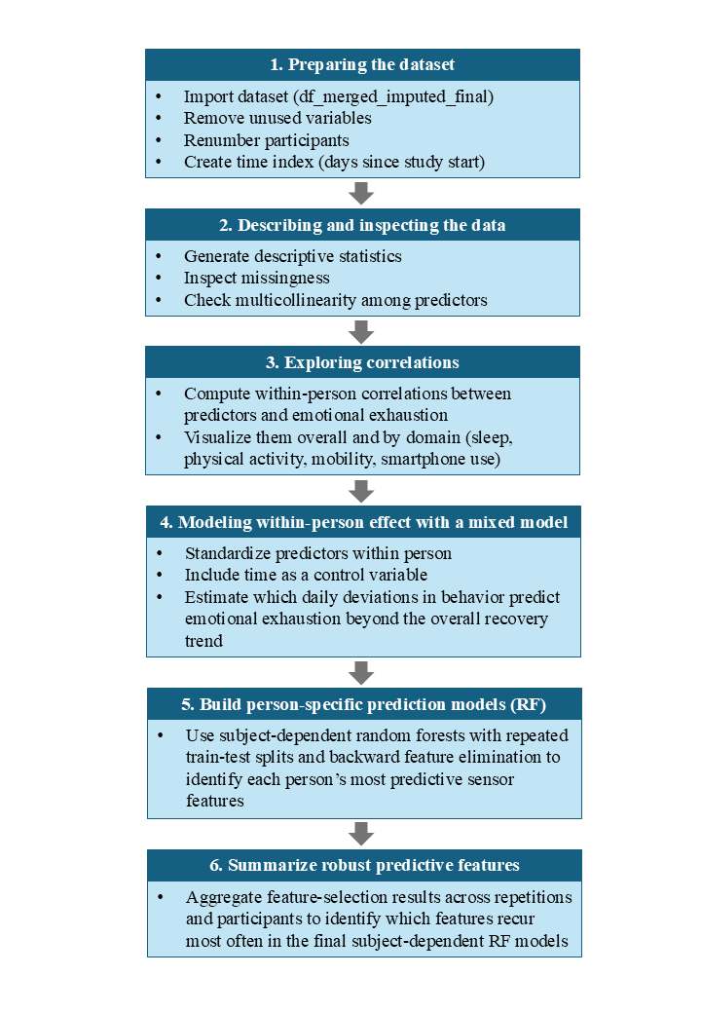

S3: Descriptive summary of demographics

Table S.1. Participant characteristics
Sex (% in total)  Male  Female | 8 (44.4%)  10 (55.6%)
Mean age (SD) | 39.6 (12.06)
Professions  Manager  Consultant  Human Resources  Other  NA | 4 (22.2%)  3 (16.7%)  2 (11.1%)  8 (44.4%)  1 (5.5%)
Educational level  Primary school  Secondary school  Technical secondary vocational education (MBO)  University of applied sciences bachelor (HBO)  University of applied sciences master (HBO)  University bachelor  University master  University diploma | 1 (5.5%)  2 (11.1%)  1 (5.5%)  8 (44.4%)  1 (5.5%)  1 (5.5%)  3 (16.7%)  1 (5.5%)
Counseling sessions with Occupational Physician  One session  Two sessions  Three sessions  Four sessions | 4 (22.2%)  9 (50%)  3 (16.7%)  2 (11.1%)
Smartphone type  iPhone  Android | 12 (66.7%)  6 (33.3%)
Note. Category Other: Sales Representative (1), Outpatient/Group Counselor (1), Educational Staff (1), Service Engineer (1), Physiotherapist (1), Researcher (1), Sales Person (1), Store leader (1)

S4: Emotional exhaustion of participant 9

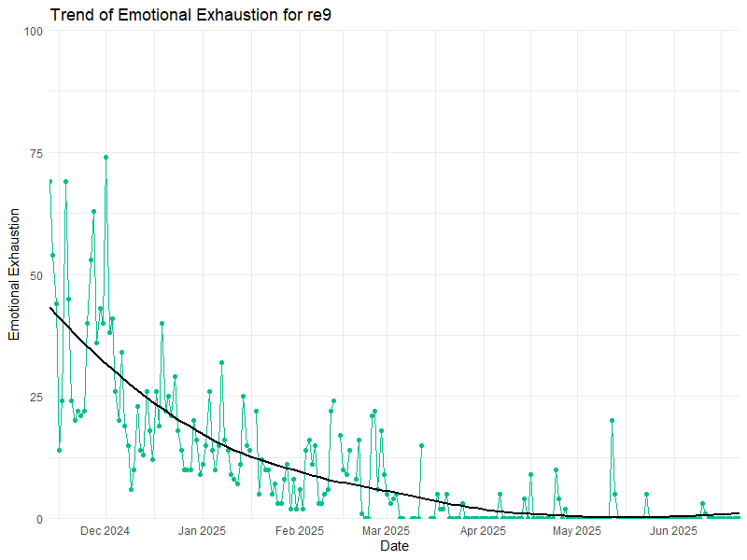
Figure S.1. Emotional exhaustion of participant 9

S5: Emotional exhaustion of participant 5

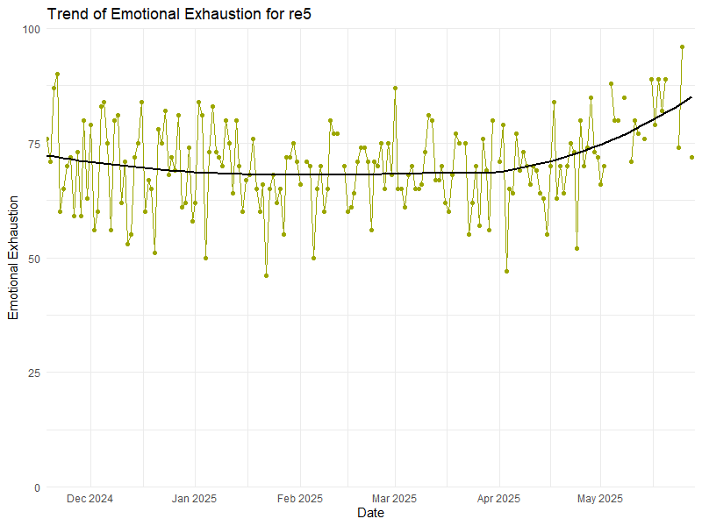
Figure S.2. Emotional exhaustion of participant 5

S6: Results of multilevel linear mixed model
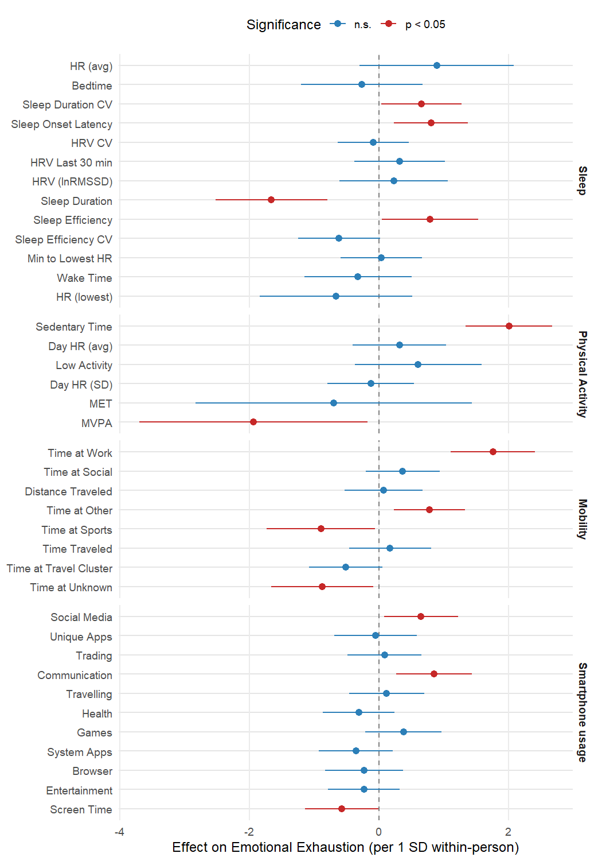
Figure S.3. Fixed effects of multilevel linear mixed model including significance

S7: Most important features from subject-dependent RF models

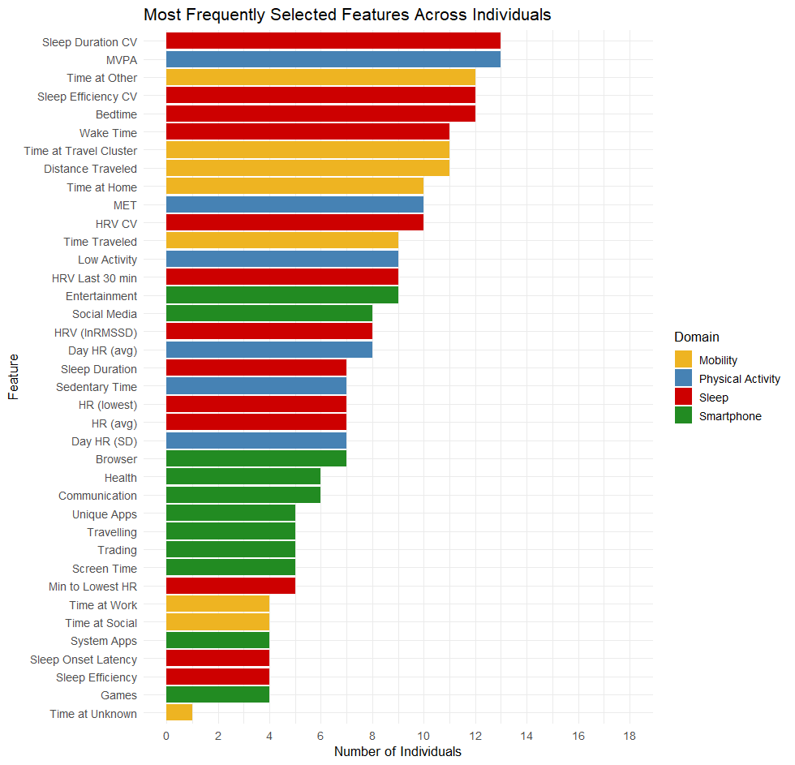
Figure S.4. Overlap of most important features across participants

