Supplementary material 2

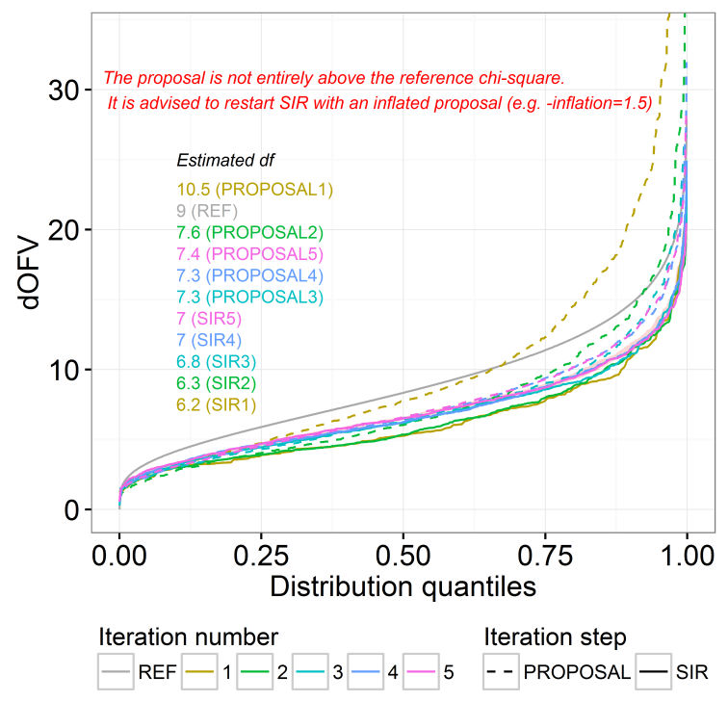
Figure S1. SIR dOFV diagnostic plot showing too narrow proposal distribution; inflation needed (example model PK3).

