Supplementary material 3

The example PK5 is taken here to illustrate how SIR should be performed.

First, the model (3-compartment PK model with transit absorption and a number of covariate relationships, 18 estimated parameters in total) was run using the PsN command:

execute Mida_PK_BA1_COV.mod

Minimization was successful. Estimation and covariance time for this dataset (20 subjects, 808 observations) was 25 minutes. SIR was then performed using the covariance matrix as proposal distribution:

sir Mida_PK_BA1_COV.mod -dir=sir_cov -rplots=2

SIR took 7 hours to run (note that a bootstrap of the same dataset took 7 hours as well). Diagnostics available in the PsN_plots_base.pdf file looked as follows (the reader is directed to the PSN user guide for a full description of the plots):

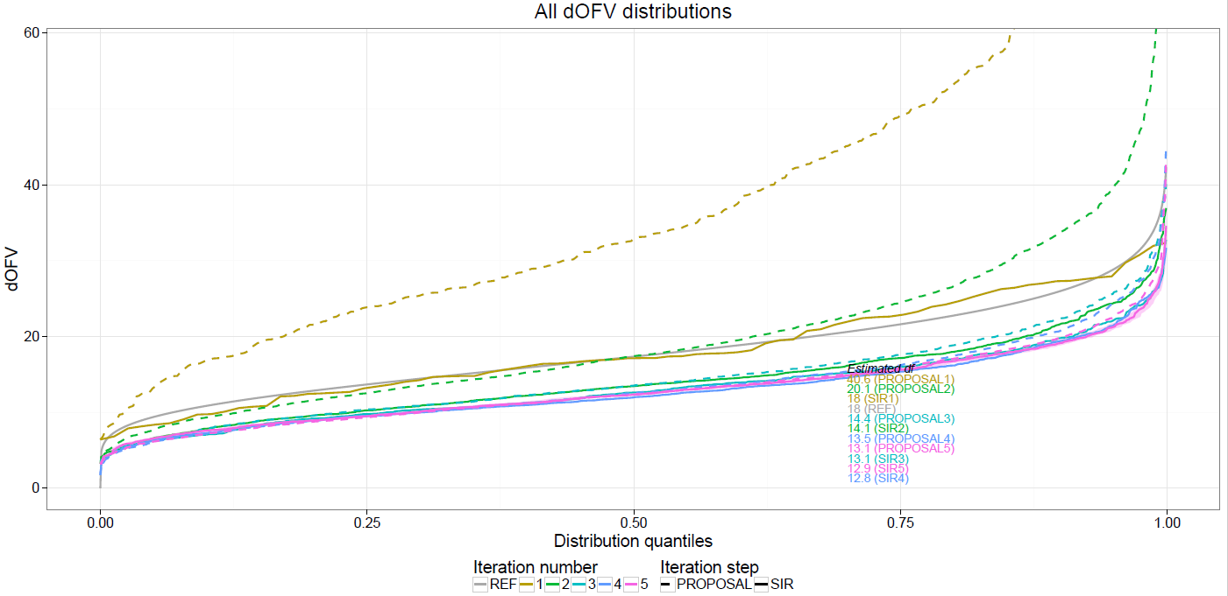

The dOFV plot showed that the proposal distribution was wide enough (i.e. above the reference chi-square distribution) and that SIR had converged (SIR distribution of iterations 3, 4 and 5 overlaid). SIR results can thus be considered valid.

Additional plots show SIR convergence parameter by parameter:

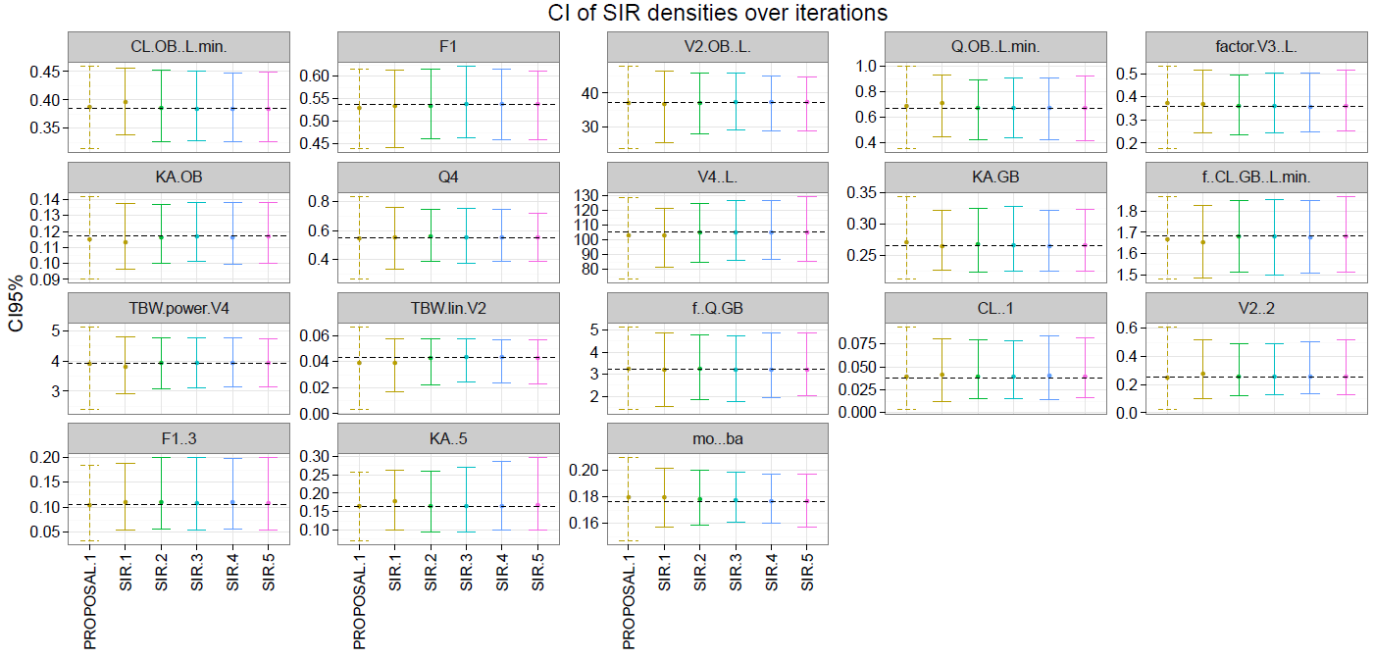

As well as a visual representation of the SIR results summarized as a covariance matrix (note that the same visual representation is also available for the proposal distribution):
