Supplementary Fig. 1. Post hoc individual estimates of cemiplimab clearance over time by treatment response in patients with CSCC
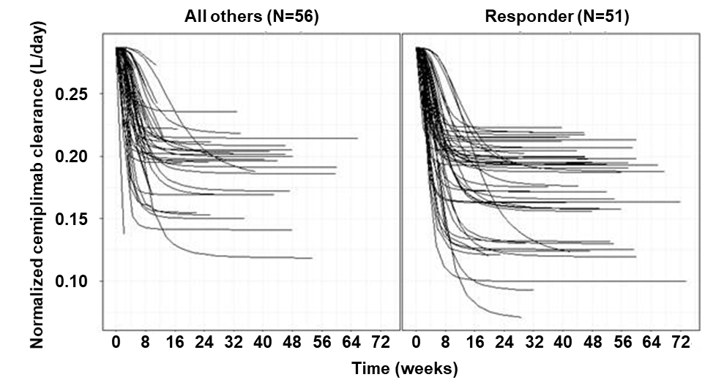
Plot shows normalized cemiplimab clearance over time from a total of 107 patients with CSCC (51 responders; 56 non-responders) in the clinical efficacy analysis population. One responder received 1 mg/kg Q2W cemiplimab; all other responders received 3 mg/kg Q2W cemiplimab.
CSCC, cutaneous squamous cell carcinoma; Q2W, every 2 weeks.

