Version: April 12, 2021
Supplemental material
for

Modeling of levothyroxine in newborns and infants with congenital hypothyroidism: challenges and opportunities of a rare disease multi-center study

Content:
Figure S1: Goodness-of-fit plots
Figure S2: Twelve (out of 61) individual profiles

a b
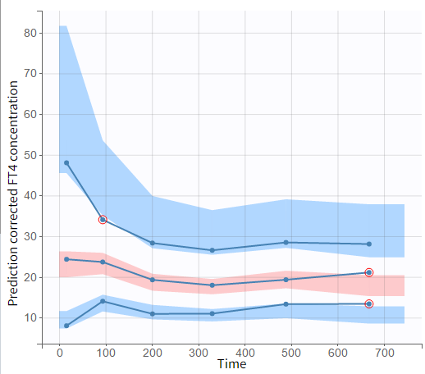
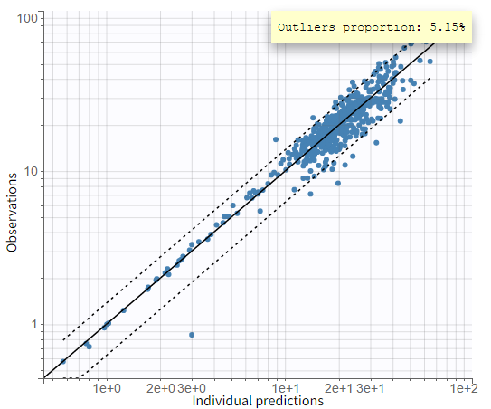

c d
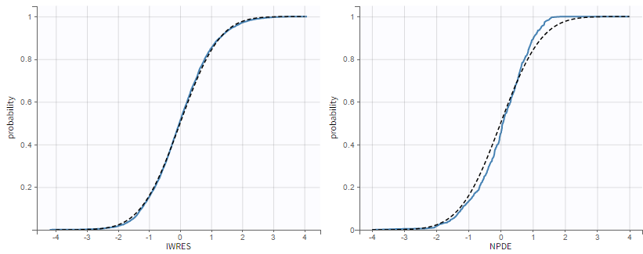

Figure S1: Prediction vs. observation is presented in panel a, where the orange curve is the spline. Visual predictive check with 10th, 50th and 90th percentiles is shown in panel b. In addition, individual weighted residuals (IWRES) (panel c) and the normalized prediction distribution error (NPDE) (panel d), each vs. the Gaussian cumulative distribution function, are shown.

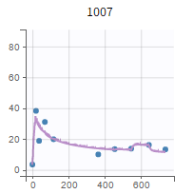
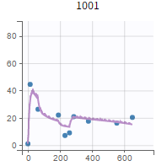
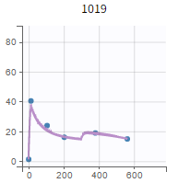
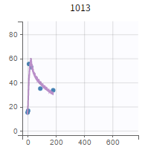

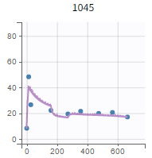
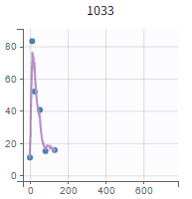
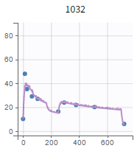
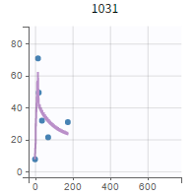

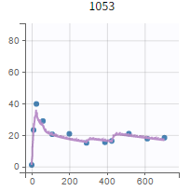
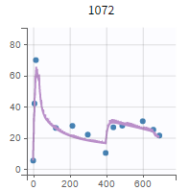
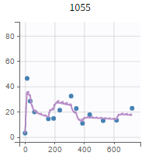
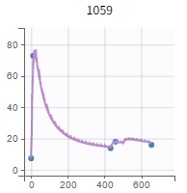

Figure S2: Twelve (out of 61) individual FT4 concentration-time profiles are shown. These profiles (i) reveal the complexity of the FT4 data, (ii) show the extreme high FT4 concentrations shortly after start of treatment, and (iii) demonstrate the long-term dynamic of FT4.

