Supplemental Information S1

1000 hypothetical individuals were simulated for each treatment group based on the tumor model (Eqs. 1 and 2) and the parameter estimates from Tables I and II. The resulting visual predictive checks comparing simulated 10th, 50th, and 90th percentiles with observed tumor volumes are shown in Fig 10. Model predictions are in relatively good agreement with data, with the exception of two outlier individuals, shown in orange and purple, in the third and sixth VPCs, respectively.

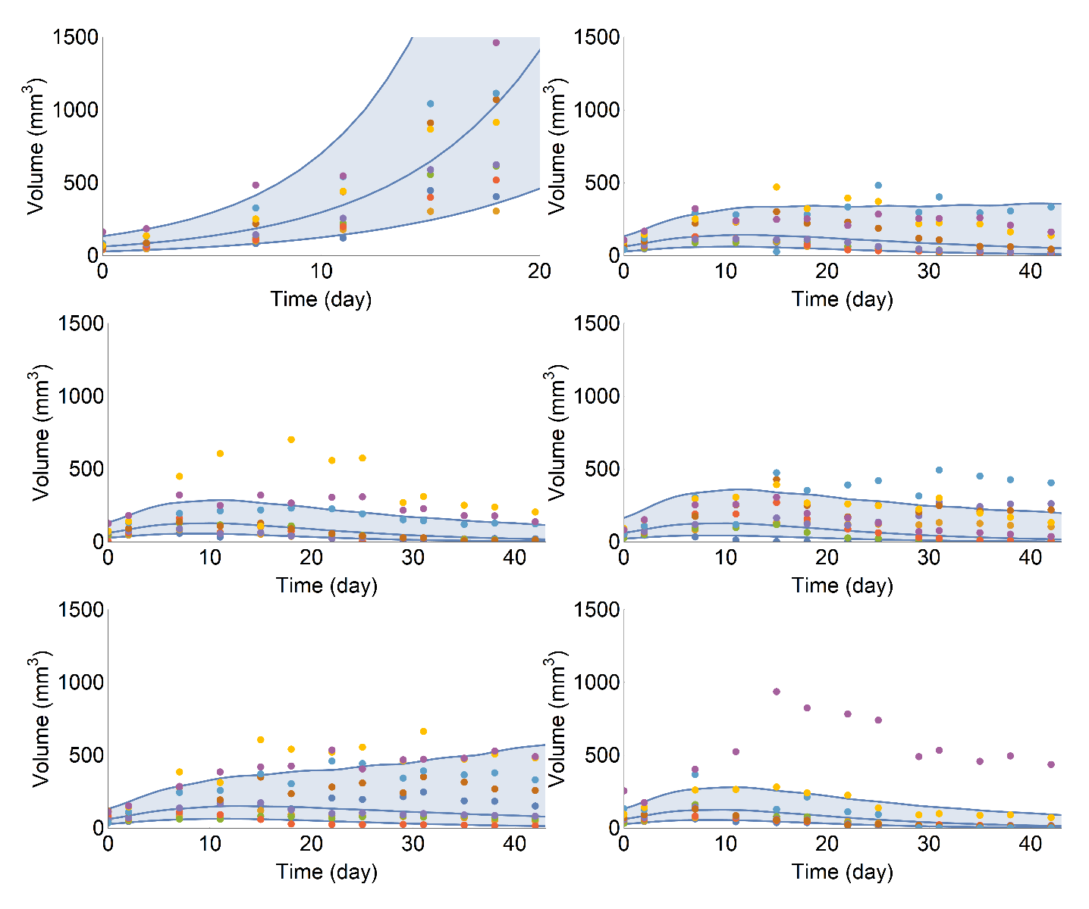

Figure 10: Visual predictive check for the tumor model in Eqs. 1 and 2 using the parameter estimates from Tables I and II. Solid lines represent the simulated 10th, 50th and 90th percentiles. Colored dots represent observations. VPCs correspond to treatment groups in the following order from top left to bottom right: vehicle, radiation, radiation + $A_{1}$ (100 mg/kg), radiation + $A_{2}$ (25 mg/kg), radiation + $A_{3}$ (100 mg/kg), and radiation + $A_{3}$ (20 mg/kg).

