Supplementary material to
Beyond the linear model in concentration-QT analysis

G. Cellière, A. Krause, G. Bonnefois, J. Chauvin

R functions
All material (datasets and R functions) can be downloaded from:
https://monolixsuite.slp-software.com/r-functions/?contextKey=package-conc-qtc.
The zip file contains the folders _mlxQTcTools, and one folder per compound (containing R script to run the analysis and the data set).
The data used in the analyses originate from Johannesen et al.. For each compound, the R script <CoumpoundName>_QTc_analysis.R executes the following steps:
- process_QTcData(): format an input dataset for analysis by averaging triplicates, extracting baseline values, calculating QTc, etc.

- generateAllQTcProjects(): generate Monolix projects to run a conc-QTC analysis using the standard linear model as well as alternative non-linear models. This function is run once for ΔQTc and once for ΔΔQTc. The generated Monolix runs are stored in the mlx_runs folder. They can be opened in the Monolix GUI for inspection.

- quarto_render(input = "../_mlxQTcTools/QTc_quarto_allModels.qmd"): generate a report (eg as Word document) using a Quarto template. The report contains exploratory data analysis plots, assessment of key modeling hypotheses, and detailed modeling results for the model identified as the best model. Separate reports are generated for ΔQTc and for ΔΔQTc.
All material is provided on an as-is basis with no warranty in any respect.

Ranolazine linear models for ΔQTc and ΔΔQTc

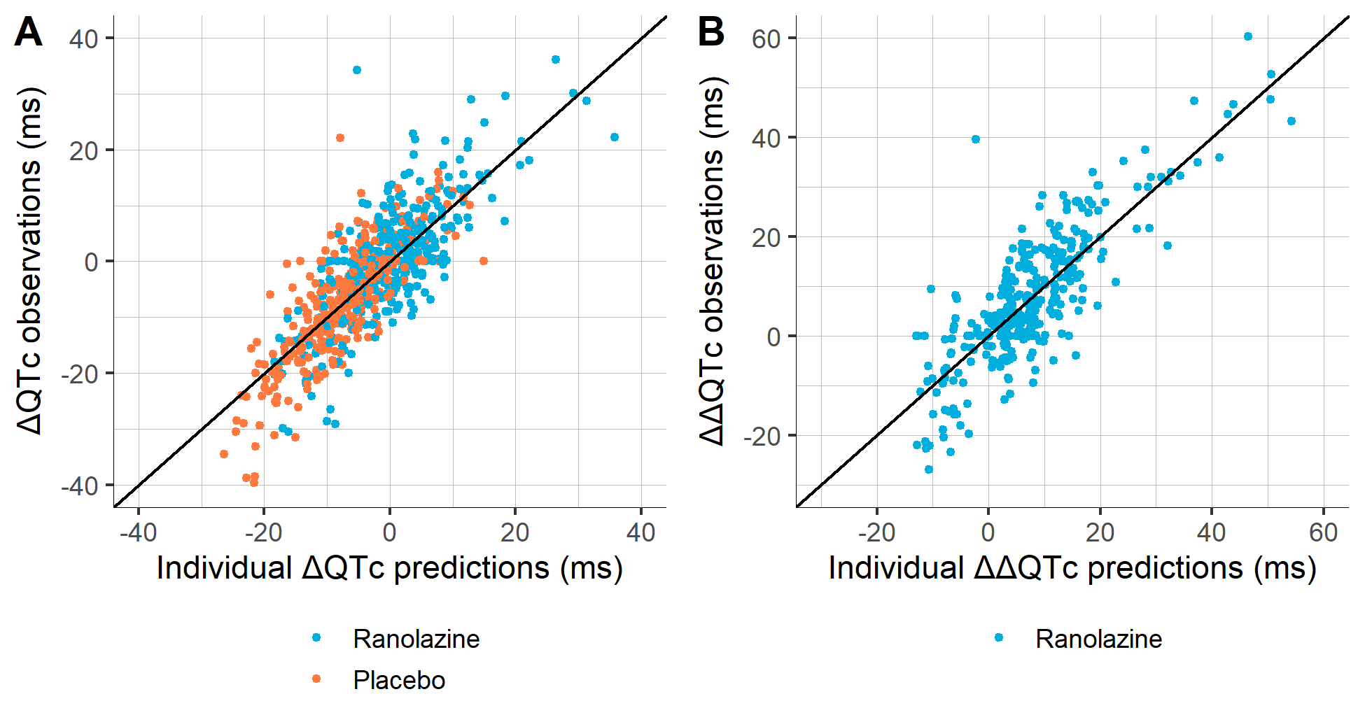
Fig. S1 Predicted versus observed ΔQTc and ΔΔQTc for ranolazine linear models.

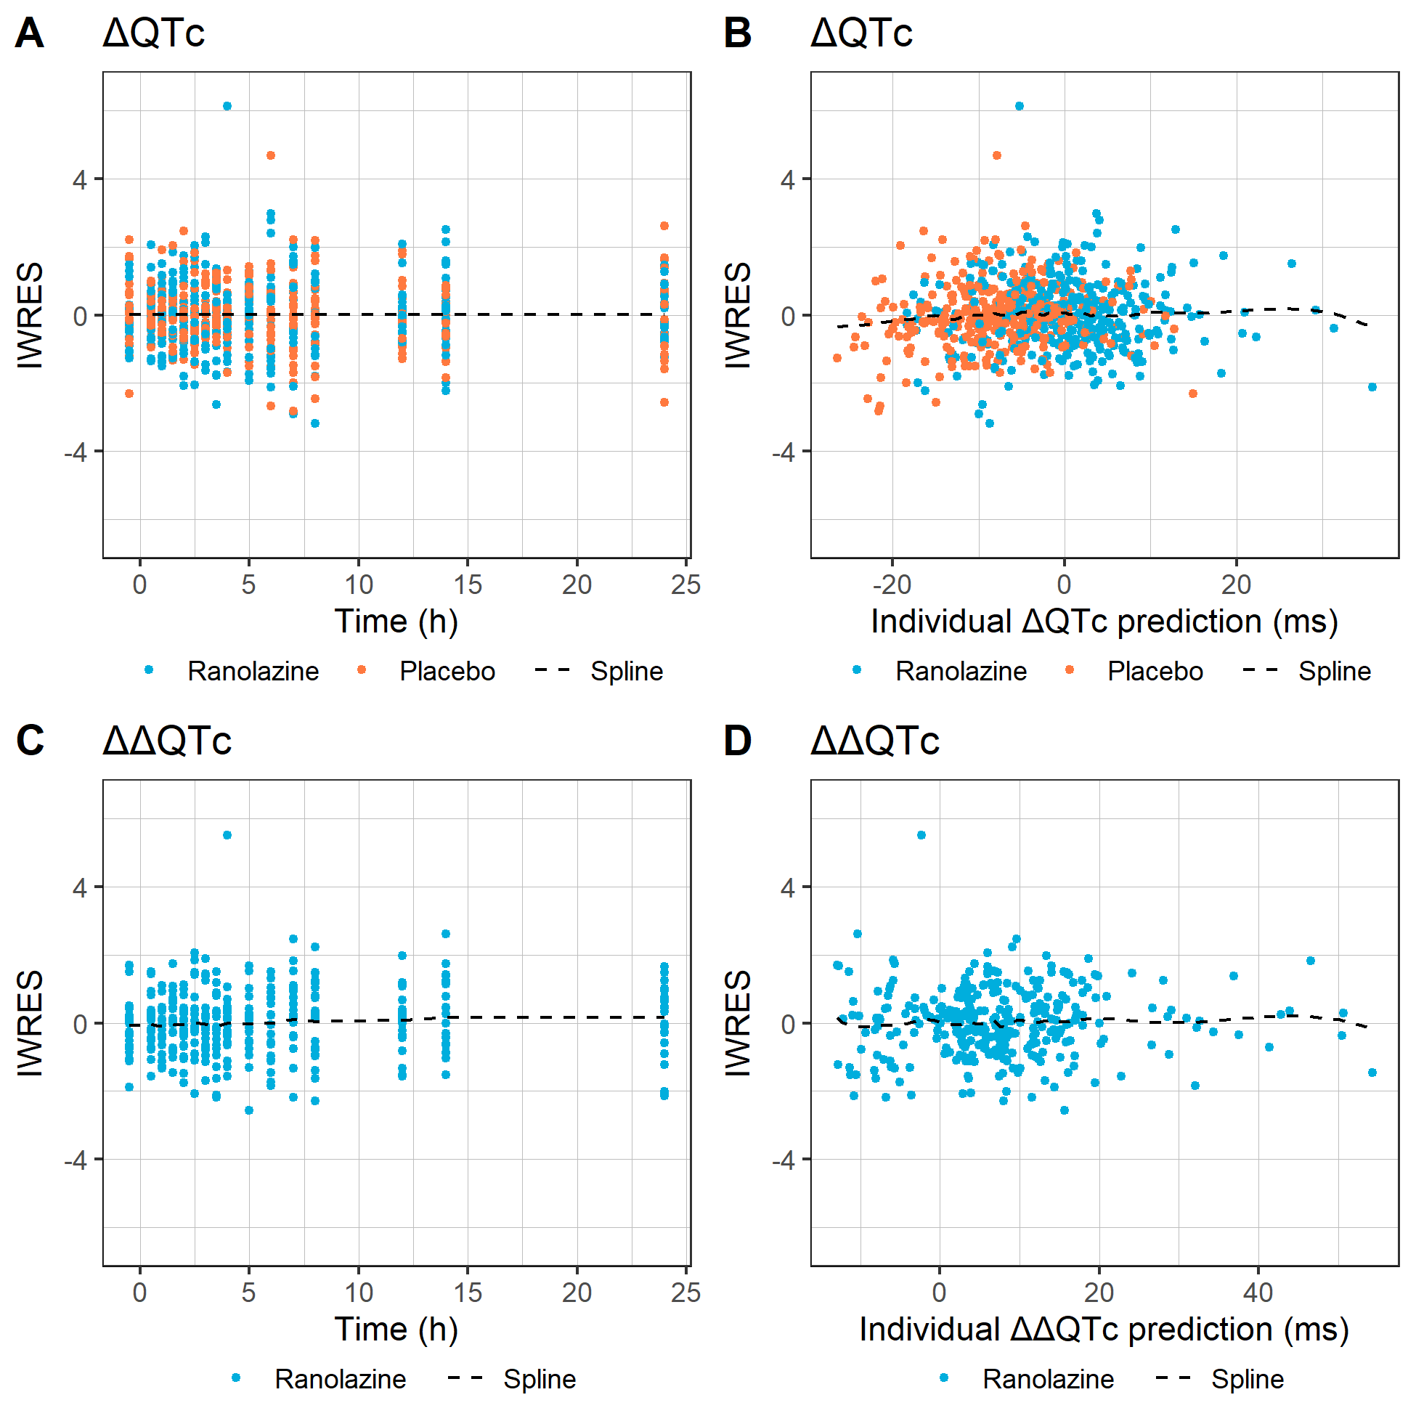
Fig. S2 Individual weighted residuals (IWRES) versus time (A, C) and versus individual predictions (B, D) for ΔQTc (A, B) and ΔΔQTc (C, D) for ranolazine linear models.

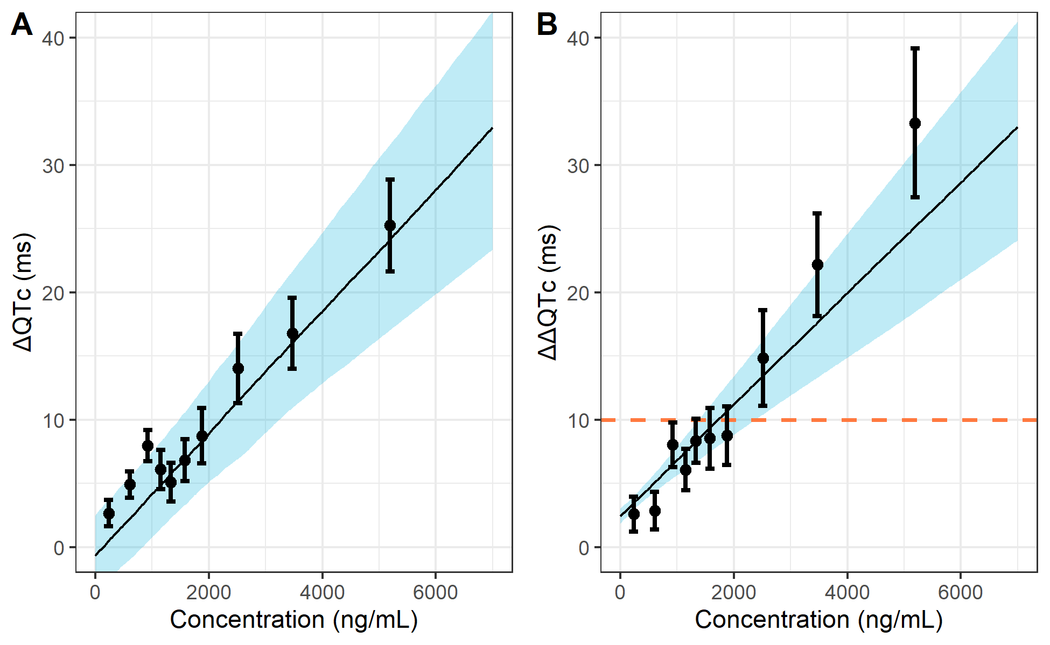
Fig. S3 Regression model fits with 90% confidence intervals for ΔQTc (A) and ΔΔQTc (B) for ranolazine linear models. Orange dashed line: 10 ms threshold for ΔΔQTc. The model prediction for ΔQTc takes into account the intercept, concentration effect and treatment effect, while time factors and the centered baseline covariate effects are ignored. The observed ΔQTc data was adjusted by the estimated time effect for each time point in order to be comparable to the model prediction. The model prediction for ΔΔQTc takes into account the intercept and the concentration effect, while the adjusted baseline covariate effect is ignored.

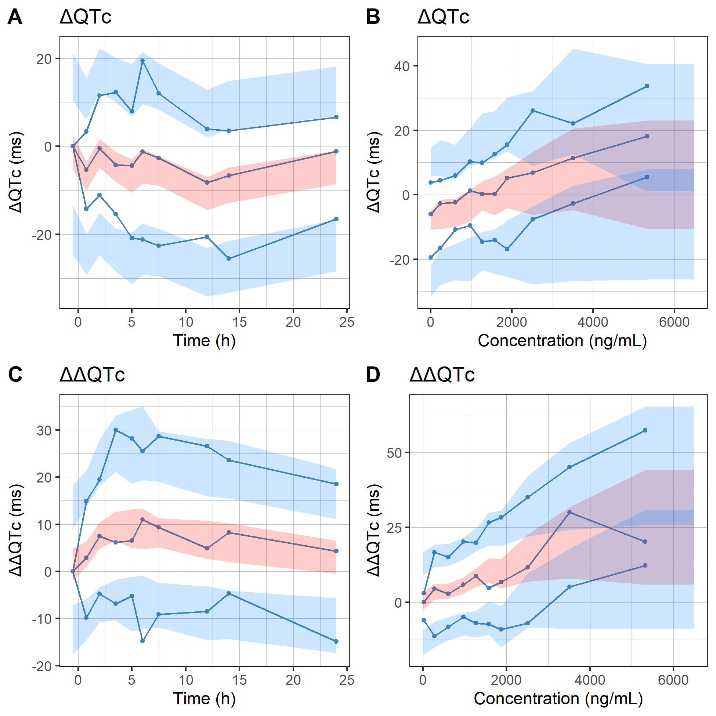
Fig. S4 Visual predictive checks for ΔQTc (A, B) and ΔΔQTc (C, D) versus time (left) and versus concentration (right) for ranolazine linear models.

Quinidine linear and non-linear model fits
Table S1 Estimated population parameters and relative standard errors (RSE) for all models
Parameter | No-drug-effect model | Linear model | Log-linear model | Emax model | Emax model with sigmoidicity
BICc | 3230.6 | 2750.4 | 2749.5 | 2746.2 | 2750.4
Intercept | 47.27  (3.4%) | 3.13 (47%) | -3.63  (55.2%) | -2.18  (87.4%) | 0.04  (5643.1%)
Slope |  | 0.04  (6.9%)
E_{max} |  |  |  | 230.48  (14.5%) | 170.21  (20.4%)
EC₅₀ |  |  |  | 3454.45  (21.6%) | 2091.67  (31.1%)
Hill coefficient |  |  |  |  | 1.21  (12%)
p1 |  |  | 76.26  (14.7%)
p2 |  |  | 979.55  (23.8%)
Centered baseline QTc, plac-adjusted | -0.47  (37.2%) | -0.62 (23.8%) | -0.56  (27.9%) | -0.58  (26.2%) | -0.67  (22%)
IIV slope (SD) |  | 0.01  (16.2%)
IIV Emax (SD) |  |  |  | 54.1  (16.4%) | 41.85  (16.4%)
IIV p1 (SD) |  |  | 16.9  (16.4%)
Residual error (SD) | 28.86  (3.9%) | 12.64  (4%) | 12.62  (4%) | 12.53  (4%) | 12.54  (4%)
Parameter estimates are shown with their relative standard errors in parentheses.

