Figure S1. Trail Profile
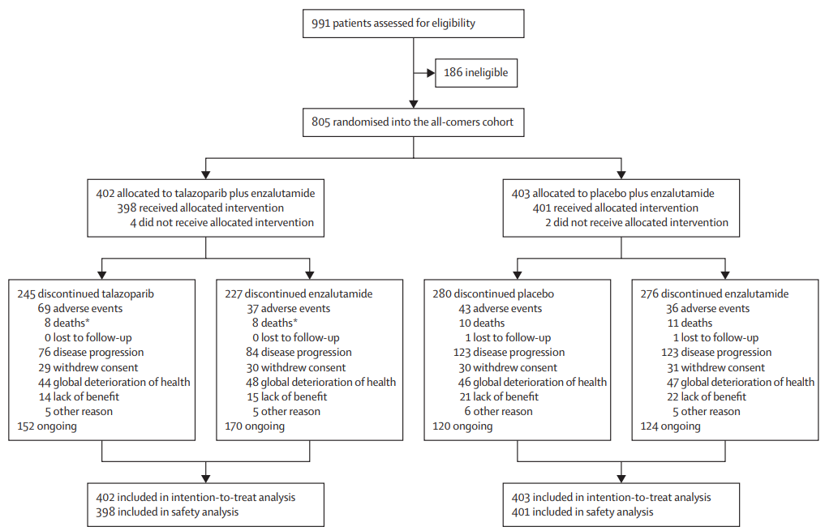
Two patients, one in each treatment group, who received enzalutamide but not talazoparib/placebo were excluded from the list of patients who discontinued treatment. One patient withdrew from the study with no protocol deviation reported; the second patient had a protocol deviation reported and discontinued from the study due to no longer meeting eligibility criteria.

Figure S2. Scatter Plot Matrix of Selected Covariates at Baseline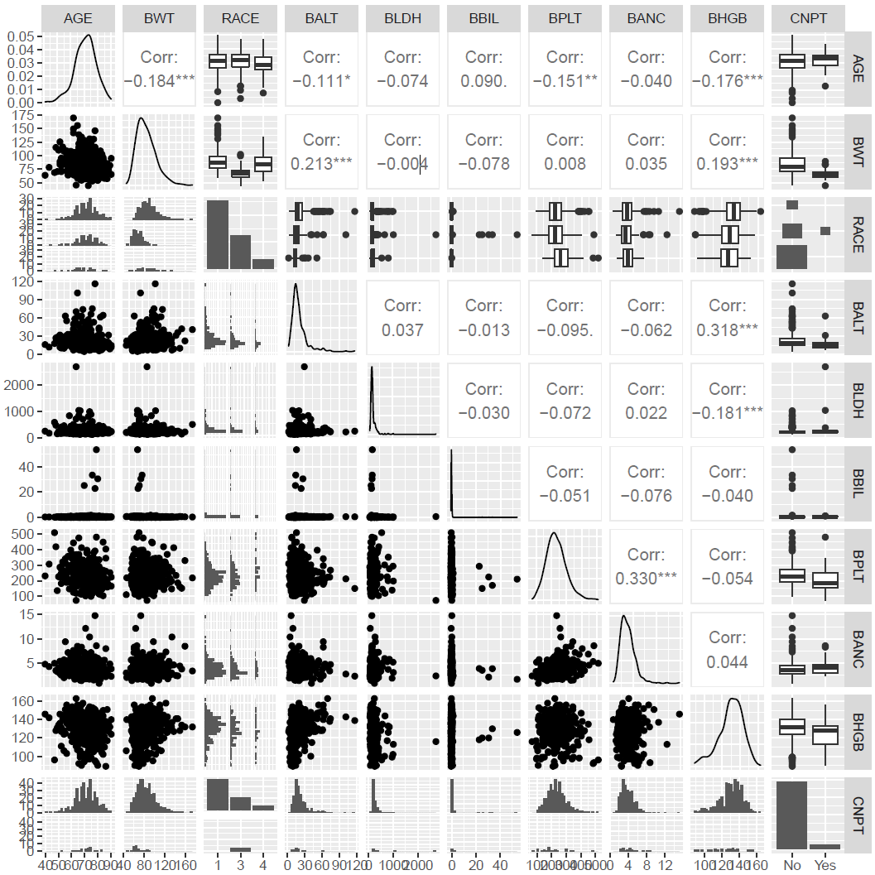
Figure S3. Diagnostic Plot for the Final Anemia Model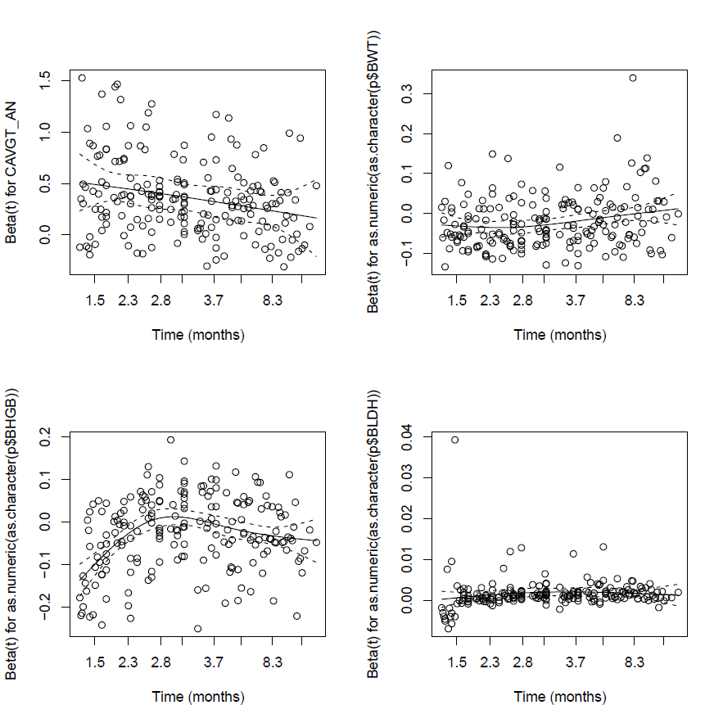
Beta(t) represent Scaled Schoenfeld residuals. The solid line is a smoothing spline fit to the plot, with the broken lines representing a 2-standard-error band around the fit. The open circles are the scaled Schoenfeld residuals.
BWT=body weight; BHGB=baseline hemoglobin; BLDH=baseline lactate dehydrogenase; CAVGT_AN=time-varying talazoparib concentration for Anemia.

Figure S4. Diagnostic Plot for the Final Thrombocytopenia Model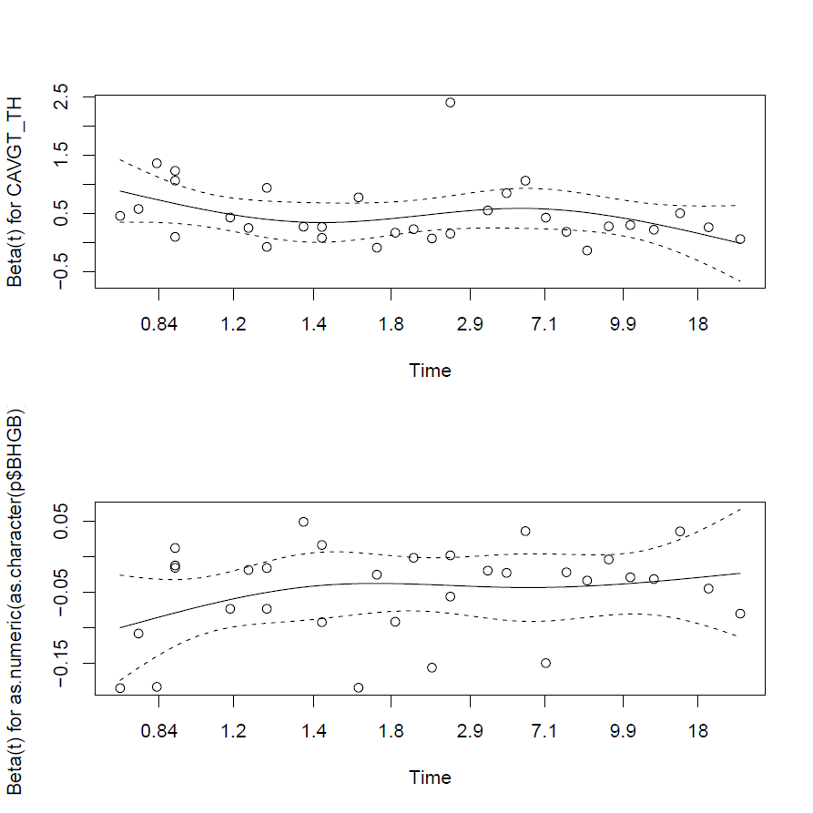
Beta(t) represent Scaled Schoenfeld residuals. The solid line is a smoothing spline fit to the plot, with the broken lines representing a 2-standard-error band around the fit. The open circles are the scaled Schoenfeld residuals.
BHGB=baseline hemoglobin; CAVGT_TH=time-varying talazoparib concentration for Thrombocytopenia.

Figure S5. Diagnostic Plot for the Final Neutropenia Model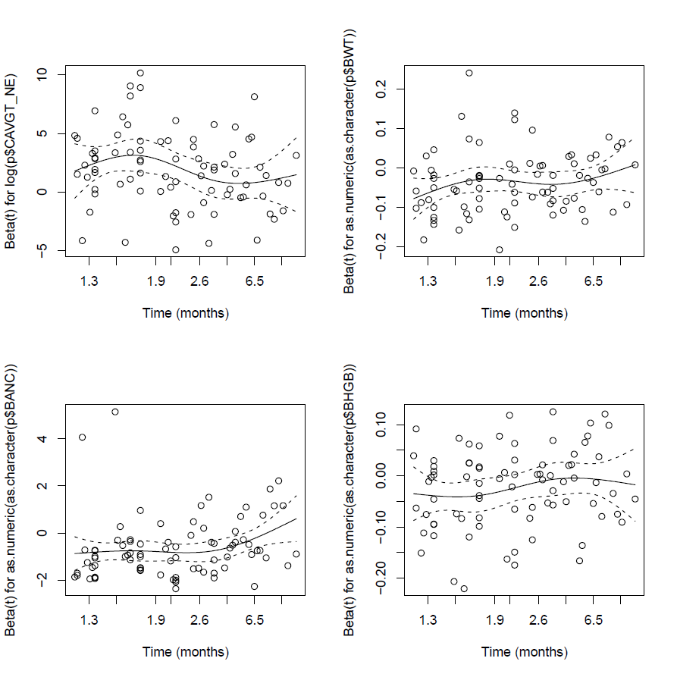
Beta(t) represent Scaled Schoenfeld residuals. The solid line is a smoothing spline fit to the plot, with the broken lines representing a 2-standard-error band around the fit. The open circles are the scaled Schoenfeld residuals.
BWT=body weight; BANC=baseline absolute neutrophil count; CAVGT_NE=time-varying talazoparib concentration for Neutropenia.

Figure S6. Boxplots Comparison of BWT, BANC, BHGB and BLDH between Asian and Non-Asian population from Part 1 and Part 2 Cohort 1 of study C3441021 Receiving Talazoparib
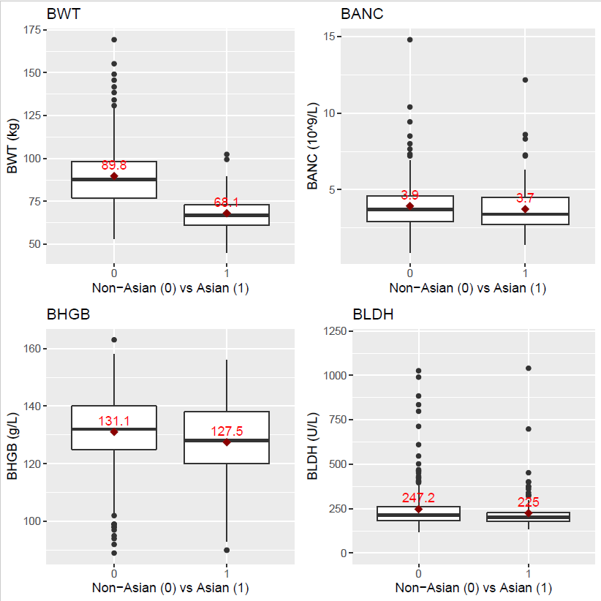
Patients with Race of "Not Reported" were not included in the boxplots.

