ELECTRONIC SUPPLEMENTARY MATERIAL (ONLINE)
ESM1. Map of northern South America showing the Northern Volcanic Zone (NVZ), in relation to the Equator. PI: Panama Isthmus. PC: Pacific Coast. Radar image courtesy of NASA/JPL-Caltech.
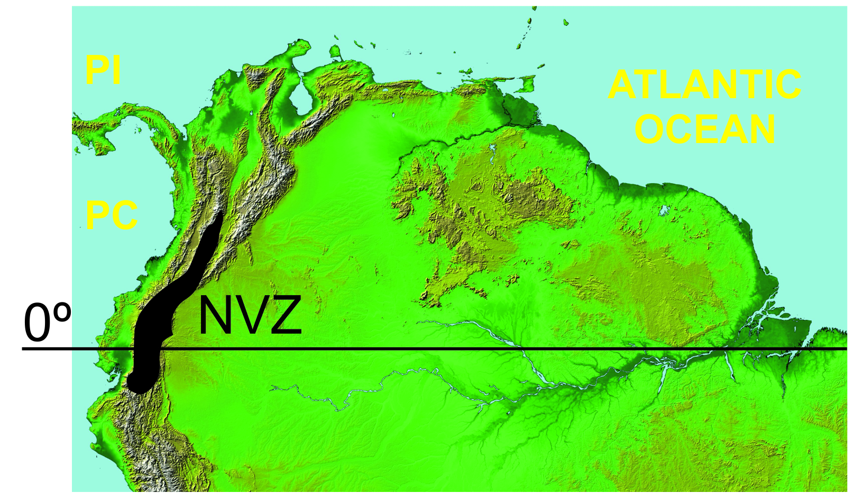

ESM2. Pre-treatment of samples for radiocarbon analysis.
Bulk sediment: Samples were acid washed in 2M HCl (8 hrs at 80 ⁰C) to remove inorganic carbon, washed free of mineral acid with distilled water, dried and homogenised.
Wood: Samples were broken into small pieces, digested in 4M HCl (80 ⁰C for 8 hrs), washed free of mineral acid with deionised water then digested in 2M KOH (80 ⁰C for 2 hrs). The digestion was repeated using deionised water until no further humics were extracted. The residue was washed free of alkali with deionised water, digested in 1M HCl (80 ⁰C, 5 hours) and rinsed free of acid with deionised water. The de-humified wood was digested at 70 ⁰C in acidified sodium chlorite solution (13g NaClO2 + 2ml conc. HCl in 500ml deionised water) until the entire sample had been oxidised to cellulose then filtered through glass fibre filter paper (Whatman GF/A), washed acid free with hot deionised water and dried in a freeze dryer.
The total carbon in a known weight of pre-treated sample was recovered as CO₂ by heating with CuO and Ag foil in a sealed quartz tube. The gas was converted to graphite by Fe/Zn reduction.

ESM3. Chemical composition of L. Baños tephras, based on XRF analysis of trace elements (expressed in wt. %).
Trace Elements | BAÑOS T1a | BAÑOS T1b | BAÑOS T2 | BAÑOS T3
Rb | 48 | 46 | 24 | 23
Sr | 364 | 402 | 432 | 471
Y | 8 | 8 | 11 | 14
Zr | 65 | 62 | 96 | 86
Nb | 5 | 5 | 4 | 4
Ba | 801 | 789 | 610 | 584
Pb | 14 | 12 | 5 | 7
Th | 6 | 5 | 4 | 3
U | 4 | 2 | 2 | 2
Sc | 4 | 5 | 10 | 13
V | 44 | 43 | 68 | 112
Cr | 10 | 11 | 18 | 25
Co | 6 | 6 | 9 | 14
Ni | 11 | 11 | 13 | 14
Cu | 47 | 39 | 25 | 22
Zn | 64 | 61 | 62 | 74
Ga | 17 | 18 | 17 | 18
Mo | 5 | 3 | 1 | 0
As | 4 | 3 | 4 | 2
S | 119 | 182 | 147 | 196

ESM4. Visual examination of minerals and grain size of L. Baños tephras and hypothesis about potential volcano origin.
Tephra layer and depth in sediment column | Characteristics of tephra-mineral %, size, color, texture | Potential volcano | Supporting evidence | Bibliographic Reference
T1a; 93cm | Light colored, scarce small white rounded pumice- 3 %; Quartz (5%), Plagioclase- 60%; Amphibole= acicular= 5%; biotite- 10%; Vitreous glass- white-~ 15%.  Overall grain size < 100 um. Ash is very fine  Could be the windowed fines of the lower T1b layer | Cosanga Volcanoes-Pumayacu o El Dorado dome.  Ash is very acid (SiO2= 68%). | In a streamcut in Cosanga area there are layers of archeological vestiges dated at about 2000 yBP. Overlying this layer are two local-source ash layers, which are sandwiched beneath the 800 yr BP Quilotoa ash. | Hall Minard L and Mothes Patricia A. 2010. New Active Rhyolitic Eruption Centers, Eastern Foot of the Ecuadorian Andes.  Abstract, Cites on Volcanoes-6, Tenerife Spain. Session: 1.1-P-86
T1b; 161 cm | Small white subangular pumice-10%; Quartz-5%; Plagioclase-60%; Black obsidian squirls- 5%, Biotite- gold and silver colored- 10%; Hornblende – 10%. Metamorphic muscovite- 1%. Overall grain size is coarser than above. Overall grain size > 150 um. | Cosanga Volcanoes- Pumayacu or El Dorado domes.  Ash is very acid (SiO2= 67%). | In a streamcut in Cosanga area there are layers of archeological vestiges dated at about 2000 yBP. Overlying this layer are two local-source ash layers, which are sandwiched beneath the 800 yr BP Quilotoa ash. | Hall Minard L and Mothes Patricia A. 2010. New Active Rhyolitic Eruption Centers, Eastern Foot of the Ecuadorian Andes.  Abstract, Cites on Volcanoes-6, Tenerife Spain. Session: 1.1-P-86
T2; 307 cm | Small white subangular pumice- well vesiculated- 10%; Quartz- 3%; Plagioclase-60%; Grey smokey obsidian squirls- 5%; Hornblende- 20%; Augite- olive green color-2%; Magnetite- 5%  Overall grain size < 150 um. | Antisana volcano | A similar tephra layer (ANTI-37) is observed in a section NW of Antisana volcano, where it directly overlies a soil dated at 3400 +/- 150 yBP. The lower SiO₂ (64%) is suggestive that this tephra is related to Antisana´s recent dacite activity. | (Hall et al., 2017).
T3; 350 cm | Small rounded White pumice- 50%: Quartz- 5%; Plagioclase- 25%, Hornblende- 10%; Black obsidian- 5%, biotite- trace; Magnetite- 5%  Overall grain size < 150 um. | Cosanga Volcanoes- Pumayacu dome | At the base of Pumayacu dome we have a dated layer of 4390 +/- 120 yBP, with a high percentage of siliceous pumice. | Hall Minard L and Mothes Patricia A. 2010. New Active Rhyolitic Eruption Centers, Eastern Foot of the Ecuadorian Andes.  Abstract, Cites on Volcanoes-6, Tenerife Spain. Session: 1.1-P-86
ESM5. DCA analysis of samples distribution based on chironomid abundances values. a Laguna Pindo and b Laguna Baños. Numbers indicate the depth of the samples in each sequence and colour defines the sample zones (white = zone PIN-A or BAÑ-A, lower zone, older samples; black = PIN-B or BAÑ-B, upper zone, younger samples).

