Figure and table captions - Supplementary Material

ESM1 Summer and winter mean air temperature (°C) profiles recorded at (a) Torbole-Riva del Garda since 1896 AD and (b) Villafranca since 1842 AD. (June-July-August) (December-January-February)

ESM2 Parallelization of the littoral core (LitG1-13) with the dry weight (DW) percentage of the Bardolino core (Bar1-11).

ESM3 The approximate significance of smooth terms of the vector fitting analysis for environmental (Environmental) and climatic (Temperatures) variables.

ESM4 Taxa identified in the three sediment cores (Bren1-09, Bar1-11, LitG1-13) and the water column (Salmaso and Naselli-Flores, 1999). The code is the species code used in the stratigraphic plots and NMDS analyses. The presence and absence of individual taxa are indicated by + and – symbols, respectively.

ESM1
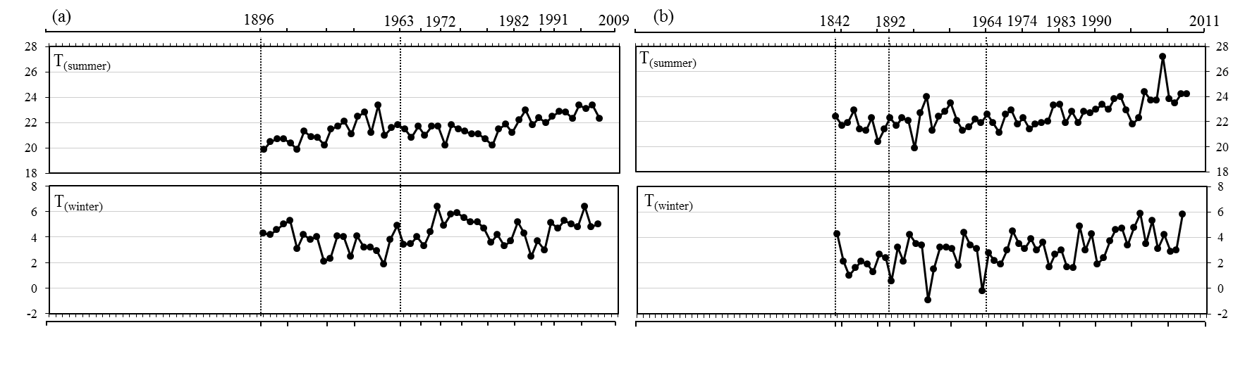

ESM2
ESM3
 | Environmental |  | Temperature
 | p-value | % | p-value | %
Brenzone | <0.001 | 52.8 | <0.05 | 54.5
Bardolino | <0.001 | 87 | <0.001 | 87.2
Littoral | <0.001 | 90.5 | <0.001 | 76.5

ESM4
Code | Species | Author | Bren1-09 | Bar1-11 | LitG1-13 | Lake
Acrelo | Acroperus elongatus | (Sars) | - | + | + | -
Acrhar | Acroperus harpae | (Baird) | + | + | + | -
Acrspp | Acroperus spp. | Baird | - | - | + | -
Aloaff | Alona affinis | Leydig | + | + | + | -
Alocos | Alona costata | Sars | + | + | + | -
Alogut | Alona guttata | Sars | + | + | + | -
Aloint | Alona intermedia | Sars | + | - | - | -
Aloqua | Alona quadrangularis | (O. F. Müller) | + | + | + | -
Alorec | Alona rectangula | Sars | + | + | + | -
Alospp | Alona spp. | Baird | - | - | + | -
Aloexc | Alonella excisa | Fischer | + | + | + | -
Aloexi | Alonella exigua | Lilljeborg | - | + | + | -
Alonan | Alonella nana | Baird | + | + | + | -
Ancema | Anchistropus emarginatus | Sars | - | + | + | -
Boscor | Bosmina (E) coregoni group | Baird | + | + | + | -
Boslro | Bosmina longirostris group | (O. F. Müller) | + | + | + | -
Boslsp | Bosmina (E) longispina group | Leydig | + | + | + | -
Bosspp | Bosmina spp. | Seligo | + | - | + | +
Bytlon | Bythotrephes longimanus | Leydig | + | + | + | +
Camlil | Camptocercus lilljeborgi | Schödler | + | - | - | -
Camrec | Camptocercus rectirostris | Schödler | + | + | + | -
Camspp | Camptocercus spp. | Baird | + | + | + | -
Chygib | Chydorus gibbus | Sars | - | + | - | -
Chyglo | Chydorus globosus | (Baird) | + | + | + | -
Chypig | Chydorus piger | (Sars) | + | + | + | -
Chyspp | Chydorus spp. | Leach | + | - | - | +
Chysph | Chydorus sphaericus | (O. F. Müller) | + | + | + | -
Daplon | Daphnia longispina group | O. F. Müller | + | + | + | +
Diabra | Diaphanosoma brachyurum | Liévin | - | + | - | +
Disros | Disparalona rostrata | Koch | + | + | + | -
Eurspp | Eurycercus spp. | Baird | + | + | + | -
Grates | Graptoleberis testudinaria | (Fischer) | - | + | + | -
Lepkin | Leptodora kindti | (Focke) | + | + | + | +
Leyaca | Leydigia acanthocercoides | (Fischer) | + | + | + | -
Leyley | Leydigia leydigi | (Schödler) | + | + | + | -
Mondis | Monospilus dispar | Sars | + | + | + | -
Pleden | Pleuroxus denticulatus | Birge | + | + | + | -
Plelae | Pleuroxus laevis | Sars | + | + | + | -
Plespp | Pleuroxus spp. | Baird | + | + | + | -
Pletri | Pleuroxus trigonellus | (O. F. Müller) | + | + | + | -
Pleunc | Pleuroxus uncinatus | Baird | + | + | + | -
Polped | Polyphemus pediculus | (Linné) | - | - | - | +
Rhyfal | Rhynchotalona falcata | (Sars) | - | - | + | -
Sidcry | Sida crystallina | (O. F. Müller) | - | - | - | +
Unalat | Unapertura latens | Sarmaja-Korjonen | - | - | + | -

