Electronic Supplementary Material
ESM 1 ²¹⁰Pb dating and core chronology data

(a) ²¹⁰Pb concentrations in core HAMP1
Depth  cm | Dry Mass  g cm⁻² | Pb-210 |  |  | Pb-210 Cum.
Depth  cm | Dry Mass  g cm⁻² | Total | Supported | Unsupp | Unsupported
Depth  cm | Dry Mass  g cm⁻² | Bq Kg⁻¹ | Bq Kg⁻¹ | Bq Kg⁻¹ | Bq m⁻²
0-1 | 0.044 | 143.67 ± 38.8 | 41.86 ± 7.87 | 101.8 ± 39.62 | 44.7 ± 12.5
10-11 | 1.52 | 115.25 ± 16.38 | 29.65 ± 2.89 | 85.6 ± 16.63 | 1426.2 ± 333
20-21 | 3.56 | 84.95 ± 12.32 | 30.83 ± 2.18 | 54.1 ± 12.51 | 2824.3 ± 449.9
30-31 | 5.42 | 78.53 ± 10.44 | 33.1 ± 1.99 | 45.4 ± 10.63 | 3750.7 ± 507.7
40-41 | 7.64 | 63.4 ± 11.58 | 32.88 ± 1.99 | 30.5 ± 11.75 | 4581.5 ± 560.1
50-51 | 10.10 | 73.59 ± 9.96 | 35.46 ± 1.86 | 38.1 ± 10.13 | 5423 ± 624.2
60-61 | 12.67 | 72.47 ± 8.17 | 34.27 ± 1.47 | 38.2 ± 8.3 | 6403.3 ± 672.9
70-71 | 15.71 | 66 ± 6.49 | 35.23 ± 1.28 | 30.8 ± 6.62 | 7448.5 ± 713.2
80-81 | 18.98 | 64.14 ± 7.1 | 33.02 ± 1.3 | 31.1 ± 7.22 | 8460.6 ± 747.4
90-91 | 22.25 | 67.53 ± 10.36 | 33.24 ± 2.15 | 34.3 ± 10.58 | 9528.8 ± 795.7
110-111 | 28.70 | 64.95 ± 9.67 | 31.46 ± 1.69 | 33.5 ± 9.82 | 11,715.2 ± 989.9
140-141 | 38.91 | 52.91 ± 6.93 | 30.81 ± 1.33 | 22.1 ± 7.06 | 14,511.5 ± 1303
180-180 | 52.31 | 44.27 ± 6.58 | 31.93 ± 1.26 | 12.3 ± 6.7 | 16,756.6 ± 1573.8

(b) Artificial fallout radionuclide concentrations in HAMP1
Depth  cm | ¹³⁷Cs | ²⁴¹Am
Depth  cm | Bq Kg⁻¹ | Bq Kg⁻¹
0-1 | 9.74 ± 5.07 | 0
10-11 | 11.59 ± 2.33 | 0
20-21 | 25.72 ± 2 | 0
30-31 | 59.73 ± 2.38 | 0
40-41 | 89.6 ± 2.81 | 2.1 ± 1.1
50-51 | 18.51 ± 1.47 | 0
60-61 | 0 | 0
70-71 | 0 | 0
80-81 | 0 | 0
90-91 | 0 | 0
110-111 | 0 | 0
140-141 | 0 | 0
180-180 | 0 | 0

(c, right) Unsupported ²¹⁰Pb and ¹³⁷Cs activity
Measured in core HAMP1
ESM 2 Occurrence of microplastics in (a) blanks and (b) <500 µm fraction

(a) Microplastics in Blanks | Fibres
 | Red | Blue | White
BLANK 1 (0-25 cm) | 1 (<0.5 mm) |  | 1 (1 mm)
BLANK 2 (25 – 50 cm) | 1 (<0.5mm), 1 (0.8mm) | 2 (<0.5 mm)
BLANK 3 (55 – 95 cm) | 1 (<0.5 mm) |  | 1 (<0.5 mm)
Max number (+1) found in a blank | 3 | 3 | 2
(b) Visible in < 500 µm sieved fraction
0-5 cm (2009-2005) | 2 (<0.5 mm), 1 (1 mm)
25-30 cm (Mid-Early 1980s) | 1 (<1mm)

ESM 3 Particle types and counts found in remaining 2.1 g cm⁻³ sodium polytungstate solution following centrifuging of 500 µm to 1mm sieved fraction. Grey shaded column indicates absence of fragments/fibres

Depth (cm) | 0-5 | 5-10 | 10-15 | 15-20 | 20-25 | 25-30 | 30-35 | 35-40
Age | 2009-2005 | 2005-2000 | Mid-late 1990s | Early-mid 1990s | Mid-late 1980s | Mid-Early 1980s | Late 1970s-1960s | Late 1960s – Early 1960s
Black Fibre (5mm) |  |  |  |  |  | 1
Black Fibre (3mm) |  |  | 1
Blue fibre (3mm) | 1 |  | 2
Blue fibre (2mm) |  |  | 2
Blue fibre (1mm) |  |  |  |  |  |  | 1
Blue fibre (0.5 mm) |  |  |  |  |  | 1 | 1
Orange "Foam" <0.5mm | 1 | 1 |  |  |  |  | 3
Red Fibre (~6mm) |  |  | 1
Red Fibre (~4mm) | 1
Red Fibre (1mm) |  |  | 2 | 1
Red Fibre (<0.5mm) |  |  |  | 1 |  | 2
Depth (cm) | 40-45 | 45-50 | 50-55 | 55-60 | 70-75 | 80-85 | 90-95
Age | Early 1960s – mid 1950s | Mid 1950s to 1940s | 1940s-1930s | 1930s | Early 20th C | Late 19th C | ~19th C
Black curved fibre (1.5mm) | 1 |  |  |  |  | 1
Blue fibre (1mm) |  |  |  | 1
Red Fibre (~4mm) |  |  | 1
Red Fibre (1mm) | 1 |  |  |  | 1 | 1

ESM 4 Description of particles analysed using Raman spectroscopy and proportion of total sample
Depth (cm) | 0-5 | 5-10 | 10-15 | 15-20 | 20-25 | 25-30 | 30-35 | 35-40 | 40-45 | 45-50
Age | ~2005 | 2005-2000 | mid-late 1990s | early 1990s | mid-late 1980s | early 1980s-late 1970s | late 1970s - 1960s | late 1960s-early 1960s | early 1960s -1950s | mid 1950s - 1940s
Description | Blue black fibre | Clear fibre | Beige fragment | Blue black fibre | Red fibre | Blue fibre | Clear fibre | Black fibre | Black fibre | Blue fibre
 | Blue black fibre | Purple fibre | Orange fragment | Red fibre | White fragment | blue fibre | Grey fibre | Black fibre | Black fibre | Blue fibre
 | Blue fibre | White fragment |  | Purple fibre |  | Red fibre | Purple fibre | Black fibre | Orange fragment
 | Blue fibre | Red-brown fibre |  |  |  | blue-black fibre | Red fibre | Blue fibre | Orange fragment
 | Clear fibre |  |  |  |  |  |  | Blue fibre
 | Clear film |  |  |  |  |  |  | Blue fibre
 | Orange fragment |  |  |  |  |  |  | Brown fibre
 | Orange fragment |  |  |  |  |  |  | Clear fibre
 | Red fibre |  |  |  |  |  |  | clear fibre
 | Red fibre |  |  |  |  |  |  | Blue/clear fibre
 |  |  |  |  |  |  |  | Black fibre
Total particles analysed (n) | 10 | 4 | 2 | 3 | 2 | 4 | 4 | 11 | 4 | 2
Total particles in sample (n) | 18 | 16 | 6 | 14 | 6 | 10 | 13 | 25 | 7 | 3
Analysed % | 55.6 | 25.0 | 33.3 | 21.4 | 33.3 | 40.0 | 30.8 | 44.0 | 57.1 | 66.7

ESM 5 Microplastic colours encountered in downcore sample depths in core HAMP1. Proportions of colours using numbers/gram sediment values before blank subtracting. Grey shading = white/grey fibres. Colours as shown

Colours | Depth (cm) | Time Period
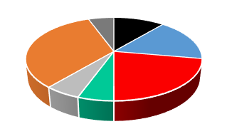 | 0-5 | 2009-2005
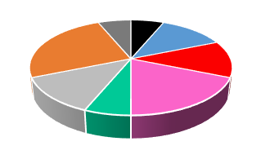 | 5-10 | 2005-2000
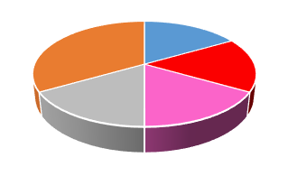 | 10-15 | Mid-late 1990s
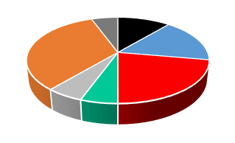 | 15-20 | Early-Mid 1990s
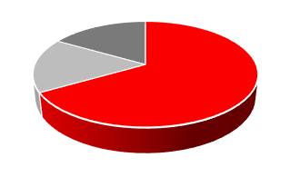 | 20-25 | Mid-late 1980s
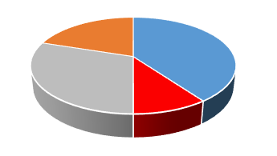 | 25-30 | Mid-Early 1980s
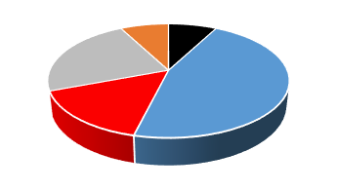 | 30-35 | Late 1970s-1960s
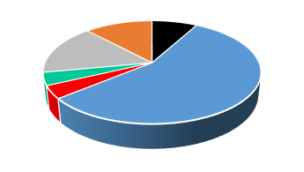 | 35-40 | Late 1960s – Early 1960s
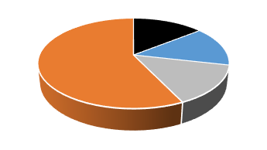 | 40-45 | Early 1960s – mid 1950s
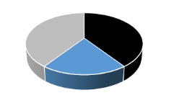  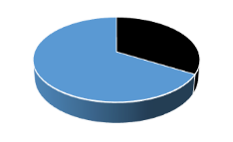 | 45-50 | Mid 1950s to 1940s
 | 50-55 | 1940s-1930s
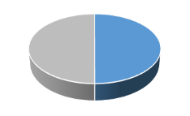 | 55-60 | 1930s
 | 70-75 | Early 20th century
 | 80-85 | Late 19th century
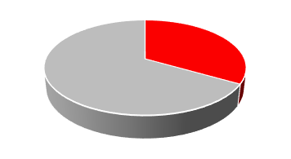  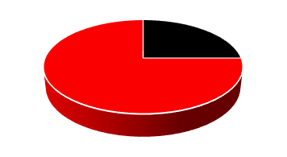  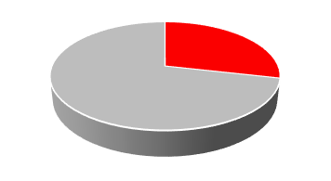 | 90-95 | ~19th century

ESM 6 Unidentified vs Identified materials in HAMP1 core (<500 μm - 1mm fraction). Samples 1-10 (Mid-20th century to present) only

