 | Lake Unterer Soiernsee | Lake Oberer Soiernsee
Latitude (N), Longitude (E) | 47°29´30´´N 11°20´53´´E | 47°29´30´´N 11°20´53´´E
Altitude (m) | 1552 | 1558
Lake area (ha) | 3.4 | 3.46
Maximum depth (m) | 5.5-15 | 12.7-14.5
Secchi-depth min/mean/max (m) | 0,5 / 4 / 7 | 0,75 / 4 / 6,5
Euphotic zone min/mean/max (m) | 3.5 / 9.5 /13 | 4 / 10 / 13
Average pH | 8.6 | 8.7
Mean Conductivity (μScm⁻¹) | 184 | 192
TP min/mean/max (μg l⁻¹) | 6 / 11 / 28 | 5 / 13 / 33
Silica min/mean/max (mg l⁻¹) | 0.16 /0.18 / 0.20 | 0.15 / 0.18 /0.24
N-NH₄⁺ min/mean/max (μg l⁻¹) | 14 /20 / 30 | 40 / 53 / 71
N-NO₃⁻ min/mean/max (mg l⁻¹) | 0.34 / 0.35 / 0.35 | 0.21 / 0.24 / 0.26
Suppl. 1: Geographical positions and, hydrological parameters of the two lakes measured during the period of August 2014 to November 2016

Suppl. 2: Phytoplankton-Succession of Lake Unterer Soiernsee
 | Dino-phyceae  g/m³ | Chryso-phyceae  g/m³ | Bacillario-phyceae (plankt.) g/m³ | Bacillario-phyceae (benth.) g/m³ | Chloro-phyceae  g/m³ | Zygnemato-phyceae  g/m³ | Other  g/m³
Juli | 0.10044 | 0.017884 | 0.18792507 | 0.01621514 | 0.00784213 | 0 | 0.00695688
August | 0.203176 | 0.0035768 | 0.08591474 | 0.07216194 | 0.04442386 | 0.00786896 | 0.00343373
September | 0.555864 | 0.0107304 | 0.25008986 | 0.0087048 | 0.09967647 | 0.06295168 | 0
Oktober | 0 | 0.0196724 | 0.01487965 | 0.0885258 | 0.08591831 | 0.0228572 | 0.0232492
November | 0.03348 | 0.0017884 | 0.00393448 | 0.00053652 | 0.00308499 | 0.00926396 | 0

Supp.3: Phytoplankton Lake Unterer Soiernsee (October)

Suppl. 4: Phytoplankton-Succession of Lake Oberer Soiernsee
 | Dino-phyceae  g/m³ | Chryso-phyceae  g/m³ | Bacillario-phyceae (plankt.) g/m³ | Bacillario-phyceae (benth.) g/m³ | Chloro-phyceae  g/m³ | Zygnemato-phyceae  g/m³ | Other  g/m³
Juli | 0.03348 | 0.0661708 | 0.36418978 | 0.0353209 | 0.02195261 | 0 | 0
August | 0.30132 | 0.0143072 | 0.17204408 | 0.03949684 | 0.03564281 | 0.06713668 | 0.00362151
September | 1.70748 | 0.022355 | 0.06667155 | 0.0114404 | 0.0546535 | 0.08893564 | 0.00464984
Oktober | 1.3496408 | 0.0039116 | 0.05400968 | 0.0665607 | 0.04897825 | 0.02919864 | 0.00109987
November | 0.3348 | 0.0277208 | 0.07711581 | 0 | 0.04039996 | 0.03022396 | 0.00639353

Suppl. 5: Phytoplankton Lake Oberer Soiernsee (August)

Suppl. 6: Achnanthidium sp.
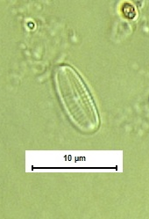
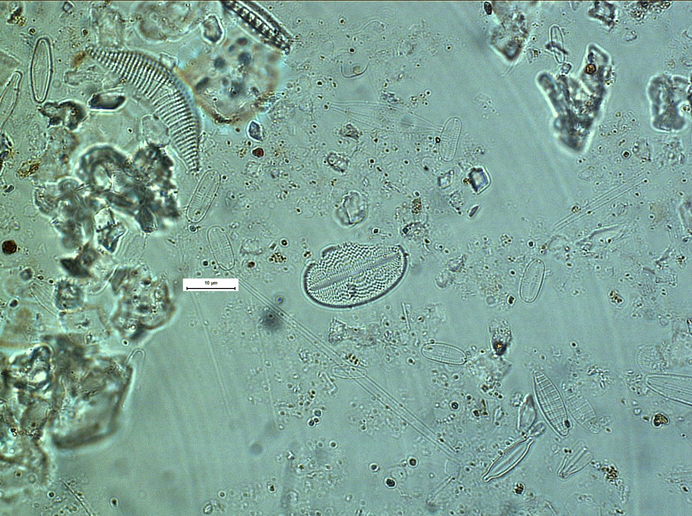

Photos of unknown Achnanthidium (Achnanthidium sp.)

Suppl. 7a: RDA (species) Lake Unterer Soiernsee
Redundancy analysis (RDA) of the relationship between depth and relative abundances of the most common diatom species (acronyms see Table 1) indicated that depth explains 23 % of the variation in the diatom community composition of Lake Unterer Soiernsee

Suppl. 7b: RDA (sites) Lake Unterer Soiernsee
Redundancy analysis (RDA) of the relationship between depth (m, N= north, S=south) and relative abundances of the most common diatom species indicated that depth explains 23 % of the variation in the diatom community composition of Lake Unterer Soiernsee

Suppl. 8a: RDA (species) Lake Oberer Soiernsee
Redundancy analysis (RDA) of the relationship between depth and relative abundances of the most common diatom species (acronyms see Table 1) indicated that depth explains 35 % of the variation in the diatom community composition of Lake Oberer Soiernsee

Suppl 8b: RDA (sites) Lake Oberer Soiernsee
Redundancy analysis (RDA) of the relationship between depth (m, N= north, S=south) and relative abundances of the most common diatom species indicated that depth explains 35 % of the variation in the diatom community composition of Lake Oberer Soiernsee

Suppl. 9: Temperature logger data of Lake Unterer Soiernsee illustrated using R package rLakeAnalyzer (Luke Winslow 2014)
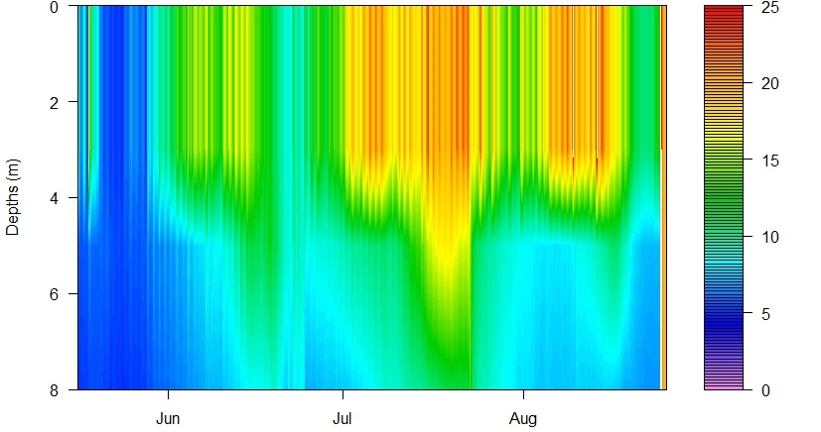
Depth-time diagram of isotherms (°C) in Lake Unterer Soiernsee (Mai-September 2015)

Suppl. 10: Temperature logger data of Lake Oberer Soiernsee illustrated using R package rLakeAnalyzer (Luke Winslow 2014)
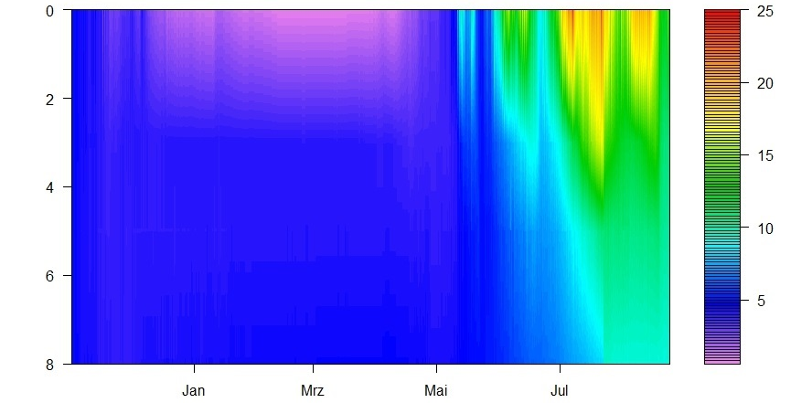
Depth-time diagram of isotherms (°C) in Lake Oberer Soiernsee (November 2014-August 2016)

Suppl. 11: Temperature logger data of Lake Oberer Soiernsee August 2015 – November 2016 illustrated using R package rLakeAnalyzer (Luke Winslow 2014)
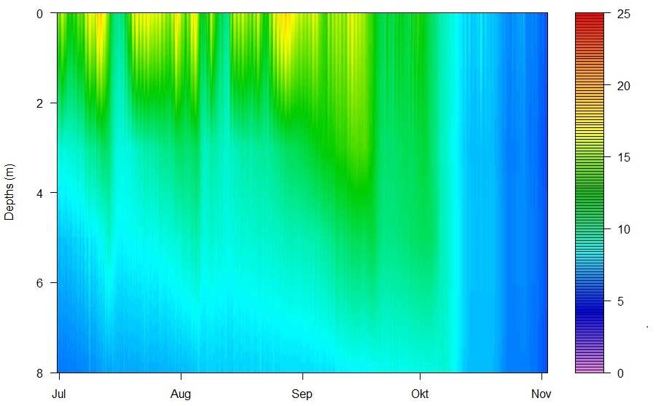
Depth-time diagram of isotherms (°C) in Lake Oberer Soiernsee (August 2015-November 2016)

Suppl. 12: Hydrochemical parameters 2015
Lake Unterer Soiernsee

Lake Oberer Soiernsee

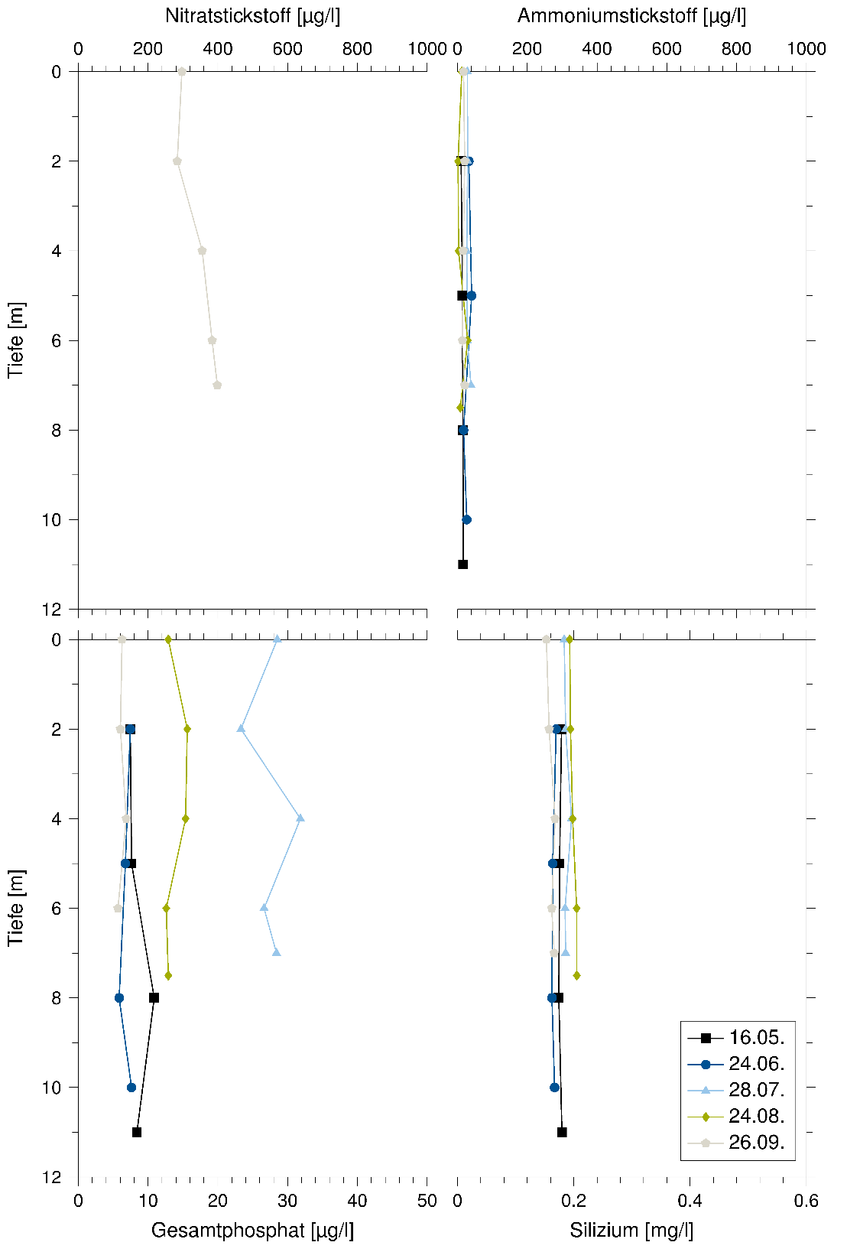

Variations of vertical distribution of hydrochemical parameters in Lake Unterer Soiernsee in 2015

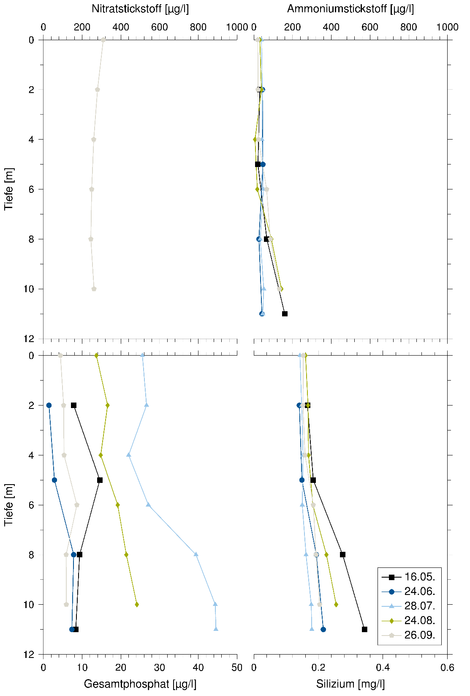

Variations of vertical distribution of hydrochemical parameters in Lake Oberer Soiernsee in 2015

Suppl. 13: Physical parameters
Lake Unterer Soiernsee 2015
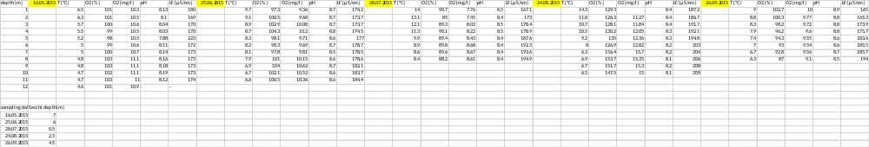
Lake Unterer Soiernsee 2016
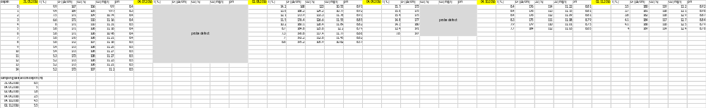
Lake Oberer Soiernsee 2015
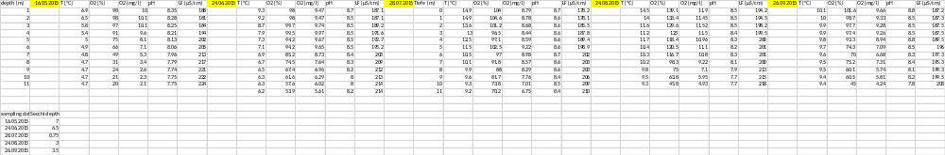
Lake Oberer Soiernsee 2016
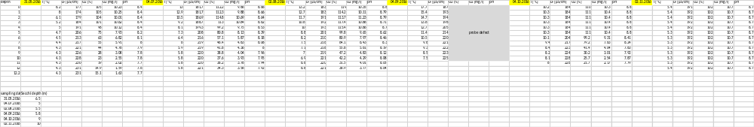

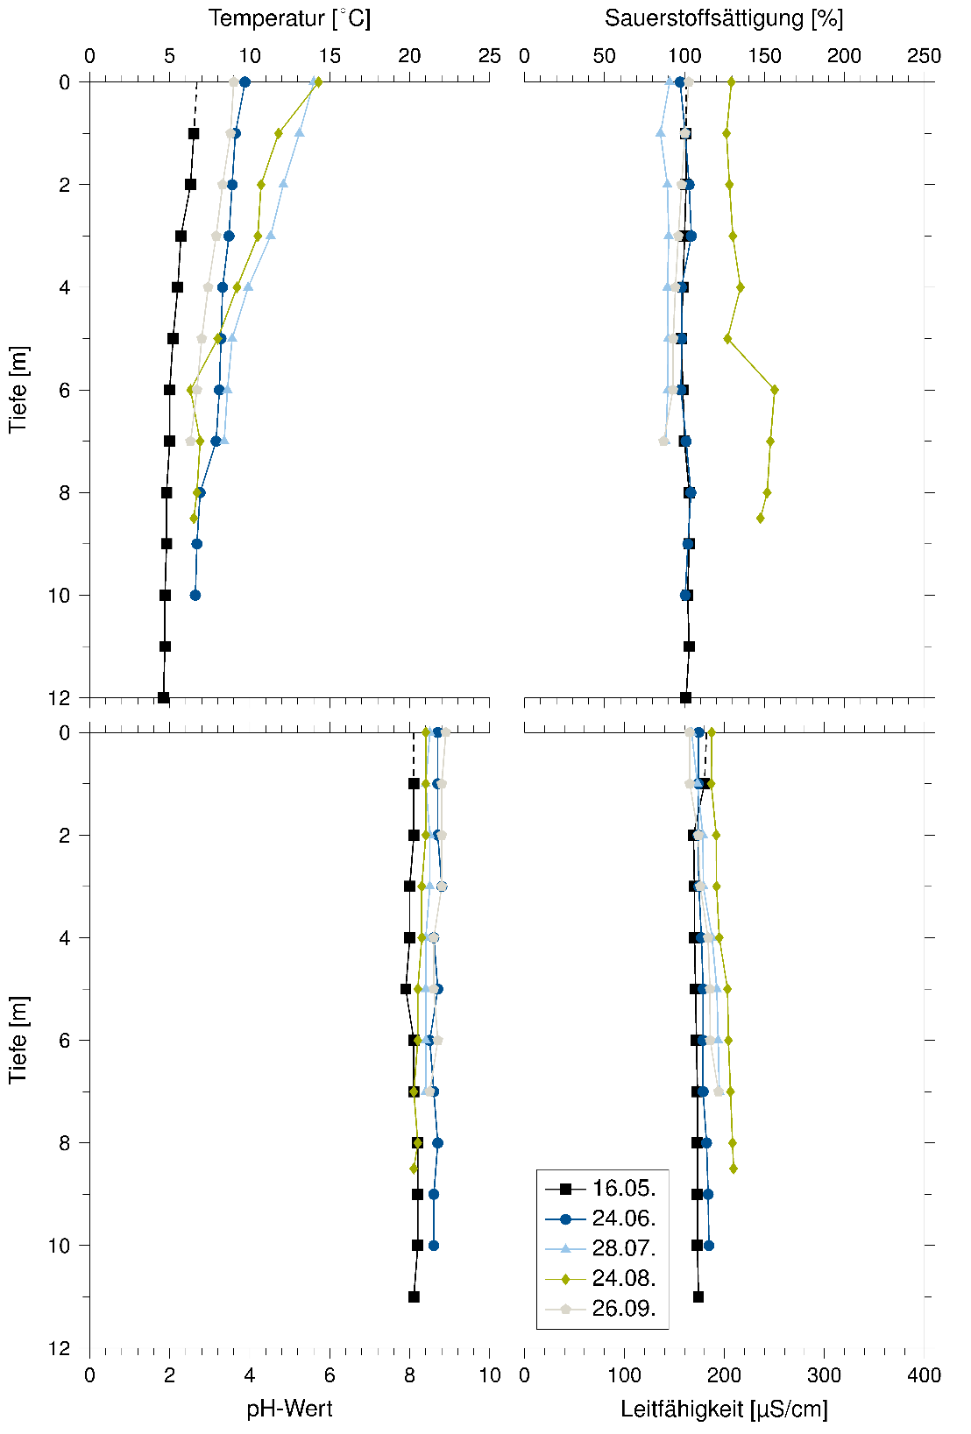
Variations of vertical distribution of physical parameters in Lake Unterer Soiernsee in 2015
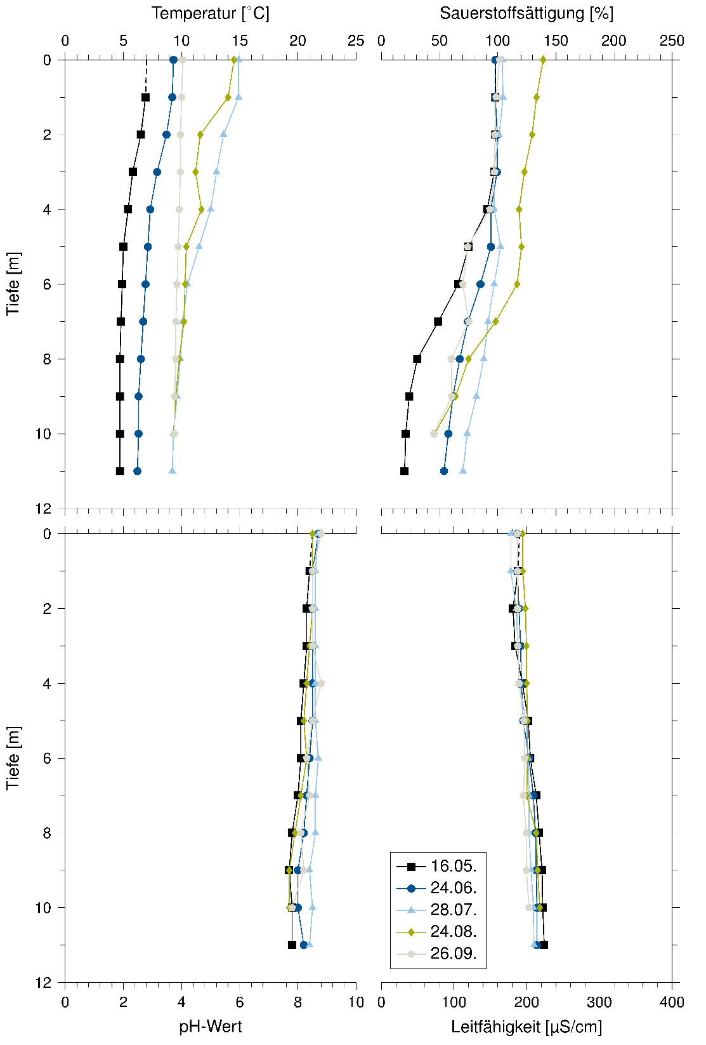
Variations of vertical distribution of physical parameters in Lake Oberer Soiernsee in 2015

